ENVIRONMENTAL SCHEME NO. 1786

PROPOSED INCLUSION OF OPEN LAND WITHIN THE BOUNDARY OF 154 GWENFRO, CAIA.

DESIGN AND ACCESS REPORT

Context

The site is located in Caia, within the area of Wrexham Town in the County Borough of Wrexham.
The adjoining area is predominately residential. There is a school opposite the property and a community centre to the front.

Existing Usage

The land, for the Proposals is owned by Wrexham County Borough Council consisting of open land.

The land affects antisocial behaviour; the area is used for illegal dumping, parking and the footpath is used as an easy get away route from police. Area can be found in Figs 1 and 2

Design Principle

Wrexham County Borough Council is proposing to incorporate open land within a residents garden. See fig 1.

The proposed land will reduce this problematic area by confining the area to a residential garden.

Accessibility – vehicles/pedestrians

The footpath at the front of the land will not be altered. The footpath at the rear of the land will be widened to 1500mm and extended to incorporate a pedestrian barrier where the footpath meets Prince Charles Road.

Vehicle and Pedestrian movements to, from and within the site

Property access will stay the same. (Fig 1)

Proposed Character

The existing timber palin fence running from the front boundary to the shed will be removed. A new 1M high, ball top metal railing (see type fig 3) will run across the front of the property incorporating the existing pedestrian barrier (which may require minor alteration) and return along Prince Charles Road to the new pedestrian barrier. It will start again on the adjacent corner of the barrier and run back to meet the new 1.8 Meter closed board fence separating the front garden from the rear, providing privacy for the tenant. (photos of type of fence in Fig 4).
Community Safety

Cars will no longer be able to park on the open land opposite the school and access to the footpath will be via the pedestrian barrier. Police are considering re-instating the gate to the alley between 154 and 155 Gwenfro in the future.
.
Environmental Sustainability

Land use – The proposed work is not on contaminated land.

Noise Pollution – Some may be generated during the construction works.

Air Quality – There may be a limited amount of dust resulting from the construction works.

Plans and Drawings

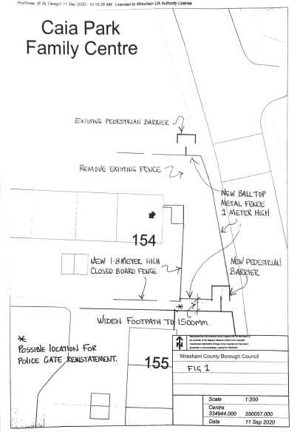
Fig 1 (NTS)

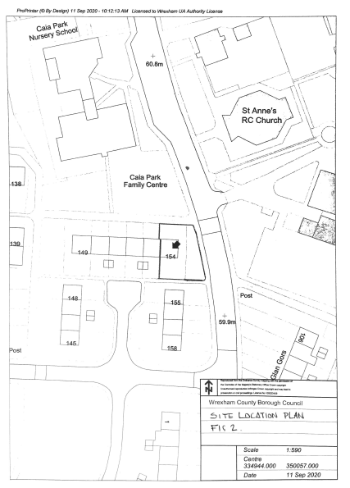
Fig 2 (NTS)

Fencing Styles

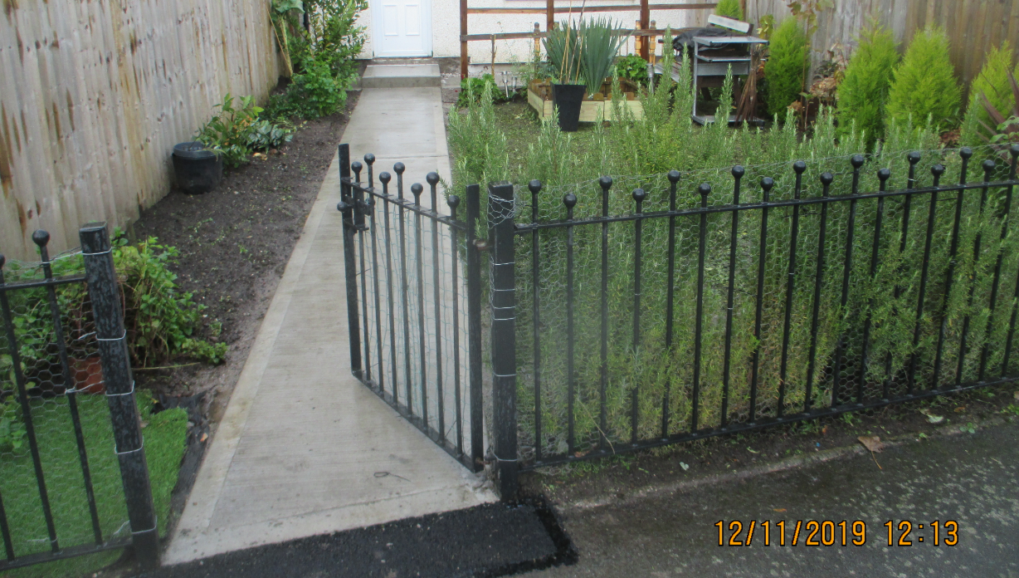
Fig 3
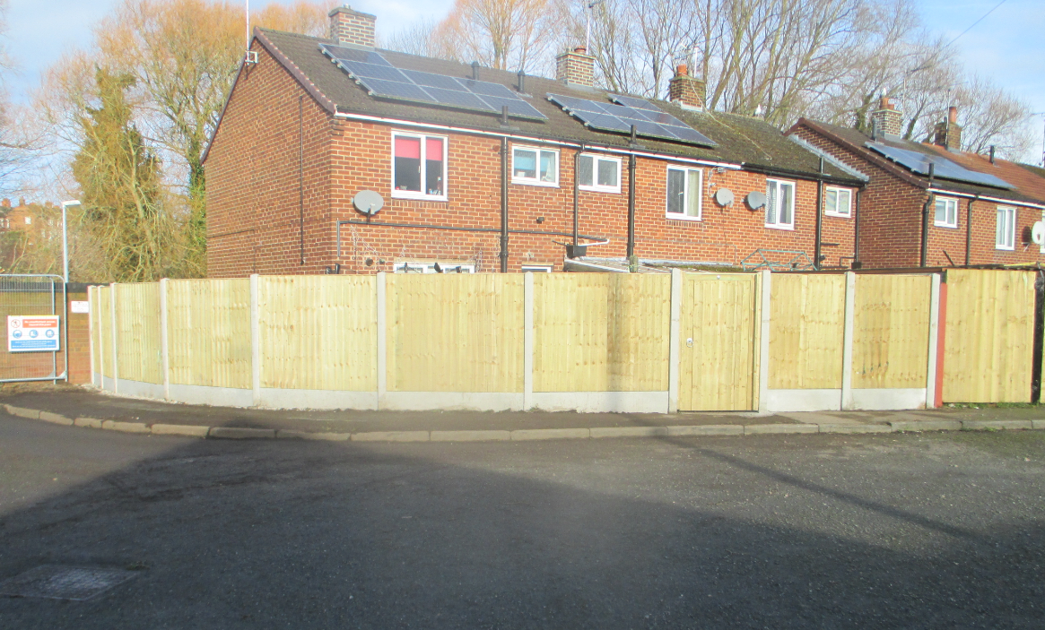
Fig 4

Existing Photographs

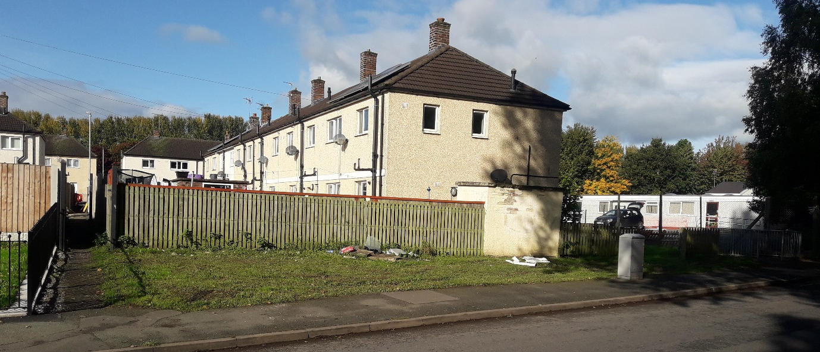
Fig 5

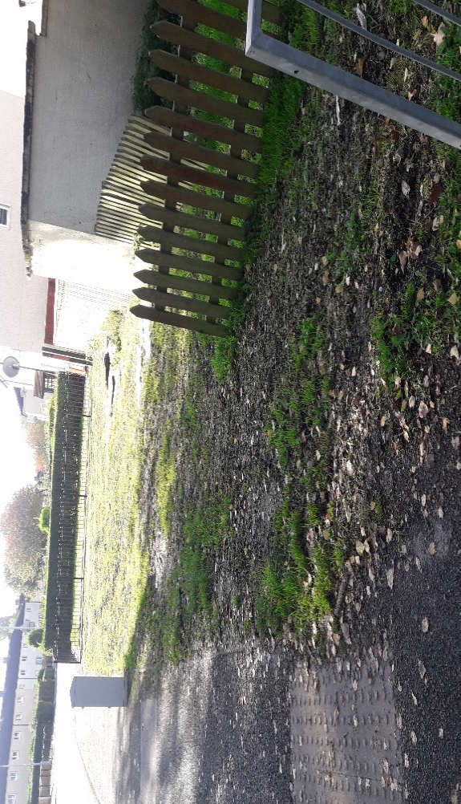
Fig 6

