Starbucks Building:

Roof Sheets
Profile - Kingspan Topdek – Membrane Armour Plan Quadcore - Light Grey

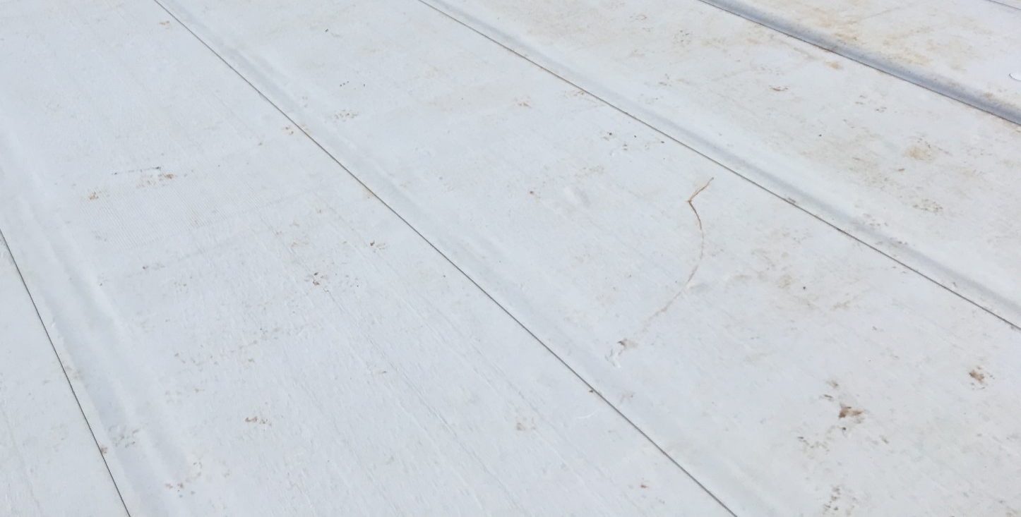

Feature Cladding
Bennets Timber BEN-STAR1 Profile in Larch. 125mm cover width finished in Teknos Paint System Base Coat: Wicker and Top Coat: Cypress

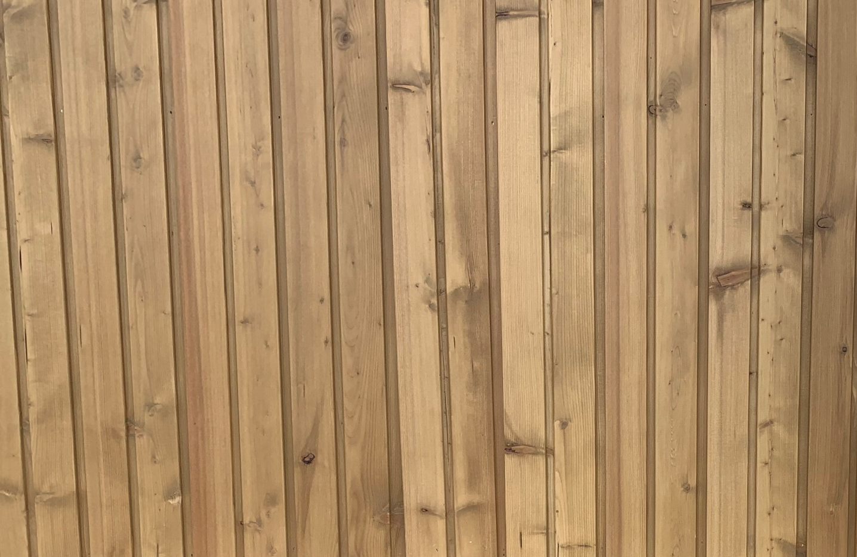

Feature Cladding
Eternet Equitone Facade Panels – Linea LT60

