SITE PHOTOGRAPHS: THE TROTTING MARE, KNOLTON, OVERTON
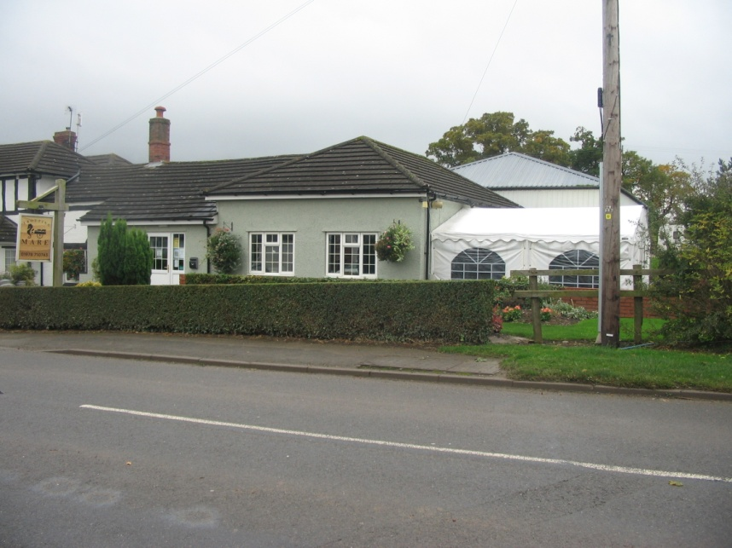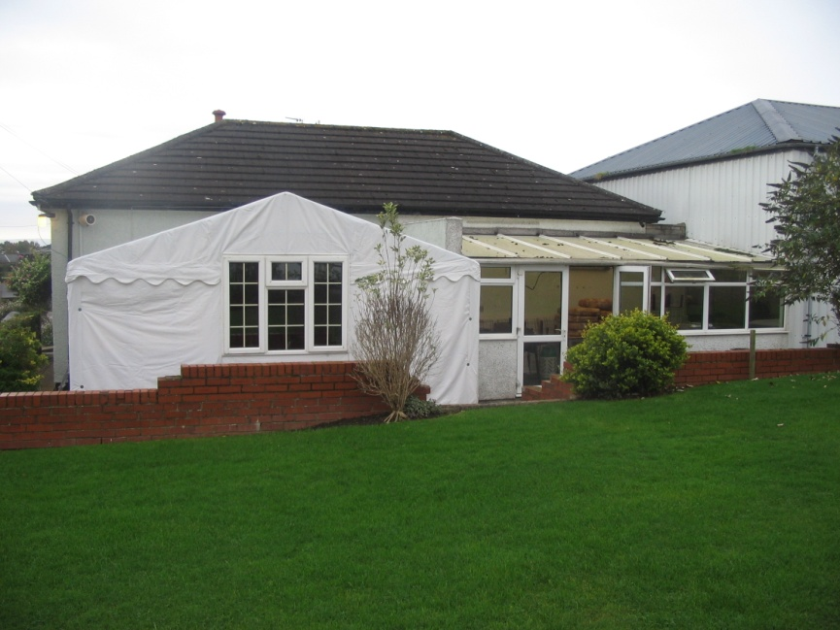
View from garden (North Elevation)
View of Marquee from A528

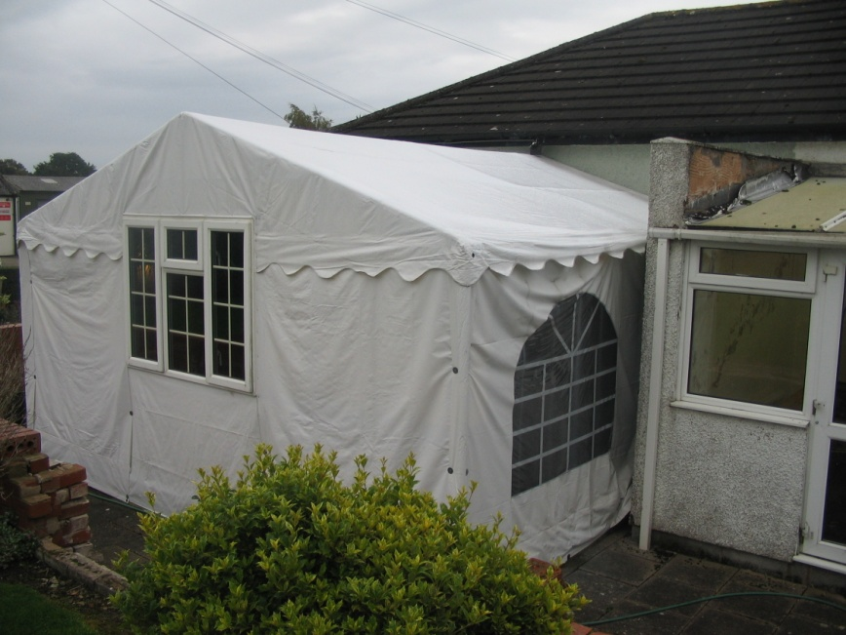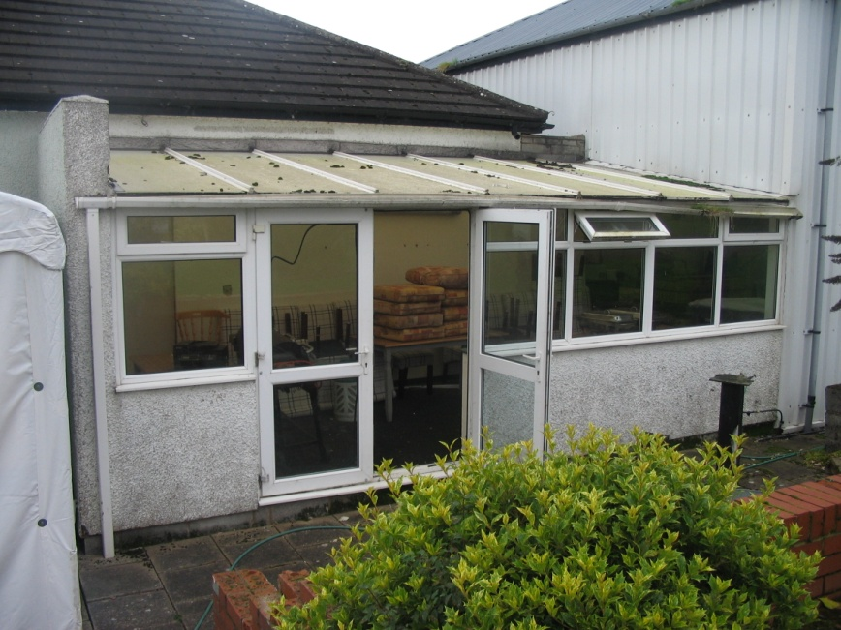
Close up of Sun Room
Close up of Marquee

