ADAPTION OF EXISTING OUTBUILDING, INCLUDING EXTENSION TO PROVIDE GARAGING AND CONSTRUCTION OF STABLES AND
CAR PORT

AT KNOLTON HALL
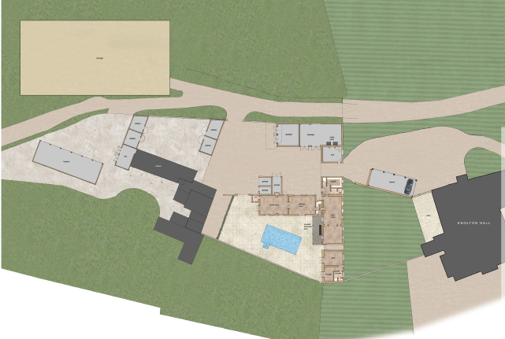
CONDITION 11 – ECW

Mr and Mrs Edward Chantler

Householder application for the adaption of existing range of buildings, extension to provide garaging, and construction of stables and car port

Knolton Hall, Oswestry Road, Overton WREXHAM Powys LL13 0LG.

Application P/2019/0397 was granted on 12th December 2019.

Condition 11 of the above consent requests:
no part of the development shall commence until details of the appointed Ecological Clerk of Works (ECW) has been submitted and approved in writing by the LPA.

Details of ECW
Will Prestwood
ARBOR VITAE ENVIRONMENT LTD
Lower Betton Farm
Cross Houses
Shrewsbury
SY56JD

T 01743 761232 E will@arborvitae.uk.com W www.arborvitae.uk.com

