CONSTRUCTION OF STABLES following DEMOLITION OF EXISTING

AT KNOLTON HALL

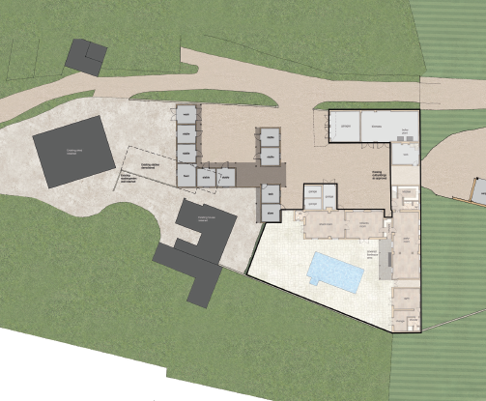

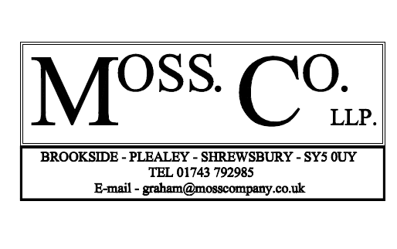
DESIGN AND HERITAGE STATEMENT

CONSTRUCTION OF STABLES following DEMOLITION OF EXISTING

AT KNOLTON HALL
SECTION 1
- Introduction And Background

SECTION 2
Planning Statement
- Design Concept And Proposals
  - Demolition of existing stables
  - Construction of new stable range
- Materials

SECTION 3
- Historical Impact Assessment

SECTION 4
- Method Of Construction

SECTION 5
- National And Local Planning Policies

SECTION 6
- Conclusions

SECTION 7
- References

SECTION 1

Introduction & Background
This Design and Heritage Statement has been prepared by Moss Co LLP on behalf of Mr and Mrs Edward Chantler in support of a full planning application for the construction of a stable range following demolition of the existing at Knolton Hall, Oswestry Road, Overton WREXHAM Powys LL13 0LG.

Knolton Hall is a grade II* listed building. The existing stable range is not listed within its own right but is within the domestic curtilage of the main dwelling.

Consent has already been granted in February 2020 on applications P/2019/0397 and 0535 for the conversion and adaptation including extension of existing buildings, construction of stables and car port. This application seeks to demolish the existing stables and revise the layout of the new stable range, whilst retaining the approval for the extension to the outbuildings and car port.

The use is and will remain ancillary to the main dwelling.

The current owner and applicants purchased the property in 2016 with a view to restore the property and reside there as their family home. Work is on-going to the alterations to the house.

In addition to this Planning Design Statement, the application is supported by the following information:

- Existing Location Plan and Existing Site Plan
- Existing Plan and Elevations of existing stables
- Approved Plan
- Proposed Site Plan
- Proposed Plan and Elevations of new stable range
- Heritage Statement
- Topographical survey
- RK Morris & Associates LII Historic England photographic Survey
- Arbor Vitae Ecology

LOCATION
Knolton Hall, Oswestry Road, Overton WREXHAM Powys LL13 0LG
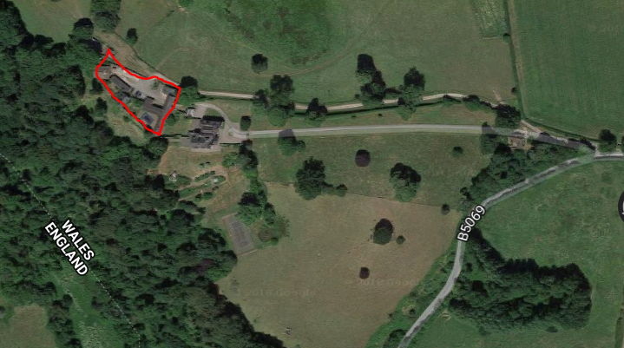
Study area
Knolton Hall
Source: Googlemaps
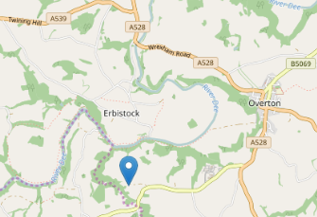
Source: Googlemaps
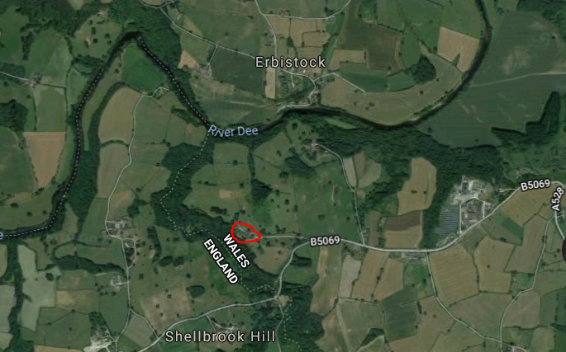
Source: Googlemaps

The application site lies close to the Wales/England border.

SECTION 2
PLANNING STATEMENT

Consent has already been granted in February 2020 on applications P/2019/0397 and 0535 for the conversion and adaptation including extension of existing buildings, construction of stables and car port. This application seeks to demolish the existing stables and revise the layout of the new stable range, whilst retain the approval for the extension to the outbuildings and carport.
Revised location and layout of stable range

dotted line … denotes existing 4 bay stable range to be demolished
Area outlined remains as approved on consents applications P/2019/0397 and 0535
Site plan

The proposed changes are minor considering their current status.

USE
The proposed use of the stable range within this application is ancillary in association with the host dwelling.

The site area is 7,892m² / 7.8ha.

Design Principles and Concept
Proposals
- Demolish the existing stables
- Revised location and layout of the new stable range

DEMOLITION OF EXISTING STABLES

This building is not listed in its own right, but is within the curtilage of the listed building and dates from the first half of the twentieth century.

This building provides for 2 stables including associated areas for feed, store and tack room and is constructed from brick and a slate roof.

The tall flank wall to rear of the stable building is likely the remainder of the walled garden and it is intended that this wall will be preserved.

The stables would not likely meet the current statutory requirements required by DEFRA for the care and owning of horses.

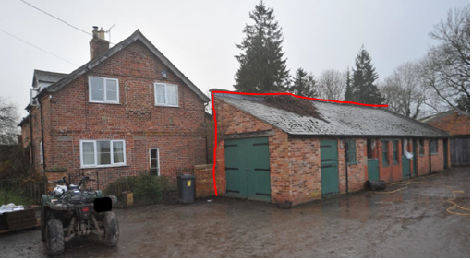
Garden wall to be retained
The Gardener’s Cottage, with adjacent stables to be demolished but retaining garden wall

AMOUNT
The existing stable range to be demolished has a footprint of 87m² and a floor area of 76m².

SCALE
The height of the existing eaves, to be demolished is 2.3metres.

The height of the existing ridge to be demolished is 4.9metres.

APPEARANCE
This building currently provides 2 stables including associated areas for feed and tack room and is constructed from brick and a slate roof.
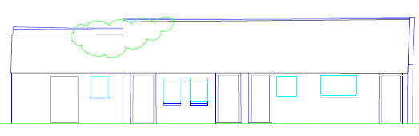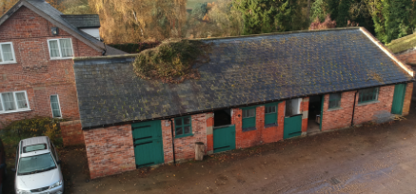
Existing north elevation
The tall flank wall to rear of the stable building is likely to have been part of the walled garden and it is intended that this wall will be preserved.
Flanking wall to be retained

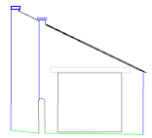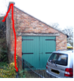

Existing east elevation

The existing flank wall and store to the west elevation which was approved to be removed in the previous applications P/2019/0397 and 0535, is to remain.

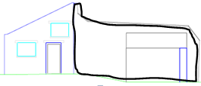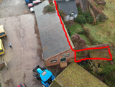
west flank wall

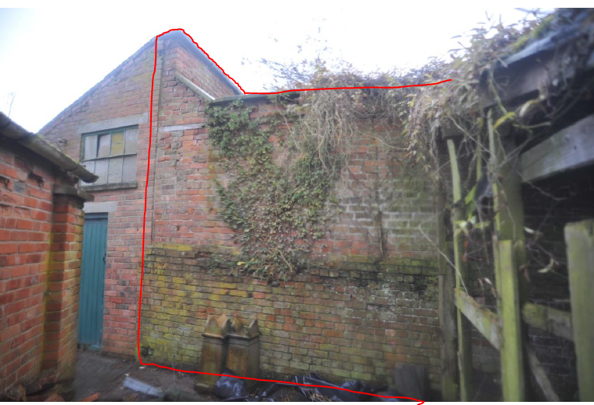
wall to be retained
west flank wall

The existing flank wall to the south elevation which was approved to be removed in the previous applications P/2019/0397 and 0535 is to remain.

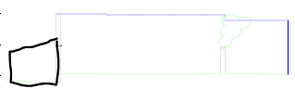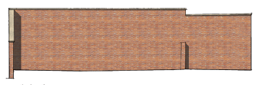
Existing south elevation Proposed south elevation

LAYOUT
The existing layout provides for 2 stables including associated areas for feed, store and tack room.
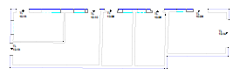
Existing layout
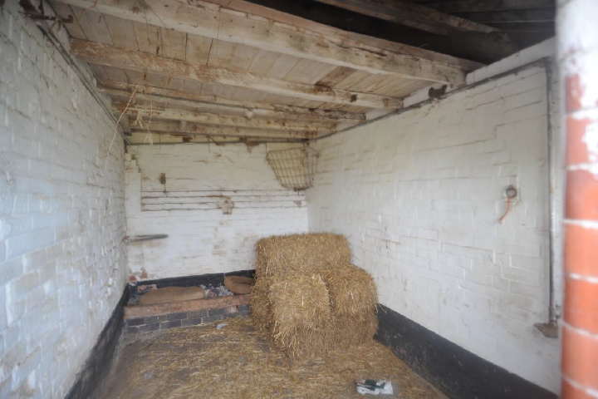
Interior view of stall

DESIGN CONCEPT OF REVISED STABLE LAYOUT
Consent has already been granted in February 2020 on applications P/2019/0397 and 0535 for the conversion and adaptation including extension of existing buildings, construction of stables and car port. This application seeks to demolish the existing stables and revise the layout of the new stable range, whilst retaining the approval for the extension to the outbuildings and car port.

This application seeks for a marginal change to that previously approved.

The proposals are to improve the layout of the new stable range.

Principle of development
- Function wells and add to the overall quality of the area, not just for the short term, but over the lifetime of the development.
- Responds with and to the local character and reflects the identity of the local surroundings and materials, while not preventing or discouraging appropriate innovation.
- The orientation of the stable range remains largely on the same axis and the approved and establishes a strong sense of place with the existing Coach House to create an attractive place.

Impact of the siting, scale and design of the stables on the appearance of the site.
- Care has been taken to ensure that the architectural style of the stable range integrates with the architectural merit of the adjacent Coach House and listed building beyond.
- Due to the existing use of the site and road layout the proposal will not result in a detrimental impact to highway safety or users.
- The orientation of the stables remains the same proximity to the listed building as approved.

Impact on neighbouring properties
- The removal of the existing stables will provide a more/amenity? open feel to Gardener’s Cottage. The proposed windows facing the cottage are within a stable and therefore no loss of amenity, sense of overshadowing or overlooking is caused by the replacement stables.

Tree Related Matters
- No protected trees will be harmed in the overall construction of the scheme.

Revised location and layout of stable range

dotted line … denotes existing 4 bay stable range to be demolished
Area outlined remains as approved on consents applications P/2019/0397 and 0535
Proposed layout

AMOUNT
The proposed stable range has a footprint of 148m² and a floor area of 135m².

SCALE
The height of the proposed eaves is 2.5metres.
The height of the proposed ridge is 5.2metres.

APPEARANCE
The proposed new stables will be constructed on a concrete pad with a brick plinth with internal blockwork and detailed with vertical shiplap weatherboarding and stone piers.

Bricks will be laid in Flemish bond using two parts building sand, one part sharp sand and one part lime for the mortar mix with a slightly recessed joint, formed by brushing back a flush joint at the end of each day’s work.

Windows will be timber.

Doors will be vertical boarding.

The roof will be finished with slate or profile cladding.

Any new rainwater goods will be Hunter “Foundry” http://www.hunterplastics.co.uk/products/rainwater/foundry-finish-125/
or Brett Martin “Cascade” cast iron look range http://www.brettmartin.com/en-gb/plumbing-and-drainage/products/cast-iron.aspx or similar.
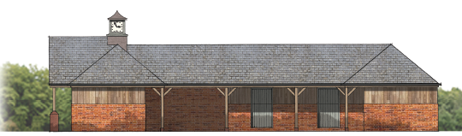
North elevation looking towards pasture

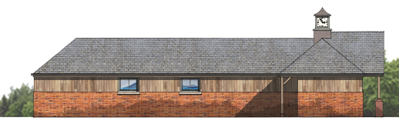
Outer south elevation looks towards The Gardener’s Cottage
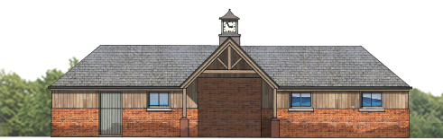
East outer courtyard elevation looks towards the Coach House

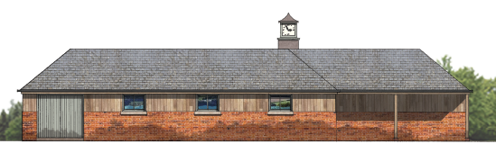
West outer courtyard elevation looks away from the Hall

LAYOUT
The layout provides for 6 stables facing the courtyard including associated areas for feed, tack room and stores. The stables are largely on average 3.6m².

The main access through the courtyard provides a more formal approach; whilst an open area is intended to the north to allow for larger horse lorries and emergency vehicle access. The formal entrance is lower than that allows for larger lorries but therefore reduces the potential impact and scale of the proposal.

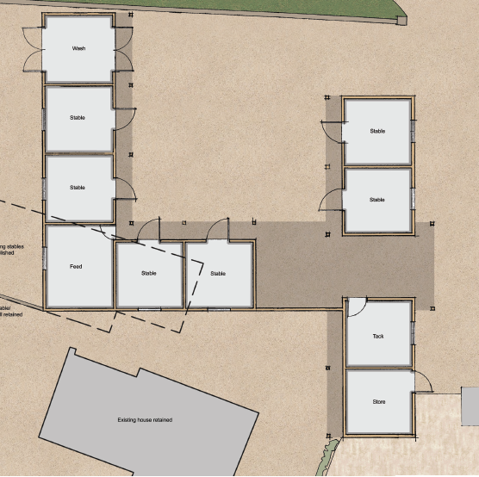
Access for horse lorries and emergency vehicles
Formal entrance
Proposed layout

ACcess
The estate yard is level and laid with concrete. All existing accesses remain.

LANDSCAPING
The proposal will include informal landscaping of the remaining area after the alterations.

ENVIRONMENTAL
Where possible materials required for the construction will be from local, sustainable and renewable sources.

An ecology survey was commissioned by Arbore Vitae on 28th February 2019 and refers to the stables, to be demolished as part of this application as Building 4. No other building is affected by this application.

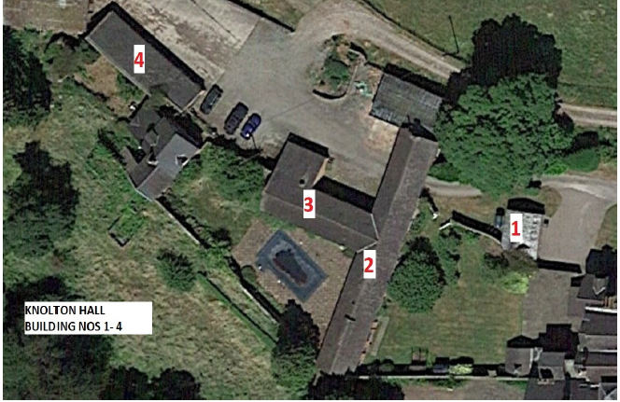
Location of stables to be demolished – building 4

No other buildings affected by this application

The conclusion was that building had no evidence of bats. Probable low to moderate suitability as a route and had former use by swallows. The full ecology report has been submitted as part of the submission documents.

Access for emergency vehicles to the site following the construction of the stable range will remain unaffected.

There are no public footpaths within the development site.
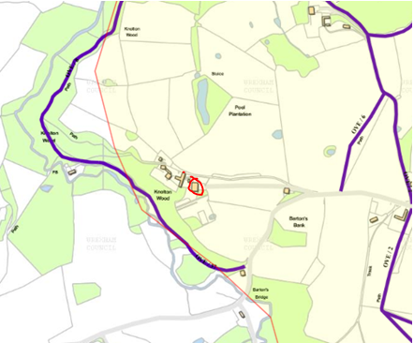
Source: http://www.wrexham.gov.uk/mapping/

No external lighting other than illumination access to the stable range and will be located sensitively for bat activity.

The site is not within an area of geological conservation importance.

The site is not within an area of special habitats or other biodiversity features.
The proposal does not involve the need to dispose of trade effluents or trade waste.
There are no known hazardous wastes within the study area.

DRAINAGE
No increase is proposed on the burden of foul drainage disposal.

Surface water run-off from the proposed stable range will connect to the existing system.

FLOOD RISK
The site is not located in an area designated as a Flood Zone and thus at negligible risk from flooding, as confirmed by the Environment Agency flood maps.

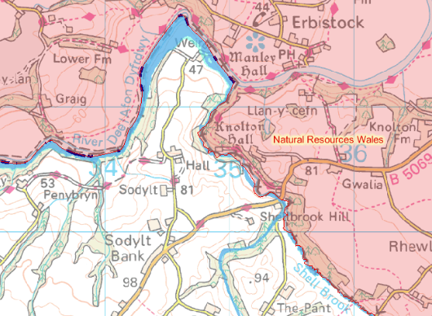
Source: Environment Agency

COMMUNITY
The layout of the site remains as existing. There are no public areas, car parks or footpaths that cross the site.

MOVEMENT TO, FROM & WITHIN THE DEVELOPMENT
The drive is existing and is privately owned.
Additional parking is provided with the courtyard area.
- Day to day parking for those involved with the horses is located within the courtyard.
- 2 bay secure garaging, as approved, is located adjacent to the biomass building.

PLANNING HISTORY
As recorded on the Wrexham planning access

Knolton Hall
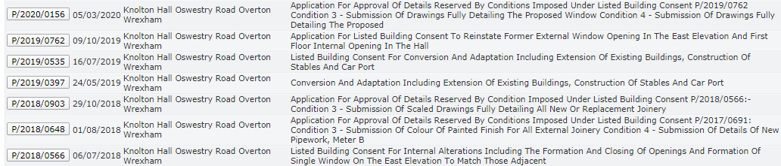
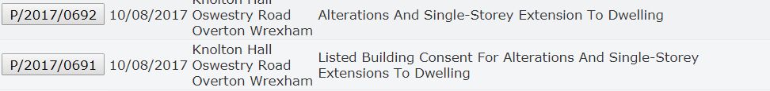
The Gardener’s Cottage
Source: Wrexham planning access
The Site & Its Surroundings
Standing in an elevated position with glorious far-reaching views, Knolton Hall is surrounded by beautiful unspoilt countryside on the Shropshire/Welsh Border, close to the Cheshire Border. Situated to the edge of a small rural hamlet, the house is close to good amenities in the nearby village of Overton-on-Dee and the town of Ellesmere. In an area known as the Wynnstay country, it is noted for its superb riding opportunities and close proximity to a number of equestrian venues.

The location of the proposed stables is set behind (to the north west) of the listed building and distanced by 70 metres.

CONSULTATION
Gardener’s Cottage will not suffer loss of amenity, sense of overshadowing or overlooking caused by the replacement stables but will gain more circulation space around the building.

SECTION 3

HERITAGE STATEMENT

The purpose of this Heritage Statement investigates the potential impact of the proposals on the nearby listed building.

Research of the following national and local policy guidelines were considered:
- Cadw Conservation Guidelines (2011
- Planning Policy Wales (Edn. 10, Dec 2018)
- Cadw Best Practice Guidance on Managing the Setting of Historic Assets in Wales (May 2017)
- Cadw Best Practice Guidance on Heritage Impact Assessment in Wales (May 2017)
- Cadw Best Practice Guidance on Managing Change to Listed Buildings in Wales (May 2017)

It is emphasised throughout that applicants “should provide proportionate information to allow the assessment of the likely impact of proposals for development on a historic asset and its setting”.

The main planning guidance for this type of application is now set out in Planning Policy Wales and Chapter 6 - The Historic Environment and states:

“The historic environment is relevant to and is a vibrant part of the culture and economy of Wales. To enable the historic environment to deliver rich benefits to the people of Wales, what is of significance needs to be identified and change that has an impact on historic assets must be managed in a sensitive and sustainable way”.

Extract from Paragraph 6.5.11 states:
“The aim should be to find the best way to protect and enhance the special qualities of listed buildings, retaining them in sustainable use. The application of development and listed building controls should recognise the need for flexibility where new uses have to be considered in order to secure a building’s survival or provide it with a sound economic future”.

Extract from paragraph 6.5.13 states:
“..The statement should be proportionate both to the significance of the building and to the degree of change proposed”.

- Consent has already been granted in February 2020 on applications P/2019/0397 And 0535 for the conversion and adaptation including extension of existing buildings, construction of stables and car port. This application seeks to demolish the existing stables and revise the layout of the new stable range, whilst retaining the approval for the extension to the outbuildings and carport.
- The proposed stable range remains ancillary use to the main dwelling.

Significance
Current national policy guidance relating to the protection and enhancement of the Historic Environment is contained within the Heritage Impact Assessment in Wales which outlines what information is required:

“ The heritage impact assessment process should be proportionate both to the significance of the historic asset and to the degree of change proposed”.

- Knolton Hall is Grade II* listed, details below.
- The proposals in this application do not affect the fabric or structure of the host dwelling.
- The existing stables are not listed in their own right.
- The replacement stables will not be visible from the house.
- The existing stable range to be demolished but the materials will be cleaned and stored carefully for reuse.
- The original garden wall will be retained.
- In 1870-72, John Marius Wilson's Imperial Gazetteer of England and Wales described Knolton as:
KNOLTON, a township in Overton parish, Flint; 5½ miles ENE of Chirk. Real property, £1, 765. Knolton Hall is the seat of the Kynaston family. http://www.visionofbritain.org.uk/

KNOLTON HALL
LISTED BUILDING STATUS
Location: On the western edge of the Community, approached by a drive this leaves the main road at the top of Barton’s Bank.
County: Wrexham Community: Overton
Locality: Knolton Traditional County: Flintshire
Lieutenancy Area (Ceremonial County): Shropshire
Listing Date: 16 November 1962 Last Amended: 15 March 1994
Grade: II* Source: Cadw Building Class: Domestic Source ID: 1691

The origins of the present house are in a house of c1600, which has been successively extended and remodelled, principally in the C18, apparently in 2 distinct phases, and then, c1857-68 by John Cunningham of Liverpool, for Mr R C Cotton of the Combermere family.

Exterior
The earliest form of the building is apparent in the layout of the entrance front, which comprises a central hall range flanked by 2 advanced gabled wings, both of which have lateral stacks. Left-hand wing is partially timber framed, the framing surviving in the gable end and in part of the return wall to the garden front: small panels with cusped quatrefoils. The rest of the building is painted brick, with heavy slate roofs throughout. In the C19 remodelling, the front gables at least were painted with mock framing which has since disappeared. Fenestration of left hand wing entirely of the C19, with carved mullioned and transomed windows, some with decorative leading. Towards the rear of this wing, a pavilion roofed tower is a C19 addition over the staircase.
The entrance hall is itself gabled, and was probably raised in height with the addition of its gabled upper storey during the C19 remodelling: the upper storey is jetted in brick. Central doorway in porch flanked by C19 carved wood mullioned and transomed windows of 2-lights. 6-light mullioned window above the doorway is also a C19 insertion, and there is a 4-light mullioned window in similar style in the attic, which has carved wood entablature bearing an inscription ‘every house is builded by some man but he that built all things is God’. Right hand gable is also almost certainly part of the original layout of the house, although the external structure appears to be no earlier than the C18. Upper windows have the carved mullions that characterise the C19 work, but there is possibly one original opening surviving to the ground floor. This wing is partially wrapped round by a later wing which seems to be mid C18: fenestration belongs to the C19 remodelling, but brickwork, which includes part bands in the return elevation, is C18. It appears to have been extended by a single bay to the rear, probably during the major C19 remodelling. Ornately panelled bargeboards throughout, all added in the C19.

Garden front: The garden front is entirely a mid C19 addition to the house, and may itself have been extended by one bay to the right (E). It comprises a 2-storeyed, 3 window range, with 2 gables over left hand windows, and a steeper gable over the narrower right hand bay, which seems to be of the newer brickwork. 4-light mullioned and transomed rectangular bay window in centre, with similar window to left; 3-light mullioned and transomed window to left above, and 2-light sashes above the bay window, and in the right hand bay. Axial stack.

Rear elevation: Gables over hall range and cross wing, with subsidiary gables of less height built against them, representing an extension of the original plan in the C19. N gables is an extension of the C18 wing, probably late C18 or early C19, and pre-dating the major C19 remodelling. Wide return gable of C19 wing to right, itself extended along its rear elevation in the early C20.

Interior
Plan comprises entrance hall with flanking wings and staircase; corridor running to rear of hall added in C19, connecting the C19 garden front wing with the back stairs (at rear of N cross wing of hall) and C18 wing to N. Entrance hall was opened out through 2 storeys in the C19 remodelling: gallery runs along E wall: with C18 ornate cast iron rail, said to have come from Overton church.
Dado panelling may partly pre-date the remodelling (perhaps C17) and can be clearly distinguished from the C19 pine panelling which forms architraves to doorways; and which frames the stairs which foliate fretwork; pine panelled pedimented over mantle is dated 1868, with initials ‘CMARC’ on scrollwork. Staircase opens off the hall towards the rear left (S): early C18, with turned balusters, 3 per tread, carved tread ends, fluted newel and swept rail. Dado panelling made from smooth planks of timber.
Decorative plasterwork over doorway to S room has dado panelling similar in style to that in the hall; simpler moulded full-height panelling, C17 in style but almost certainly late C19 in date, in N room which has plaster moulding to beams which panel the ceiling, and a corner fireplace. The room formerly extended further towards the rear of the house, where small service rooms have been created. ‘Cromwell Road’ in C18 N wing also appears to have been remodelled in the C19: graining over oak dado panelling, and ornate carved surround to corner fireplace.
Upper rooms in this wing have chamfered ceiling beams and bolection moulded fireplaces, one of which retains a rectangular hob-grate of the late C18. Double ogee grate also survives in first floor of N cross wing of hall.

Reasons for Listing
Listed at II* as a substantial, complex country house with some external and internal parts of considerable quality.
Source: British Listing
Setting
Setting of Historic Assets in Wales 2017 states
“When change or development is proposed, it is important to identify the historic assets that might be affected, define their setting and understand how that setting contributes to the significance of the historic assets”.

“If a proposed change or development is likely to have an impact on a historic asset and its setting, the applicant should prepare a proportionate and objective written assessment of that impact”.

“Setting describes the relationship of a historic asset to the surrounding landscape or townscape. Its importance lies in what it contributes to the significance of a historic asset.

- The study area is not listed but is within the curtilage of Knolton Hall.
- The existing Coach House (no change is intended within this application but is part of the setting of the replacement stable range) was originally constructed as a carriage house or coach house and associated tack. Although evidence remains of an earlier possibly late seventeenth century building (now vestigial), the main structure was significantly enlarged in the nineteenth century.
- Carriage houses for large estates could be quite elaborate and large enough to house many carriages, horses, tack, and hay. Horses were an essential part of day to day life and much status was associated with the accommodation.
- Knolton Hall has the remit of outbuildings which one would expect with a country house ensemble of this period. The Coach House is an important part of the group and in the traditional manner this has been given a prominent location and particular architectural consideration. The stables (for which application proposes to demolish) and cart sheds at Knolton Hall are of a largely mid nineteenth century build, at a period when the house was substantially remodelled and extended. There are however vestigial remains of oak box framing at the south west end of the buildings indicating the presence of an earlier structure.
- The Coach House provides a screen from the listed building for the replacement stables as one might expect with a country estate.
- There is no change to the scale, amount or mass of the Coach House. The proposed revised stable range layout is minor considering that already approved.
- The proposals are unseen from public areas or the highway.
- Views to, from and across the historic asset largely remain the same.
- HER records confirm only the listing of Knolton Hall and the Building at Risk register where the building is classed ‘Not at Risk (6)’.
- The proposals will have no sensory impact on the historic asset.
- A photographic survey of the general outbuildings has been prepared by R K Morriss & Associates in December 2019, albeit the majority of the report is not relevant to this application.
Harm
“The impact of a proposed change or development within the setting of a historic asset can be a material consideration in determining a planning application or other consents. Therefore, it is important to consider whether the change or new development can be incorporated sensitively”.
- There is no visual impact relative to the scale of the historic asset or its setting.
- There is little change to visual impact relative to the location of the historic asset.
- Consideration of the proposals results in the least impact on the setting, character or significance of the listed building, due to the concealed nature of the site and its physical and visual separation from the main dwelling.
- The demolition works relate to the existing stables which were constructed in C20th and do not have any features of architectural and historic interest
- The works will be carried out sensitively using appropriate construction techniques and materials sympathetic to the structure and fabric of the surrounding structures.
- There are no existing features of architectural and historic interest within the stables to be demolished.
- The proposals will not affect or increase pressure on the existing natural features, tranquillity or noise to the surrounding area.
- The proposals will improve the character, appearance, functionality and future life of outbuildings by creating a suitable and appropriate function, within the fabric of the original structure.
- The proposals are reversible, minimising the impact of the work and will ensure the original plan, form or appearance of the courtyard isn’t lost forever.
- Any new work or alteration will respect the inherited character.

Mitigation
- A photographic survey of the general outbuildings has been prepared by R K Morriss & Associates in December 2019 for the record, albeit the majority of the report is not relevant to this application.
- There are no existing features of architectural and historic interest within the stables to be demolished.

Conclusions
- There is no loss of heritage features from the demolition of the stables.
- The replacement stables are of an appearance in line with its function and setting in the courtyard.
- The replacement stables are of ancillary use to the main dwelling.
- This statement is considered to be proportionate in its detail to the proposals.
- The location of the replacement stables range is invisible from the listed building, being well screened by surrounding buildings and foliage.
- It is considered that the proposals will not result in harm as defined by the PPW to the setting, significance or character of the Knolton Hall.
SECTION 4

CONSTRUCTION METHOD STATEMENT

Introduction
This statement considers the issues surrounding the development during the construction works, to ensure that neighbouring properties, residents and local amenities as well as the general public are not adversely affected by the construction works and site operations that may be taking place.

Some of the issues and suitable solutions to ensure the well-being, safety and to protect the local residents are as follows:

- Site traffic and deliveries including parking of vehicles for visitors and site operatives
- Working Practices
- Piling / Blasting
- Vibration
- Storage of plant and materials used in constructing the development
- The erection and maintenance of security hoarding including decorative displays and facilities for public viewing, where appropriate
- Measures to control the emission of dust and dirt during construction including wheel washing facilities
- Material use, waste and recycling
- Impact to neighbours

Site Traffic and Deliveries
All deliveries will take place in a dedicated location as agreed on site. The study area has the necessary storage facilities for deliveries and staff traffic.

Site traffic, will due to the nature of the site, be limited to within the development boundaries and therefore have little risk to the general public.

Construction works shall take place between 7.30am and 6pm Monday to Friday and 8am and 1pm on Saturday, unless otherwise agreed. No construction work on Sunday or Bank Holidays. These hours apply to any work causing noise audible at the site boundary.

Working Practices
The contractor will use the best practical means to minimise noise on site and will consult the useful guidance detailed in BS5228 2009: ‘Noise and Vibration Control on Construction Sites’ Parts.

The following items will be considered in particular, although not limited to:

Any vehicles, mechanical plant and machinery, used for the purpose of the works associated with the contract, shall be fitted with proper and effective silencers and shall be maintained in good and efficient working order.

The quietest plant and machinery available should be used. For example hoists and cement mixers will be electrically powered wherever possible; vehicles on the site should (where possible) be fitted with broadband white noise reversing alarms.

Items such as compressors and generators should always have acoustic covers in place.

When machinery is not actually in use, it should be switched off and not left running.

Wherever possible, fixed noise sources should be sited away from noise sensitive areas such as nearby dwellings.

Employees should be informed of the noise control measures required by, or agreed with the council and given training where necessary.

Piling or Blasting
Is it not intended this type of operation is required for the proposals.

Vibration
Is it not intended this type of operation is required for the proposals.

Storage of plant and materials
On site storage will be kept to a minimum possible to reduce the attraction to thieves
and vandalism. Materials will be stored in the designated area as agreed on site.

Site hoarding and site displays
Should site security hoarding/fencing be provided around the construction site, the gate to the site is to be securely locked shut, at all times the site is inactive, to prevent un-authorised persons entering the site un-supervised. The security hoarding/fencing would be maintained and repaired/replaced, as necessary.

Measures to control emission of dust and dirt from site
During spells of dry weather if the site becomes dusty, a damping down procedure will be in place to prevent effect to neighbouring properties. If any works taking place are likely to cause effect of dust to neighbours appropriate notice shall be given to prevent damage to any of the neighbouring properties or items.

Due to the nature of the site, any construction plant will remain on site, reducing the risk of dust and mud being tracked onto the carriageway. Visitors and contractors will park on a hard surface car park as agreed on site.

No excavation work is intended due to the existing nature of the site.

The construction site manager will be aware of the potential health effects of dust particulates and ensure that basic remedial action is taken to limit particle pollution.

Material use, waste and recycling
All materials used in the construction will be sourced as environmentally friendly and
economically as possible.

All waste will be sorted into the appropriate skips for either preferably re-use, recycling or as a last resort disposal.

Any hazardous wastes will be dealt with by an appropriately qualified and competent person as shall be disposed of in the correct manor at a registered disposal plant for the particular waste; receipts of disposal shall be kept in the site office as proof of the correct disposal.

No waste materials generated as a result of the proposed construction operations will be burnt on site. All such refuse will be disposed of by suitable alternative methods.

Impact to neighbours
The contractor will ensure to keep local residents informed in advance of any unavoidably noisy operations and length of timings, particularly if these are to take place outside the normal working hours.

The site foreman will be the responsible contact for residents whom they may contact and who will be able to deal with any complaints or enquires about the work.

If for any reason there is a need to switch off services at mains supply appropriate notice shall be given to all affected neighbours.

SECTION 5
PLANNING POLICY

NATIONAL PLANNING POLICY - Planning Policy Wales (PPW).
The proposals are considered to meet all national and local planning policies related to heritage matters. The Ancient Monuments and Archaeological Areas Act 1979, Planning (Listed Buildings and Conservation Areas) Act 1990 and Historic Environment (Wales) Act 2016 provide the legislative framework for the protection and sustainable management of the historic environment in Wales.

Planning Policy Wales provides the national planning policy framework for the consideration of the historic environment and this is supplemented by guidance contained in Technical Advice Note 24: The Historic Environment and Cadw associated best practice guidance on the historic environment.

Planning Policy Wales states in paragraphs 6.1.10 and 11
“There should be a general presumption in favour of the preservation or enhancement of a listed building and its setting, which might extend beyond its curtilage. For any development proposal affecting a listed building or its setting, the primary material consideration is the statutory requirement to have special regard to the desirability of preserving the building, its setting or any features of special architectural or historic interest which it possesses.

“For listed buildings, the aim should be to find the best way to protect and enhance their special qualities, retaining them in sustainable use. The continuation or reinstatement of the original use should generally be the first option, but not all original uses will now be viable or appropriate. The application of planning and listed building controls should recognise the need for flexibility where new uses have to be considered in order to secure a building’s survival or provide it with a sound economic future”.

Many listed buildings can sustain a degree of sensitive alteration or extension to accommodate continuing or new uses. Indeed, a cumulative changes reflecting the history of use and ownership are themselves an aspect of the special interest of some buildings, and the merit of new alterations or additions, especially where they are generated within a secure and committed long term ownership, should not be discounted”.

- The applicants purchased the property is 2016 and have since been carefully carrying out the alterations and the construction phase of the work to restore Knolton Hall and its outbuildings to a new glory.
- Consent has already been granted in February 2020 on applications P/2019/0397 and 0535 for the conversion and adaptation including extension of existing buildings, construction of stables and car port. This application seeks to demolish the existing stables and revise the layout of the new stable range, whilst retaining the approval for the extension to the outbuildings and car port.
- A photographic survey of the general outbuildings has been prepared by R K Morriss & Associates in December 2019, albeit the majority of the report is not relevant to this application.
- This application seeks for a marginal change to that previously approved, whilst incorporating more design detail to the stable range.
- We believe the overall scheme will ensure the optinum viable use and long term future of the courtyard environment. Such buildings have always evolved over time as their occupant’s aspirations evolve and such change forms part of their significance as heritage assets.
- The pattern of proposed use for the outbuildings is no more or less than what they have currently been used for. The proposed stable range are an enhancement of the current use of this part of the building complex.

PPW: Chapter 4 - Planning for Sustainability and TAN note 6
The planning system provides for a presumption in favour of sustainable
development to ensure that social, economic and environmental issues are balanced and integrated, at the same time

The proposals seek
- To improve the overall quality, function and visual attractiveness of the ancillary buildings of the heritage asset, not just for the short term, but over the lifetime of the development.
- To retain a strong sense of place by creating an attractive and comfortable place to live, work and visit for both the Hall and The Gardener’s Cottage amenity.
- To retain with, and to add to the local character and history of the site, and reflects the identity of the local surroundings and materials, while not preventing or discouraging appropriate innovation.
- Promotes innovation to keep the outbuildings useful, by making changes to accommodate today’s lifestyle.
- The proposal adds little to the existing loading of local infrastructure.
- Off street parking facilities remain as existing.
- The proposals will not burden or negatively impact on the existing local road network.

PPW: Chapter 6 - The Historic Environment and TAN note 24
To enable the historic environment to deliver rich benefits to the people of Wales, what is of significance, needs to be identified and change that has an impact on historic assets, must be managed in a sensitive and sustainable way.

The proposals and the Heritage Statement, referred to earlier in this report, confirm the following:-

- Knolton Hall is listed and policies in relation to this, have been respected and considered whilst forming this application.
- The proposals are sympathetic and the alterations to the appearance of the non-designated outbuildings are not considered to result in an adverse impact on the existing setting and character of the heritage asset or its surroundings.
- The proposals ensure no significant harm or loss to the existing structures. The replacement stables are reversible.
- The proposals will not have a detrimental impact on the existing amenity of the host dwelling or The Gardener’s Cottage.
- The proposals will greatly improve the character, appearance, functionality and future life of ancillary buildings as a whole entity.
- The proposals will not affect or increase pressure on the existing natural features, tranquillity or noise to the surrounding area.
- A photographic survey of the general outbuildings has been prepared by R K Morriss & Associates in December 2019, albeit the majority of the report is not relevant to this application.

Natural Environment
The study area is not within any designated or protected land form area.
The proposals will not have a significant adverse effect of any of the natural assets and in particular:

Ecological assets
- No harm or removal of trees or hedges in intended.
- The Construction Method Statement, within the document, has assessed the construction impact of the site.
- Landscape character does not change with the proposals.
- Visual amenity to the host dwelling does not change with the proposals.
- The Gardener’s Cottage amenity is improved (with the demolition of the existing stables), whilst retaining the existing private amenity area.

The proposals involve seeking positive improvements in the quality of the built, natural and historic environment, including (but not limited to):
1. Energy
2. Materials and Resources
3. Water Use
4. Landscape and Biodiversity
5. Place and Local Distinctiveness
6. Robust Building

- Where possible materials required for any new construction will be from reclaimed, local, sustainable and renewable sources.
- The replacement stable range adds no additional loading to the foul drainage system.
- The study area is not protected by or adjacent to any ecological or landscape designations, and will not have any detrimental impact of any protected species.
- No trees or hedgerows will be harmed by the construction of the stable range.
- The proposal improves the conditions in which people live, work and take leisure.
- The proposal provides employment during the construction.
- The proposal will provide local employment with care of the horses after the construction.

Managing Change to Listed Building in Wales
- The existing stables are not listed in their own right, only within the curtilage of the Knolton Hall.
- The proposals do not affect the fabric or structure of the host dwelling and therefore no change to the historical significance of the Knolton Hall.
- The remaining outbuildings within the courtyard area have already been converted and continue to be of ancillary use to the main dwelling. There is no change to the form, scale, amount or mass of the existing outbuildings.
- The existing Coach house provides a screen to the listed building.
- The existing stables are not considered historical although all other historical features and materials on the remaining buildings will remain.
- The replacement stable range will be constructed on a concrete pad with brick plinth with internal blockwork and vertical shiplap weatherboarding.
- Where possible any new materials required, will be from local, sustainable and renewable sources.
- Any existing internal and external historical features and materials will remain.
- The proposals are unseen from public areas or the highway.
- This statement is considered to be proportionate in its detail to the proposals.
- It is considered that the proposals will not result in harm as defined by the PPW to the setting, significance or character of the Knolton Hall.

We ask that the LPA take a supportive approach to the proposed development in a positive and creative way and work proactively with the agent/applicant to secure a consent that will generally improve the economic and environmental conditions of the area.

SECTION 6

Conclusions

We believe the proposals
- Will function well and add to the overall quality of the area, not just for the short term, but over the lifetime of the development.
- Retain a strong sense of place on the landscape to create an attractive and comfortable place to live, work and visit.
- Creates a safe and accessible environment where crime and disorder, and the fear of crime, do not undermine quality of life.
- A review of the Environment Agency’s web indicates that the study area is located within Flood Zone 1 – low risk i.e. with an area assessed as having a less than 1 in 1000 annual probability of the risk of river flooding.
- The site is using existing hardstanding land.
- The study area not protected by or adjacent to any ecological or landscape designations, and will not have any detrimental impact of any protected species.
- The site remains suitable for its use – no known adverse ground conditions or stability.
- The development will enhance the use of neighbouring heritage asset.
- The proposal provides positive contribution to innovation and distinctiveness.
- Any historic environment record applicable to this application has been researched and included within this statement.
- The proposals will not affect or increase pressure on the existing natural features, tranquillity or noise to the surrounding area.
- This statement is considered to be proportionate in its detail to the proposals.
- The location of the replacement stable range is largely invisible from the listed building, being well screened by surrounding buildings and foliage.
- It is considered that the proposal will not result in harm as defined by the PPW to the setting, significance or character of the Knolton Hall.

SECTION 7

REFERENCES

All sites have been researched, although some provide no information.

National Policy
Department of Communities and Local Government
- Planning Policy Wales (Edn. 10, Dec 2018)
- PPW - Chapter 6 – The Historic Environment
- Cadw Conservation Guidelines (2011)
- Cadw Best Practice Guidance on Managing the Setting of Historic Assets in Wales (May 2017)
- Cadw Best Practice Guidance on Heritage Impact Assessment in Wales (May 2017)
- Cadw Best Practice Guidance on Managing Change to Listed Buildings in Wales (May 2017)

Local Policy
- Wrexham Council Natural Environment Supplementary Planning Document
- Wrexham Core Strategy

www.Googlemaps.co.uk

www.Britishlistedbuildings.co.uk

Flood-map-for-planning.service.gov.uk

http://planning.wrexham.gov.uk/Planning/

http://www.wrexham.gov.uk/mapping/

Wrexham Historic Environment Record

http://www.shropshirefire.gov.uk/sites/default/files/planning-and-developers_0.pdf

