JACQUES WAY, WREXHAM LL11 2BY

External Material Finishes - (1)Face Brick, (2)Roof Tiles

(1) FACE BRICK
Terca Harvest Buff Multi
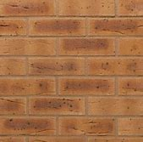

(2) ROOF TILES
Marley Modern Interlocking Tile
Colour - Smooth Grey
