TRIAL PIT 1
Depth (m) | Strata
0.00 – 0.10 | Black TARMAC.
0.10 – 0.30 | Dense light greyish brown sandy angular to subangular fine to coarse GRAVEL of limestone. (SUB-BASE)
0.30 – 0.60 | Medium dense dark greyish brown silty gravelly SAND. Gravel is angular to subangular fine to coarse of brick and concrete fragments with whole bricks. (MADE GROUND)
0.60 – 0.70 | Black TARMAC. (OLD CARPARK)
0.70 – 0.80 | Dense light greyish brown sandy angular to subangular fine to coarse GRAVEL of limestone with a medium cobble content of subangular limestone. (SUB-BASE)
0.80 – 1.00 | Medium Dense dark greyish brown silty gravelly fine to coarse SAND. Gravel is angular to subangular fine to coarse of brick and concrete fragments with a medium cobble content of bricks and concrete.  (MADE GROUND/ HARDCORE)
1.00 – 3.50 | Stiff becoming firm and soft at the base orangish brown slightly sandy becoming sandier with depth slightly gravelly CLAY. Gravel is subrounded to rounded fine to coarse of limestone and mudstone. (GLACIAL TILL)
3.50 – 4.00 | Loose to medium dense brown slightly silty sandy subrounded to rounded fine to coarse GRAVEL. (GLACIAL DEPOSITS).
Notes
- No groundwater observed.
- Sides of pit stable.
- Samples – ES @0.50m, D@1.50m.

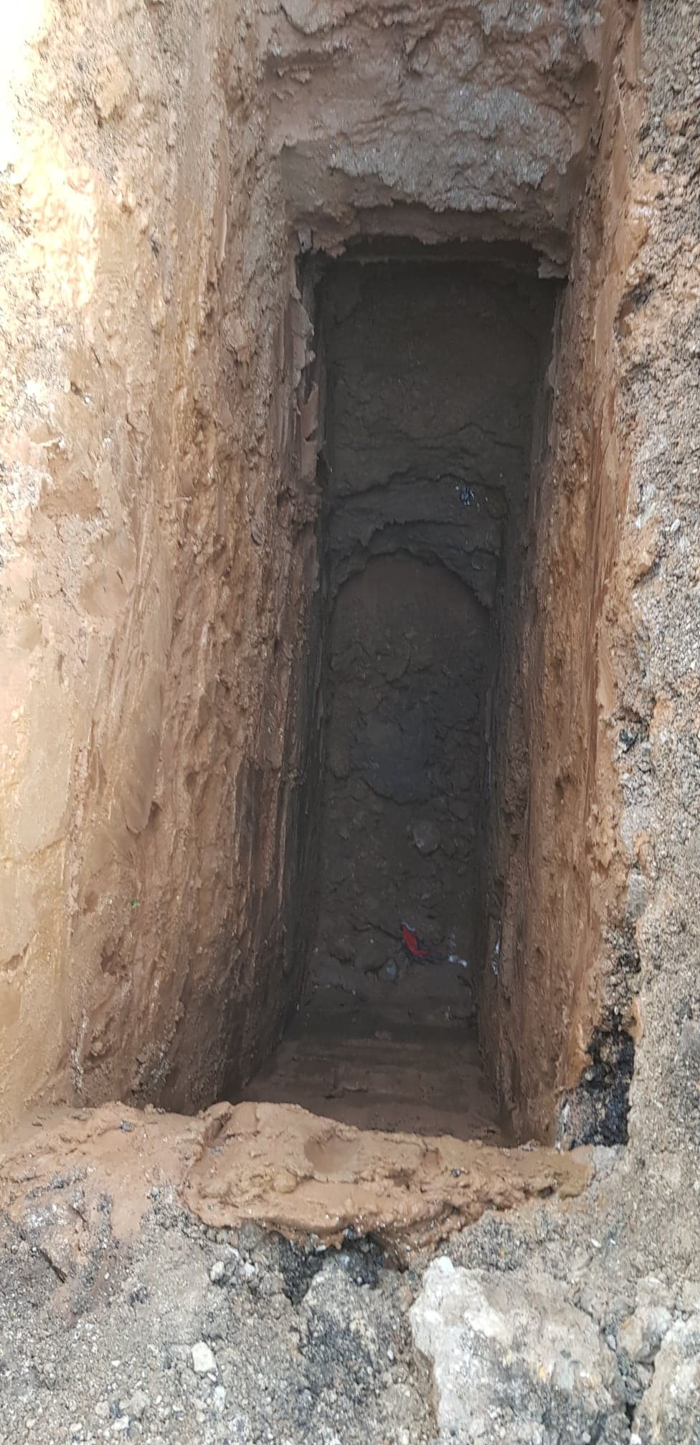
TRIAL PIT 1

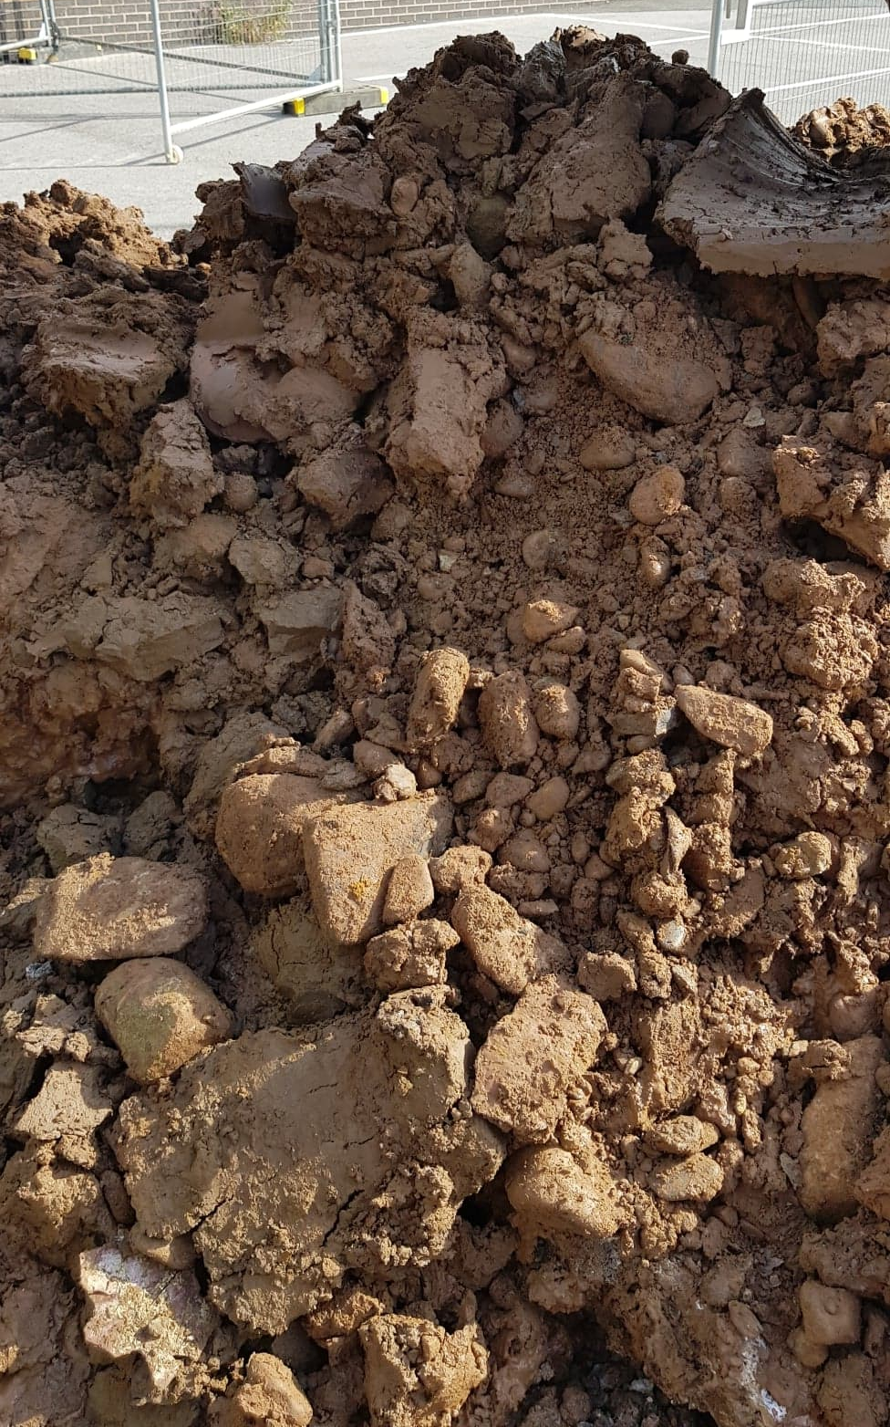
TRIAL PIT 1 SPOIL

TRIAL PIT 2
Depth (m) | Strata
0.00 – 0.30 | Loose dark brown slightly gravelly sandy silty angular to subangular fine to coarse GRAVEL of brick and concrete fragments. (TOPSOIL/ MADE GROUND)
0.30 – 0.90 | Loose to medium dense slightly clayey sandy gravelly SILT. (SUBSOIL)
0.90- 1.00 | Black TARMAC. (OLD CARPARK)
1.00 – 1.10 | Medium dense light greyish brown sandy fine to coarse angular to subangular GRAVEL of limestone with a medium cobble content of subangular limestone. (SUB-BASE)
1.10 – 1.20 | Firm dark brown slightly silty slightly gravelly CLAY. Gravel is angular to subrounded fine to coarse of limestone, sandstone and brick fragments. (MADE GROUND)
1.20 – 2.40 | Soft to firm light brown to orangish brown slightly gravelly sandy to very sandy CLAY. Gravel is subrounded to rounded fine to coarse of limestone and mudstone. (GLACIAL TILL)

Notes
- No groundwater observed.
- Sides of pit stable.
- Samples – ES@0.60m, D@1.10m, CS@1.50m, B@1.50m.

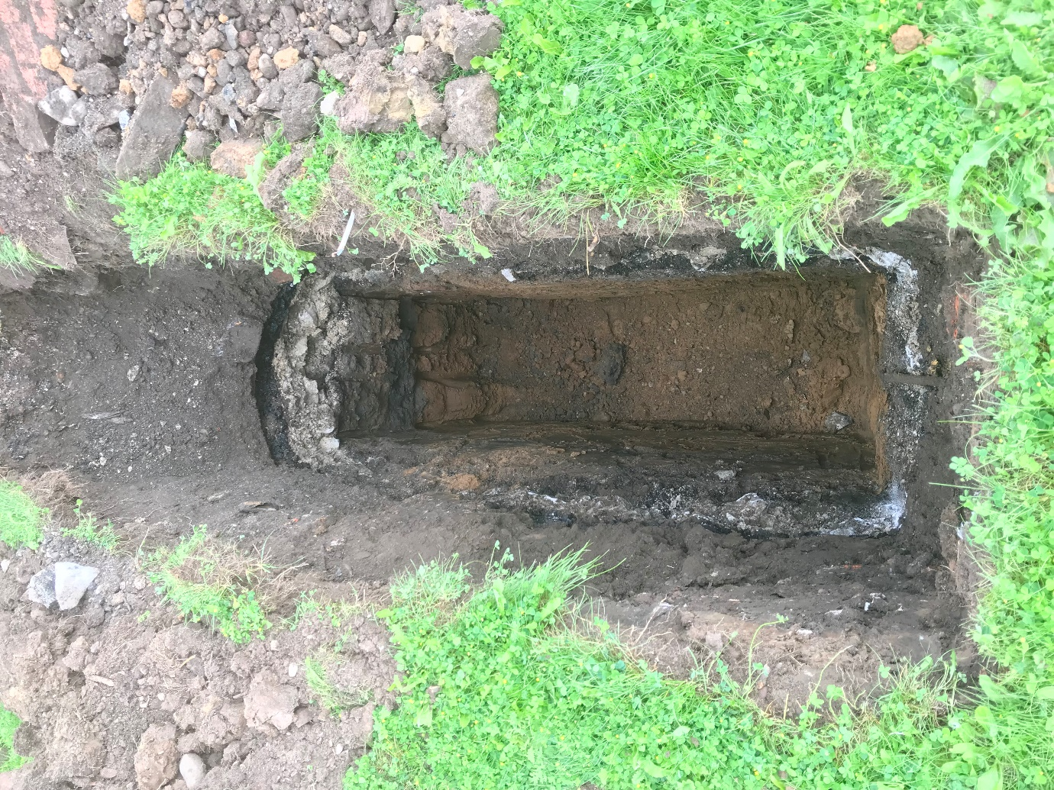
TRIAL PIT 2

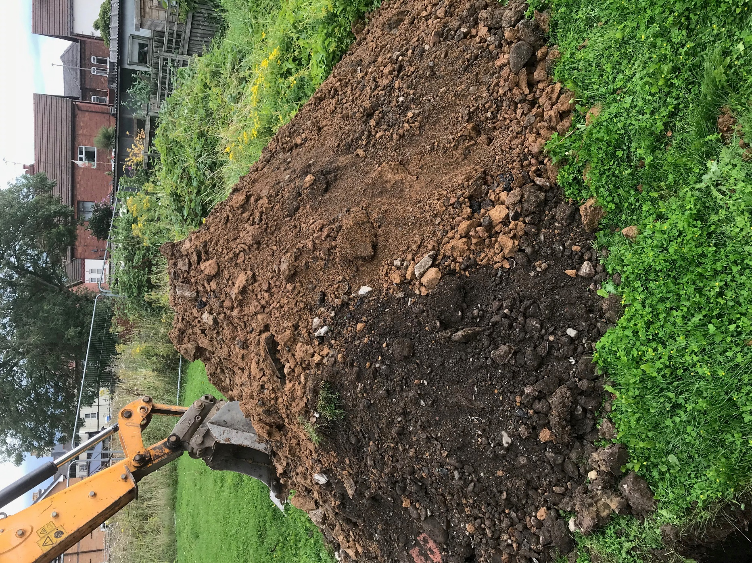
TRIAL PIT 2 SPOIL

TRIAL PIT 3
Depth (m) | Strata
0.00 – 0.40 | Loose black sandy SILT with rootlets. (TOPSOIL)
0.40 – 0.80 | Medium dense black to dark brown gravelly silty fine to coarse SAND. Gravel is angular to subangular fine to coarse of brick and concrete fragments. (MADE GROUND)
0.80 - 0.90 | Black TARMAC. (OLD CARPARK)
0.90 – 1.20 | Medium dense light greyish brown sandy angular to subangular fine to coarse GRAVEL of limestone with a medium cobble content of subangular limestone. (SUB-BASE)
1.20 – 3.50 | Stiff brown slightly gravelly sandy CLAY with occasional fine sand lenses, coal fragments and soft clay pockets. Gravel is subrounded to rounded fine to coarse of limestone and mudstone. (GLACIAL TILL)
3.50 – 4.00 | Loose to medium dense brown slightly silty sandy subrounded to rounded fine to coarse GRAVEL. (GLACIAL DEPOSITS).

Notes
- No groundwater observed.
- Sides of pit stable.
- Samples – ES@0.50m, D@1.30m.
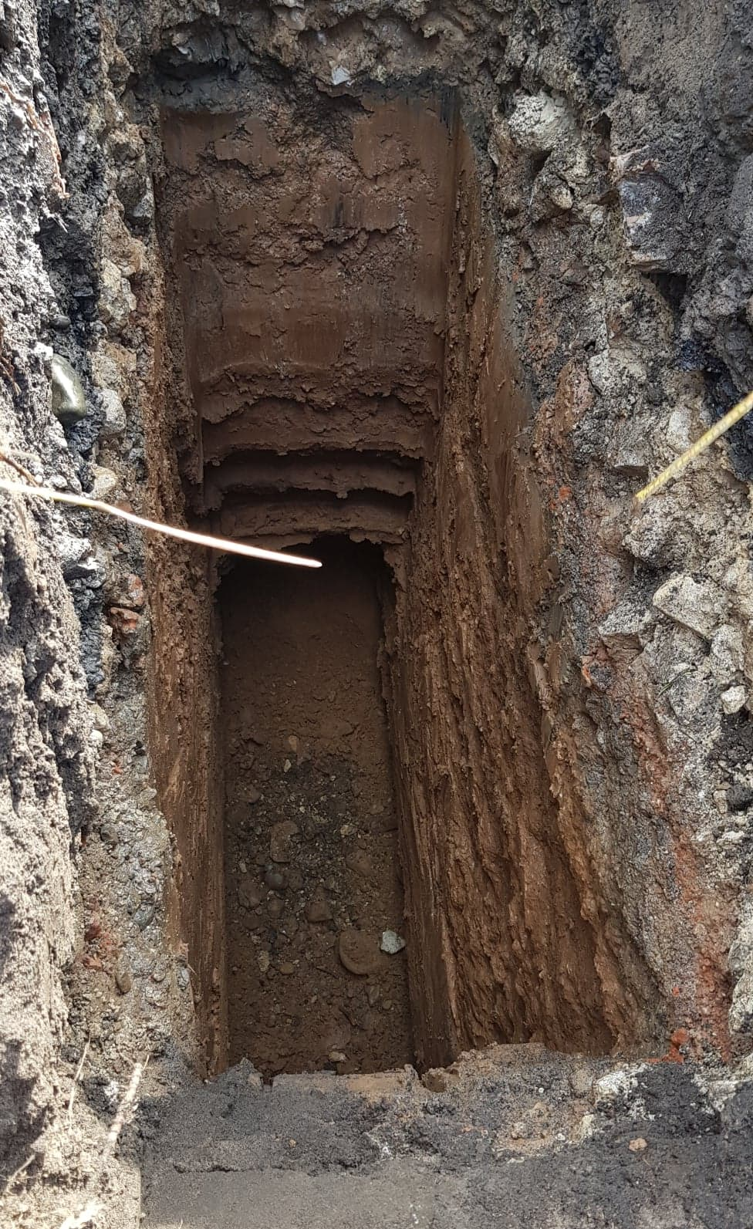
TRIAL PIT 3
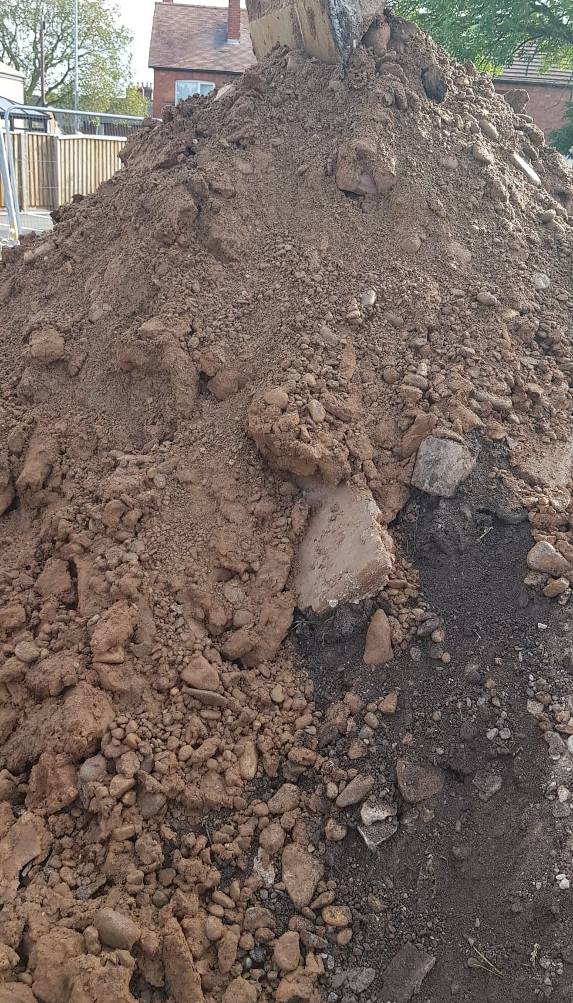
TRIAL PIT 3 SPOIL

