For the Attention of: Simon Greenland – Case Officer
Wrexham County Borough Council

[By Email: planning@wrexham.gov.uk]

[Copy Email: Simon.Greenland@wrexham.gov.uk]

23 December 2019

Dear Mr Greenland

PLANNING APPLICATION: P/2019/0884

APPLICATION FOR APPROVAL OF DETAILS RESERVED BY CONDITIONS IMPOSED UNDER PLANNING PERMISSION P/2019/0055: CONDITION 3 - SUBMISSION OF A DETAILED SCHEME OF GROUND STABILISATION WORKS CONDITION 4 - SUBMISSION OF VALIDATION REPORT; Pavilion, Clarke Street, Ponciau, Wrexham, LL14 1RP

Thank you for your notification of 06 December 2019 seeking the views of the Coal Authority on the above discharge of condition application.

The Coal Authority Response:

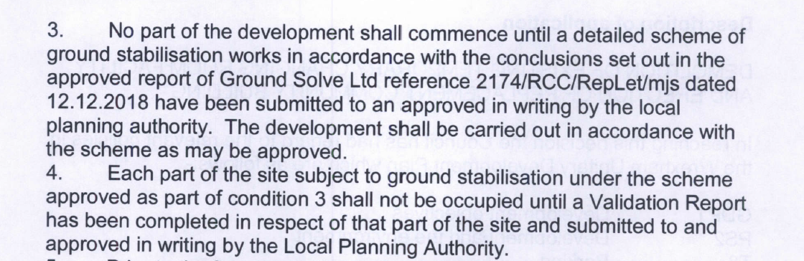

We note that the wording of the conditions reflects our recommendation to the Local Planning Authority (LPA) dated 15 February 2019 made in light of the content and conclusions of the Mining Appraisal (Ground Solve Ltd, 12 December 2018) submitted by the applicant in support of their planning application.

This discharge of condition application is accompanied by a Mining Appraisal (25 November 2019) prepared for the approved development by Ground Solve Ltd. This Appraisal has been informed by the results of intrusive ground investigations in the form of 3no. rotary boreholes to a maximum depth of 20.3m (to investigate shallow workings) and dynamic probing (to investigate the 2no. recorded mine entries). We are pleased to note that the Coal Authority’s written consent was obtained for these ground investigations and carried out under Permit: 18820.

Mine shafts
Based on the findings of the ground investigations, the report author identifies that both shaft caps were encountered and both shafts have been filled. Taking into consideration the depth to rock head (between 2.30m and 4.60m) within the site, the report author concludes that the approved building will not be affected by these two mining features and the risk can be reduced to ‘negligible’. No further mitigatory measures have been identified.

Shallow Coal Workings
The report author identifies that shallow coal workings have taken place beneath the site within 2no. coal seams (Main and Brassey) and therefore a programme of stabilisation works (drill and grouting) is required (full specifications are provided within Section: Conclusion / Recommendations). A drill and grouting plan have also been provided to illustrate how the stabilisation works relate to the approved layout (Figure Title: Grouting Grid).

In light of the supporting information submitted, the Coal Authority has no objection to the LPA discharging Condition 3 of issued consent P/2019/0055. The applicant should be made aware that the treatment of the coal seams will require a further permit from our Licensing and Permitting team.

As Condition 4 requires the completion of a Validation Report, this type of Report cannot be submitted until the above ground stabilisation works have been completed, therefore currently we are unable to recommend that the LPA discharge Condition 4. However once all works have been undertaken, the Validation Report is completed and submitted to the LPA, we would welcome the opportunity to review and comment on such a Report.

Please do not hesitate to contact me if you would like to discuss this matter further.

Yours sincerely
D Roberts
Deb Roberts M.Sc. MRTPI
Planning Liaison Manager

General Information for the Applicant

Under the Coal Industry Act 1994 any intrusive activities, including initial site investigation boreholes, and/or any subsequent treatment of coal mine workings/coal mine entries for ground stability purposes require the prior written permission of The Coal Authority, since such activities can have serious public health and safety implications. Failure to obtain permission will result in trespass, with the potential for court action. In the event that you are proposing to undertake such work in the Forest of Dean local authority area our permission may not be required; it is recommended that you check with us prior to commencing any works. Application forms for Coal Authority permission and further guidance can be obtained from The Coal Authority’s website at:
https://www.gov.uk/get-a-permit-to-deal-with-a-coal-mine-on-your-property

Disclaimer

The above consultation response is provided by The Coal Authority as a Statutory Consultee and is based upon the latest available data on the date of the response, and electronic consultation records held by The Coal Authority since 1 April 2013. The comments made are also based upon only the information provided to The Coal Authority by the Local Planning Authority and/or has been published on the Council's website for consultation purposes in relation to this specific planning application. The views and conclusions contained in this response may be subject to review and amendment by The Coal Authority if additional or new data/information (such as a revised Coal Mining Risk Assessment) is provided by the Local Planning Authority or the Applicant for consultation purposes.

In formulating this response The Coal Authority has taken full account of the professional conclusions reached by the competent person who has prepared the Coal Mining Risk Assessment or other similar report. In the event that any future claim for liability arises in relation to this development The Coal Authority will take full account of the views, conclusions and mitigation previously expressed by the professional advisers for this development in relation to ground conditions and the acceptability of development.

