ADAPTION OF EXISTING OUTBUILDING, INCLUDING EXTENSION TO PROVIDE GARAGING AND CONSTRUCTION OF STABLES AND
CAR PORT

AT KNOLTON HALL
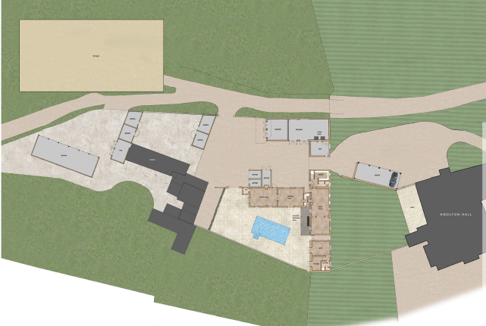

DESIGN AND HERITAGE STATEMENT
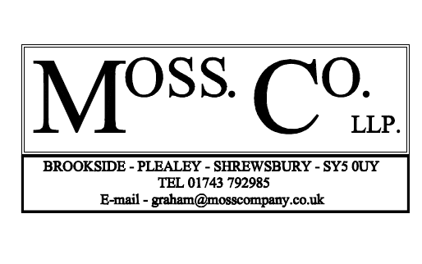

ADAPTION OF EXISTING BUILDING, INCLUDING EXTENSION TO PROVIDE GARAGING, CONSTRUCTION OF STABLES AND CAR PORT
AT KNOLTON HALL
SECTION 1
- Introduction And Background

SECTION 2
Planning Statement
- Design Concept And Proposals
  - Conversion and adaption of existing outbuilding building
  - Extension (to biomass building) to provide garaging
  - Refurbishment of stables
  - Construction of stables
  - Demolition of existing, and construction of 4 open bay car port
- Materials

SECTION 3
- Historical Impact Assessment

SECTION 4
- Method Of Construction

SECTION 5
- National And Local Planning Policies

SECTION 6
- Conclusions

SECTION 7
- References

SECTION 1

Introduction & Background

This Design and Heritage Statement has been prepared by Moss Co LLP on behalf of Mr and Mrs Edward Chantler in support of a full planning application for the adaption of existing range of buildings, extension to provide garaging, and construction of stables and car port at Knolton Hall, Oswestry Road, Overton WREXHAM Powys LL13 0LG.

Knolton Hall is a grade II* listed building. The outbuildings within this application are not listed within their own right but are within the domestic curtilage. The buildings within this application have already been converted. The use is and will remain ancillary to the main dwelling.

The current owner and applicants purchased the property in 2016 with a view to restore the property and reside there as their family home.

In addition to this Planning Design Statement, the application is supported by the following information:

- Existing Location Plan
- Existing Site Plan
- Proposed Site Plan
- Existing Plans and Elevations of outbuildings
- Proposed Plans and Elevations of outbuildings
- Heritage Statement
- Topographical survey

LOCATION
Knolton Hall, Oswestry Road, Overton WREXHAM Powys LL13 0LG
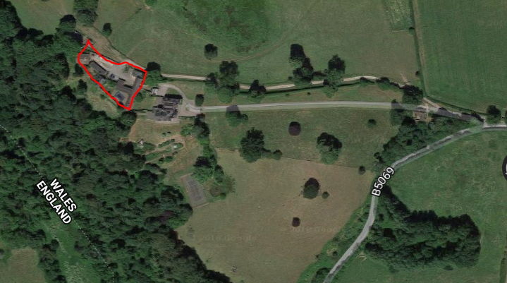
Study area
Knolton Hall
Source: Googlemaps
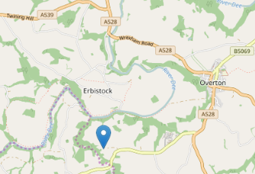
Source: Googlemaps
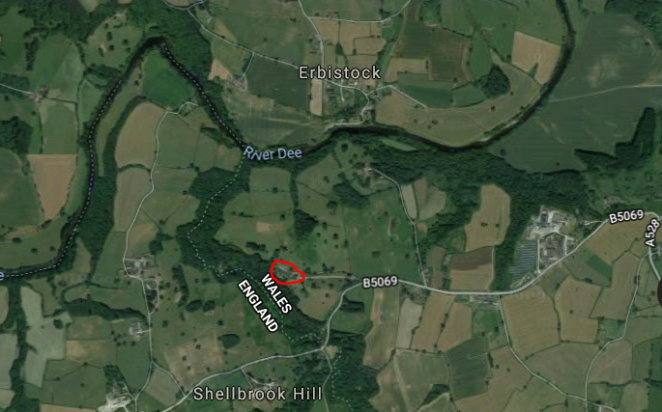
Source: Googlemaps

The application site lies close to the Wales/England border.

SECTION 2
PLANNING STATEMENT in General
Construction of stables

Refurbishment of existing stables

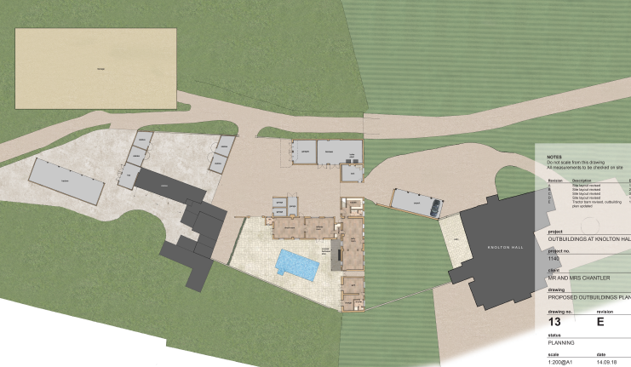
Garage Extension
Construction of carport
Adaption of outbuilding
Knolton Hall

Site plan

The buildings within this application have already been converted and are of ancillary use to the main dwelling.

The proposed changes are minor considering their current status.

The alterations relate to a range of buildings which have been largely converted and in these circumstances we believe this statement is proportionate to the overall scheme proposed.

USE
The existing and proposed use of the outbuildings within this application is ancillary in association with the host dwelling.

Design Principles and Concept
The proposals are to improve the ancillary use of the outbuildings. There are no neighbours and therefore no loss of amenity, sense of overshadowing or overlooking caused by the proposals.

Proposals
- Conversion and adaption of existing outbuilding
- Extension (to biomass building) to provide garaging
- Refurbishment of existing stables
- Construction of stables
- Demolition of existing, and construction of replacement 4 open bay garage

AMOUNT
The extent of the site will adequately accommodate the proposals.

- The range of outbuilding remains as existing.
- The single storey 2 bay garage (attached to biomass) has a footprint of 39m² and a floor area of 33m².
- Refurbishment of existing stable block remains as existing.
- The proposed stables 1 has a footprint of 60m² and a floor area of 54m².
- The proposed stables 2 has a footprint of 35m² and a floor area of 30m².
- Construction of car port has a footprint of 78m² and a floor area of 72m².

The site area is 7,892m² / 7.8ha.

ADAPTION OF EXISTING OUTBUILDING

This range of outbuilding is not listed in its own right but is within the curtilage of the main dwelling.

The stables and cartshed at Knolton Hall are now of a largely mid nineteenth century build, at a period when the house was substantially remodelled and extended. There are however vestigal remains of oak box framing. At the south west end of the buildings indicating the presence of an earlier structure.

The remains extend to a width of two bays, at first floor level only on the south elevation and this has now been built into the brick walls of the buildings, appearing a facing only, of which substantial parts have been replaced with new oak, when the building was rehabilitated some twenty years ago. The remainder of this T shape range of barns remains resolutely nineteenth century in date, of single storey and an attic with notable “estate” features such as the ridge vents and also the tack room. This has a finely fitted out panelled interior in painted softwood of a commensurate style of the period. No alterations are proposed to this space.

In the twentieth century additions were made to two of the ends of the building to the west and north, adding single storey structures. These are to be retained. The detached brick built range of stables is also early twentieth century, but up against a possibly earlier wall.

Some twenty years ago the eastern range closest to the house was taken over as a party room, but with minimal alterations including retention of the cobbled floor etc, This is all to be retained.

The southern end of the eastern range was also loosely converted to take the pool plant etc and it is the intention that the additional work will be carried out in the same manner.

Also some twenty years ago the western end of the range was rebuilt and repaired as part of a scheme of conversion, but was never completed. These proposals simply complete what was stated, retaining all the structure. All of the existing flooring will be retained.

As stated these buildings have already been converted in the recent past and are ancillary to the needs of the main dwelling.

Area of extension to provide garaging. See later section

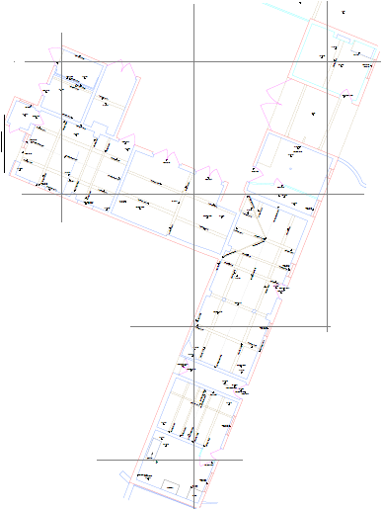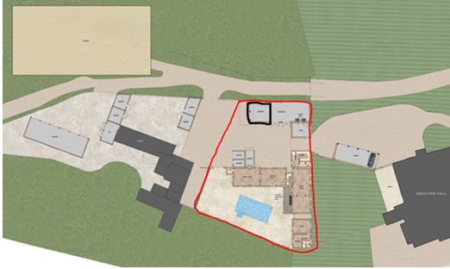
Area of outbuilding for adaption

SCALE
The scale of the outbuilding does not change from the existing.

AMOUNT
The amount of the existing outbuilding does not change from the existing.

Appearance
This statement details the proposed changes to the appearance. Any other existing external historical features and materials will remain.

The elevations change very little with the only the addition of fixed fenestration and 3 new openings.

The north elevation, shows the inner courtyard side. The external appearance does not change from the existing, with the only alterations being the carriage doors on the north elevation which will be retained, but with casements behind to provide light and ventilation. The doors will be secured open when the building is in use, otherwise locked shut for security reasons.

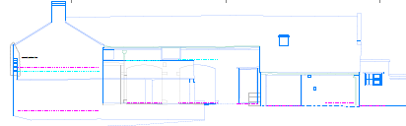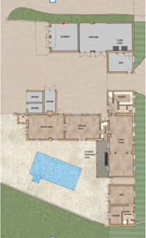
Existing north elevation

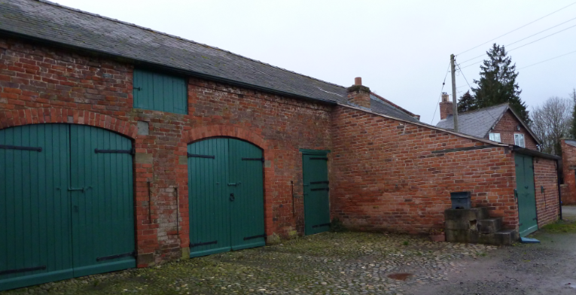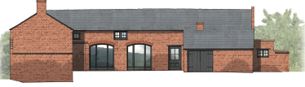
Existing barn doors are proposed as fixed fenestration behind outer doors
Proposed north elevation

The whole of the eastern range is of ancillary use to the house. The party room, pool plant and changing area are already in place. By far the finest space in this range is the tack room, which retains all its original fittings for that purpose and as the plans indicate, will remain exactly as existing and serving its original function. The party room has a cobbled floor and as no change is indicated and will be retained.

The east elevation shows the outer courtyard side and remains largely the same, with the exception of the formation of two additional windows, of the same pattern and size of the existing, to provide additional light to the building. The existing windows are of varying sizes and dates.
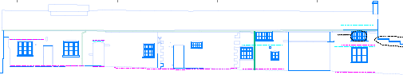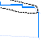
Existing east elevation

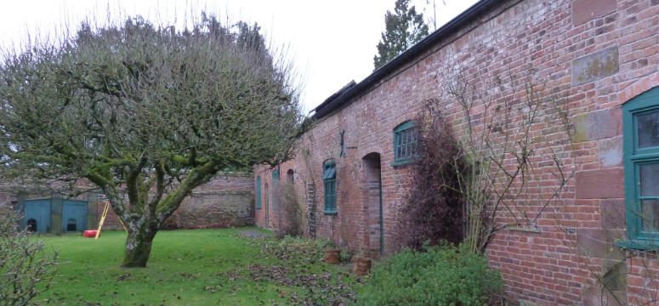
Additional windows

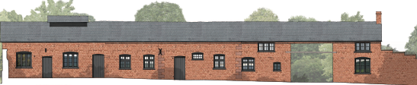
Proposed east elevation

The south elevation remains largely the same, with the exception of the formation of French doors to provide light and access to the billiard room, from the outdoor entertainment area. Fenestration is also proposed to the incompleted openings at the west end.
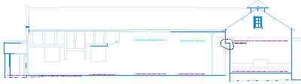
Existing south elevation
Covered BBQ area
Formation of French doors

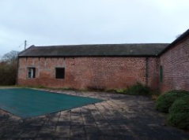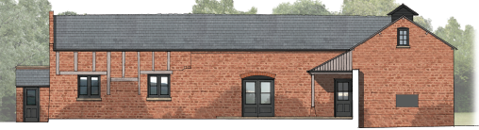
Proposed south elevation

The west end has already been part converted and the exposed timber is vestigial and does not continue to the interior, as it is encapsulated in the brickwork. Much has been replaced in any case with new timber.

The west elevation shows the inner courtyard side and remains largely the same, with the exception of the formation of an additional window, of the same pattern and size of the existing and two existing openings enlarged to allow for French doors. A covered BBQ area leads from the party room and overlooks the swimming pool.

A single storey 2 bay secure garage is proposed on the end of the biomass building – see later section.
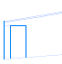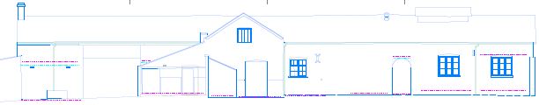
Existing west elevation

Additional window
Formation of French doors

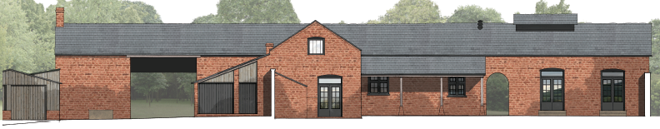
Proposed west elevation
Covered BBQ area

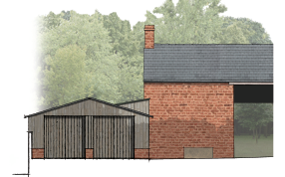

New fenestration is to be painted timber. A window schedule and details will be prepared. At this stage we ask that this can be conditioned as part of the consent.

French doors are to be painted timber. A door schedule and details will be prepared. At this stage we ask that this can be conditioned as part of the consent.
The roof will be finished in slate to match the existing.

The proposed extension on the north will be constructed in timber frame on a brick plinth.

Any new rainwater goods will be Hunter “Foundry” http://www.hunterplastics.co.uk/products/rainwater/foundry-finish-125/
or Brett Martin “Cascade” cast iron look range http://www.brettmartin.com/en-gb/plumbing-and-drainage/products/cast-iron.aspx or similar.

LAYOUT
The buildings within this application have already been converted in the recent past and have been in use as ancillary to the main dwelling.

This statement states proposed changes to the layout. Any existing internal historical features and materials will remain.

The layout of the outbuilding remains largely similar to the existing. The plan is annotated in line with the points below.

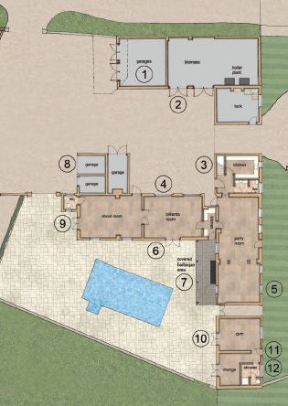

Northerly block
Provides existing accommodation for a tack room, the biomass plant and its wood chippings, and a new double bay garage.
- The proposed extension includes a secure and undercover double bay garage and enlarge the existing store to provide for the biomass unit and boiler plant – see later section.
- Double doors are provided to allow for the access/equipment for the loading/unloading of material for the biomass.

Middle block
Provides accommodation for a small kitchen, party, shoot and billiard room and WCs.
- A kitchen and WC is proposed to north end, new partitions will be studwork and plasterboard and will be reversible.
- The existing barn doors, facing north, will be retained with fully glazed panels behind.
- The formation of two additional windows, of the same pattern and size of the existing, has been added to the eastern elevation to provide additional light to the building.
- The formation of an additional window, of the same pattern and size and two existing openings are enlarged to allow for French doors, on the south elevation.
- A covered BBQ area leads from the party room and overlooks the swimming pool.
- The existing garage door on the west facing elevation is removed to provide an open bay area.
- The shoot room west facing window is to be deepened to provide for a French door.

The existing internal floors will be retained.
The existing joinery is recent.

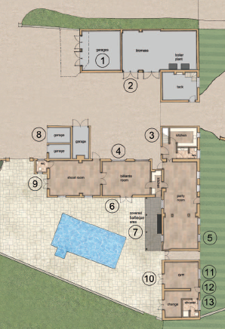
Southerly block
Provides accommodation for a gym and changing room and WC.
- French doors provide openings looking to the entertainment area into both these rooms.
- The swimming pool shower and WC are included in the changing area.
- New partitions will be studwork and plasterboard and will be reversible.

The existing internal floors will be retained.
There is no change to the first floor layout in any part of the building.

EXTENSION FOR GARAGING
The proposed extension is attached to a modern vertical boarded cladded building which houses the Estate biomass plant and materials.
Existing biomass structure. The extension area is set against this elevation, constructed of similar materials

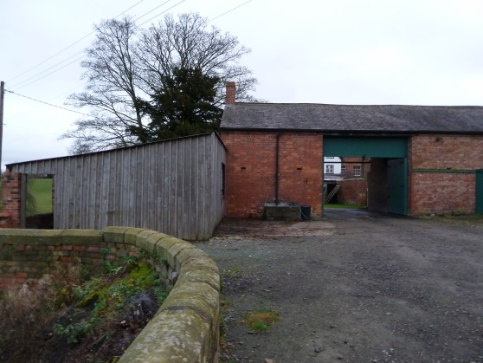
This extension is to provide double bay secure garaging.
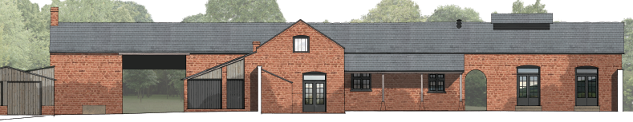

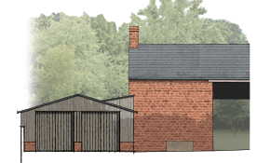
SCALE
The height of the proposed single storey extension eaves is 2300mm.

The height of the existing mono pitch roof (biomass) is 3200mm.
The height of the proposed single storey extension ridge is 3230mm.

AMOUNT
The single storey extension has a footprint of 39m² and a floor area of 33m².

APPEARANCE
The proposed extension will be constructed on a concrete pad with brick plinth with internal blockwork and vertical shiplap weatherboarding.

The roof will be finished with slate or profiled sheeting.

Any new rainwater goods will be Hunter “Foundry” http://www.hunterplastics.co.uk/products/rainwater/foundry-finish-125/
or Brett Martin “Cascade” cast iron look range http://www.brettmartin.com/en-gb/plumbing-and-drainage/products/cast-iron.aspx or similar.

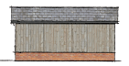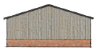
Proposed north east elevation Proposed south east elevation
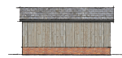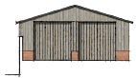
Proposed south west elevation Proposed north west elevation
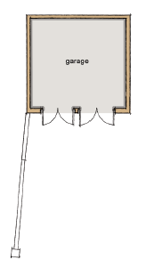
Proposed layout

REFURBISHMENT OF STABLES

This building is not listed in its own right but is within the curtilage of the listed building. This range dates from the first half of the twentieth century.

This statement details the proposed changes to the appearance. Any other existing external historical features and materials will remain.

Essentially there is very little external change to this building, with the only the removal of the flank wall and store to the south/west side. This allows for private parking for The Gardener’s Cottage. The internal layout remains as existing.

This building will continue to provide 4 stables and is constructed from brick and a slate roof.

SCALE
The scale of the outbuilding does not change from the existing.

AMOUNT
The amount of the outbuilding does not change from the existing.

APPEARANCE
The external changes are minimal. Any existing external historical features and materials will remain.

The north elevation remains as existing.
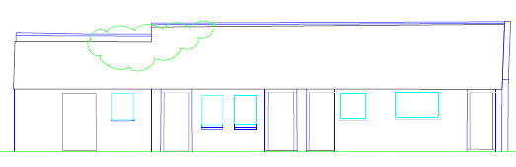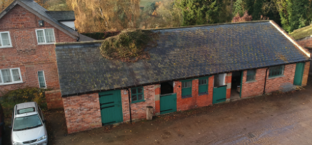
Existing north elevation

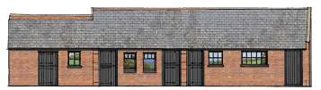
Proposed north elevation

The east elevation remains as existing.

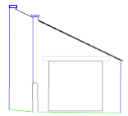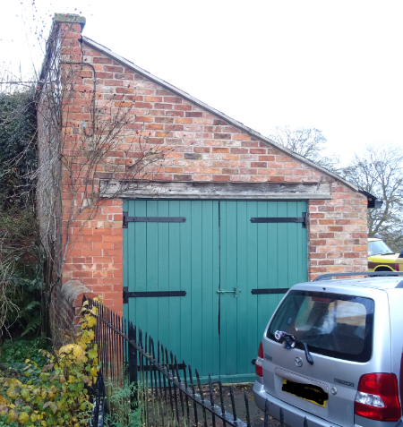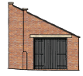
Existing east elevation Proposed east elevation
The flank wall and store to the west elevation is to be removed.

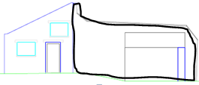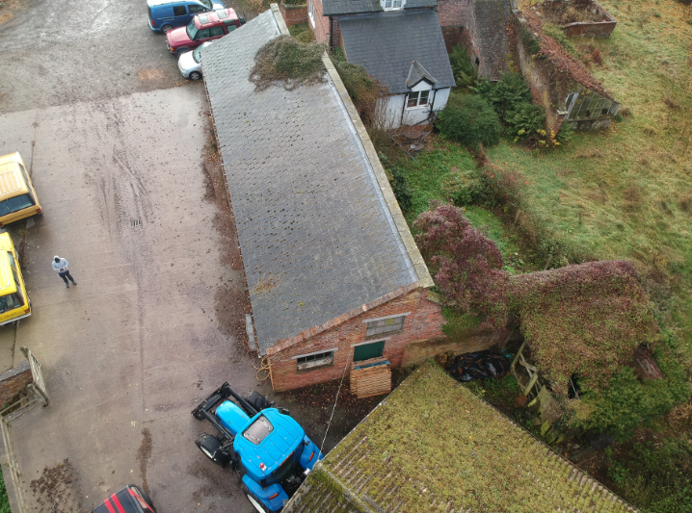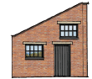
Existing west elevation Proposed west elevation

The flank wall and store to the south elevation is to be removed.
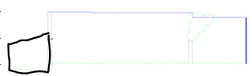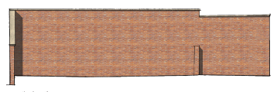
Existing south elevation Proposed south elevation

LAYOUT
This statement details the proposed changes to the layout. Any existing internal historical features and materials will remain.

The general layout of the building does not change, except for the removal of the flank wall.

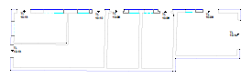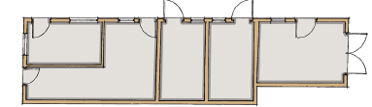
Existing layout Proposed layout

MATERIALS
All materials remain as existing. Following the demolition of the flank wall and store, bricks and copings will be cleaned and stored for reuse.
CONSTRUCTION OF NEW STABLES

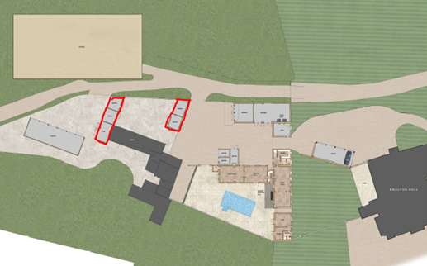
Stable Block 2
Stable Block 1

The stables are new build.
Block 1 has 2 stables with a hay/straw barn.
Block 2 has 2 stables/wash box.

BLOCK 1
SCALE
The height of the proposed eaves is 2450mm.
The height of the proposed ridge is 3850mm.

AMOUNT
Block 1 has a footprint of 60m² and a floor area of 54m².

APPEARANCE
The proposed new stables will be constructed on a concrete pad with brick plinth with internal blockwork and vertical shiplap weatherboarding.

The roofs will be finished with slate or profile cladding.

Any new rainwater goods will be Hunter “Foundry” http://www.hunterplastics.co.uk/products/rainwater/foundry-finish-125/
or Brett Martin “Cascade” cast iron look range http://www.brettmartin.com/en-gb/plumbing-and-drainage/products/cast-iron.aspx or similar.

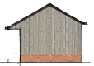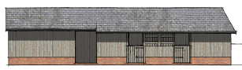
Proposed north east elevation Proposed south east elevation
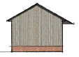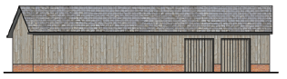
Proposed south west elevation Proposed north west elevation

LAYOUT
The layout provides for 2 stables facing the courtyard and a hay barn. The stables are on average 4.5 x 3.6 metres.

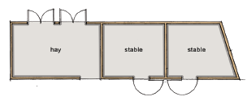
Proposed layout

BLOCK 2
SCALE
The height of the proposed eaves is 2500mm.
The height of the proposed ridge is 4050mm.

AMOUNT
Block 2 has a footprint of 35m² and a floor area of 30m².

APPEARANCE
The proposed new stables will be constructed on concrete pad with brick plinth with internal blockwork and vertical shiplap weatherboarding.

Bricks will be laid in Flemish bond using two parts building sand, one part sharp sand and one part lime for the mortar mix with a slightly recessed joint, formed by brushing back a flush joint at the end of each day’s work.

The roof will be finished with slate or profile cladding.

Any new rainwater goods will be Hunter “Foundry” http://www.hunterplastics.co.uk/products/rainwater/foundry-finish-125/
or Brett Martin “Cascade” cast iron look range http://www.brettmartin.com/en-gb/plumbing-and-drainage/products/cast-iron.aspx or similar.

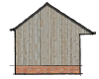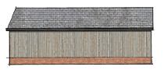
Proposed north east elevation Proposed south east elevation
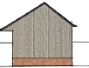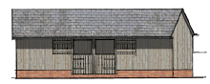
Proposed south west elevation Proposed north west elevation

LAYOUT
The layout provides two stables facing the courtyard. The stables are on average 4.5 x 3.6 metres.

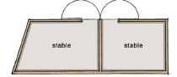
Proposed layout

DEMOLITION AND CONSTRUCTION OF
4 OPEN BAY CAR PORT
.
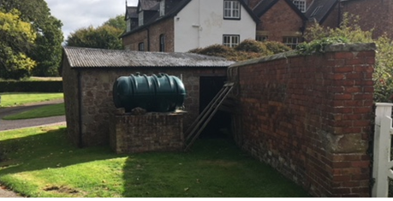
The existing shed, illustrated above, is to be demolished but the materials cleaned and stored carefully for reuse. The garden wall is not attached to the house. The proposed car port is aligned along the wall, in a similar position.

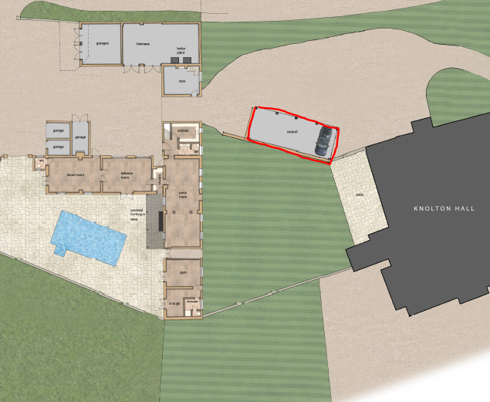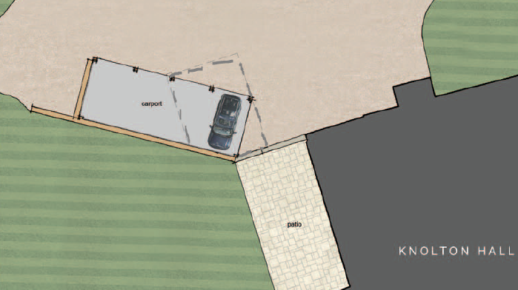
Proposed open bay garage
Dashed line denotes original structure
Layout of 4 open bay garages

SCALE
The height of the existing eaves is 2300mm.
The height of the proposed eaves is 2630mm

The height of the existing ridge is 3300mm.
The height of the proposed ridge is 5900mm.

AMOUNT
The existing shed has a footprint of 41m² and a floor area of 31m².
The proposed open bay garaging has a footprint of 78m² and a floor area of 72m².

Appearance
The proposed open bay garaging will be constructed on concrete pad with random rubble coursed stonework, reclaimed from the demolition of the existing building.

The roof will be supported by oak post and finished with reclaimed slate.

Any new rainwater goods will be Hunter “Foundry”. http://www.hunterplastics.co.uk/products/rainwater/foundry-finish-125/
or Brett Martin “Cascade” cast iron look range http://www.brettmartin.com/en-gb/plumbing-and-drainage/products/cast-iron.aspx or similar.

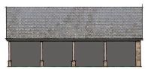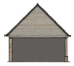
Proposed north east elevation Proposed south east elevation
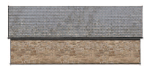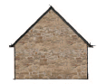
Proposed south west elevation Proposed north west elevation

LAYOUT
The layout provides 4 open bays – including one side wall
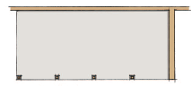
RELEVANT TO ALL BUILDINGS

ACcess
The estate yard is level and laid with concrete. All existing accesses remains as existing.

The tenants in The Gardener’s Cottage have a revised access along the track (instead of the front drive). With the demolition of the flank wall and store, parking is now proposed to the rear of the cottage.

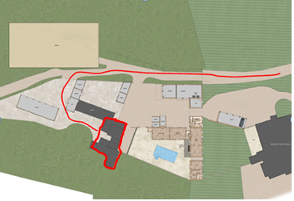
The Gardener’s Cottage and access and parking area

LANDSCAPING
The proposal will include informal landscaping of the remaining area after the alterations.

A paved area will lead out from the south west facing entertainment and swimming pool area.

ENVIRONMENTAL
The proposals will be built to meet current energy and thermal efficiency standards required by Building Regulations.

Where possible materials required for the construction will be from local, sustainable and renewable sources.

An ecology survey was commissioned by Arbore Vitae on 28th February 2019. The conclusion was protected species mitigation is not necessary for bats although care must be taken not to cause any disturbance to roosting bats in the loft of outbuilding (3 – see ecology report).

- Adaption including extension of existing building.
  - There is no intention to work within the existing roof space. The garage extension butts up to an existing roof but no work is intended to attach the two.
- Refurbishment of stables.
  - There is no intention to work within the roof space.
- Construction of stables
- Demolition of existing, and construction of replacement 4 open bay garage.
  - The building is sealed and has a corrugated roof.

Access for emergency vehicles to the site following the construction of the extension will remain unaffected.

There are no public footpaths within the development site.
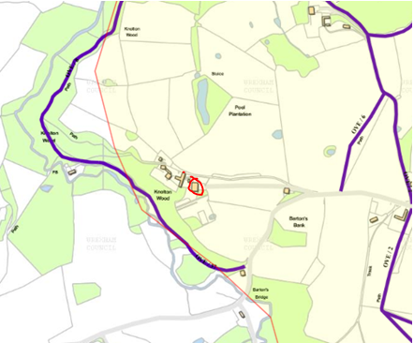
Source: http://www.wrexham.gov.uk/mapping/

The applicant seeks no external lighting other than illumination access to the new buildings and will be located sensitively for bat activity.

The site is not within an area of geological conservation importance.

The site is not within an area of special habitats or other biodiversity features.
The proposal does not involve the need to dispose of trade effluents or trade waste.
There are no known hazardous waste within the study area.
DRAINAGE
Any of the new build will not result in an increase on the burden of foul drainage disposal. The proposals to the middle and southerly range of the outbuilding provide 3 WCs for which the foul drainage system will connect to the existing drainage system.

Surface water run-off from the existing buildings will be via the existing system.
The new stables surface water run-off will connect to the existing system.

FLOOD RISK
The site is not located in an area designated as a Flood Zone and thus at negligible risk from flooding, as confirmed by the Environment Agency flood maps.

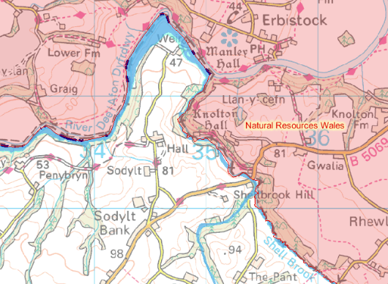
Source : Environment Agency

COMMUNITY
The layout of the site remains as existing. There are no public areas, car parks or footpaths that cross the site.

MOVEMENT TO, FROM & WITHIN THE DEVELOPMENT
The drive is existing and is privately owned.
Additional parking is provided with the courtyard area.
- Day to day parking is proposed adjacent to the house with the construction of a 4 open bay car port.
- 2 bay secure garaging is located adjacent to the biomass building.
- 2 existing garages (south west side of outbuilding) are proposed with wider openings to provide secure storage of machinery.

PLANNING HISTORY
As recorded on the Wrexham planning access

Knolton Hall
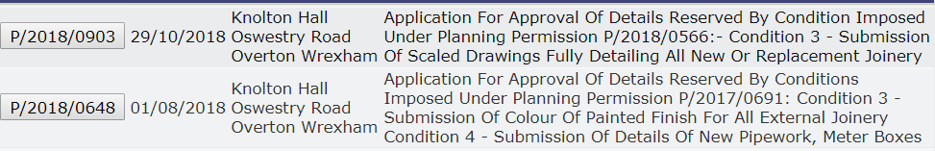
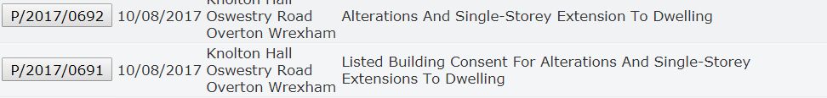

The Gardener’s Cottage
Source: Wrexham planning access

The Site & Its Surroundings
Standing in an elevated position with glorious far-reaching views, Knolton Hall is surrounded by beautiful unspoilt countryside on the Shropshire/Welsh Border, close to the Cheshire Border. Situated to the edge of a small rural hamlet, the house is close to good amenities in the nearby village of Overton-on-Dee and the town of Ellesmere. In an area known as the Wynnstay country, it is noted for its superb riding opportunities and close proximity to a number of equestrian venues.

CONSULTATION
There are no neighbours and therefore no loss of amenity, sense of overshadowing or overlooking is caused by the proposals.
SECTION 3

HERITAGE STATEMENT

The purpose of this Heritage Statement investigates the potential impact of the proposals on the nearby listed building.

Research of the following national and local policy guidelines were considered:
- Cadw Conservation Guidelines (2011
- Planning Policy Wales (Edn. 10, Dec 2018)
- Cadw Best Practice Guidance on Managing the Setting of Historic Assets in Wales (May 2017)
- Cadw Best Practice Guidance on Heritage Impact Assessment in Wales (May 2017)
- Cadw Best Practice Guidance on Managing Change to Listed Buildings in Wales (May 2017)

It is emphasised throughout that applicants “should provide proportionate information to allow the assessment of the likely impact of proposals for development on a historic asset and its setting”.

The main planning guidance for this type of application is now set out in Planning Policy Wales and Chapter 6 - The Historic Environment and states:

“The historic environment is relevant to and is a vibrant part of the culture and economy of Wales. To enable the historic environment to deliver rich benefits to the people of Wales, what is of significance needs to be identified and change that has an impact on historic assets must be managed in a sensitive and sustainable way”.

Extract from Paragraph 6.5.11 states:
“The aim should be to find the best way to protect and enhance the special qualities of listed buildings, retaining them in sustainable use. The application of development and listed building controls should recognise the need for flexibility where new uses have to be considered in order to secure a building’s survival or provide it with a sound economic future”.

Extract from paragraph 6.5.13 states:
“..The statement should be proportionate both to the significance of the building and to the degree of change proposed”.

- The existing buildings within this application have already been converted and are of ancillary use to the main dwelling.
- The proposed changes are minor considering their current status.
- Any existing internal and external historical features and materials will remain.
Significance
Current national policy guidance relating to the protection and enhancement of the Historic Environment is contained within the Heritage Impact Assessment in Wales which outlines what information is required:

“ The heritage impact assessment process should be proportionate both to the significance of the historic asset and to the degree of change proposed”.

- Knolton Hall is Grade II* listed, details below.
- The proposals in this application do not affect the fabric or structure of the host dwelling.
- In 1870-72, John Marius Wilson's Imperial Gazetteer of England and Wales described Knolton as:
KNOLTON, a township in Overton parish, Flint; 5½ miles ENE of Chirk. Real property, £1, 765. Knolton Hall is the seat of the Kynaston family. http://www.visionofbritain.org.uk/

KNOLTON HALL
LISTED BUILDING STATUS
Location: On the western edge of the Community, approached by a drive which leaves the main road at the top of Barton’s Bank.
County: Wrexham Community: Overton
Locality: Knolton Traditional County: Flintshire
Lieutenancy Area (Ceremonial County): Shropshire
Listing Date: 16 November 1962 Last Amended: 15 March 1994
Grade: II* Source: Cadw Building Class: Domestic Source ID: 1691

The origins of the present house are in a house of c1600, which has been successively extended and remodelled, principally in the C18, apparently in 2 distinct phases, and then, c1857-68 by John Cunningham of Liverpool, for Mr R C Cotton of the Combermere family.

Exterior
The earliest form of the building is apparent in the layout of the entrance front, which comprises a central hall range flanked by 2 advanced gabled wings, both of which have lateral stacks. Left-hand wing is partially timber framed, the framing surviving in the gable end and in part of the return wall to the garden front: small panels with cusped quatrefoils. The rest of the building is painted brick, with heavy slate roofs throughout. In the C19 remodelling, the front gables at least were painted with mock framing which has since disappeared. Fenestration of left hand wing entirely of the C19, with carved mullioned and transomed windows, some with decorative leading. Towards the rear of this wing, a pavilion roofed tower is a C19 addition over the staircase. The entrance hall is itself gabled, and was probably raised in height with the addition of its gabled upper storey during the C19 remodelling: the upper storey is jetted in brick. Central doorway in porch flanked by C19 carved wood mullioned and transomed windows of 2-lights. 6-light mullioned window above the doorway is also a C19 insertion, and there is a 4-light mullioned window in similar style in the attic, which has carved wood entablature bearing an inscription ‘every house is builded by some man but he that built all things is God’. Right hand gable is also almost certainly part of the original layout of the house, although the external structure appears to be no earlier than the C18. Upper windows have the carved mullions that characterise the C19 work, but there is possibly one original opening surviving to the ground floor. This wing is partially wrapped round by a later wing which seems to be mid C18: fenestration belongs to the C19 remodelling, but brickwork, which includes part bands in the return elevation, is C18. It appears to have been extended by a single bay to the rear, probably during the major C19 remodelling. Ornately panelled bargeboards throughout, all added in the C19.
Garden front: The garden front is entirely a mid C19 addition to the house, and may itself have been extended by one bay to the right (E). It comprises a 2-storeyed, 3 window range, with 2 gables over left hand windows, and a steeper gable over the narrower right hand bay, which seems to be of the newer brickwork. 4-light mullioned and transomed rectangular bay window in centre, with similar window to left; 3-light mullioned and transomed window to left above, and 2-light sashes above the bay window, and in the right hand bay. Axial stack.

Rear elevation: Gables over hall range and cross wing, with subsidiary gables of less height built against them, representing an extension of the original plan in the C19. N gables is an extension of the C18 wing, probably late C18 or early C19, and pre-dating the major C19 remodelling. Wide return gable of C19 wing to right, itself extended along its rear elevation in the early C20.

Interior
Plan comprises entrance hall with flanking wings and staircase; corridor running to rear of hall added in C19, connecting the C19 garden front wing with the back stairs (at rear of N cross wing of hall) and C18 wing to N. Entrance hall was opened out through 2 storeys in the C19 remodelling: gallery runs along E wall: with C18 ornate cast iron rail, said to have come from Overton church.
Dado panelling may partly pre-date the remodelling (perhaps C17) and can be clearly distinguished from the C19 pine panelling which forms architraves to doorways; and which frames the stairs which foliate fretwork; pine panelled pedimented overmantle is dated 1868, with initials ‘CMARC’ on scrollwork. Staircase opens off the hall towards the rear left (S): early C18, with turned balusters, 3 per tread, carved tread ends, fluted newel and swept rail. Dado panelling made from smooth planks of timber.
Decorative plasterwork over doorway to S room has dado panelling similar in style to that in the hall; simpler moulded full-height panelling, C17 in style but almost certainly late C19 in date, in N room which has plaster moulding to beams which panel the ceiling, and a corner fireplace. The room formerly extended further towards the rear of the house, where small service rooms have been created. ‘Cromwell Road’ in C18 N wing also appears to have been remodelled in the C19: graining over oak dado panelling, and ornate carved surround to corner fireplace. Upper rooms in this wing have chamfered ceiling beams and bolection moulded fireplaces, one of which retains a rectangular hob-grate of the late C18. Double ogee grate also survives in first floor of N cross wing of hall.

Reasons for Listing
Listed at II* as a substantial, complex country house with some external and internal parts of considerable quality.
Source: British Listing
As stated previously in this Statement, the changes are minimal to the range of outbuilding directly adjacent to the listed building.

- The only alterations “facing” the listing building are
- The formation of two additional windows, of the same pattern and size of the existing, added to the eastern elevation of the outbuilding to provide additional light to the building.
- The existing shed on the drive is to be demolished but the materials cleaned and stored carefully for reuse.
- All other proposals are unseen from the listed building.

Setting
Setting of Historic Assets in Wales 2017 states
“When change or development is proposed, it is important to identify the historic assets that might be affected, define their setting and understand how that setting contributes to the significance of the historic assets”.

“If a proposed change or development is likely to have an impact on a historic asset and its setting, the applicant should prepare a proportionate and objective written assessment of that impact”.

“Setting describes the relationship of a historic asset to the surrounding landscape or townscape. Its importance lies in what it contributes to the significance of a historic asset.

- The study area is not listed but is within the curtilage of Knolton Hall.
- The outbuilding was originally constructed as a carriage house or coach house and associated tack. Although evidence remains of an earlier possibly late seventeenth century building ( now vestigial), the main structure was significantly enlarged in themed nineteenth century.
- Carriage houses for large estates could be quite elaborate and large enough to house many carriages, horses, tack, and hay. Horses were an essential part of day to day life and much status was associated with the accommodation.
- Knolton Hall has the remit of outbuildings which one would expect with a country house ensemble of this period. The Coach House is an important part of the group and in the traditional manner this has been given a prominent location and particular architectural consideration. The stables and cartsheds at Knolton Hall are of a largely mid nineteenth century build, at a period when the house was substantially remodelled and extended. There are however vestigal remains of oak box framing at the south west end of the buildings indicating the presence of an easier structure.
- The remains extend to a width of two bays, at first floor level only on the south elevation and this has now been built into the brick walls of the buildings, appearing as a facing only, of which substantial parts have been replaced with new oak, when the building was rehabilitated twenty years ago. The remainder of this T shape range of barns remains resolutely nineteenth century in date, of single storey and an attic with notable “estate” features such as the ridge vents and also the tack room. This has a finely fitted out panelled interior in painted softwood of a commensurate style of the period. No alterations are proposed to this space.
- In the twentieth century additions were made to two of the ends of the building to the west and north, adding single storey structures. These are to be retained. The detached brick built range of stables is also early twentieth century, but up against a possibly earlier wall.
- Some twenty years ago the eastern range closest to the house was taken over as a party room, but with minimal alterations including retention of the cobbled floor etc. This is all to be retained.
- The southern end of the eastern range was also loosely converted to take the pool plant etc and it is the intention that the additional work will be carried out in the same manner.
- Some twenty years ago, the western end of the range was rebuilt and repaired as part of a scheme of conversion, but was never completed. These proposals simply complete what was stated, retaining all the structure. All of the existing flooring will be retained.
- The outbuilding provides a screen for the other more perfunctory buildings behind, stables, Gardener’s Cottage etc, one would expect with a country estate.
- The 4 open bay carport is the only proposal within the immediate setting of the host dwelling, and will not significantly affect the visual amemity, as it is a low key, open fronted structure.
- Two new openings are proposed on the eastern elevation of the outbuilding, facing the house but are screened by the existing orchard.
- The existing buildings within this application have already been converted and are of ancillary use to the main dwelling. This work was carried out some twenty years ago and was never completed.
- There is no change to the scale, amount or mass of the existing outbuildings.
- The proposed changes are minor considering their current status.
- Any existing internal and external historical features and materials will remain.
- The proposals are unseen from public areas or the highway.
- Views to, from and across the historic asset largely remain the same.
- HER records confirm only the listing of Knolton Hall and the Building at Risk register where the building is classed ‘Not at Risk(6)’.
- The proposals will have no sensory impact on the historic asset.

Harm
“The impact of a proposed change or development within the setting of a historic asset can be a material consideration in determining a planning application or other consents. Therefore, it is important to consider whether the change or new development can be incorporated sensitively”.
- There is no visual impact relative to the scale of the historic asset or its setting.
- The majority of the alterations faces away from and is not visible from the listed building .
- There is no change to visual impact relative to the location of the historic asset.
- Consideration of the proposals results in the least impact on the setting, character or significance of the listed building, due to the concealed nature of the site and its physical and visual separation from the main dwelling.
- There is no demolition in relation to the listed building. A small random stone built outhouse is to be demolished, however the materials will be reused for the carport. This building is in a poor state and has no obvious use.
- The works will be carried out sensitively using appropriate construction techniques and materials sympathetic to the structure and fabric of the building.
- Any existing features of architectural and historic interest are intended to be retained in-situ and fully protected during the approved works.
- The proposals will not affect or increase pressure on the existing natural features, tranquillity or noise to the surrounding area.
- The proposals will improve the character, appearance, functionality and future life of outbuildings by creating a suitable and appropriate function, within the fabric of the original structure.
- The proposals are largely reversible, minimising the impact of the work and will ensure the original plan, form or appearance of the building isn’t lost forever.
- Any new work or alteration will respect the inherited character.

Mitigation
- Any existing features of architectural and historic interest (e.g. windows, doors,
joinery etc) shall be retained in-situ and fully protected during the approved works.
- New joinery will be prepared to match the original and existing joinery features.

Conclusions
- The existing buildings within this application have already been converted and are of ancillary use to the main dwelling.
- There is no change to the scale, amount or mass of the existing outbuildings.
- This statement is considered to be proportionate in its detail to the proposals.
- The locations of the proposals are largely invisible from the listed building, being well screened by surrounding buildings and foliage.
- It is considered that the proposals will not result in harm as defined by the PPW to the setting, significance or character of the Knolton Hall.
SECTION 4

CONSTRUCTION METHOD STATEMENT

Introduction
This statement considers the issues surrounding the development during the construction works, to ensure that neighbouring properties, residents and local amenities as well as the general public are not adversely affected by the construction works and site operations that may be taking place.

Some of the issues and suitable solutions to ensure the well-being, safety and to protect the local residents are as follows:

- Site traffic and deliveries including parking of vehicles for visitors and site operatives
- Working Practices
- Piling / Blasting
- Vibration
- Storage of plant and materials used in constructing the development
- The erection and maintenance of security hoarding including decorative displays and facilities for public viewing, where appropriate
- Measures to control the emission of dust and dirt during construction including wheel washing facilities
- Material use, waste and recycling
- Impact to neighbours

Site Traffic and Deliveries
All deliveries will take place in a dedicated location as agreed on site. The study area has the necessary storage facilities for deliveries and staff traffic.

Site traffic, will due to the nature of the site, be limited to within the development boundaries and therefore have little risk to the general public.

Construction works shall take place between 7.30am and 6pm Monday to Friday and 8am and 1pm on Saturday, unless otherwise agreed. No construction work on Sunday or Bank Holidays. These hours apply to any work causing noise audible at the site boundary.

Working Practices
The contractor will use the best practical means to minimise noise on site and will consult the useful guidance detailed in BS5228 2009: ‘Noise and Vibration Control on Construction Sites’ Parts.

The following items will be considered in particular, although not limited to:

Any vehicles, mechanical plant and machinery, used for the purpose of the works associated with the contract, shall be fitted with proper and effective silencers and shall be maintained in good and efficient working order.

The quietest plant and machinery available should be used. For example hoists and cement mixers will be electrically powered wherever possible; vehicles on the site should (where possible) be fitted with broadband white noise reversing alarms.

Items such as compressors and generators should always have acoustic covers in place.

When machinery is not actually in use, it should be switched off and not left running.

Wherever possible, fixed noise sources should be sited away from noise sensitive areas such as nearby dwellings.

Employees should be informed of the noise control measures required by, or agreed with the council and given training where necessary.

Piling or Blasting
Is it not intended this type of operation is required for the proposals.

Vibration
Is it not intended this type of operation is required for the proposals.

Storage of plant and materials
On site storage will be kept to a minimum possible to reduce the attraction to thieves
and vandalism. Materials will be stored in the designated area as agreed on site.

Site hoarding and site displays
Should site security hoarding/fencing be provided around the construction site, the gate to the site is to be securely locked shut, at all times the site is inactive, to prevent un-authorised persons entering the site un-supervised. The security hoarding/fencing would be maintained and repaired/replaced, as necessary.

Measures to control emission of dust and dirt from site
During spells of dry weather if the site becomes dusty, a damping down procedure will be in place to prevent effect to neighbouring properties. If any works taking place are likely to cause effect of dust to neighbours appropriate notice shall be given to prevent damage to any of the neighbouring properties or items.

Due to the nature of the site, any construction plant will remain on site, reducing the risk of dust and mud being tracked onto the carriageway. Visitors and contractors will park on a hard surface car park as agreed on site.

No excavation work is intended due to the existing nature of the site.

The construction site manager will be aware of the potential health effects of dust particulates and ensure that basic remedial action is taken to limit particle pollution.

Material use, waste and recycling
All materials used in the construction will be sourced as environmentally friendly and
economically as possible.

All waste will be sorted into the appropriate skips for either preferably re-use, recycling or as a last resort disposal.

Any hazardous wastes will be dealt with by an appropriately qualified and competent person as shall be disposed of in the correct manor at a registered disposal plant for the particular waste; receipts of disposal shall be kept in the site office as proof of the correct disposal.

No waste materials generated as a result of the proposed construction operations will be burnt on site. All such refuse will be disposed of by suitable alternative methods.

Impact to neighbours
The contractor will ensure to keep local residents informed in advance of any unavoidably noisy operations and length of timings, particularly if these are to take place outside the normal working hours.

The site foreman will be the responsible contact for residents whom they may contact and who will be able to deal with any complaints or enquires about the work.

If for any reason there is a need to switch off services at mains supply appropriate notice shall be given to all affected neighbours.

SECTION 5
PLANNING POLICY

NATIONAL PLANNING POLICY - Planning Policy Wales (PPW).
The proposals are considered to meet all national and local planning policies related to heritage matters. The Ancient Monuments and Archaeological Areas Act 1979, Planning (Listed Buildings and Conservation Areas) Act 1990 and Historic Environment (Wales) Act 2016 provide the legislative framework for the protection and sustainable management of the historic environment in Wales.

Planning Policy Wales provides the national planning policy framework for the consideration of the historic environment and this is supplemented by guidance contained in Technical Advice Note 24: The Historic Environment and Cadw associated best practice guidance on the historic environment.

Planning Policy Wales states in paragraphs 6.1.10 and 11
“There should be a general presumption in favour of the preservation or enhancement of a listed building and its setting, which might extend beyond its curtilage. For any development proposal affecting a listed building or its setting, the primary material consideration is the statutory requirement to have special regard to the desirability of preserving the building, its setting or any features of special architectural or historic interest which it possesses.

“For listed buildings, the aim should be to find the best way to protect and enhance their special qualities, retaining them in sustainable use. The continuation or reinstatement of the original use should generally be the first option, but not all original uses will now be viable or appropriate. The application of planning and listed building controls should recognise the need for flexibility where new uses have to be considered in order to secure a building’s survival or provide it with a sound economic future”.

Many listed buildings can sustain a degree of sensitive alteration or extension to accommodate continuing or new uses. Indeed, a cumulative changes reflecting the history of use and ownership are themselves an aspect of the special interest of some buildings, and the merit of new alterations or additions, especially where they are generated within a secure and committed long term ownership, should not be discounted”.

- The applicants purchased the property is 2016 and have since been carefully considering the alterations and the construction phase of the work to restore Knolton Hall and its outbuildings to a new glory.
- They intend to make Knolton Hall their family home.
- We believe the overall scheme will ensure the optinum viable use and long term future of the outbuildings. Such buildings have always evolved over time as their occupant’s aspirations evolve and such change forms part of their significance as heritage assets.
- The pattern of proposed use for the outbuildings is no more or less than what they have currently been used for. The proposed stables and garages are an enhancement of the current use of this part of the building complex.

PPW: Chapter 4 - Planning for Sustainability and TAN note 6
The planning system provides for a presumption in favour of sustainable
development to ensure that social, economic and environmental issues are balanced and integrated, at the same time

The proposals seek
- To improve the overall quality and visual attractiveness of the ancillary buildings of the heritage asset, not just for the short term, but over the lifetime of the development.
- To retain a strong sense of place by creating an attractive and comfortable place to live, work and visit.
- To retain with, and to add to the local character and history of the site, and reflects the identity of the local surroundings and materials, while not preventing or discouraging appropriate innovation.
- Promotes innovation to keep the outbuildings useful, by making changes to accommodate today’s lifestyle.
- The proposals add little to the existing loading of local infrastructure.
- Off street parking facilities remain as existing.
- The proposals will not burden or negatively impact on the existing local road network.

PPW: Chapter 6 - The Historic Environment and TAN note 24
To enable the historic environment to deliver rich benefits to the people of Wales, what is of significance, needs to be identified and change that has an impact on historic assets, must be managed in a sensitive and sustainable way.

The proposals and the Heritage Statement, referred to earlier in this report, confirms the following:-

- Knolton Hall is listed and policies in relation to this, have been respected and considered whilst forming this application.
- The proposals are sympathetic and the alterations to the appearance of the non-designated outbuildings are not considered to result in an adverse impact on the existing setting and character of the heritage asset or its surroundings.
- The proposals ensure no significant harm or loss to the existing structures. All the proposals are reversible.
- Any existing features of architectural and historic interest are intended to be retained in-situ and fully protected during the approved works.
- The proposals will not have a detrimental impact on the existing amenity of the host dwelling.
- The proposals will greatly improve the character, appearance, functionality and future life of ancillary buildings by revising the internal layout, fenestration and with little increase in footprint.
- The proposals will not affect or increase pressure on the existing natural features, tranquillity or noise to the surrounding area.

Natural Environment
The study area is not within any designated or protected land form area.
The proposals will not have a significant adverse effect of any of the natural assets and in particular:

Ecological assets
- No harm or removal of trees or hedges in intended.
- The Construction Method Statement, within the document, has assessed the construction impact of the site.
- Landscape character does not change with the proposals.
- Visual amenity to the host dwelling does not change with the proposals.
- The Gardener’s Cottage amenity is improved with parking placed to the rear of the cottage, whilst retaining the existing private amenity area.

The proposals involve seeking positive improvements in the quality of the built, natural and historic environment, including (but not limited to):
1. Energy
2. Materials and Resources
3. Water Use
4. Landscape and Biodiversity
5. Place and Local Distinctiveness
6. Robust Building

- A biomass system has already been installed to provide a positive strategy for energy resources.
- Where possible materials required for any new construction will be from reclaimed, local, sustainable and renewable sources.
- The proposals do not add to the loading of the existing foul drainage system.
- The majority of the application site is not protected by or adjacent to any ecological or landscape designations, and will not have any detrimental impact of any protected species.
- No trees or hedgerows will be harmed with the construction of the proposals.
- The proposals improve the conditions in which people live, work and take leisure.
- The proposals will provide employment during the construction.
- The proposals will provide local employment after the construction.

Managing Change to Listed Building in Wales
- The buildings in this application are not listed in their own right, only within the curtilage of the Knolton Hall
- The proposals do not affect the fabric or structure of the host dwelling and therefore no change to the historical significance of the Knolton Hall.
- The existing buildings within this application have already been converted and are of ancillary use to the main dwelling.
- The existing outbuilding provides a screen the courtyard, where the majority of this application relates to.
- The 4 open bay carport is the only proposal within the immediate setting of the host dwelling, and will not significantly affect visual appearance or amemity.
- The two new openings proposed on the eastern elevation of the outbuilding, facing the house are screened by the existing orchard.
- There is no change to the form, scale, amount or mass of the existing outbuildings.
- The proposed changes are minor considering their current status.
- There is no change to external materials on existing buildings.
- Existing historical features and materials will remain.
- The proposed garage extension will be constructed on a concrete pad with brick plinth with internal blockwork and vertical shiplap weatherboarding.
- The proposed open bay garaging will be constructed on concrete pad with random rubble coursed stonework, reclaimed from the demolition of the existing building.
- Where possible any new materials required, will be from local, sustainable and renewable sources.
- Any existing internal and external historical features and materials will remain.
- The proposals are unseen from public areas or the highway.
- This statement is considered to be proportionate in its detail to the proposals.
- It is considered that the proposals will not result in harm as defined by the PPW to the setting, significance or character of the Knolton Hall.

We ask that the LPA take a supportive approach to the proposed development in a positive and creative way and work proactively with the agent/applicant to secure a consent that will generally improve the economic and environmental conditions of the area.

SECTION 6

Conclusions

We believe the proposals
- Will function well and add to the overall quality of the area, not just for the short term, but over the lifetime of the development.
- Retain a strong sense of place on the landscape to create an attractive and comfortable place to live, work and visit.
- Creates a safe and accessible environment where crime and disorder, and the fear of crime, do not undermine quality of life.
- A biomass system has already been installed to provide a positive strategy for energy resources including renewable and low carbon energy and supporting infrastructure.
- A review of the Environment Agency’s web indicates that the study area is located within Flood Zone 1 – low risk i.e. with an area assessed as having a less than 1 in 1000 annual probability of the risk of river flooding.
- The site is using existing hardstanding land.
- The application site is not protected by or adjacent to any ecological or landscape designations, and will not have any detrimental impact of any protected species.
- The site remains suitable for its use – no known adverse ground conditions or stability.
- The development will enhance the use of neighbouring heritage asset.
- The proposal provides positive contribution to innovation and distinctiveness.
- Any historic environment record applicable to this application has been researched and included within this statement.
- The proposals will not affect or increase pressure on the existing natural features, tranquillity or noise to the surrounding area.
- This statement is considered to be proportionate in its detail to the proposals.
- The existing buildings within this application have already been converted and are of ancillary use to the main dwelling.
- There is no change to the scale, amount or mass of the existing outbuildings.
- The locations of the proposals are largely invisible from the listed building, being well screened by surrounding buildings and foliage.
- It is considered that the proposals will not result in harm as defined by the PPW to the setting, significance or character of the Knolton Hall.

SECTION 7

REFERENCES

All sites have been researched, although some provide no information.

National Policy
Department of Communities and Local Government
- Planning Policy Wales (Edn. 10, Dec 2018)
- PPW - Chapter 6 – The Historic Environment
- Cadw Conservation Guidelines (2011)
- Cadw Best Practice Guidance on Managing the Setting of Historic Assets in Wales (May 2017)
- Cadw Best Practice Guidance on Heritage Impact Assessment in Wales (May 2017)
- Cadw Best Practice Guidance on Managing Change to Listed Buildings in Wales (May 2017)

Local Policy
- Wrexham Council Natural Environment Supplementary Planning Document
- Wrexham Core Strategy

www.Googlemaps.co.uk

www.Britishlistedbuildings.co.uk

Flood-map-for-planning.service.gov.uk

http://planning.wrexham.gov.uk/Planning/

http://www.wrexham.gov.uk/mapping/

Wrexham Historic Environment Record

http://www.shropshirefire.gov.uk/sites/default/files/planning-and-developers_0.pdf

