Method Statement
Subject: | Game Larder at Whitewell Lodge, Whitewell SY13 3AL

Introduction
  - On the north eastern elevation of Whitewell Lodge there is a game larder that is accessed from what is currently a storage room, and forms part of the service wing of the house. As can be seen in the photographs below, the lower half is of a red brick construction that matches the main wall of the house with a timber upper section (part of which was open and contained mesh) and lead roof. There are vertical metal bars to the open sections and horizontal metal bars to the other sections.
  - The game larder is in need of some restoration in order to preserve it as some of the timber is rotten, in particular the external sills. The minimum works required are to be carried out and are outlined below. They form part of the listed building and planning applications (refs P/2019 /0951 and P/2019 /0952) to split the house into two separate dwellings.
Figure 1 Photographs of game larder
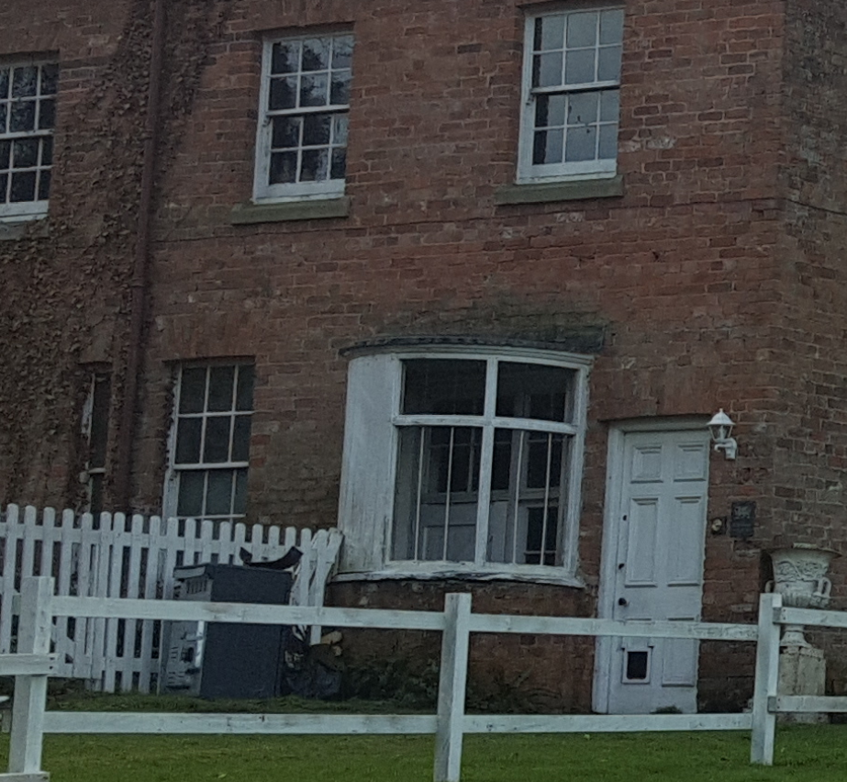
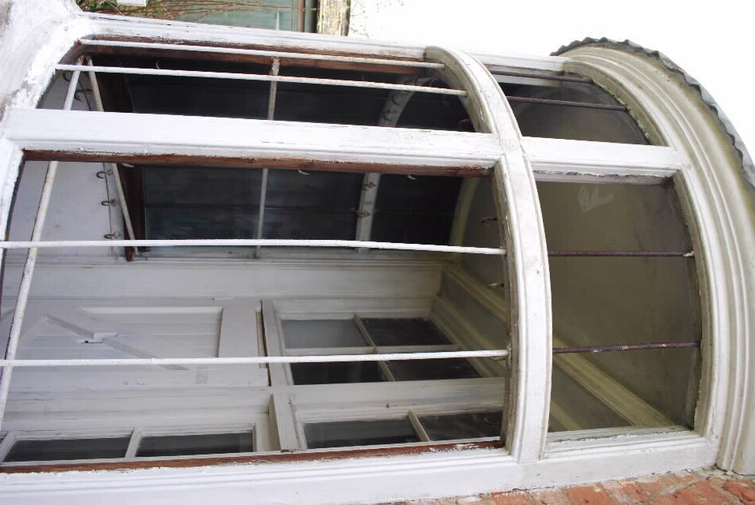
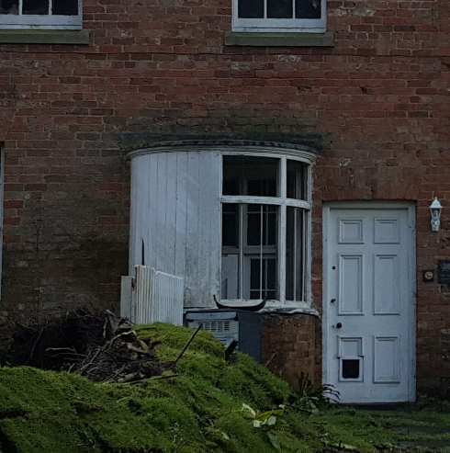
Method statement
  - The existing timber work is to be examined and any rotten sections are to be carefully chiseled out and replaced with new timber in a profile and detail that matches the existing.
  - The new timber work will be primed and painted white to match the rest of the external timber, which will also be sanded down and repainted in white.
  - The metal bars are to be rubbed down, primed and painted in order to prevent further damage from rust caused by weathering.
  - A metal mesh to match that currently present internally is to be sourced and carefully inserted into the remaining openings where it is currently missing.
  - The condition of the brickwork and pointing will be examined but it is not planned to carry out any remedial works to this part of the game larder, or to the roof as there is no evidence of it leaking.
  - Internally, the game larder will be re-painted but no other works are proposed.

