For the attention of:
The Planning Inspectorate
Crown Buildings
Cathays Park
Cardiff
CF10 3NQ

APPEAL FULL STATEMENT OF CASE
Gamford House, Gamford Lane, Rossett, Wrexham, LL12 0EW
Local Authority ref: P/2019/0246
PINS Ref: APP/

Prepared on behalf of the Appellant - Urban Developments and Construction Ltd.

 Appleton Deeley Planning and Landscape

Contents

- Introduction
- Appeal Documents
- Reasons for Refusal
- Site Description and Context
- Planning History
- The Proposals
- Representations Made by Interested Parties
- Key Planning Issues
- Relevant Appeal Decisions
- Principle of Development
- Openness
- Policy Framework
- National Planning Framework
- Local Planning Framework
- Housing Delivery and Viability
- Development Principles
- Policy PS1 – Location
- Policy PS3 – Brownfield Land
- Policy PS4 – Sustainable Development
- Policy PS2 and Policy H5 Impacts Upon Openness and Landscape Character
- Green Barrier Review
- Special Landscape Areas Review
- Economic Policy Objectives
- Social Policy Benefits
- Environmental Benefits
- Conditions and Unilateral Undertaking
- Summary Planning Benefits
- Design Considerations - HBA
- Conclusions

Prepared in accordance with The Town and Country Planning (Hearings Procedure) (Wales) Rules 2003 (Statutory Instrument 1271); as amended by Town and Country planning (Amendment of Appeals Procedures) (Wales) Rules 2007 (Statutory Instrument 2007/2285)

1. Introduction
1.1 On 1st July 2019 Wrexham County Borough Council Planning Committee refused planning permission for the following proposals at Gamford House, Gamford Lane, Rossett, Wrexham, LL12 0EW, under reference: P/2019/0246:
‘Change of Use, Conversion and Replacement of Agricultural Barns and Farmhouse to Form 8no. Detached Dwelling Houses, Including Removal of Derelict Structures Across the Site.’
1.2 The Reasons for Refusal of this Application are strongly refuted and a Hearing Procedure is requested for the consideration of this Appeal for the following reasons:
- The Inspector is likely to need to test the evidence by questioning, particularly on brownfield status and viability issues;
- There is no need for evidence to be tested through formal questioning by an advocate or given on oath;
- The case has generated a level of local interest such as to warrant a hearing.
1.3 This Appeal Full Statement of Case strictly follows the guidance contained within The Town and Country Planning (Hearings Procedure) (Wales) Rules 2003 (Statutory Instrument 1271); as amended by Town and Country planning (Amendment of Appeals Procedures) (Wales) Rules 2007 (Statutory Instrument 2007/2285).
1.4 Rebuttal to the Reasons for Refusal will focus on the following areas of difference:
- The proposals for Gamford House do not materially detrimentally affect countryside, landscape character, open space, or the quality of the natural environment, but preserve openness and are carefully designed in response to landscape and visual impact analysis.
- The settlement limits to which new housing should be directed are outdated and do not have the brownfield site capacity to meet housing and economic regeneration aspirations of the County Borough.
- Policies regarding the location of new residential development should be applied with appropriate weight that acknowledges the very special circumstances of an outdated evidence base on settlement patterns and the absence of a five year housing supply.
- The brownfield status of the site has been ignored.
- The proposals should be considered against policies protecting the Open Countryside rather than a former Green Barrier or Special Landscape Area status.
1.5 The existence of Very Special Circumstances is key to the rebuttal. In considering the location of new housing there is a presumption against development in open countryside unless very special circumstances can be demonstrated. Our case, demonstrating that this development proposal meets the exceptional circumstances test as set out in Planning Policy Wales edition 10, is based on the following:
- The Authority cannot present any case for a 5 year housing land supply;
- The site is brownfield land, previously with a commercial use
- The approved scheme presents an opportunity to deliver on a range of social, economic and environmental policy objectives
- That TAN1 continues to have significant material weight despite the temporary suspension of para 6.2 as confirmed by Julie James Minister for Housing and Local Government in her decision letter dated 10 June 2019 on the called in Land at East of Tan Y Bont scheme ref. APP/H6955/A/17/3182282.
- That the site does not meet any of the 4 purposes of including and retaining the land within the Green Barrier, nor does it have Special Landscape quality and has been removed from those designations.
- That there are no acceptable or deliverable alternative uses and in terms of Viability this site outperforms all other possible alternative housing sites, including the approved conversion scheme
- The proposals will achieve sustainable development in accordance with an emphasis on generating significant and mutually supportive economic, housing strategy and environmental benefits which collectively constitute sustainable development

1.6 We have demonstrated that the strategic policies of the Wrexham Unitary Development Plan for the broad location of development are satisfied in that:

- The settlement limits to which new housing should be directed are outdated and do not have the brownfield site capacity to meet housing and economic regeneration aspirations of the County Borough
- The proposals for Gamford House do not materially detrimentally affect countryside, landscape/townscape character, open space, or the quality of the natural environment.
- The site is previously developed brownfield land and,
- The development maintains the existing settlement pattern and character of the County Borough
- The proposals constitute a combination of conversion of buildings in accordance with Unitary Development Plan (UDP) Policy H3 and infill development to achieve residential amenity with a rural character, in compliance with UDP Policy H5.

1.7 The design approach taken in these proposals is forward looking and responsive to the development aspirations of the County Borough. This approach is essential to the success of the emerging Local Development Plan and is articulated in the comments of the Planning Inspector at the Examination of the Wrexham Local Development Plan in 2016, who highlighted fundamental concerns including:

- A significant shortfall in the supply of housing which, if it were to be addressed, would undermine the strategy of the Plan of confining general housing to within settlement boundaries.
- The overall level of growth proposed by the Plan may lack sufficient ambition in terms of strengthening Wrexham’s role as a key hub as envisaged in The Wales Spatial Plan 2008 Update, (reiterated in the North Wales Regeneration Plan 2018-2035).
- A lack of flexibility in the Plan, in particular overly rigid policies.
- The approach to green barriers does not have adequate regard to national policy.
- Concern that the envisaged scale of growth in the employment sector may be hampered by the limited pool of suitably skilled workforce that would be likely to result from the Plan’s more restrictive approach to housing growth.
- Concern that the proposed imbalance between the scale of employment and housing growth may lead to employees commuting into the County to work, thus limiting the economic benefits to the area and increasing car borne journeys.
- Although part of County has recently been designated as an Area of Outstanding Natural Beauty, it was accepted at the hearing that there was no reason to believe that the character of the County was such that it could not accommodate any expansion of settlements.
- Evidence from the house building industry raises concerns that many of the allocated sites will not come forward in the short term because of the particular challenges in developing brownfield sites in a difficult economic climate when lenders are risk averse in the face of potential unidentified abnormal costs. The evidence provided in the Entec Urban Potential Study (page 53) also indicates that for viability reasons a brownfield strategy would not provide a reliable source of supply.
1.8 These proposals accord with the policy thrust that the Inspector is seeking in the emerging LDP. We therefore consider that we have presented a strong justification for the Gamford House redevelopment proposals to be accepted. However, the proposals were not afforded due consideration by Planning Committee as comments by both the Chair and Chief Planning Officer were imbalanced and led the vote. National Policy has been ignored and the broader economic, social and environmental benefits of the scheme discounted.
2. The Appeal Documents
2.1 This Appeal Full Statement of Case should be read in conjunction with the following plans and documents, which are enclosed as separate items in the submission package:
- Design Principles Hardie Brack Associates
- Development Cost Appraisal (Abstract) Hardie Brack Associates
- Architectural Masterplan drawings: Hardie Brack Associates
- Design & Access Statement: Hardie Brack Associates
- Landscape & Visual Impact Assessment: Appleton Deeley Planning and Landscape
- Planning Statement: Appleton Deeley Planning and Landscape
- Topographical Survey: Hardie Brack Associates
- Ecological Assessment: Tyrer Ecological Consultants
- Application Forms and Ownership Certificates Appleton Deeley Planning and Landscape
The application pack satisfies both national and local validation requirements.
3. Reasons for Refusal
3.1 REPORT OF THE CHIEF OFFICER PLANNING AND REGULATORY – Date 1st JULY 2019
1. The site lies outside of a settlement limit in open countryside and will have a detrimental impact upon the rural character of the site, its surroundings and the Special Landscape Area. The proposals therefore conflict with policies PS1, GDP1, EC5, H3, H5 and H10 of the Wrexham Unitary Development Plan.
2. The proposals represent inappropriate development for sites within Green Barriers and therefore conflict with Policy EC1 of the Wrexham Unitary Development Plan.
In reaching this Decision the Council has had regard to the relevant policies in the Wrexham Unitary Development Plan which are as follows:-
EC1 Green Barriers
EC5 Special Landscape Areas
EC6 Biodiversity Conservation
GDP1 Development Objectives
H10 Replacement Dwellings in the Countryside
H3 Residential Conversion of buildings outside settlement limits
T8 Parking
3.2 Officer Report Conclusion
The development lies in open countryside, represents inappropriate development within the Green Barrier and will have a harmful urbanising effect on the site, the rural character of the locality and Special Landscape Area. It therefore does not accord with policies PS1, EC1, EC5, H5, H10 and GDP1 or advice contained in Planning Policy Wales regarding the location of new development in the countryside.
3.3 Rebuttal to these two reasons for refusal will be given under the following headings;
- Out of Settlement Development
- Harm to Character of the Open Countryside
4. Site Description
4.1 The application site is located close to the eastern built up edge of Rossett and its established residential estates. Rossett is a large village to the north of Wrexham and is home to some 3,500 residents. Gamford House is located on the northern side of Gamford Lane, approximately 0.2 miles east of the village of Rossett. The village is structured along Station Road and Chester Road (B5445). The A483 (which forms a bypass for the Village) bounds the village and its landscape setting to the immediate west. The village is also bound to the south by the River Alyn. The site is well located within easy access to Rossett’s village centre, with local schools, shops and bus routes all within a reasonable walking and cycling distance.
4.2 The proposed development plot is relatively square in plan shape having approximate dimensions 118m in length by 98m in width at its widest points, providing a total area of 13,105m2 (3.23acres) including residential curtilage. There is adjoining agricultural land surrounding the application site to North, East and West boundaries also owned by the Applicant having a total area of 8,215m2 (2.03acres).
4.3 The site comprises a range of vacant, dilapidated farm buildings and a single derelict dwelling house. Gamford Farm was originally a working pig farm and then a workshop depot for commercial vehicle repairs, but has now not been in use for over 12 years. The buildings are not suitable for any other agricultural purpose, having been constructed specifically for pig farming. Their layout and design are not appropriate for modern agricultural requirements and the economies of scale that is essential for commercially successful modern farming. British pig farming declined dramatically during the 1990’s due to competition from modern production units in mainland Europe.
Fig.1 Application Red Line Boundary and area of land in applicant’s ownership marked by Blue Line
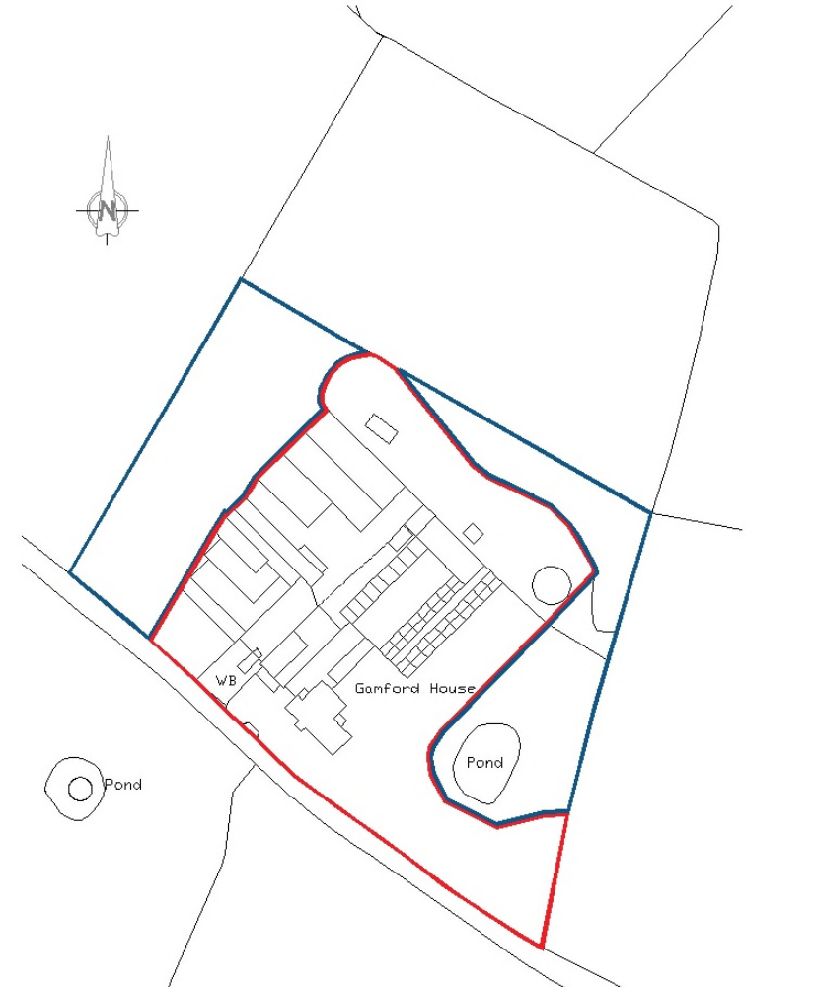
4.4 There are three main access points onto the site from Gamford Lane, one wider entrance to the west (accessing the barns) and two smaller entrance to the east (accessing the Gamford House) one of which will be amended to increase highway safety. The site is level with a slight fall from north to south towards the River Alyn. Perimeter hedgerows run along the western and eastern perimeter of the wider site, (edged in blue), and short stretches of hawthorn hedgerows and buildings define all other boundaries. Direct vehicular access is available to the site off Gamford Lane which links Rossett with Holt to the south east and the A534.
4.5 The site is considered to be located in a highly sustainable and accessible position to take advantage of existing community facilities and transportation related infrastructure and the redevelopment of this brownfield site making use of existing buildings is the most sustainable approach to the provision of new housing in the County Borough. The sustainability credentials of the proposals are augmented by the fact that the developer, Urban Developments and Construction Ltd., is a local Company that employs a workforce from the Wrexham area and sources local sub-contractors and suppliers.
The proposals aimed to secure the delivery of new housing of a design that responds to today’s demands, attracting families to sustain local services and amenities.

5. Planning History
5.1 P/2016/0384 Change of Use and Conversion of Barns to Form 8no. Residential Units, Construction of 2no. Semi Detached Dwelling Houses (replacement of existing farm house) and Demolition of Remaining Structures Across the Site.
Granted 7.11.16.
CB1060 Redevelopment of the site with 18no. dwellings and associated garages, including conversion of existing buildings and alteration to existing vehicular and pedestrian access.
Refused 16.5.97. Appeal dismissed 19.11.97.
6/0036 Erection of pig unit, grain store and storage tank. Granted 25.4.74
6/1856 Proposed extension to existing farm office. Granted 29.1.76
6/0122 Alterations and extension to dwelling and improvements to existing vehicular access. Granted 23.5.74
6/1432 Proposed extension to dwelling to provide additional lounge, and construction of new vehicular access. Granted 5.9.75
CB1060 Redevelopment of site with 18 dwellings and associated garages, including conversion of existing buildings and alteration to existing vehicular and pedestrian access.
Refused 16.5.97. Appeal dismissed 19.11.97
P/2016/0384 Change of use and conversion of barns to form 6no. residential units, construction of 2no. semi detached dwelling houses (replacement of existing farmhouse) and demolition of remaining structures across the site. Granted 7.11.2016
6. The Proposals
6.1 The application was made for Full Planning Permission. The description of the development is as follows:
6.2 The creation of 8no. detached dwelling houses through conversion and redevelopment to replace a derelict farm house, agricultural and workshop buildings at Gamford House, Gamford Lane, Rossett, Wrexham, LL12 0EW, including landscaping and access.
The accommodation schedule comprises the following:
8no. 4 bed detached dwellings at 1.5 to 2.5 storeys and a density of 9.1 dwellings per Hectare.
6.3 Our approach to design development has been to incorporate the most distinctive characteristics and features of the existing site where appropriate. The design process has responded to the pre-application advice within correspondence with Wrexham County Borough Council and in the meeting of 28th April 2018. The scheme seeks to deliver a high quality, contemporary development that creates a rural feel from the existing built elements, with a positive impact upon the character and openness of the countryside.
Site Context
6.4 The settlement pattern of Rossett comprises a core around the route of the B5445 Chester road and surrounding hamlets and clusters of agricultural buildings. The Settlement Review of January 2018 redefined the eastern boundary of Rossett to the extent that the site is now closer to the edge of the settlement. Early buildings are characterised by red brick, render and slate roofing construction materials. Building are constructed in a range of building styles. Early housing is linear, structured along and within the road and lane patterns.
6.5 The streetscape and building pattern has little correlation with the historic street and field pattern, creating less structured, less cohesive places. The River Alyn contains development to the south, while Chester Road contains development to the west creating a strong, intact parkland landscape edge. The A483 by passes the village and provides connections to Wrexham, Chester and beyond.
Local Amenities
6.6 Recently, Darland High School and St. Peter’s Primary School have created community hubs to the north of the historic village core. As such, all community hubs are within walking or cycling distance from the Gamford House site.
6.7 The vehicular access to the site is proposed exclusively off Gamford Lane. Highway capacity was considered acceptable for the approved conversion scheme ref. P/2016/0384 Two existing access points are to be retained. A third access will be created to replace the access to Plot 1, to improve highway safety. The proposed layout would provide safe entrance points with adequate visibility splays of 2.4m x 56m in both directions.
6.8 Careful and selective hedgerow management will be undertaken to ensure the established landscape screening will remain in place along with the perimeter boundaries of the site. The scheme has been designed to ensure that the rural edge is maintained and enhanced and that the style and character befits the location and its surroundings.

Alternative Uses
6.9 The attached ‘Development Cost Appraisal Abstract’ details the consideration of alternatives uses. The appellant has explored the continued use of the site for commercial premises and has concluded that the only viable use of the site would be residential. Furthermore, in order for these eight dwellings to be deliverable they would have to appeal to those seeking a high quality executive home. The viability evidence was dismissed out of hand by Wrexham CBC despite its relevance to the design approach in the context of the approved scheme.
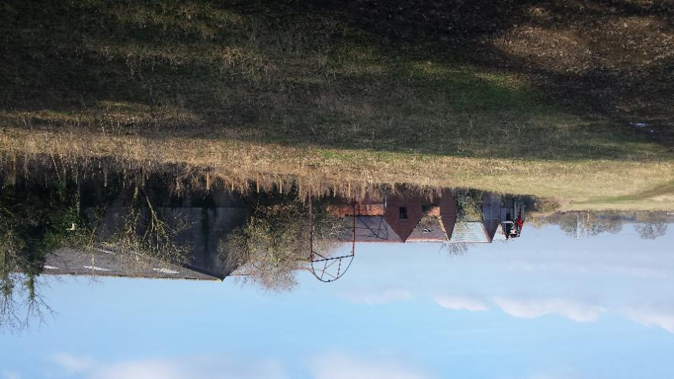
Fig.2 The site is intensively developed and impacting on openness of the countryside
Design Considerations
6.10 Planning Policy Wales edition 10 (PPW10) introduces the concept of ‘place making’: ‘Placemaking is a holistic approach to the planning and design of development and spaces, focused on positive outcomes. It draws upon an area’s potential to create high quality development and public spaces that promote people’s prosperity, health, happiness, and wellbeing in the widest sense.’
6.11 Our proposals have been developed in accordance with the principles set out in relevant national and local design guidance. The Planning Officer’s report considered each dwelling individually and failed to consider their importance to the integrity and character of the overall scheme concept. As part of this Appeal the applicant has commissioned a report on ‘Design Principles’ which details the design process and is a direct response to the comments on design as made by the Case Officer in his Report to Committee on 1st July 2019.
Pre-Application Discussions
6.12 The applicant considered it essential to engage with Officers in seeking their advice and guidance pertaining to this proposal and undertook to hold detailed pre-application discussions with Officers at Wrexham County Borough Council, on 27th April 2018. Officers emphasised that the impacts upon the open countryside could only be acceptable through a carefully designed conversion scheme and that other housing developments in the Borough successfully achieved a ‘rural’ character. A further pre-application meeting was requested on 12th September 2018 but denied. A letter from WCBC was received dated 27th September 2018 with comments on the proposals, (see Appendix E). A number of significant issues emerged from these pre application discussions and these are examined below.
7. Consultation Responses and Representations
7.1 Community Council: The Community Council are keen for this site to undergo work as it is deemed an eyesore in its current state. Whilst they have no objection regarding the development of the house and within the footprint of the current agricultural buildings they do not feel this permission should be extended to the pond and orchard area. It was also noted that there should be an immediate instruction/condition to make this site secure as it is proving to be a health and safety risk as children are known to be entering the site.
7.2 Local Member: I cannot agree to it being dealt with under delegated powers and would wish the Committee to consider it. I am in favour of the development as I feel that this is exactly the type of small development needed on an appropriate site as opposed to taking massive swathes of green barrier.
Highways: Have made the following comments:
• Visibility splays of 2.4 x 56m required in both directions;
• Access to plots 3-7 is 6m wide which is considered adequate for a shared access.
• Access to plot 3 appears to be 4m wide which is considered adequate. .
• Access to plot 1 appears to be 7m wide which is considered adequate;
• Recommend no gates be erected across the accesses, that they are surfaced with hard bound materials for a minimum of 5m behind the adjoining highway and an Aco drain or similar installed to intercept private surface water run-off;
• Given the relatively remote/unsustainable location of the site, I would recommend that provision is provided with LPG16;
• Suitable turning provision required for plots 1 and 2;
• A turning head to accommodate the movements of a medium sized delivery vehicle for plots 3-7. The proposed turning area is considered inadequate;
• It is important that any proposed bin store/compound is suitability located to serve such a development in close proximity to the highway.
• Gamford Lane has no footway or street lighting provision. Pedestrians would therefore have to walk a significant distance along an unlit rural lane. I would therefore not consider this site to be a sustainable location to support any significant residential development;
• I would recommend any proposed development is limited to previous traffic generation levels;
• The information submitted appears to indicate that the farm previously generated a particularly high number of daily movements. Based on the information submitted the development is likely to generate fewer vehicular movements;
• Recommend the current speed limit is reduced to 30mph in the interest of pedestrian safety;
• Recommend the applicant funds street lighting along Gamford Lane. Public Protection: Condition regarding construction/working times and advisory notes in respect of minimising impacts during development and contaminated land recommended.
Education: Contributions to secondary provision required.
Welsh Water: Conditions recommended.
NRW: Consulted 2.4.2019 CPAT: Information held within the regional Historic Environment Record indicates that although the development appears to have limited archaeological implications, the proposals will affect a former group of brick barns and a farmhouse which appear on the first edition OS mapping and are at least 130 years old. The buildings are of local architectural and historical interest and it would be unfortunate if these buildings were now altered or demolished without some form of record of their current architectural style and present form being made. The applicant should be required to carry out a Photographic Survey before development commences, in order to preserve a record of these buildings. To facilitate this request an appropriate planning condition is attached to any permission granted.
Site Notice: Expired 25.4.19 Press Notice: Expired 4.5.19
Alyn Family Doctors: Strongly object for the following reasons: - Our practice is at serious risk of closure; - As a practice we are already overstretched and cannot cope with current workload; - Any other developments in our area are unmanageable; - Numerous developments have already occurred in our practice area. We cannot continue to absorb the pressure; - The Health Board have stated they are liaising with the practice regarding increasing our practice. This is not correct. There are no plans to expand our premises. Even if there was we cannot cope with demand; - We are looking to close one of our practice sites as we cannot safely staff it; - The gradual increase in hoses in the Alyn Family Doctors area of Llay, Gresford, Marford and Rossett has reached the stage where we must place on record our objection; - Our inability to increase our service to any of these new houses seriously threatens the provision we can give to existing patients; - Developer contributions will not cure these inherent overload problems.

THE CASE FOR THE APPELLANT – OUT OF SETTLEMENT DEVELOPMENT
8. The Key Planning Issues
Housing Delivery
8.1 It was acknowledged at the pre-application meeting that the County Borough does not have a five year housing supply. Moreover, this is unlikely to change for at least another year until the emerging Local Plan had been adopted. The slippage in the production of a Local Development Plan preparation has been severe and it places the Authority in an even more difficult position as the housing backlog is becoming greater.
8.2 Planning Policy Wales (Edition 10 December 2018) sets out the land use planning policies of the Welsh Government and translates the Government’s commitment to sustainable development. Planning Policy Wales (PPW10) indicates at paragraph 4.2.15 that: “Planning authorities must ensure that sufficient land is genuinely available or will become available to provide a five‑year supply of land for housing judged against the general objectives, scale and location of development required in the development plan. This means that sites must be free, or readily freed, from planning, physical and ownership constraints and be economically viable, in order to support the creation of sustainable communities. For land to be regarded as genuinely available it must be a site included in either a Joint Housing Land Availability Study”.
8.3 There is a clear requirement to provide a 5 year supply of housing land within PPW10. The Council has yet to adopt its emerging Local Development Plan and its Unitary Development Plan (14 Feb 2005) is now outdated. This has implications for the County Borough’s ability to constrain its supply to settlement limits:
Part 6 of TAN1 relates to the issue of housing supply and states that:
“6.2 The housing land supply figure should also be treated as a material consideration in determining planning applications for housing. Where the current study shows a land supply below the 5-year requirement or where the local planning authority has been unable to undertake a study, the need to increase supply should be given considerable weight when dealing with planning applications provided that the development would otherwise comply with development plan and national planning policies.”
8.4 Wrexham is to be treated as not having a five year supply and the latest Housing Land Monitoring Statement (April 2017) confirms it is a zero supply authority.
8.5 The fact that the UDP cannot be treated as providing an appropriate basis for a housing requirement figure for a joint housing land availability statement is a clear indicator that the UDP’s approach to housing is out-of-date. Further, the fact that the Council cannot meet its five year requirement shows that settlement limits constraining the ability to do so cannot continue to command significant weight. The Urban Capacity Study update (2013) identifies a shortage of suitable, available and deliverable brownfield sites within existing settlement limits and the quantum of need cannot be met without considering the need for the release of green field sites currently on the edge of, but outside existing settlement limits.
8.6 In contrast, the position is as set out in paragraph 6.2 of TAN1 which is that the need to increase supply should be given considerable weight.
8.7 Recent Appeal decisions in Wrexham demonstrate very clearly the weighting to be given to the lack of a five year supply and therefore the need to increase supply:
Rhosrobin appeal decision – lack of a five year supply weighed heavily in favour of the proposed development (paragraph 25 of the decision letter)
Gresford appeal decision – lack of a five year supply carried considerable weight (paragraph 19 of the decision letter)
Minera appeal decision – the lack of housing land carried significant weight (paragraph 16 of the decision letter).
8.8 These weightings were applied notwithstanding the conflict of the proposals in the above cases with the Green Barrier policy (Policy EC1) of the UDP and the interpretation of paragraph 6.2 of TAN1. No different conclusion could be reached for the application at Gamford House. Both the lack of a five year supply and the need to increase supply carries considerable weight in this determination.
Delivery and Viability Challenges
8.9 In an exploration of suitable housing sites the Authority have produced a Site Register of comments and Officer Responses (doc. Ref. KPD14a dated January 2018); in which it provides a summary of comments made at the Preferred Strategy stage in relation to the single candidate site in Rossett (and indeed across the County Borough). The Register highlights the physical and legal constraints impeding delivery and that larger sites will place a burden on local amenities and infrastructure.
Even the Appeal site has deliverability and viability challenges and these have been addressed to produce a scheme based on the approved scheme for eight dwellings but developing the scheme to a deliverable standard.
Viability
8.10 An important element of our submission is the financial viability assessments of this scheme and the approved scheme. The Gamford House site is available, suitable and, of significant policy importance, it is viable. There are no site or viability constraints impeding deliverability of these proposals, and comparisons will be made with other sites in the County Borough. Issues regarding viability include the following:
The site is currently detracting from the character of the County Borough and has a detrimental impact upon the residential amenity of nearby residents.
- The site will not exceed service capacity. We are confident that through appropriate dialogue with third parties that all services will be provided and improved if required. The development is limited to 8no. dwellings which ensures there will be no strain on local services and amenities.
- The applicant is ready to bring this site forward for development, as is demonstrated by the submission of this application and the investment thereto; a number of people have expressed an interest in purchasing a property at this site and demonstrates the market appetite.
- We have proven through our own evidence base that there are no known technical environmental or engineering constraints in bringing these sites forward for development.
- All known issues (e.g. contamination, drainage/floodrisk, ecological, highway/access, minerals, agricultural land quality, tree and archaeological) have either been addressed or are in hand.
8.11 Wrexham’s Candidate Sites Assessment Paper Feb 2016 states that, ‘Small Sites will not be allocated in the LDP, however where the sites are relatively constraint free and there is a prospect of them being developed over the lifetime of the LDP (2013 – 2028), there is potential for them to contribute to the windfall supply over the Plan period. Where small sites are located in existing settlement limits, no action needs to be taken, as these sites can come forward for development at any time provided any site specific constraint issues can be overcome and the scheme complies with the relevant development management considerations. Similarly, the sites on brownfield land in the open countryside could come forward at any time under the same proviso as those within settlement.’ (Our emphasis).
8.12 The Appraisal Methodology as applied to the Candidate sites and Alternative sites has been used in a sequential approach to illustrate the scheme’s credentials. We have assessed the proposal against some of the key relevant policies from the emerging LDP Deposit Plan and consider the principal policies examined in Section 5 below to be the most relevant and appropriate in this instance.
Wrexham CBC LDP2 Site Assessment Methodology (January 2018):
8.13 National planning policy and guidance on the preparation of LDP’s and, in particular advice that ‘The LPA should apply a set of criteria or filtering mechanism to classify and prioritise sites as to their acceptability for further consideration. Criteria will need to address deliverability issues and reflect the integrated plan objectives so that they meet sustainability appraisal requirements’.
8.14 Paragraph 3.39 of PPW10 states that, ‘When identifying sites in their development plans planning authorities should consider previously developed land and/or underutilised sites located within existing settlements in the first instance with sites on the edge of settlements considered at the next stage. It is recognised, however, that not all sites of this nature are suitable for all types of development.’
At Stage 1 of the assessment, no small sites progressed to the allocation stages. However, the methodology states that;
‘Where small sites are located in existing settlement limits, no action needs to be taken, as these sites can come forward for development at any time provided any site specific constraint issues can be overcome and the scheme complies with the relevant development management considerations. Similarly, the sites on brownfield land in the open countryside could come forward at any time under the same proviso as those within settlement. Only those sites where the constraints cannot be overcome or those on Greenfield land in the open countryside which are not proposed as rural enterprise dwellings are likely to be unsuitable for development and have been discounted.’
8.15 It is clear that a site with a capacity for just eight dwellings is a small site and as a brownfield site can contribute to the windfall supply. The scheme has broader credentials in comparison to the allocated sites. In accordance with Planning Policy Wales the following criteria should influence the allocation of housing sites in the LDP:-
- the availability of previously developed sites and empty or underused buildings and their suitability for housing use;
- the location of potential development sites and their accessibility to jobs, shops and services by modes other than the car, and the potential for improving such accessibility;
- the capacity of existing and potential infrastructure, including public transport, water and sewerage, other utilities and social infrastructure (such as schools and hospitals), to absorb further development, and the cost of adding further infrastructure;
- the scope to build sustainable communities to support new physical and social infrastructure, including consideration of the effect on the Welsh language, and to provide sufficient demand to sustain appropriate local services and facilities;
- the physical and environmental constraints on development of land, including, for example, the level of contamination, stability and flood risk, taking into account the possible increase of such risk as a result of climate change, and the location of fragile habitats and species, archaeological and historic sites and landscapes;
- the compatibility of housing with neighbouring established land uses which might be adversely affected by encroaching residential development; and
- the potential to reduce carbon emissions through co-location with other uses
8.16 Although the Gamford House site was considered too small to be assessed for allocation it is clear that it would have scored well against these criteria.
9. Relevant Appeal Decisions
9.1 Whilst planning appeals and applications are considered independently and on an individual basis, there are several recent decisions made under similar circumstances in the Wrexham area that act as strong precedent, and are evidence of the strong requirement for new housing in the County Borough. The comparable attributes of these sites are the Green Barrier designations and outside of settlement boundary locations.
P/2014/0905 | APP/H6955/A/16/31 47116 | Outline application for up to 365 dwellings and erection of 300 square metre retail unit - all detailed matters reserved | Home Farm,  Gresford Road,  Llay,  Wrexham  LL12 0NW | Refused:  05/10/15  Appeal Upheld:  26/06/2017

P/2013/0545 | APP/H6955/A/15/31 35739 | Outline Application For Redevelopment Of Land For Proposed Mixed Use Development Of Up To 300 (Use Class C3) Residential Dwellings, 465Sqm (Use Class B1, B2 And B8) Business, Industrial, Storage And Distribution Units, 235Sqm (Use Class A1) Retail, E | Land At Former Site Of Hafod Tileries, Hafod Road And Bangor Road,  Johnstown, Wrexham, LL14 2SP | Refused: 16/06/2015  Appeal Upheld:  14/11/2016
P/2016/0189 APP/H6955/A/17/3182282 189 dwellings Tan y Bont, Appeal Upheld:
Rhosrobin 17 June 2019
Tan y Bont Appeal APP/H6955/A/17/3182282 - The Council’s reason(s) for refusal:
“The site lies outside of a settlement limit and within a Green Barrier. The development will result in the coalescence of Wrexham and Old Rhosrobin and significant harm to the openness of the Green Barrier separating Old Rhosrobin and Pandy. The development is therefore contrary to policies PS1 and EC1 of the Wrexham Unitary Development Plan”.
“There must be very exceptional circumstances to grant individual planning applications for housing development in Green Barriers. It is clear there is a considerable need to increase the supply of land available for housing in the County Borough. In appropriate cases this could be considered to be a very exceptional circumstance sufficient to outweigh the Green Barrier designation. However the importance of the site in the context of the Green Barrier it lies within must also be carefully considered”.
“Whilst I acknowledge that the contribution the development can make towards housing land supply is a significant benefit, as would be the provision of up to 47 affordable houses, the development will significantly and detrimentally impact upon the openness of the Green Barrier and result in the coalescence of Wrexham and Old Rhosrobin as well as a significantly eroding of the existing gap separating Old Rhosrobin and Pandy. I do not consider housing land supply issues constitute the very exceptional circumstances to set aside the Green Barrier objections to the development in this instance”.
Tan y Bont Appeal - Wrexham’s Appeal Statement of Case
“In the light of the current situation in respect of housing land supply, the Council considered that Policy PS1 is outdated and therefore should be afforded less weight in the determination of planning applications. However, it does not automatically follow that all proposals to develop sites located outside of settlement limits should be granted planning permission, particularly if those sites are afforded greater protection by other policies of the UDP.”
Tan y Bont Appeal - Inspector’s Planning Balance and Recommendation
“Although the proposal would be inappropriate development within the Green Barrier, very exceptional circumstances have been found to exist which clearly outweigh the harm, in accordance with Policies PS1 and EC1 of the UDP. I have not found any other matters which weigh against the appeal. For these reasons, and having had regard to all other matters raised, I recommend that the appeal be allowed, subject to the conditions as set out in the Schedule to the report.
In reaching my recommendation I have taken into account the requirements of sections 3 and 5 of the Well Being of Future Generations (Wales) Act 2015. I consider that this decision is in accordance with the Act’s sustainable development principle, through its contribution towards the Welsh Ministers’ well-being objective of supporting safe, cohesive and resilient communities.”
9.2 The letter from Minister for Housing and Local Government 10th June 2019, Julie James is critical to the decision framework for the Gamford House proposals, with paragraphs 9 and 10, extracted below, as most pertinent:
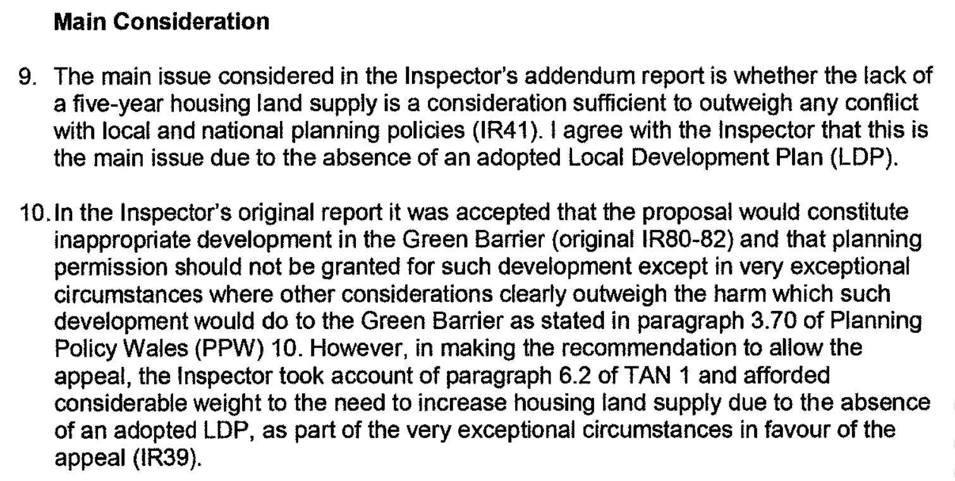

The fundamental concerns of the LDP1 Inspector are also relevant to our Full Statement of Case and are summarised as follows:
- A significant shortfall in the supply of housing and the associated conflicting Plan strategy to confine general housing to within settlement boundaries.
- A failure to take reasonable steps to secure an appropriate supply of affordable housing.
- A failure in the Plan to respond to its own evidence base.
9.3 It was accepted at the LDP1 hearing that there was no reason to believe that the character of the County was such that it could not accommodate any expansion of settlements.
Paragraph 6.1 of TAN 1 (situations where supply is below 5 years) explains that:
“Where the current study shows a land supply below the 5 year requirement, the need to increase supply should be given considerable weight when dealing with planning applications, provided that the development would otherwise comply with national planning policies.
In addition, local planning authorities must take steps to increase the supply of housing land. This may include reviewing the development plan, releasing land in its ownership, expediting planning applications or securing the provision of infrastructure for particular sites, which prospective developers may be prepared to finance in whole or in part."
Therefore, despite being close to the settlement boundary, it is submitted that the planning application at Gamford House should be considered in the context of the presumption in favour of sustainable development in line with Planning Policy Wales. On this basis the scheme will assist in delivering houses within the framework of TAN 1 and national planning policies.
9.4 Wrexham County Borough Council Joint Housing Land Availability (JHLAS) Study for 2013 acknowledges that this is the only viable alternative to increase housing land supply in the short term.
10. Principle of Development
10.1 Where a five-year land supply does not exist, TAN 1 indicates that the need to increase supply should be given considerable weight when dealing with planning applications, provided that the development would otherwise comply with the Development Plan and National Planning Policies.
10.2 This was temporarily suspended in July 2018 by the Housing Minister and the weight to be afforded to the absence of a 5 year supply left to the discretion of the Local Planning Authority. The weight afforded to the absence of a 5 year housing supply at Wrexham County Borough was regarded to be considerable by both the Housing Minister, Julie James, and the Planning Inspector for the recent Tan y Bont Appeal Decision. This ruling is very significant to the current Appeal and was made on 10th June 2019 under Appeal reference APP/HY955/A/17/3182282.
Planning Policy Wales includes a ‘presumption in favour of sustainable development’, against which these proposals should be assessed.
10.3 The introduction to PPW10 at paragraph 1.4.3 states: “The Welsh Government has specific duties regarding equal opportunities and sustainable development under the Government of Wales Act 2006 and the Well-being of Future Generations (Wales) Act 2015. The Well-being of Future Generations Act (Wales) 2015 places a duty on the Welsh Ministers (and other public bodies) to produce well-being objectives and take reasonable steps to meet those objectives in the context of the principle of sustainable development.”
10.4 Paragraph 4.3 of the PPW advises that: “The Well-being of Future Generations (Wales) Act establishes a ‘sustainable development principle’ which means that a defined public body must act in a manner which seeks to ensure that the needs of the present are met without compromising the ability of future generations to meet their own needs.”
Policy PS1 - Location
10.5 As Policy PS1 of the UDP was worded on the basis of population projections and housing allocations at the time of its adoption, the inability of the Council to now demonstrate a sufficient supply of land means that the requirements can no longer be met within existing defined settlements. As such Policy PS1 is out of date and can therefore now only be afforded limited weight.
10.6 PPW10 para 3.37 states, ‘An essential component for a sustainable place is where development is to be located. Development plans will provide the basis for this by identifying areas and sites for new development. This will be based not only on the consideration of the needs of existing urban and rural areas but also future relationships between urban settlements and their rural hinterlands, particularly in the light of ensuring strong rural and urban communities, maintaining places which are resilient to the effects of social and economic change and are resilient in the light of the impacts of climate change.’
10.7 The site is located on the edge of Rossett which is noted as being an ‘Urban Village’ in the UDP. These urban villages comprise the larger settlements to the north, west and south of Wrexham Town. While their range of services is narrower than Wrexham, they are capable of supporting some additional growth, particularly on derelict or underused land.
10.11 The location of Gamford House would not need to solely rely on private cars to access services, education or employment and in terms of its location and services, scores highly from a sustainability perspective.
Settlement Limits and Policy PS1
10.12 In the absence of an up-to-date UDP and adopted LDP, in accordance with latest Welsh Government Guidance on JHLAS, TAN1, there is no requirement for a Local Authority to produce a JHLAS and the authority is considered to have a zero land supply. The Housing Land Monitoring Statement 2017 is of relevance to the assessment of housing supply. The five-year land supply comprises sites with outline or full planning permission, sites with a resolution to grant planning permission subject to the signing of a section 106 agreement and remaining site allocations from the UDP, categorised as prescribed in TAN 1.
10.13 The Wrexham Settlement Boundary Review (January 2018) identified under section 3. Development Sites: -3(a) Sites identified as Key Strategic Sites or Non-strategic settlement extensions. This amended the development boundary to include allocated sites, and
3(b) Additional Small sites/Infill sites. Development boundary amended to include previously unidentified sites suitable for development 10 or less dwellings, including brownfield sites on the edge of settlements.
10.14 The Gamford House site fits with 3(b) above. The conclusion must be that the UDP settlement limits are out of date and must be given significantly reduced weight. That is in line with paragraph 2.8.4 of PPW which states that it is for the decision-maker to determine whether policies in the adopted UDP are outdated for the purposes of determining a planning application but advises that, where such judgment is made, local planning authorities should “give the plan decreasing weight in favour of other material considerations such as national planning policy, and the presumption in favour of sustainable development.”
10.15 As a result, the pressure to release some Green Barrier sites in advance of the Local Development Plan having reached adoption must be a significant material consideration. We have assessed whether or not the site has significant impact upon the purposes of the Green Barrier. The site must be considered on its individual merits, with housing land supply and impacts on openness of the countryside being the key material considerations.
10.16 Rossett comprises some 1,364 existing households (2015 census) and the proposal represents a modest increase in household growth, which is not considered to be either significant or unsustainable for a community of this size.
10.17 In February 2017 Wrexham County Borough Council published its Green Barrier Review and this site is proposed to no longer be classified as Green Barrier nor a Special Landscape Area once the emerging LDP has been adopted. This evidence base for the removal of Green Barrier and Special Landscape Area status at the Gamford House site is published and should be afforded considerable weight in the determination of this Appeal. Nonetheless, we have undertaken a detailed Landscape and Visual Impact Assessment (LVIA) as policies towards new housing in the open countryside still require that the impacts of the proposals on the character of the open countryside must be acceptable.
Summary of Key Planning Issues
10.18 In summary, our case, in demonstrating that this development proposal meets the exceptional circumstances test as set out in PPW, is based on the following:
- the Authority cannot present any case for a 5-year housing land supply;
- that TAN1 is of significant material weight;
- the site does not meet any of the 4 purposes of including and retaining the land within the Green Barrier;
- the proposals contribute towards meeting the County Borough’s economic development aspirations, as the provision for executive housing is both a vehicle for regeneration as well as an essential component in the attraction of high tech research and development facilities.

10.18 These cumulatively present a compelling case as to why this scheme should be supported and granted planning permission.

Brownfield Land and Policy PS3
10.19 National and local policy express a strong and clear preference for the use of brownfield land. Paragraph 4.9.1 of Planning Policy Wales (PPW) states that “PDL should, wherever possible, be used in preference to greenfield sites, particularly those of high agricultural or ecological value.” The Appeal site in this case not only lies close to the edge of the revised settlement boundary of Rossett but it is also previously developed land which retains a legacy of dilapidated and derelict buildings.
10.20 Wrexham UDP Policy PS3 provides that “development should use previously developed brownfield land comprising vacant, derelict or underused land in preference to the use of greenfield land, wherever possible”. The application site comprises vacant, derelict and underused land and is in accordance with Policy PS3.
10.21 It is also of relevance that brownfield capacity in the County Borough is limited. Paragraph 3.2 of BP2: Settlement Hierarchy and Development Potential (revised February 2016) makes it clear that the majority of brownfield sites have been developed, that it is apparent that the housing requirement cannot be accommodated on brownfield sites alone and that greenfield allocation is inevitable “due to the limited capacity on brownfield sites.” The LDP2 Preferred Strategy concludes that, ‘There is a lack of brownfield capacity to accommodate projected household growth in the County Borough.’ Suitable and available brownfield land such as found on the application site is therefore a premium resource. Its development would reduce the need to release less preferable green field land for new housing.
10.23 The search sequence which is set out in paragraph 4.9.1 of PPW in respect of housing allocations in development plans provides that the starting point should be “the reuse of previously developed land and buildings within settlements, then settlement extensions and then new development around settlements with good public transport links.” It is clear that the Council cannot meet its pressing need for additional land for housing on previously developed land within settlements. It is equally obvious that, if previously developed land within settlements cannot provide the required extra capacity, previously developed land outside settlement limits should, providing it is otherwise suitable, take sequential preference over green field land outside such limits. In this case, the reuse of this previously developed site is in accordance with National Policy (PPW10).
10.25 The historic figures show a considerable and persistent undersupply of housing in the area compounding the undersupply of housing within the Council’s area. The current application seeks to assist in the increase in the supply of housing land within the Wrexham County Borough area in line with the requirements of Planning Policy Wales and TAN 1.
Sustainable Development – Policy PS4
10.26 On the 29th April 2015 the Wellbeing of Future Generations Act became law. This Act places a duty on all public bodies in Wales to ‘carry out sustainable development’. Planning Policy Wales (PPW10) promotes sustainable development in terms of the location of development, re-use of previously developed land and by setting minimum sustainable building standards. The access infrastructure has already been approved under P/2016/0384 and the site is served by foul drainage, a 90mm water main and electricity supply. It is within walking distance of the community hub and all local amenities.
10.27 Para 1.17 Planning Policy Wales edition 10 states ‘Legislation secures a presumption in favour of sustainable development in accordance with the development plan unless material considerations indicate otherwise to ensure that social, economic, cultural and environmental issues are balanced and integrated.’ It identifies ‘Outcomes’ that a development must meet to achieve sustainability objectives, including:
• Is accessible by means of active travel and public transport
• Prioritises the use of previously developed land and existing buildings
• Unlocks potential and regenerates
• Is of high quality and built to last
• Has homes and jobs to meet society’s needs
10.28 Our proposals are designed to achieve these outcomes. Residents of the development would have to travel some 450m to access local amenities such the nearest school, nonetheless such walking distances are not unusual as evidenced by the National Travel Survey 2012 (NTA). In addition Manual for Streets (MfS) advocates that walking offers the greatest potential to replace short car trips, particularly those under 2km.
10.29 PPW10 places a strong emphasis on the importance of good design and the creation of places to live that are safe and attractive. This is highlighted as being the responsibility of all those in the development process, at all scales with PPW placing greater emphasis on quality, good design and the creation of places to live that are safe and attractive. Our proposals are of exceptional design quality.
10.30 As a result of the issues and drivers highlighted in the Preferred Strategy, a review of the existing evidence base surrounding the housing, including national and local policy has identified the following additional issues and drivers that should be taken into account;
When building new homes it is important that their impact on the environment is carefully considered and that they are of a high standard of design, enhancing rather than having a negative impact on existing communities.
10.31 PPW also seeks to promote sustainability through good design. Paragraphs 4.11.1 and 4.11.2 of PPW provide the following definition of design:
“Design is taken to mean the relationship between all elements of the natural and built environment. To create sustainable development, design must go beyond aesthetics and include the social, environmental and economic aspects of the development, including its construction, operation and management, and its relationship to its surroundings. Good design can protect and enhance environmental quality, consider the impact of climate change on generations to come, help to attract business and investment, promote social inclusion and improve the quality of life…”
10.32 PPW10 indicates that consideration should be given to the re-use of rural buildings for commercial use before residential. However, the policy recognises that conversion for commercial use often has a more detrimental impact upon the character of a building as more of its features will be lost. Our proposals aim to protect and enhance distinctive features of the existing buildings.
10.33 For the purposes of formulating our proposals design sustainability is taken to mean the relationship between all elements of the natural and built environment. Sustainability must include the social, environmental and economic aspects of the development, including its construction, operation and management, and its relationship to its surroundings. The location is highly sustainable and the site is well served by facilities available in Rossett.
10.34 A number of Technical Advice Notes within Planning Policy Wales seek to ensure sustainable development:
TAN 5: Nature Conservation & Planning (2009) This document contains specific guidance about how the land use planning system should contribute to protecting and enhancing biodiversity and geological conservation. The current Green Barrier in which the site was situated was reviewed within the ‘Strategic Green Wedge Review Stage 1’ document dated February 2016.
TAN 15: Development and Flood Risk (2004)
10.35 This document covers flood risk from all sources including surface water and identifies the acceptability requirement and the relevant development advice. It stresses that in all flood risk zones, any development will require an appropriate drainage strategy to demonstrate that the development itself will not create, increase or exacerbate surface water flood risk. The site is within Environment Agency Wales Zone B and further advice will be sought from Environment Agency Wales regarding the preliminary flood risk assessment undertaken as part of the scheme design.
TAN 18: Transport (2007)
10.36 This requires transport and movement to be considered at the strategic and detailed level. The Wrexham Unitary Development Plan, paragraph 3.4, relates to Settlement Strategy and states that: “Large scale extensions of settlements which occurred in the past are no longer appropriate”. Rossett is classed as a Rural Village and the settlement strategy states, “The range of services available in these settlements is generally confined to those meeting purely local needs. The settlements themselves are surrounded by attractive countryside and some are not conveniently accessible by public transport. New development is therefore restricted to small sites.”
10.37 The following Unitary Development Plan Strategic policies relate to the broad location of development and inform an assessment of sustainable development:
Policy PS1 New development for housing, employment, and community services will be directed to within defined settlement limits/employment areas.
Policy PS2 Development must not materially detrimentally affect countryside, landscape/townscape character, open space, or the quality of the natural environment.
Policy PS3 Development should use previously developed brownfield land comprising vacant, derelict or underused land in preference to the use of green field land, wherever possible.
Policy PS4 Development should maintain the existing settlement pattern and character and be integrated with the existing transport network to help reduce the overall need to travel and encourage the use of alternatives to the car.
4.41 Importantly, the proposals respond to the Housing Strategy and Economic Development aspirations of LDP2 by providing large, high specification executive homes that will encourage the leaders of industry to invest in employment uses in the Borough. This provision means less travel to employment areas from outside, and less commuting into the County Borough.
THE CASE FOR THE APPELLANT – HARM TO THE CHARACTER OF THE OPEN COUNTRYSIDE
11. Openness and Policy PS2 and Policy H5
11.1 We consider that the Landscape and Visual Impact Assessment element of this submission underpins the view that the development of this site for residential development is visually lost very quickly as you move away from the site and the LVIA serves to demonstrate that the impact upon the wider Green Barrier will be negligible.
11.2 In April 2018 Members of Wrexham County Borough Council approved (for public consultation) the Deposit Strategy version of the emerging LDP and all of its supporting evidence base. They have therefore conferred with their Officers’ recommendations with respect to Green Barrier release being acceptable. The priority must therefore be given to releasing the most logical and sustainable locations for new development and, the sequential assessment of the candidate sites and alternative sites illustrates that there are few options which are capable of delivering growth of any scale and substance as only a few infill sites now remain, (see section 5 below). This proposal is considered to be at a location that is available, achievable, viable and deliverable.
11.3 Green Barrier policy is enshrined in PPW (Edition 9 November 2016) Section 4.8 and reflected locally by the UDP Policy EC1. At the pre-application meeting of 27th April 2018 it was acknowledged that the Wrexham UDP failed to pass this test in providing any reasoning for the Green Barrier designation over large swathes of land that could have been easily protected through Unitary Development Plan policies towards open countryside / landscape policy designations.
11.4 In addressing the impacts of development on such areas PPW states (Para 4.8.12) that factors such as “openness, topography and the nature of urban edges” should be taken into account. These have been acknowledged and addressed in the attached Landscape and Visual Impact Assessment.
11.5 The provisions of Wrexham’s UDP Policy H5 and GDP1 require that the proposals ensure that any built development in its scale, design and layout, and in its use of materials and landscaping, accords with the character of the site and makes positive contribution to the appearance of the nearby locality. If not, it would have to be classified as “inappropriate development” as it does not meet one of the exceptions of current UDP Policy EC1 and is a departure from the development plan. The test therefore has to be that the proposal meets exceptional circumstances where other considerations clearly outweigh the harm. These exceptional circumstances will be examined below.
11.6 It is recognised (in both PPW and UDP Policy) that there are essentially 4 purposes for including land in the Green Barrier and these are:
- To prevent coalescence of urban areas and villages with other settlements
- To assist in safeguarding the countryside from encroachment
- To protect the setting of urban areas and villages
- To assist in urban regenerations by encouraging the recycling of derelict and other urban land

11.7 In dealing with each purpose in turn we will demonstrate that this site no longer functions or meets its definition of Green Barrier and its loss would not have a significant impact upon any of its purposes:
To prevent coalescence of urban areas and villages with other settlements:
11.8 The redevelopment of this site will take place within a tightly defined and defensible boundary. The site is visually contained and enclosed by defined physical boundaries. It will not therefore result in any coalescence with neighbouring settlements for the closest defined settlement is Holt to the south east and the hamlet of Trevalyn is washed over Green Barrier.
To assist in safeguarding the countryside from encroachment:
11.9 A sensitive and sympathetic design solution has been developed to be very low density (9.1 dwellings per hectare) using as much of the existing built fabric as possible. Its character and style has a rural feel with retention of existing landscaping and new planting and biodiversity areas. Any encroachment must be considered alongside volumetric calculations when considering impacts on ‘openness’. The proposed development is self-contained and the additional volume carefully accommodated. Thus, the countryside will be protected and this development will not harm or impact upon the wider ‘openness’ of the countryside, as demonstrated by the Landscape and Visual Impact Assessment (LVIA).
To protect the setting of urban areas and villages:
11.10 The setting of Rossett is not defined by this piece of land but by the more sensitive open parkland to the west of Chester Road on the other side of the settlement. This site does not contribute to that setting and character and the development would also not undermine the setting or character of the eastern side of Rossett as has been demonstrated by the LVIA, but instead enhance and redefine its urban edge; the benefit of it being contained by a strong landscape enclosure and that development within it will be discreet and have a soft rural edge to it. The Wrexham Settlement Boundary Review of January 2018 has expanded this part of Rossett so that Gamford House is now edge of settlement.
To assist in urban regeneration by encouraging the recycling of derelict and other urban land:
11.11 The development of brownfield land in Wrexham has peaked and the availability of suitable, viable and developable brownfield sites is minimal to such an extent that few are now coming forward to deliver housing land supply. There is a recognition that Green Barrier and open countryside must now be identified to serve the future needs of delivering jobs, homes and other infrastructure. The Green Barrier is no longer serving this purpose and is undermining regeneration and economic growth. The LDP1 strategy of trying to force all new development into unviable areas and not release any land on the edge of settlements has so far failed. A new strategy is therefore required as LDP2 emerges and the Green Barrier Review is part of this.
11.12 Local precedent does exist in respect of the Authority agreeing to the release of Green Barrier sites for housing (with housing land supply cited as a principal reason) and some examples of these include the following recent cases in Wrexham:
Case Reference P/2014/0021 Ruabon Business Park site: Release of green barrier strip to facilitate this proposal was considered to be acceptable in the light of the pressing need for additional housing land. Permission granted to Wynnstay Framing Co. Ltd for a mixed-use scheme of 319 houses, care use, foodstore, pub, light industrial and hotel.
Case Reference: P/2015/0178, Appeal reference: APP/H6955/A/14/2229577 Pont Adam, Ruabon: On appeal the case brought by Castlemead was dismissed solely on highway grounds, but the Inspector recognised that housing land supply took precedence and that all other technical matters had been satisfied. Permission has now been subsequently granted for 19 residential dwellings with the highway issue having been resolved.
Case Reference: P/2013/0545 Appeal reference: APP/H6955/A/15/3135730 Hafod Tileries, Ruabon: Gladman were refused permission for this open countryside site that lies outside of the closest settlement (Johnstown) but won on appeal for 300 new dwellings. The Inspector noted that the settlement policy (PS1) which seeks to focus growth within defined settlements is effectively out of date and carries limited weight given the lack of housing supply and this outweighs countryside protection policies.
Case reference: P/2014/0262 Chestnut Court, Summerhill: It was recognised that housing land supply outweighed the loss of this green barrier site and permission was granted to Castlemead (SG Estates) for 20 residential dwellings.
Case reference: P/2015/0790 Boozey Fields, Gwersyllt: Permission approved for 56 homes in the Green Barrier: It was recognised that housing land supply outweighed the Green Barrier designation.
Case reference: P/2014/0905 Appeal reference: APP/H6955/A/16/3147116 Home Farm, Llay: Permission granted on appeal for up to 365 dwellings on edge of settlement in open countryside.

11.13 The Authority produced a “Strategic Green Wedge Review: Stage 1” report in February 2016 as part of their Preferred Strategy consultation exercise. The stage 1 review was limited to just Wrexham town and the Western villages. This study has now been enhanced by the Stage 2 report (LDP2 evidence document ref. EBNB01) dated October 2017 that has sought to address the fuller Green Barrier context of Wrexham to include the areas of Green Barrier around Rossett, Marford and Gresford (the relevant extract to this document is provided – see APPENDIX C).

11.14 The Review proposes to retain strategic Green Barrier between Rossett and Pulford; between Rossett and Marford/Gresford and; between Rossett and Trevalyn. But importantly it recognises that Green Barrier ought to be removed covering the area comprising the application site as it would not materially lessen the gap between Rossett and Trevalyn and this concurs with the findings of our Landscape & Visual Impact Assessment and is consistent with Para 4.8 of PPW edition 10. This is illustrated by the Unitary Development Plan (UDP) Proposals Map extracts shown below (Fig.5):

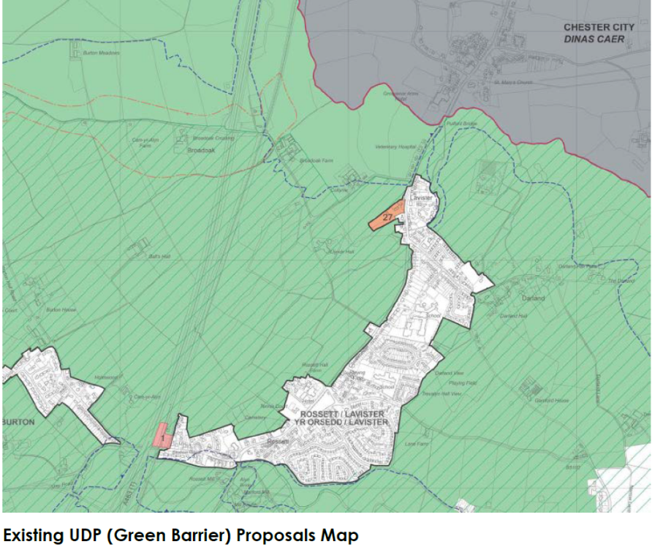
Gamford House

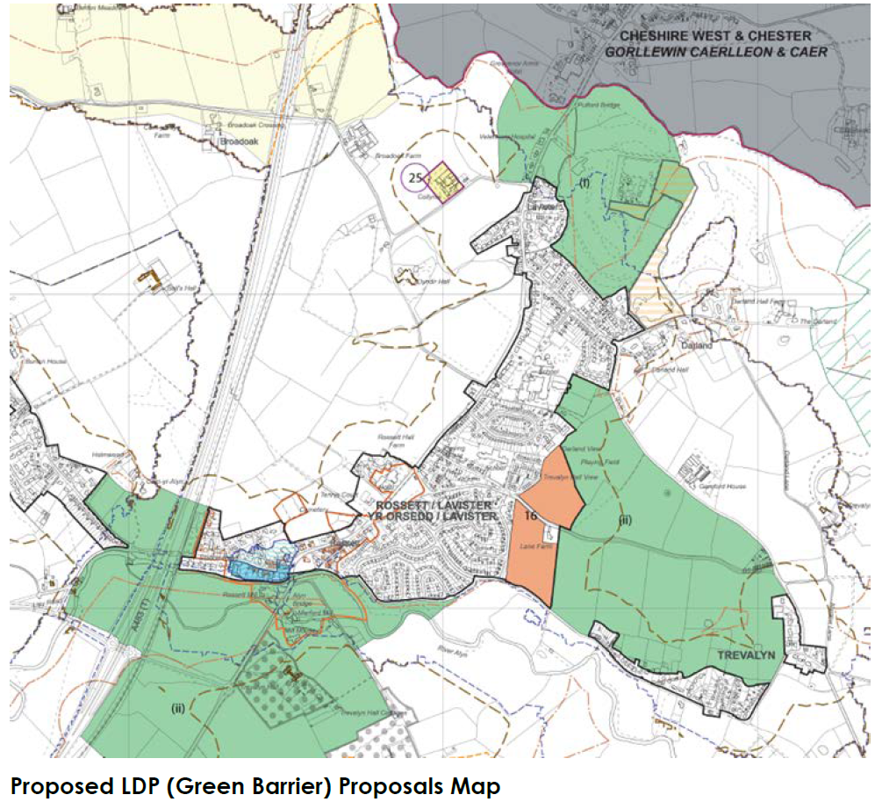
Gamford House
Fig.6
11.15 In addition, the Deposit Stage has also involved consideration of the UDP landscape policy designation of Special Landscape Areas. Evidence base has been prepared on behalf of the Authority by TACP and an SLA Study undertaken in January 2017 (LDP evidence doc. Ref. EBNB03) which finds that land ought to be released from this designation in compliance with PPW guidance and the assessment undertaken.
11.16 The County Borough has followed this advice and dramatically reduced the area of SLA, which again concurs with the Landscape & Visual Impact Assessment we have undertaken, as shown on the plans below:

Fig.7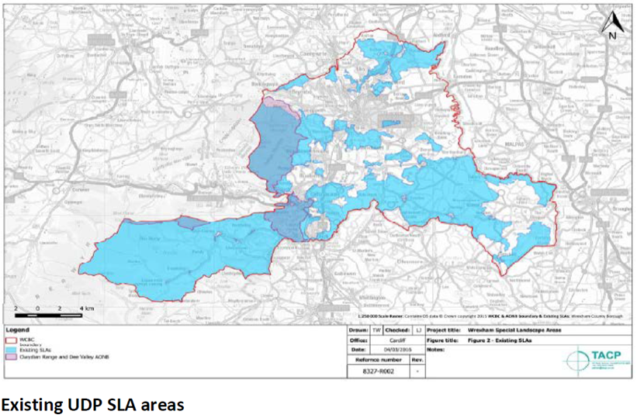Fig.8
Gamford House
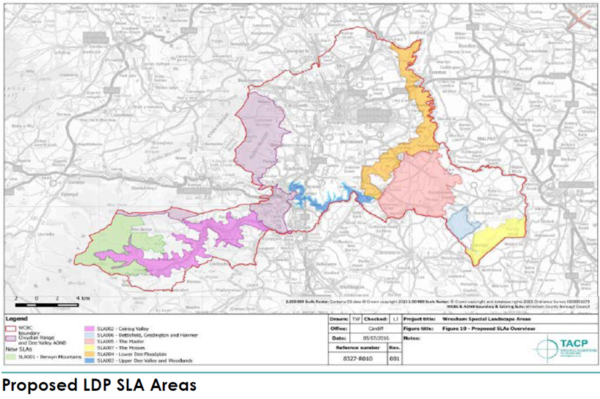
Gamford House

12. Policy Framework
12.1 Policy H5 is applicable generally, but also specifically to a new build dwelling identified on the submitted plans as plot 3. Policy H10 is applicable to the proposals to demolish the existing farmhouse and erect 2 detached properties – identified as plots 1 and 2. Policy H3 is applicable to existing buildings that are subject to proposals for conversion, identified as plots 4, 5, 6, 7 and 8. In addition to the above proposals, a number of other buildings will be demolished with the resulting space used to provide the curtilages to individual plots, along with parking. New garage buildings will also be erected. These aspects have been addressed to ensure compliance with policies GDP1, EC1 and EC5.
13. National Policy Framework
PLANNING POLICY WALES (2018) EDITION 10
13.1 Planning Policy Wales (PPW10) sets the context for sustainable land use planning policy in Wales, within which local planning authorities’ statutory Unitary Development Plans and Local Development Plans are prepared and development control decisions on individual applications and appeals are taken.
13.2 PPW10 para 1.2 states; ‘The primary objective of PPW is to ensure that the planning system contributes towards the delivery of sustainable development and improves the social, economic, environmental and cultural well-being of Wales, as required by the Planning (Wales) Act 2015, the Well-being of Future Generations (Wales) Act 2015.’ It follows that, in line with the presumption in favour of sustainable development (para 1.17), applications for planning permission should be determined in accordance with the approved or adopted development plan for the area, unless material considerations indicate otherwise. These include current circumstances, policies in an emerging development plan and planning policies of the Welsh Government. All applications should be considered in relation to up-to-date policies.
13.3 The application is considered to be in accordance with the adopted development plan for the area, with further material considerations to support this view.
Chapter 4 – Planning for Sustainability
Paragraph 2.12 states: “Planning should seek to maximise delivery of outcomes against all aspects of well-being/sustainable development, thus seeking to maximise contributions towards all of the goals of the Well-being of Future Generations Act. This can be achieved by adopting a place making approach.”
13.4 Five Key sustainable development principles are established, including; Making best use of resources, and Creating & sustaining communities. The proposal minimises land take by utilising previously developed buildings, avoiding development on Greenfield sites. The development minimises carbon emissions by utilising existing buildings, with energy already locked into the construction.
13.5 The site is not located within the centre of Rossett but can be reached by methods other than private car. Cycling is a viable option and there are public transport links within Rossett in the form of a bus service (Arriva 1).
13.6 The development will respect the character of the surrounding area in utilising existing buildings and retaining their traditional character and form, with sensitive alterations where necessary. 5.14 13.7 The proposals are considered sustainable and enjoy the benefit of the presumption in favour of sustainable development embodied in PPW10. The contribution of the proposals to remedying the deficiency in the supply of market housing is a benefit which is entitled to considerable weight. Environmental benefits are achieved in the form of an improvement in the character and appearance of the area, the redevelopment of a site which makes no positive contribution at present.
13.8 PPW10 is clearly in support of a proposal such as this. It introduces a “presumption in favour of sustainable development”, where developments enhance the economic, social and environmental well-being of people and communities now and over the long term and that weight is given to national policy in determining individual applications where policy in adopted or approved development plans is outdated or superseded (para 1.17).
13.9 The most relevant TAN’s (and MTAN’s) that are considered to be material for the Appeal proposals comprise the following:
• TAN1 : Joint Housing Land Availability Studies (2015)
• TAN2 : Planning & Affordable Housing (2006)
• TAN5 : Nature Conservation & Planning (2009)
• TAN6 : Planning for Sustainable Rural Communities (2010)
• TAN12 : Design (2016)
• TAN15 : Development & Floodrisk (2004)
• TAN18 : Transport (2007)
• TAN22 : Sustainable Buildings (2010)
• TAN23 : Economic Development (2014)

13.10 As a general comment we consider that the proposals at Gamford House comply with them all:
TAN1 requires that every Authority must publish on an annual basis and it identifies what housing land supply they consider is present. The Council released its last Joint Housing Land Availability Study (JHLAS 2014) in March 2015. PPW (Para 9.2.3) states that it is a requirement of all Authorities to provide a 5 year housing land supply.
The LDP2 Delivery Agreement date is continuing to slip into the future. This places the authority in a position where it must seek to halt the growing shortfall in housing land supply. TAN2 Para 10.12 recognises that it is important that there is adequate housing provision in rural areas to meet the needs of local people and to contribute to the delivery of sustainable communities.
TAN5 Protected species and habitats have been assessed and examined; with an extended Phase 1 Ecological Assessment undertaken. New areas of biodiversity are proposed and a ‘dark corridor’ and buffer is identified along the northern/eastern perimeter of the site for bats.
TAN6 Although mainly dealing with agricultural related development this TAN does seek to support development that will serve to enhance the future sustainability of rural communities through new residential opportunities. Para 3.1.2 of TAN6 states that: Planning authorities should support the diversification of the rural economy as a way to provide local employment opportunities, increase local economic prosperity and minimise the need to travel for employment. New housing is an important vehicle for the growth of the rural economy.
TAN12 Para 2.5 states: Good design is not inevitable. It requires a collaborative, creative, inclusive, process of problem solving and innovation – embracing sustainability, architecture, place making, public realm, landscape, and infrastructure. The design solution, as described in the Design and Access Statement, demonstrates that TAN12 has been followed and has taken a sensitive and sympathetic approach in response to the local natural and built environment assets. Simply converting these buildings severely compromises good design. However, the proposed modifications and extensions required to meet standards of residential amenity are modest. Dwellings are retained on the existing building footprint set out with reasonable separation between the built forms whilst providing adequate interface distances to deliver positive impact on the site.
TAN 15 – Development and Flood Risk (2004). TAN15 contains a development advice map (DAM); based on Environment Agency and British Geological Survey mapping. The DAM shows three development advice zones, A, B, C. Zones A and B are areas of generally low risk (i.e. outside the main river flood plain). Zone C represents the extreme flood outline, and is further subdivided into two zones. The site lies within Flood Zone B of the DAM map. It is considered that surface water storage should not be required in this instance given the significant betterment which will already be provided over the existing situation in relation to runoff rates and volumes.
TAN18 Pre application advice considered that a full Transport Assessment would not be necessary for the modest scale of this development. Highway impacts were considered under the approved application P/2016/0384. We believe this shows that the site is located in a highly sustainable location and accessible.
TAN22 The standard Code will be met and building Regulations will serve to ensure buildings meet current standards of sustainability.
TAN23 This is of significant material weight given that PPW defines economic development broadly so that it can include any form of development that generates wealth, jobs and income (including residential). It follows therefore, that the economic impact of these proposals must be given serious weight; the nature and extent of the benefits are provided in the summary to this section. Para 1.15 recognises that economic land uses include construction and house building. PPW references on a number of occasions the need to align housing and jobs and the delivery of meeting affordable housing need in a sustainable travel to work area.
13.11 The most relevant and pertinent Paragraphs in TAN23 comprise the following:
Para 1.2.1 As a consequence it is essential that the planning system recognises, and gives due weight to, the economic benefits associated with new development. Key factors in determining the weight and benefits of supporting schemes will be to ask the questions of what viable alternative uses exist for Gamford House, how many jobs will be directly provided and what other special merit might exist. This scheme will deliver and generate many construction and supply chain jobs and the new housing will serve to support enhanced local services and facilities once occupied.
5.29 TAN23 discusses supporting strong rural economies; recognising that sustainable development is essential to building strong and vibrant rural economic communities; and it is important in aligning existing and future homes and jobs.

14. Local Planning Framework
Emerging LDP2
14.1 The LDP as submitted in 2012 was withdrawn for reasons that must carry significant weight in the assessment of the current application. The Planning Inspector’s Report highlighted fundamental concerns:
• A significant shortfall in the supply of housing which, if it were to be addressed, would undermine the strategy of the Plan of confining general housing to within settlement boundaries.
• A failure in the Plan to respond to its own evidence base.
• An incoherent use of evidence e.g. short and long term trends used inconsistently to justify low housing figures.
• The overall level of growth proposed by the Plan may lack sufficient ambition in terms of strengthening Wrexham’s role as a key hub as envisaged in The Wales Spatial Plan 2008 Update, (reiterated in the North Wales Regeneration Plan 2018-2035).
• Some policies lack effect, are unduly onerous, pull in the opposite direction to their intended objectives, and contain drafting errors.
• A lack of flexibility in the Plan, in particular overly rigid policies.
• The approach to green wedges does not have adequate regard to national policy.
• Concern that the envisaged scale of growth in the employment sector may be hampered by the limited pool of suitably skilled workforce that would be likely to result from the Plan’s more restrictive approach to housing growth.
• Concern that the proposed imbalance between the scale of employment and housing growth may lead to employees commuting into the County to work, thus limiting the economic benefits to the area and increasing car borne journeys.
• Although part of County has recently been designated as an Area of Outstanding Natural Beauty, it was accepted at the hearing that there was no reason to believe that the character of the County was such that it could not accommodate any expansion of settlements.
• Evidence from the house building industry raises concerns that many of the allocated sites will not come forward in the short term because of the particular challenges in developing brownfield sites in a difficult economic climate when lenders are risk averse in the face of potential unidentified abnormal costs. The evidence provided in the Entec Urban Potential Study (page 53) also indicates that for viability reasons a brownfield strategy would not provide a reliable source of supply.
14.2 Any local planning policy assessment must consider the “Wrexham Unitary Development Plan”, which was adopted in February 2005 and whose plan policies are currently being used for Development Control purposes. The plan period ran from 1996 to 2011.
14.3 Wrexham County Borough Council is pursuing the replacement of the UDP with the Local Development Plan (LDP) which will cover the plan period 2013 to 2028, but the plan has not been through Examination and been adopted and, until it has been, Planning Policy Wales (edition 10) para 2.14 must apply. At the time of writing the LDP2 has reached the Submission Plan stage with a full suite of evidence base and draft policies and allocations, and as such, we consider that significant weight must apply, despite it not having been subject of a binding Inspectors Report. We consider that the proposals for Gamford House meet the following Objectives:
14.4 Relevant LDP2 Objectives
Objective 1: Meet the future needs of a growing population by providing the right type, mix, quality and amount of development and infrastructure in sustainable and accessible locations, ensuring that the role of Wrexham as a key settlement of national importance in the Wales Spatial Plan Wrexham – Deeside – Chester hub is strengthened;
Objective 2: Foster mixed communities by delivering housing, including affordable homes to meet the needs of the County Borough, ensuring a range of dwelling types, sizes and tenure through the identification of deliverable housing land allocations with supporting social, environmental and physical infrastructure;
Objective 6: Promote and encourage a healthy, active and safe lifestyle that improves wellbeing through increasing accessibility to services and facilities by locating development in sustainable locations, protecting our green spaces for people and wildlife and designing safe, secure and walkable communities;
Objective 9: Reduce the need to travel by car by locating new development in the most sustainable locations, within accessible distances by foot, bicycle, bus and rail to jobs, schools, community, leisure and health facilities, homes and shops, as well as seeking to alleviate known highway infrastructure capacity constraints on the road network within the County Borough.
14.5 This site will contribute to this housing delivery requirement and importantly will also seek to address the delivery of large executive homes that are not viable at alternative sites. The challenge that Rossett faces with just a single allocation is that it has very few opportunities for anything other than minor infill as no larger brownfield sites exist.
14.6 We consider that the application site outperforms all other alternative sites that have been promoted or identified in the Local Plan and by other speculative submissions. The application site performs on all levels, is free from constraint, is deliverable and ought to be encouraged.
14.7 In the meantime, the approach should be to identify the provisions of the (existing and emerging) development plan and determine if this application is in accordance or in conflict. If in compliance the starting point will be to approve our proposals by granting planning permission as the decision is in accordance with the plan.
14.8 It is therefore essential to consider Policy H3 and Policy H5 of the UDP, but we have also assessed and tested the proposals against all relevant local and national policies and consider those listed below to be the most relevant and appropriate in this instance.
PS1 Broad Location of Development: The UDP requires that development should be directed towards defined settlement boundaries. Such settlement limits are out of date and can only command significantly reduced weight. Correspondingly, the requirement of this policy that development be confined to settlement limits is also subject to the same diminished weight.
PS2 Development should not materially or detrimentally affect countryside, landscape character, open space or the quality of the natural environment. The existing settlement pattern includes the Village, ribbon development along the radial routes and well established clusters. The Gamford House site has been developed since the 19th century, and the contribution that such sites make to the character of the landscape is examined in more detail in the Landscape and Visual Impact Assessment. Our design, landscape, trees and ecology evidence demonstrates that the proposals will not harm such interests by virtue of the site’s enclosed and contained character and the retention of hedgerow and ecological habitats.
PS3 Development should preferably use previously developed land wherever possible. The previous use of the Gamford House was as commercial premises for the storage and repair of distribution wagons. Substantive evidence of this use was offered to Wrexham CBC but declined by the Case Officer, leading to an erroneous Committee Report where the site was referred to as ‘greenfield’.
PS4 Development should maintain the existing settlement pattern and character and be integrated with the existing transport network. The existing settlement pattern includes the well-established clusters that surround Rossett and Gamford House lies closest to the Village within comfortable walking and cycling distance.
PS8 Transport. The site is located within walking distance of many of the amenities and services that the Tier 3 settlement of Rossett has to offer. Junction 7 of the A483, 1.5 miles from the site provides excellent access to the regional road network. Chester Road passes through Rossett 450m west of the site.
Policy GDP1– Development Objectives, addresses Wrexham CBC’s general development principles and states that all new development should satisfy a set of criteria. It is an extensive list which includes matters of location, layout, design and appearance.
The proposed development particularly complies with criterion a) of the policy: All new development should ensure that built development in its scale, design and layout, and in its use of materials and landscaping, accords with the character of the site and makes positive contribution to the appearance of the nearby locality.
14.9 The scheme design accords with the character of the countryside and will make a positive contribution to the character of the landscape in removing buildings in a poor state of repair, unattractive hardstanding and the general detritus of a former commercial site. The detailed response to Design issues is provided in the attached ‘Design Principles’ document. The approved scheme has not been implemented due to its unviability having zero profit margin, contributed being undesirable for the following reasons:
- Does not offer full potential of utilising a brownfield site
- Uninspirational low quality design
- Semi-detached low-mid range value housing
- Lack of privacy
- Shared open garden amenity
- Shared parking arrangements
- Garden allotments
- Apartment complex opposed to private housing
- Difficult to sell for required price
- Expensive build and conversion costs
- Does not actively contribute to property market chain
With regard to criterion d) of the policy, safe and convenient pedestrian and vehicular access to and from the site was approved under the application P/2016/0384, and has not changed.
14.10 The following general UDP policies also apply to these proposals:
GDP2 Capacity of Infrastructure and Community Facilities: Due to its modest scale the proposal would not result in any local infrastructure or community facilities becoming deficient as a result of this development being implemented.
EC1 Green Barriers: The emerging LDP2 and its evidence base has reviewed the extent of the Green Barrier and found it should be ‘rolled back’. This designation will no longer apply to the site under the Local Development Plan. Within Green Barriers, Policy EC1 of the UDP only allows development if it is for “agriculture, forestry, essential facilities for outdoor sport and recreation, cemeteries and other uses of land which maintain the openness of the Green Barrier and do not conflict with the purpose of including land within it”.
EC2 Agricultural Land: The site does not have an agricultural use, but is Brownfield.
EC4 Hedgerows: Trees and Woodland. The scheme has been designed to ensure that any loss of these features is minimal; in particular those already providing a landscape buffer to Gamford Lane.
EC5 Special Landscape Area: The development will be constructed to a high standard of design as outlined in the Design and Access Statement. The presence of a built form and any impact it may have upon the Special Landscape Area has already been established through the existing barns and commercial buildings. However the demolition proposed will enhance the Special Landscape Area. The emerging LDP2 and its evidence base has reviewed the extent of the Special Landscape Barrier and found it should be ‘rolled back’. As discussed above this designation will no longer apply to the site under the Local Development Plan.
EC6 Biodiversity Conservation: In support of this application a report has been commissioned from Tyrer Ecological Consultants. Their Report forms part of the submission package and should be read in conjunction with this Statement.
EC12 Development and Flood Risk: The site lies within Environment Agency Flood Risk Zone B, with minimal risk of flooding.
EC13 Surface Water Flooding: The site is currently predominantly concrete hardstanding covering an area of 2,460m² but the proposals will reduce this area and create extensive permeable areas in rear gardens and structural landscaping, thus reducing run-off and the risk of off-site flooding.
EC15 – Small Scale Neglected Sites: This policy aims to enhance amenity through the restoration of sites and dilapidated buildings, particularly those in sensitive locations.
H1 Housing Allocations: The lack of a sufficient supply is a significant material consideration that must be afforded considerable weight in the determination of this application.
H3 – Conversion of Buildings Outside Settlement Limits: For those buildings capable of conversion at Plots 3, 4, 5, and 8 the proposals have been designed to address all of the requirements of this Policy. 14.11 Guidance Note 13 outlines the various categories of housing that are considered acceptable in the countryside. Among these is the conversion of rural buildings, which are no longer suitable for their original purpose. The viable conversion of buildings at Gamford House demands that extensive rebuilding is required to achieve residential amenity and the desired rural character of this cluster development.
14.12 The issue of whether the works required are tantamount to the erection of a new build in the countryside should not be afforded significant weight in the context of the site being brownfield, the County Borough not having a 5 year housing supply and the goal of making a positive contribution to the character of the landscape.
14.13 In accordance with paragraph 6.10 of the UDP the proposals reflect the local vernacular and alternative non-residential uses are considered inappropriate. Residential is the only viable use as the site access is unsuitable for a commercial traffic.
H5 – Housing in the Countryside: provides that: Outside defined settlement limits new dwellings will only be permitted where:-
a) proposals accord with Policies H3, H4, and H8; or
b) proposals comprise infilling subject to Policy GDP1; or
c) an essential need to house a full time agricultural or forestry key worker can be established.
14.14 Where existing buildings at Gamford House require modest rebuilding or alteration then they will be considered as infilling to contribute to the integrity of a scheme that creates a rural character. The proposals at Gamford House comply with Policy GDP1, and therefore with Policy H5(b) above. Although the requirements of Policy H5 are important at this location it should be remembered that Gamford House is a Brownfield site.
14.15 In compliance with UDP Policy H5 the impact upon the openness of the countryside has been mitigated, as evidenced in a detailed Landscape and Visual Impact Assessment, and by ensuring that scale and mass of the proposals equates to that of existing buildings.
14.16 As detailed in our response to policy PS1 Broad Location of Development, settlement limits are out of date and can be given only significantly reduced weight. Correspondingly, the presumption against development in the countryside in policy H5 is also subject to the same diminished weight.
H7 Affordable Housing: The proposal for 8no. Dwellings means that this site falls below the threshold for an Affordable Housing requirement.
CLF5 Open Space Requirements from New Residential Developments: The proposal for 8no. Dwellings means that this site falls below the threshold for the Provision of Open Space requirement to apply.
T8 Parking: In conformity with SPG16 adequate parking provision is proposed to satisfy standards. For C3 residential use, the parking standards are:
3 / 4 bedrooms – 3 spaces (including garaged parking)

T9 Walking, Cycling and Horse Riding: As the site is not classed as a major development there is no requirement to make provision for these activities but the location lends itself to the pursuit of these with access to both the village and the open countryside.
Local Planning Guidance Note 3 – Converting Rural Buildings
14.17 This guidance note explains the approach of Wrexham Council with regards to the change of use or conversion of rural buildings and expands upon policies GDP1, H3, E5 and CLF9 from the Wrexham Unitary Development Plan. The note states that there are some buildings which are unsuitable for conversion, including those which are:
- structurally unsound;
- roofless, missing substantial sections of wall, or so ruined that only vestiges remain of the original structure;
- of temporary construction;
- eyesores which should be removed in the interests of landscape conservation;
- unsuitable in terms of size and form of construction;
- at risk of flooding
14.18 Those former agricultural and commercial buildings which are proposed to be retained and converted at Gamford House do not fall into any of the above categories.
In addition, guidance states that planning permission would not normally be granted if:
‘There is insufficient floor area in the existing building to provide acceptable standards of accommodation (in the case of conversions to dwellings, this should be a minimum of 40m2);
The proposals involve rebuilding more than 10% of the walls if the roof structure needs to be rebuilt; or 20% of the walls if the roof structure is to be retained.’
14.19 LPG 3 requires that, in terms of development principles, it is essential that converted buildings should keep their original character and not have the appearance of being fundamentally new structures. ‘The aim should therefore be to retain such key features. Where the building has no original or traditional features of merit, the Council will expect the design of a conversion to reflect the vernacular character and appearance of other buildings in the locality.’ The design process has considered the character of rural properties in the locality and incorporated materials, fenestration details and roof designs that are in keeping with the local vernacular.
14.20 Part 2 of the Guidance Note relates specifically to the conversion of agricultural buildings to dwellings. Several material considerations are set out for when it is proposed to convert an agricultural building to a dwelling: General Location, Local Road Network, Site Access, and External Appearance.
14.21 Local Planning Guidance Note 13 – Housing in the Countryside
Guidance Note 13 outlines the various categories of housing that are considered acceptable in the countryside. Amongst these (part b) is the conversion of rural buildings, which are no longer suitable for their original purpose.
Provided the building is structurally sound and capable of conversion without extensive rebuilding tantamount to the erection of a new building, it is recognised that conversion to other use(s) such as residential, employment, community or visitor accommodation, can safeguard the building's future.
14.22 Supplementary Planning Guidance
There are some relevant approved/adopted non-statutory supplementary planning guidance documents that exist which have been considered in preparing this proposal; these comprise the following:
• SPG6 – Access to and use of Buildings
• SPG7 – Landscape and Development
• SPG10 – Public Open Space on New Housing Development
• SPG15 – Cycling
• SPG16 – Parking Standards
• SPG17 – Trees & Development
• SPG21 – Space Around Dwellings
• SPG24 – Designing Out Crime
• SPG27 – Developer Contributions to Schools
• SPG28 – Affordable Housing
• SPG30 – Design Guide for Developers & Architects when Designing Residential Development
• SPG31 – The Welsh Language & Welsh Communities
• SPG32 – Biodiversity & Development

SCHEME SPECIFIC ECONOMIC BENEFITS
14.23 In addition to the linkages made in TAN6 and TAN23 paragraph 2.21 of Planning Policy Wales, edition 10, makes the link between social, economic and environmental goals. The proposals for high quality executive style homes at Gamford House have relevance for the economic regeneration aspirations of the County Borough and fit well with the economic objectives of National Policy. EBE01 Employment Land Review 2015 states importance of the planning system supporting economic growth, and ensuring that there is sufficient land that is suitable for economic uses:
- Local planning authorities should facilitate the provision of sufficient land to meet market demand, except where there are good reasons to the contrary. In addition, local planning authorities should steer economic development to the most appropriate locations by:
- Coordinating development with infrastructure provision
- Supporting national, regional and local economic policies/strategies
- Aligning jobs and services with housing (where possible) to reduce the need for travel, especially by car
- Promoting brownfield, vacant and underused land
- Delivering physical regeneration and employment opportunities to disadvantaged communities
Para 2.29 An example of a development of ‘special merit’ could be a greenfield development that could attract high-value, high-skill businesses that would not be interested in a lower-quality urban environment.
Para 2.30 In rural areas, development may be acceptable in countryside locations if it makes communities more sustainable (encouraging people to work close to home), meets the expansion needs of an existing local business or an existing business cluster.
14.24 Planning Policy Wales (PPW) (Edition 10 December 2018) provides detailed strategic guidance on planning policy and sets out land use policy, which is supplemented by the Technical Advice Notes (TAN’s) and by draft Ministerial Interim Planning Policy Statements (MIPPS).
14.25 Chapter 5 of PPW10 is of particular importance as it deals with Economic Development; it is the context for what TAN 23 explores in more detail. The Productive and Enterprising theme covers the economic components of placemaking. Local planning authorities are required to ensure that the economic benefits associated with a proposed development are understood and that these are given equal consideration with social and environmental issues in the decision-making process, and should recognise that there will be occasions when the economic benefits will outweigh social and environmental considerations.
14.26 The Economic Prosperity Strategy 2012-2016 identifies four main priorities towards achieving economic prosperity within Wrexham: Investment, Employment, Wealth and Quality of life. Our proposals aim to achieve all of these objectives. Housing is a key sector of economic activity both in its own terms, for instance, construction work as well as design, maintenance, architecture, and sales. Affordable, attractive and integrated housing creates places where people want to live and businesses want to invest.
14.27 Wrexham is identified in the Wales Spatial Plan as a key hub which ought to be strengthened as a focus for investment in, among other sectors, housing. There is concern that the restrictive approach of the Plan to housing in particular fails to have regard to the Wales Spatial Plan. It is vital that economic development supports a healthy housing market and vice versa and the Local Housing Strategy is aligned to and will support the Economic Prosperity Strategy. Restricting housing growth would limit the number of workers available in the local pool of labour making it more difficult to attract investment from potential employers. (Planning Inspector’s comments at the LDP Inquiry 2016).
14.28 The proposals would bring the following specific economic benefits:
● The total project contract value for this project is in the region of £2M and this will help to secure existing construction jobs based locally and create new ones.
● The creation of employment for skilled trades in the locality will help maintain employment and provide and contribute towards the ongoing economic investment.
● It is estimated that the development would need a constant 10 direct operative jobs a day to sustain a 2-year construction programme with another 40 supply chain jobs indirectly supported.
● Significant local spend and economic output during the construction period of the development will represent a big boost to existing businesses.
● Post-completion, the spending power of another 8 households into the local economy can also be expected to be significant; not only in first occupation expenditure but ongoing local expenditure in sustaining local services and facilities beyond just the construction cycle
● The completed development will also generate Council Tax revenue for the Authority and with an average £3,262 bill per Band I household this will generate up to £26,000 per annum in supporting and enhancing existing public services.
● With a local Community Council precept seeing new income being devoted to local initiatives to address any local expenditure needs at grass roots.
● This proposal seeks to attract the leaders of industry to the County Borough, bringing economic growth and prosperity into the local economy.
• The proposed development would generate employment opportunities in construction and in other sectors linked to the construction market. There would also be ongoing maintenance costs and services required by the occupants which would supplement the local economy;
• The proposal would support social infrastructure, providing a contribution towards education facilities.
- Developer contributions to local schools.
Local Planning Guidance Note No. 27 - Developer Contributions to Schools is one of a series of notes deriving from policy GDP2 in the Wrexham Unitary Development Plan and identifies the circumstances and locations in which developer contributions to the provision of education facilities, such as additional classrooms, will be necessary. It is understood that any developer contribution will be based on the following considerations:
14.29 It will apply to proposed developments of four or more residential units, whether by new build, conversion or changes of use. It will only apply to schools deemed to have a shortage of places taking into account other residential developments within the area and after addition of the extra pupils likely to be generated by the proposed development.
14.30 If the potential pupils generated by the proposed development cannot be accommodated within existing schools then it is understood that a commuted payment will be calculated by multiplying the additional places required by the pupil cost figure (in accordance with Table 1 of the guidance note) to produce the commuted sum to be included in the planning obligation. We would be keen to learn of the Council’s current position in regards to the school capacity and associated need in order to seek compliance with these requirements within the final Section 106 Agreement.
SCHEME SPECIFIC SOCIAL BENEFITS
14.31 PPW10 para 4.2.1 states, ‘New housing development in both urban and rural areas should incorporate a mix of market and affordable house types, tenures and sizes to cater for the range of identified housing needs and contribute to the development of sustainable and cohesive communities.’ This need to broaden the housing offer was confirmed in the Local Housing Market Update 2017, where stakeholders provided their views on the potential/actual market weaknesses in Wrexham (see extracts in Appendix A below). These included:
- A lack of housing stock (supply) and suitable land for new development;
- More diversity and choice required, especially to enable households to trade up;
- Stagnant house prices in affecting smaller and terraced homes with the price of semidetached 3 bedroom and 4 bedroom homes in rising due to lack of supply;
- Imbalanced housing stock – lower proportion of detached properties;
- Low levels of greenfield sites coming forward for development;
- Little/low confidence in the local economy to encourage further house building.

14.32 The Local Housing Market Update Report (2017) outlines the scale of future strategic challenges which include the ongoing delivery of new market and affordable housing to address need and support economic growth. The proposals address these challenges in the following way;
● as an “exclusive executive” housing scheme the proposal creates a range of 8no. 4 bed detached dwellings,
● this new housing will offer the opportunity to secure the future of the Primary and Secondary schools. New housing brings families, retains families; thus providing future community sustainability.
● it will provide for access for all sectors of the community, particularly those with mobility difficulties; the design incorporates DDA compliant grade access into the buildings and across the site.
● the development is accessible by foot/cycling to local amenities and facilities, and taking advantage of public transport interfaces (bus routes); thus promoting sustainable travel choices and reducing the need to travel using private modes of transport.
● the development of the site meets Highway safety needs and will provide for sufficient off-street parking spaces, turning and access for all refuse, emergency and delivery vehicles.
- the proposals will replace a derelict site that is deflating local property values and attracting crime and anti-social behaviour.

Public Rights of Way: There is no Public Right of Way (PRoW) crossing through the site.
Designing Out Crime:
14.33 Local Planning Guidance Note No. 24 - Designing Out Crime amplifies development plan policies which acknowledge that the design of the physical environment can positively influence human behaviour. Attractive, imaginative, and feasible design can help reduce crime, the fear of crime, and anti-social behaviour, thereby achieving a safer and higher quality environment, and an improvement in residents' quality of life. The note is a material consideration in the determination of all relevant planning applications including this submission. The Design and Access Statement outlines how this design has been prepared taking into account of this guidance note.
14.34 During the design process, design measures such as layout, appearance and landscaping have been carefully assessed to help to prevent crime. The following safety measures have been implemented as part of the design process:-
- Security through natural surveillance: overlooking of car parking areas from habitable room windows
- A sense of ownership through clearly defined boundaries between private and public areas
- Adequate street lighting for all areas including car parking
- External environment to be designed to avoid inadvertent creation of opportunities for crime through, for example, providing hiding places. The positioning and choice of planting in a way to minimize the potential for such problems
- In its current state the site is attracting crime and anti-social behaviour

Residential Amenity of Future Residents:
14.35 The proposals as approved under P/2016/0384, by virtue of an attempt to convert existing commercial buildings, has significantly compromised residential amenity to the extent that the proposals do not meet standards aspired to in both the UDP and LDP2. Such constraints imposed by conversion limits has resulted in a scheme that fails to achieve a rural character, but rather reinforces the commercial alignment of buildings.
14.36 The impact that the current proposal would have in improving this residential amenity is an important consideration of this planning application. Residential amenity includes noise, odour, vibration through construction, and overshadowing and overlooking from the dwellings once built. Local Planning Guidance Note No. 21 - Space around Dwellings amplifies policies in development plans on residential amenity.
Highway Safety:
14.37 On the basis of pre-application advice the application is submitted without an accompanying Highways Impact Assessment, as the necessary improvements required to facilitate the proposed development were considered under the approved scheme P/2016/0384. However, we have regarded it a duty to improve highway safety wherever possible and for this reason have improved the access to Plot 1.
14.38 Parking would be provided in accordance with the Council’s guidance note (requirement for 3 parking spaces) and parked vehicles should not project into, and interfere with the use of the road or pavement to ensure that the scheme does not prejudice highway safety. To achieve this, all new driveways would measure at least 5.5m in length. There will be sufficient turning space for delivery and waste collection vehicles.
SCHEME SPECIFIC ENVIRONMENTAL BENEFITS
- The site will benefit from a holistic approach with a sympathetic and sensitive design taking account of the neighbouring rural and urban grain and its landscape setting and character.
- It will deliver a development in a way that reflects the existing urban grain of the settlement and at density that is appropriate and delivers “place-making” in accordance with PPW10.
- The design has taken account of and respects its landscape setting, ecological habitat and hedgerow infrastructure and sought to integrate these features. Maximum retention, mitigation and enhancement of existing landscape features is enabled through new reinforced planting, buffer, dark corridor and biodiversity opportunities and will safeguard the open countryside.
- The proposed layout and detail of the scheme in design terms offers the highest quality design solution that could be expected for this site and the applicant has invested heavily in this to get it right and it will serve to significantly enhance the design quality of the area, benefiting the special character and appearance of the site in its rural / urban fringe setting.
- The properties would be built to modern building regulations requirements and therefore provide excellent thermal performance through insulation and heating systems, helping to ensure the proposal is contributing towards carbon savings and the move to a low carbon economy.

Conditions and Unilateral Undertaking

14.39 The applicant is willing to make a contribution to local schools provision, to be secured under Condition, and this is detailed in the Planning Statement which formed part of the planning application.

15. SUMMARY PLANNING BENEFITS
15.1 The development proposals generate significant and mutually supportive economic, social and environmental benefits and gains which collectively constitute sustainable development in line with PPW10, and must not be underestimated.
15.2 We consider these scheme deliverables should be afforded full weight as material planning considerations and as part of the case for very special circumstances. They are significant enough to justify and demonstrate that the proposals are acceptable and would serve to outweigh any perceived or apparent or harm that this proposal could be considered to have upon the locality, its open countryside and Green Barrier designation. This proposal has also demonstrated that it is in full accordance and wholly compliant with all national and local planning policy and associated best practice guidance governing development proposals. We submit that considerable and significant weight should be afforded to the Policy documents referred to as material considerations in support of the proposals.
15.3 This application is technically robust and it has been demonstrated that there are few, if any, negative impacts that would result. The overall planning balance is weighted strongly in favour of granting permission as per Section 38(6) of the Planning & Compulsory Purchase Act 2004. The proposals must be supported and permission approved without any delay in accordance with the emerging LDP2 because we have demonstrated that no adverse impacts are evident in impeding such a positive determination being reached and any impacts which might be judged to occur would have to significantly and demonstrably outweigh the benefits when assessed against policies of the Development Plan taken as a whole.
15.4 This statement has assessed the suitability of the application site for the proposed development and having concluded that the proposal is inherently compliant with Local and National policy it is our opinion that this Appeal must be upheld.
15.5 We have then sought to consider whether there are any other material considerations that might balance out any reason for approval and actually outweigh its compliance with policy to such an extent, so as to make the proposal unacceptable. Our conclusion is that there is nothing to prejudice a positive determination and indeed we are strongly of the opinion that this proposal should be granted.
15.6 There is a presumption against developing Green Barrier (open countryside) for residential use unless very special circumstances can be demonstrated. We consider that we have presented a strong justification for the Gamford House site to be developed for the purposes proposed by this application, which is supported by national planning policy guidance.
15.7 With regard to ‘very special circumstances’, the Council has recognised for some time that it will have to release land outside the UDP’s settlement limits if it is to meet its emerging requirement. The Vision, Objectives and Strategic Growth and Spatial Options document of the Local Development Plan which was consulted on in March-April 2015, states in paragraph 5.15 that, ‘the urban capacity study (2013) identifies a shortage of suitable, available and deliverable brownfield sites within the existing settlement limits. Whilst some of these brownfield sites may be developed as windfall sites over the plan period, the quantum of new development required cannot be met without considering the need for the release of green field land currently on the edge of, but outside the existing settlement limits.’ The fact that current settlement limits will have to be breached to meet housing requirements is therefore apparent.
15.8 This matter was expressed strongly in the officer’s report in respect of proposed housing development at Gresford Road, Llay: ‘It will not be possible to significantly increase the supply of land available for housing unless planning permission is granted to develop appropriate sites located outside of existing settlement limits. Indeed, the decreasing housing land supply in recent years suggests that the current UDP settlement boundaries are becoming a significant constraint to providing the land that is needed to meet the housing requirements of the County Borough.’ The weight afforded to the absence of a 5 year housing supply at Wrexham County Borough was regarded to be considerable by both the Housing Minister, Julie James, and the Planning Inspector for the recent Tan y Bont Appeal Decision. This ruling is a very significant response to the existence of very special circumstances and was made on 10th June 2019 under Appeal reference APP/HY955/A/17/3182282.
15.9 We therefore feel that the proposals suitably reflect the advice and guidance provided. Having assessed the relevant national planning policy guidance, it is our contention that the proposed development is supported, fully compliant, is endorsed by local and national planning policy, and this Appeal should be upheld.
15.10 We believe this Statement, together with the accompanying and supporting documentation and associated plans demonstrate this and satisfactorily illustrate all the points that need to be considered. Our case, in demonstrating that this development proposal meets the exceptional circumstances test as set out in PPW10, is based on the following:
- The Authority cannot present any case for a 5 year housing land supply;
- The site is brownfield land, previously with a commercial use
- The approved scheme presents a missed opportunity to deliver on a range of policy objectives
- That TAN1 is of significant material weight
- That there are no acceptable or deliverable alternative uses and indeed we have shown this site outperforms all other possible alternative sites, including the approved conversion scheme
- The proposals bring a range of site specific economic, social and environmental benefits
- There will be a significant reduction overall in the built form present on the site through the demolition of several portal framed barn buildings. Large areas of hardstanding will be removed and soft landscaping introduced, resulting in a net improvement with regards to surface water runoff and biodiversity. The proposal will create a high quality, attractive residential development which makes best use of the existing buildings on site, improving the landscape character and openness of the countryside in this part of the County Borough.
15.11 These cumulatively present a compelling case as to why the Appeal should be upheld. We believe the proposals will achieve sustainable development in accordance with an emphasis on generating significant and mutually supportive economic, housing strategy and environmental benefits. The proposals accord with the ambition of the Place Making agenda promoted by Planning Policy Wales edition 10.
15.12 The proposals will prevent this derelict site having a continuing detrimental impact upon the landscape and character of the neighbourhood. This development will enhance the vitality of the rural community at Rossett. It will re-use redundant and disused buildings and lead to an enhancement to the immediate setting through the provision of homes of exceptional quality. The development will relieve pressure on more valuable green field sites in the County Borough, make a contribution towards overall housing land provision and constitutes sustainable development through the reuse of land and buildings.
15.13 The plans and elevations that accompany this submission show the proposed dwellings to be truly outstanding in their design and the materials specified. They significantly enhance the quality and character of the landscape, are sensitive to the defining characteristics of the local area and should be approved.
16. DETAILED COMMENTS ON DESIGN
16.1 Please refer to the document titled ‘Design Principles’ for a full explanation of how the shortcomings of the approved scheme for 8no. dwellings has informed the design approach to create a scheme which is financially viable and substantially more policy compliant. In support of the development the applicant has put forward a Development Cost Appraisals that suggests the extant planning permission would not provide a sufficient rate of return to a developer and is therefore unviable. The extant permission would deliver a 5.8% return compared to 23.5% for the proposed development should no investment financing be required or 18.5% if it is. Viability can be a material consideration in the determination of planning applications. Indeed, it is viability issues that have impeded the delivery of housing in the County Borough.
16.2 The letter from Julie James, Minister for Housing and Local Government of 10 June 2019 makes it very clear that Wrexham CBC should apply considerable weight to the absence of a 5 year supply. Although the Officer makes reference to the original letter withdrawing para 6.2 of TAN1 he has chosen to ignore the advice in the letter from the Minister for Housing and Local Government her consideration of the Appeal at Tan Y Bont, Rhosrobin, Appeal ref. APP/HY955/A/17/3182282.

17. CONCLUSION
17.1 In summary, our case, in demonstrating that this development proposal meets the exceptional circumstances test as set out in PPW, is based on the following:
- the Authority cannot present any case for a 5-year housing land supply;
- that TAN1 is of significant material weight;
- the site does not meet any of the 4 purposes of including and retaining the land within the Green Barrier;
- the proposals contribute towards meeting the County Borough’s economic development aspirations, as the provision for executive housing is both a vehicle for regeneration as well as an essential component in the attraction of high tech research and development facilities.
17.2 The conclusion must be that the UDP settlement limits are out of date and must be given significantly reduced weight. That is in line with paragraph 2.8.4 of PPW which states that it is for the decision-maker to determine whether policies in the adopted UDP are outdated for the purposes of determining a planning application but advises that, where such judgment is made, local planning authorities should “give the plan decreasing weight in favour of other material considerations such as national planning policy, and the presumption in favour of sustainable development.”
17.3 The pressure to release some Green Barrier sites in advance of the Local Development Plan having reached adoption must be a significant material consideration. We have assessed whether or not the site has significant impact upon the purposes of the Green Barrier. The Landscape and Visual Impact Assessment demonstrates insignificant impacts upon openness and a positive contribution to landscape character. The site must be considered on its individual merits, with housing land supply and impacts on openness of the countryside being the key material considerations. Additionally, an appraisal of the site’s sustainability credentials must also be taken into account.
17.4 The applicants have invested in a high quality design solution as they wish to ensure that they raise the standard of the residential offer in Rossett to preserve its status as a desirable place to live and augment local property values.
17.5 The applicants will be the developers of this site and have taken steps to ensure that what is being proposed is “fit for purpose” and commercially attractive to the market as a location, layout and product. As a local Company they wish to secure a future for Rossett and reinforce their reputation for high quality development.
17.6 There is evidence of interest from estate agents (see Appendix D) and it is considered that this demonstrates the sites credentials as an attractive and viable development proposition. The applicant has sought to ensure all technical and design issues have been resolved prior to submitting for planning. The attached ‘Development Cost Appraisal’ document must be considered as an important submission in this appeal.
17.7 In February 2017 Wrexham County Borough Council published its Green Barrier Review and this site is proposed to no longer be classified as Green Barrier nor a Special Landscape Area once the emerging LDP has been adopted. This evidence base for the removal of Green Barrier and Special Landscape Area status at the Gamford House site is published and should be afforded considerable weight in the determination of this Appeal.

APPEAL FULL STATEMENT OF CASE
Gamford House, Gamford Lane, Rossett, Wrexham, LL12 0EW
Local Authority ref: P/2019/0246
PINS Ref: APP/
Prepared on behalf of the Appellant - Urban Developments and Construction Ltd.
Appleton Deeley Planning and Landscape
August 2019

