
Bob Dewey

PLANNING

GROUNDS OF APPEAL
PROPOSED increase in occupancy of HMO
46 BEECHLEY ROAD, WREXHAM

Background:

This statement is intended to explain why an appeal against the decision of Wrexham County Borough Council should succeed. The decision was to refuse permission to increase occupancy of existing HMO from 6 Occupants to 8 occupants to allow for 2 couples to share

Planning History

None

The site:

The site is located within an area almost entirely residential in character with very few properties having their own off street parking facilities.

It is located about 0.5 Km south of the town centre of Wrexham and thus is within easy walking distance. It is about 100 metres east of Ruabon Road which is served by many regular bus services. It is a short walk, with part being through the park, leading to the railway station.

The streets are of restricted widths but traffic flows are for the most part limited to access to properties. Although most are through roads they are not generally used as distributor roads.

Officer’s Report to Committee by the Chief Officer planning and regulatory:

The application was reported to the Council’s Planning Committee on 4 November 2019

He said: he had “ considered the concerns of the residents in regard to parking and noise nuisance… (he appreciated )…. that there are a significant number of vehicles that park on the carriageway with no provision for parking on site but noted that “ …Highways had no objections to the proposed development on the grounds that the proposed development is unlikely to result in parking demand compared with its current residential use. “
He also said that “Noise nuisance can be addressed by public protection.”

He had considered guidance in the Local Planning Guidance note 5 and recorded that there is a rear garden 6 metres x 4 metres and a rear private yard 7 metres x 104 metres, a secure bicycle store and bin storage to the rear for rubbish and recycling.

Accordingly his recommendation was that permission be granted

Committee decision:

In coming to its decision, the committee debated the situation and were advised by both the planning oficer and the Chair that the parking standard for the existing use and the proposed use would be idenitcal,. (By way of clairifcation, a point which neither person stated is that the standard is the MAXIMUM parking standard.

Notwithstanding that, the committee resolved to refuse the applcaition by 16 – 0 (with two abstentions).

Grounds of Appeal:

There appears little doubt that Beechley Road is often full of parked vehicles. With a typical site frontage of 5 metres, there is not even enough space for a vehicle to park outside a property and manoeuvre into it.

Certainly for a street of 3 or 4 bed houses there is a serious deficieny existing.

The Council has recently adopted increased parking standards for HMOs. This was despite the opportunity to make the standards more relevant to actual requirements and to reflect the Welsh Government’s requiremtns to make the standards maxima and to reflect the exhortation that:
“Parking provision should be informed by the local context, including public transport
accessibility, urban design principlesand the objective of reducing reliance on the private car and supporting a modal shift to walking, cycling and public transport. Planning authorities must support schemes which keep parking levels down” (PPW 10 para 4.1.51).

The actual requirments were clearly demonstrated by a survey undertaken by the appellant and by the Council’s own survey work.

The planning oficer’s report to committee made this very clear:

“In addition the applicant has referred to a car ownership survey carried out in March 2017 and demonstrated car ownership in existing HMOs is 1 car per 10-12 people. These results are consistent with a survey undertaken by WCBC in the planning department in March 2018 to inform the revised Local Planning Guidance note.”

On another similar application he said
“very few households living in rental accommodation in Wrexham have more than 2 vehicles, with a significant proportion of households in rental accommodation not having access to a vehicle or only have 1 vehicle per household”

This site is sustainably located close to the town centre and within walking distance of public transport.

Anyone purchasing or seeking to rent a property will not be in any doubt that they are unlikely to be able to park outside or even close to a property. If they require to park at or near, then they should be in no doubt that this is not the area for them.

Of particular relevance is the fact that taking the situation in the light of actual demand based upon survey work, the proposal is likely to reduce the parking demand and potentially improve matters. An assertion by the local councillor that this is an affluent area not therefore likely to generate more cars is not (so far as we are aware) based upon any evidence.

 | Max standard | Actual - expected | available
3 / 4 bed dwelling | 3 | 3 ? | 1 | def 2
HMO ( less than 10 persons) | 4 | 1 | 1 | def 0

Other Comments:

The apppellant has always tried to engage with the local community and remains anxious to be a good and responsible landlord willing to respond to any problems that may arise, His contact details and telephone number have been in the possession of the immediate neighbours of 86 Erddig Road since the house became an HMO. On the very few occasions where a call regarding the property has been made, any issues were dealt with quickly, It is interesting that no calls have been received since 2015. No objective evidence was supplied to support the concerns and it rightly did not form any part of the stated reason for the Council’s decision.

The appellant is well aware of the Council’s revised planning guidance. He was disappointed that it was approved apparently without taking any notice of the detailed and carefully arguments and concerns raised by him during the public consultation. Recent history relating to applications for HMOs in Wrexham shows that there were 12 HMO applications that were supported by the planning officers since the beginning of 2017.

Of these 12, four were granted by the committee, of the remaining eight, 6 were appealed and all were granted on appeal. Of the remaining two, 1 was not appealed and the remaining 1 is 86 Erddig Road. It is deeply unhelpful to applicants if recently adopted guidance is gone against so frequently.

There is a strong demand for a vareity of accommodation. In the appellant’s view, a more varied occupation will surely enhance its suitability for fitting in with the community.

Conclusion:

The Council has repeatedly failed to justify how the maximum standard was arrived at.

The refusal of planning permission is, in the apppellant’s opinion, likely to impose more pressure on the limited parking in the area. It is his assertion that the development could improve rather than worsen the situation.

The Council must expalin why it appears not to take any account the Welsh Government’s policiesto reduce parking deamnds.

The Inspector is asked to allow the appeal..

R A Dewey BA(Hons) MBA MRTPI.
12th November 2019
Rev 3
The Gables, Llanfynydd WREXHAM. LL11 5HG
tel: 01978 761315 (m) 07947 186 777
e mail bobdeweyplanning@gmail.com
Survey undertaken by appellant autumn 2016.
Licenced HMO's in Wrexham |  |  | 318
HMO's out of town |  |  | 33
HMO's in town |  |  | 285
QTY in town HMO's car parking info gathered |  |  | 92
 |  |  | 32%
Bedrooms |  |  | 516
Student Houses |  |  | 47
No of Students |  |  | 246
Cars |  |  | 29
Car Ownership % |  |  | 12%
Non Student Houses |  |  | 45
Tenants |  |  | 270
Cars |  |  | 27
Car Ownership % |  |  | 10%

There are 318 HMO Properties in Wrexham and the outlying area.

Beds wise I expect if there are 500 beds in 92 HMO properties there will be in the region of 1750 in all 318 HMO properties.
------------------------------------------------------------------------
Full tabulation at the end of this report.

Wrexham Council’s parking standards
C3 Dwellings |  | 1 bedroom |  | 1.5 car space per unit |  | Sufficient space to provide at least 2 secure cycle parking spaces per dwelling. In the case of flats, this should be provided via safe and secure communal cycle parking areas.
 |  | 2 bedrooms |  | 2 car spaces per unit
 |  | 3/4 bedrooms |  | 3 car spaces per unit
 |  | 5 or more bedrooms |  | 4 car spaces per unit
Houses in Multiple Occupation | 1 car space per two bed spaces |  | Provision for at least 2 secure covered cycle parking spaces per HMO via a safe and secure cycle parking area.

Student Accommodation | 1 car space per two bed spaces, and an area suitable for drop off/pick up either on site or close to the development. | 1 cycle space per 5 bed spaces via a safe and secure cycle parking area.
.

Welsh Government Policy (PPW 9 Nov 2016)

8.4.2 Car parking provision is a major influence on the choice of means of transport and the pattern of development. Local authorities should ensure that new developments provide lower levels of parking than have generally been achieved in the past. Minimum parking standards are no longer appropriate. Local authorities should develop an integrated strategy on parking to support the overall transport and locational policies of the development plan.

TAN18
Maximum parking standards
4.6 Maximum car parking standards should be used at regional and local level as a form of demand management. Turning minimum standards into maximum standards will not necessarily be appropriate. Therefore evidence based on the likely effects of different parking levels for each land use should be considered, including consideration of the relative locations of land uses and their consequent accessibility.
4.13 Maximum parking standards should not be applied so rigidly that they become minimum standards. Maximum standards should allow developers the discretion to reduce
parking levels.

Residential car parking
4.15 Some car free housing development may be appropriate in locations with good walking, cycling and public transport links and in areas where parking is controlled. On-site cycle and parking provision for those with disabilities will be required if such on-street parking cannot be provided… It is essential that, prior to occupation, the future residents
should be made aware of the car free status of the development.

--------------------------------------------------------------------------------------------------------------------------

for detailed tabulation of appellants survey please see final four pages of this report)
extract from Planning Officer’s advice to Committee on application at 86 Erddig Road, Wrexham

In 2018 l undertook a survey of parking demand generated by HMOs in conjunction with the preparation of the current version of LPG16. A total of 10 landlords responded to the survey who together owned 83 HMOs –approximately a third of the licences HMOs in the County Borough at that time and therefore a representative sample. The survey found that:
- 49% of the HMOs in the survey had no demand for parking
- 35% of the HMOs in the survey required parking 1 vehicle
- 8.4% of the HMOs in the survey require parking for 2 vehicles
- 3.6% of the HMOs in the survey required parking for 3 vehicles
- 2.4% of the HMOs in the survey required parking for 4 vehicles
- 1.4% of the HMOs in the survey required parking for 5 vehicles
Based on the above survey there are on average 0.8 cars per HMO in Wrexham.

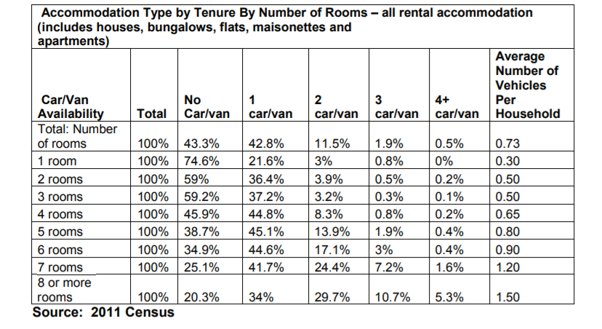

The above demonstrates that very few households living in rental
accommodation in Wrexham have more than 2 vehicles, with a significant
proportion of households in rental accommodation not having access to a
vehicle or only have 1 vehicle per household. The average number of cars
per households in rental accommodation in Wrexham ranges from 0.5 per for
properties with 1 room to 1.5 per dwelling for properties with 8 or more rooms,
with an overall average being 0.8 cars.

