

Registered Office: Unit 1 Charter Court, Well House Barns, Chester Road, Bretton, Flintshire CH4 0DH
Company Registration: 5129487
Unit 1 Charter Court,
Well House Barns,
Chester Road, Bretton,
Flintshire, CH4 0DH
Tel: 01244 661361
Mob: 07977 218184
Email: mikescott@groundsolve.com

GroundSolve Ltd
Consulting Geotechnical, Engineering Geology and Environmental Engineers.

REF: 2002/Grango/CA/mjs

Dafydd Edwards
Blueprint Architectural Services
Unit 3K4 Redwither Tower
Wrexham LL13 9XT

28th May 2019

Dear Dafydd,

RE: LAND NORTH OF 8 GRANGO LANE

Regarding the letter received from the Coal Authority dated 9th May 2019, we have the following reply.

Shallow Mine Workings
We understand that the previous adjacent plots, which were grouted in 2003 and 2006 were not subject to ground treatment outside of the building area.

In addition, in thirty-three years of undertaking drilling and grouting works, we have never been questioned about treating external areas, with the exception of access roads. We are also unaware of any current guidance, which shows this should be addressed.

Therefore, in reply we have reproduced sections of the findings of the drilling and grouting works for Plots 1 to 3.

The works were undertaken by Forkers between the 5th and 22nd December 2017, with the validation report being issued to the Coal Authority in January 2018.

The boreholes were drilled to 1m below the base of the Brassey seam in Plots 1 to 3. The seam was encountered at depths starting at around 9.50m in the west falling to around 10.50m in the east, a fall of 1m, which corresponds to the known regional dip. It is also possible beneath Plots 1 to 3 that the Main seam outcrop was encountered, although no workings were recorded.

Of 54 boreholes drilled, 36 encountered an intact coal seam, giving an abstraction ratio of only 33%, see Figure 1. All of the workings were encountered around the seam horizon, and no voids were encountered in any of the boreholes, with the workings being backfilled/collapsed.

A total of 170tonnes of grout being pumped into the ground, each plot taking around 38 tonnes with the exception of Plot 3, which was just over 50 tonnes. The drilling records from the report are presented below.

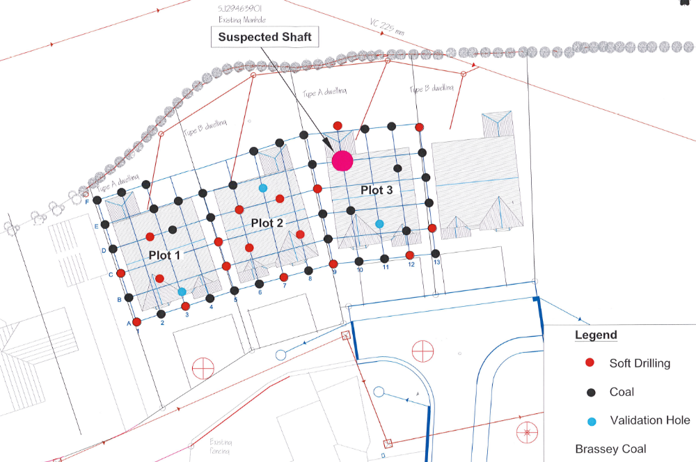
Figure 1: Drilling Results

The low extraction ratios, the fact that the workings have been backfilled, the lack of any evidence of any upward migration of voids, and the lack of colliery spoil at surface, despite there being nearby shafts, suggests that the workings were largely backfilled. No residual voidage was encountered during the drilling, although some would be anticipated to exist. In addition, the site has no evidence of previous surface instability.

The Brassey seam was encountered at a depth of 9.50m to 10.50m, with bedrock generally around 3.0m depth, giving a rock cover of 6.5 to 7.5m of mudstone. Consequently, any residual voidage in the workings would choke before it is able to reach surface.

Given the above and that fact that the grouting would have extended outside of the building footprint and the small size of the gardens and hardstanding means that the risk to external areas is considered to be very low.

In conclusion, the properties have been grouted in accordance with current good practice and the properties constructed on reinforced concrete foundations. The risk to external areas is considered to be low with the adjacent access roads being treated by the incorporation of reinforcing geotextiles in their construction. We understand that these details have been submitted by Mr John Hughes Lloyd to the Local Authority for approval.

Suspected Mine Entrance
Following submission of the drilling and grouting report a search was undertaken for the suspected shaft using a 13T excavator a report was then issued to the Coal Authority on the 10th June 2018, with the relevant sections reproduced below.

PERMIT CLOSURE, REF 14816 & 14817: GRANGO LANE

On the 18th January 2018, we submitted our permit closure report for the above job.

In the report we recorded a possible shaft, which was based on the drilling of Borehole E10, where 15m of soft drilling was reported. Consequently, a second borehole was drilled some 0.50m away from E10, which recorded the same strata. Both boreholes were topped up with grout following drilling.

The location of the suspected shaft is shown on the Figure 1 above. The excavation was undertaken using a 13T tracked excavator and achieved a depth of 4.40m and was roughly 4m by 4m in plan area. It was excavated under the full-time supervision of a chartered engineering geologist from GroundSolve Ltd, with extensive experience of finding and treating mine shafts.

The excavation was set out using the co-ordinates used for setting out during the initial drilling and grouting. Photographs of the excavation are presented below, which failed to record the presence of a shaft, however, the position was confirmed as two adjacent grout columns were observed in the excavation. The excavation encountered similar ground conditions to TP 1, with made ground overlying glacial till, resting on a coal seam and then onto dark grey mudstone, see photographs below.

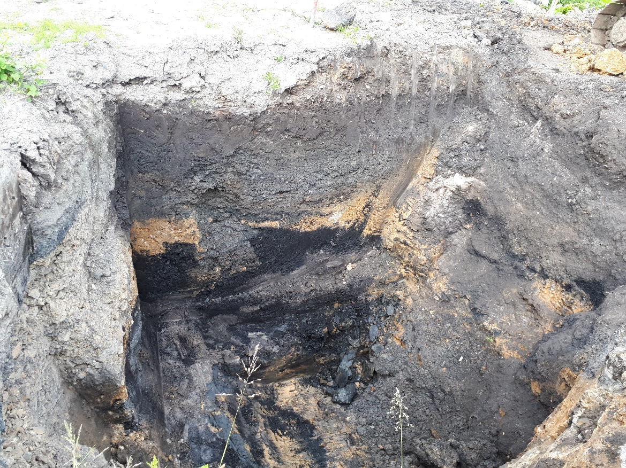

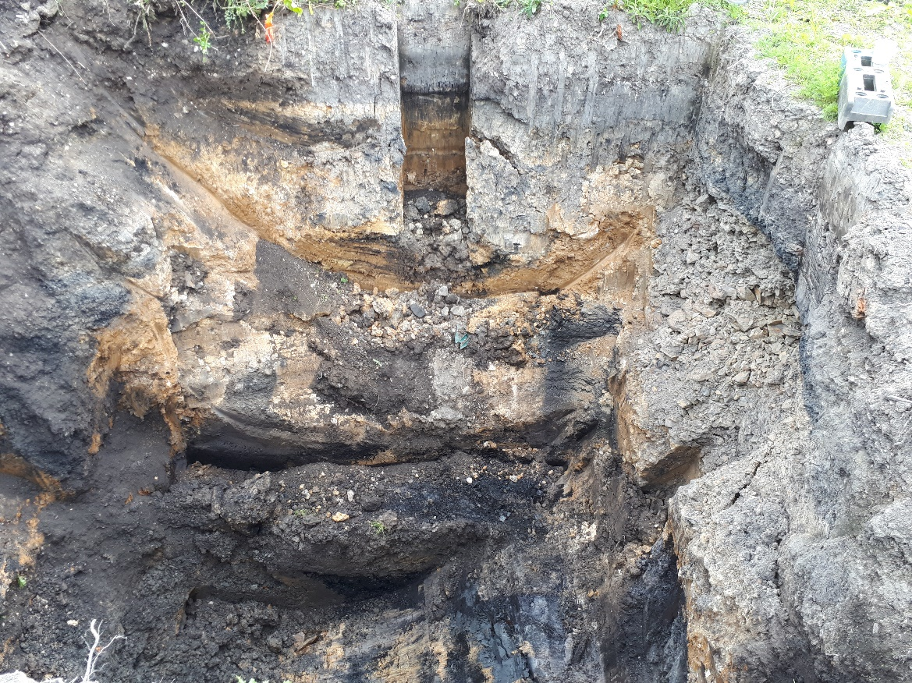

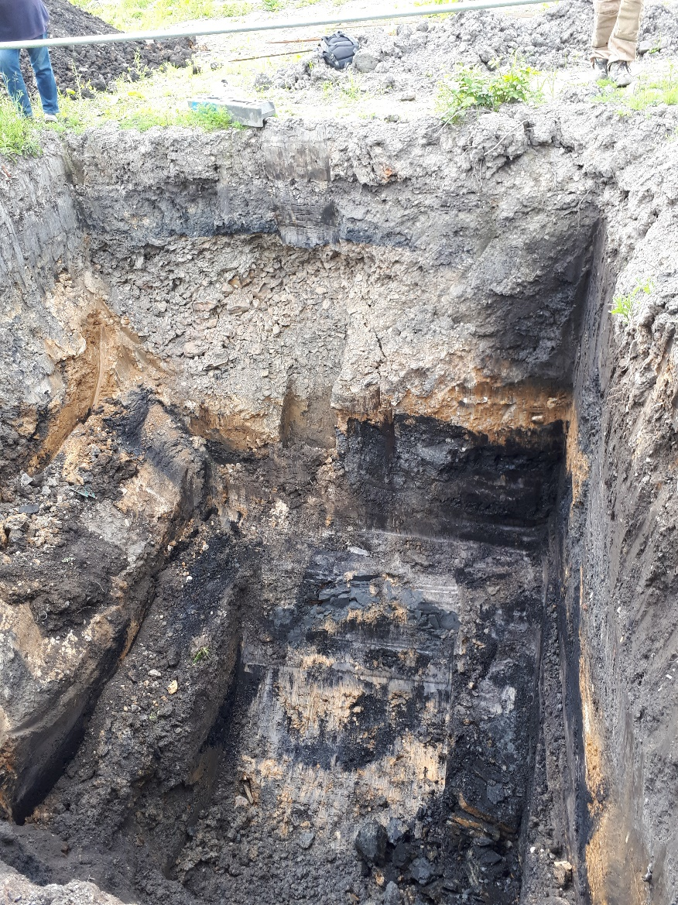
Grout columns

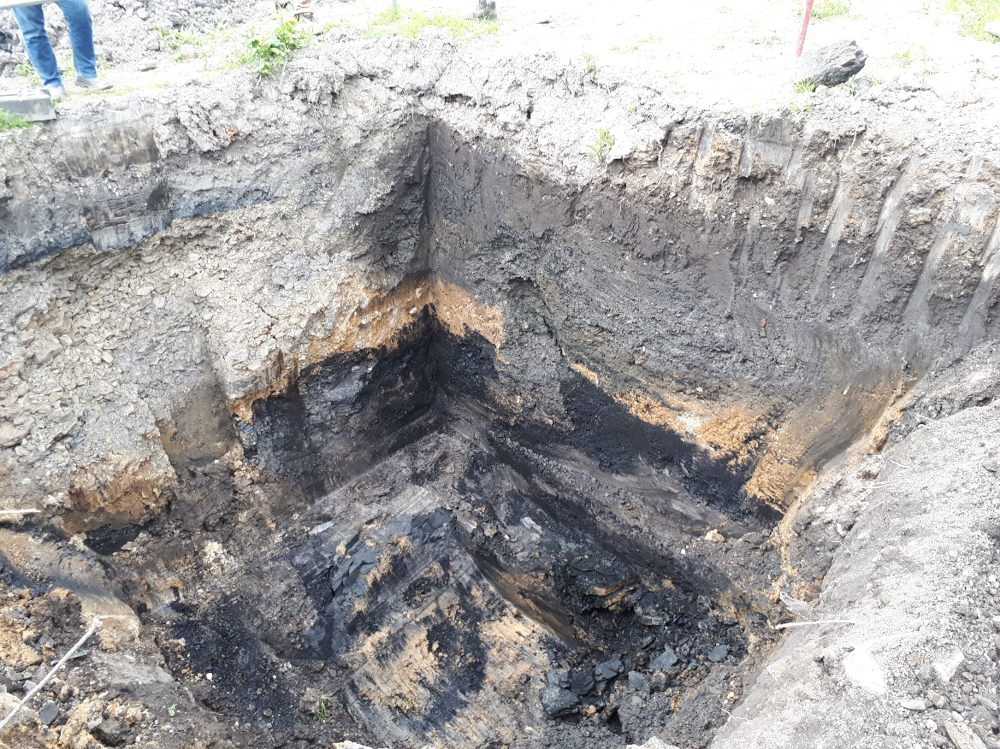
Grout columns

We therefore concluded that there is not a shaft at this location.

Mine Shaft 329346-060
As discussed above, it is our understanding that a geotextile reinforcement is to be incorporated into the road construction and we have advised My Hughes Lloyd on this matter.

Shaft 329346-529
In our past reports, we have managed to accurately locate the position of this shaft from the 1850 Public Health plans at a scale of 1: 500. This has enabled it to be established that it is at sufficient distance from the road and the depth to rock such, that should it collapse it could not affect the adjacent adopted road. However, again this road is to be protected using reinforcing geotextiles.

We trust this is satisfactory, should you have queries please call Mike Scott on 01244 661361.

Yours sincerely

M J Scott
CC John Hughes Lloyd

