DEMOLITION, EXTENSIONS AND ALTERATIONS and REPLACEMENT STABLES AT
ALTHREY WOODHOUSE
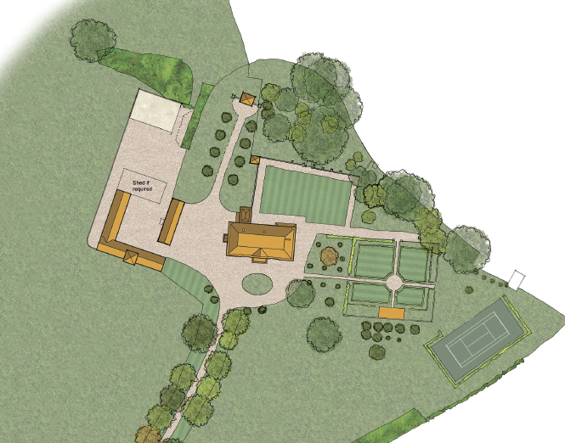
for HERITAGE STATEMENT
See
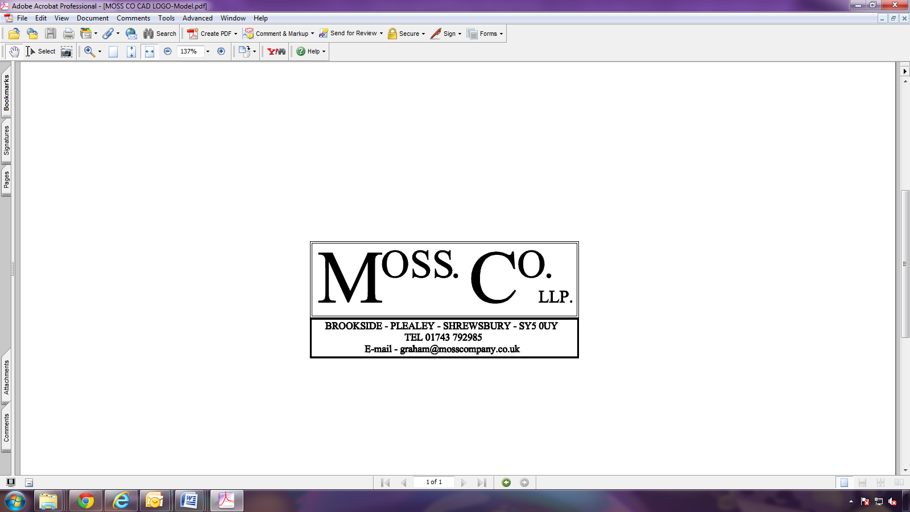
PLANNING STATEMENT

