DEMOLITION, EXTENSIONS AND ALTERATIONS and REPLACEMENT STABLES AT
ALTHREY WOODHOUSE
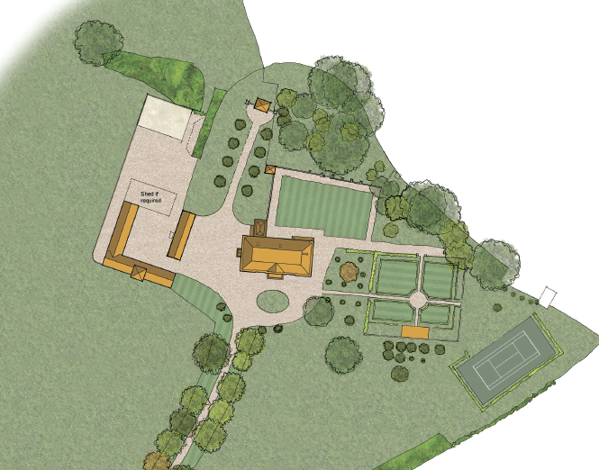
for ACCESS STATEMENT
See
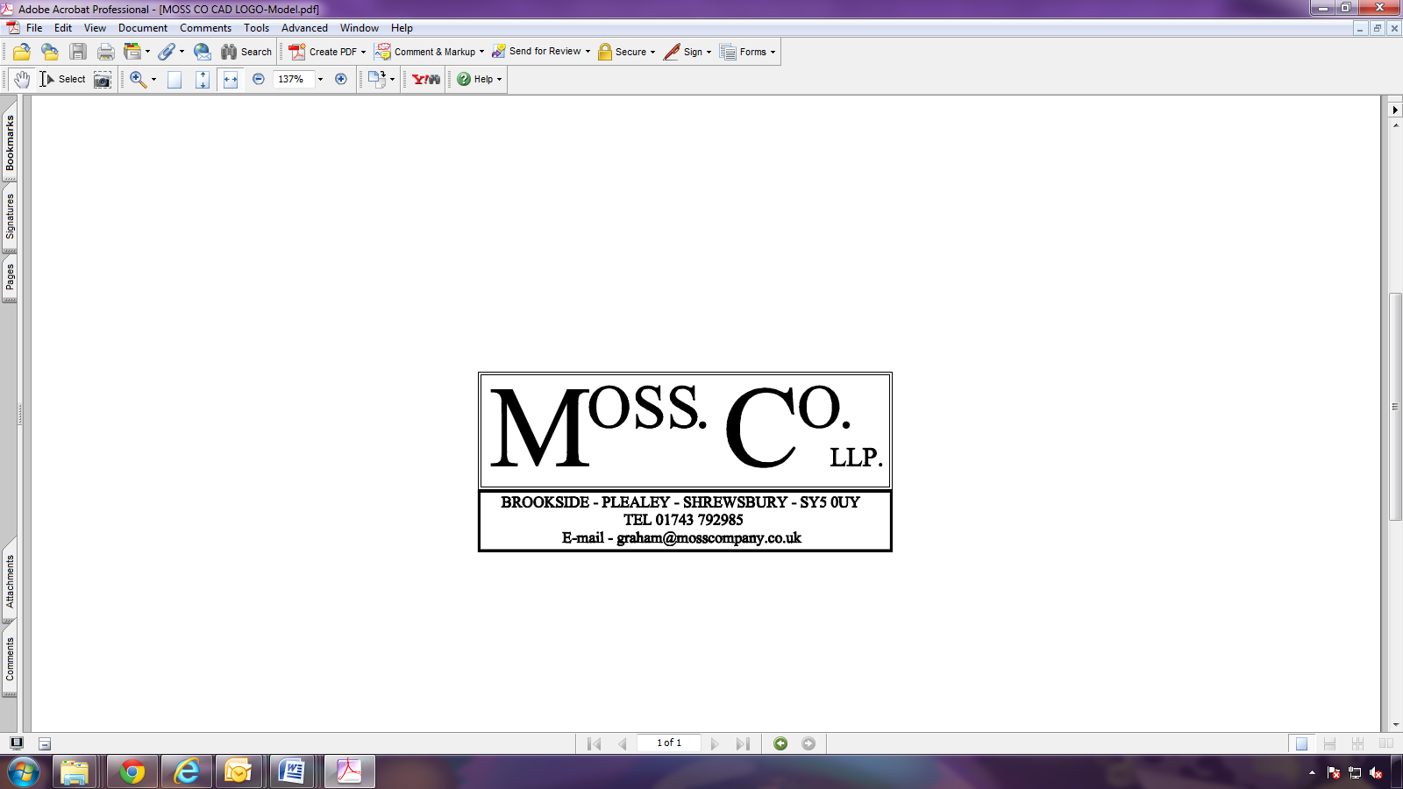
PLANNING STATEMENT

