Unit 1 Charter Court,
Well House Barns,
Chester Road, Bretton,
Flintshire, CH4 0DH
Tel: 01244 661361
Mob: 07977 218184
Email: mikescott@groundsolve.com

GroundSolve Ltd
Consulting Geotechnical, Engineering Geology and Environmental Engineers.

REF: 2174/RCC/RepLet/mjs

Lisa Parry
Blueprint Architectural Services
Office 3K4
Redwither Business Tower
Wrexham LL13 9XT

12th December 2018

Dear Lisa,

RE: COMMUNITY CHANGING FACILITY, PONCIAU BANKS: MINING APPRAISAL

Introduction
It is proposed to construct a new changing facility at Ponciau Banks near Wrexham. The proposed site layout is presented below in Figure 1.

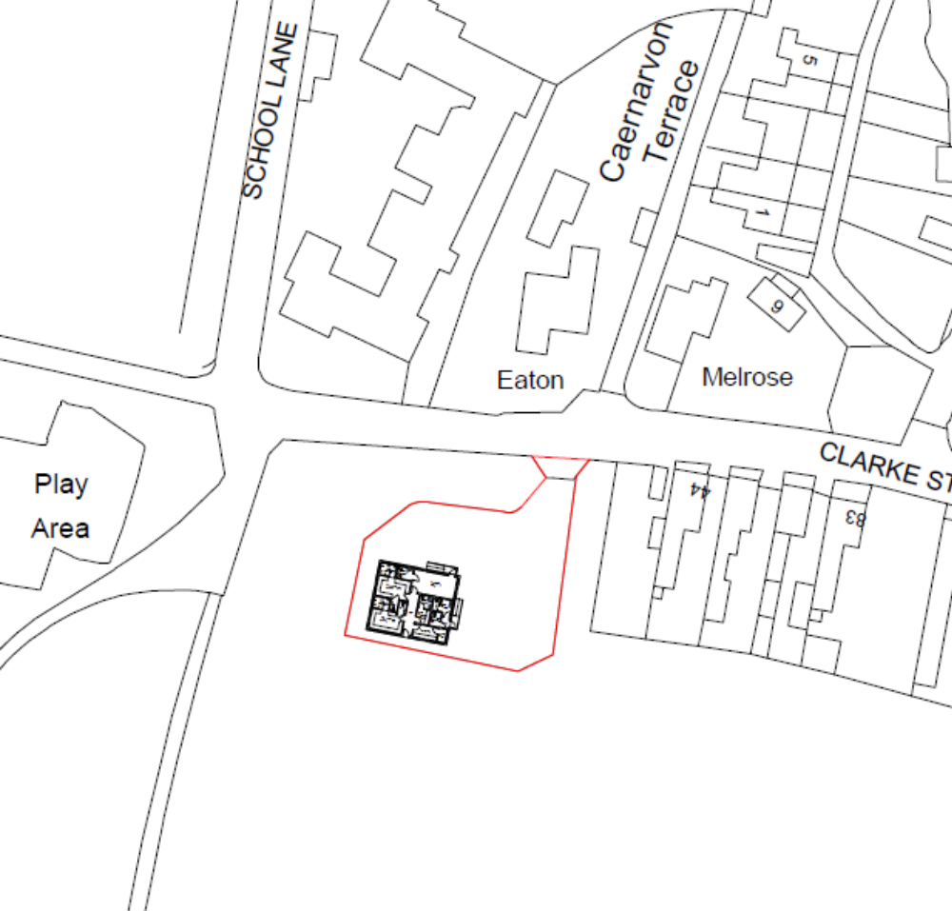
Site
Figure 1 Site Location

Blueprint are the architects for the scheme and they have appointed GroundSolve Ltd to undertake a brief desk study to understand the mining risks at the site and present a way forward for the site’s development.

Geology
The geology of the site has been studied on the following sources:

- 1:50,000 scale geology plan, Sheet 121, Wrexham,
- Historical geology plans,
- Wrexham study at a scale of 1:25,000,
- Geological memoirs,
- BGS web site.

The geology plans show the Main Coal seam to outcrop immediately west of the site, with a borehole on site recording 13’ (3.96m) of glacial till. The area was mined by the Ponkey Colliery. The dip of the strata in this area is gentle in an easterly direction, consequently, the Main coal seam would be anticipated to be at shallow depth beneath the site.

A borehole immediately east of the site recorded the following strata.

Depth (m) Strata
0.0-3.05 Soil and Clay
3.05-6.1 Sandstone
6.1-6.48 Coal (Bind Coal)
6.48-9.14 Black Shale
9.14-9.60 Void (Main Coal)
9.60-11.60 Fireclay
11.60-11.93 Shale
11.93-12.5 Coal
12.50-14.93 Fireclay
14.93-15.77 Coal
15.77-18.3 Shale
18.3-19.5 Fill (Backfilled Workings-Brassey Coal)
19.5-20.70 Fireclay

Shaft 220, which was 3.70m away from the borehole, and on the site, encountered 19.81m of made ground overlying 0.46m of coaly shale, with fireclay encountered to 21.34m. Consequently, this shaft did not go deeper than the Main Coal seam.

The geological memoirs record the Bind coal to be 2’3” thick (0.69m) parted from the Main coal by 2’ (0.61m) of carbonaceous shale with the underlying Main coal being 7’ 5” (2.28m) thick.

History
The history of the site has been studied on old plans dating from the 1850 Public Health plan. A copy of this is presented below, which failed to record the presence of any shafts, see Figure 2.
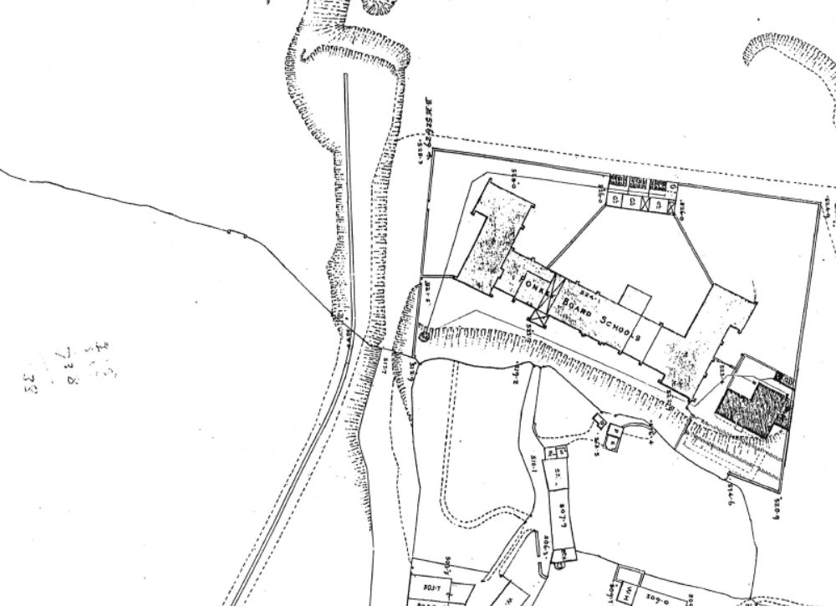
Site Location
Figure 2 Public Health plan dated 1850

None of the later OS plans revealed any evidence of shafts on the site. Consequently, the mining pre-dates 1850 and as such is probably un recorded.

It is known from previous experience at Ponciau Banks, that many of the shafts were small in diameter, being around 1m in diameter, probably as the coal was close to surface. It is also known that the school north of the site has experienced subsidence, associated with shafts in the past.

Mining
A Coal Consultants report has been obtained from the Coal Authority, the findings of which are summarised below, with the report presented in full in Appendix A.

The shafts recorded on site are 453 and 220, see Figure 3.
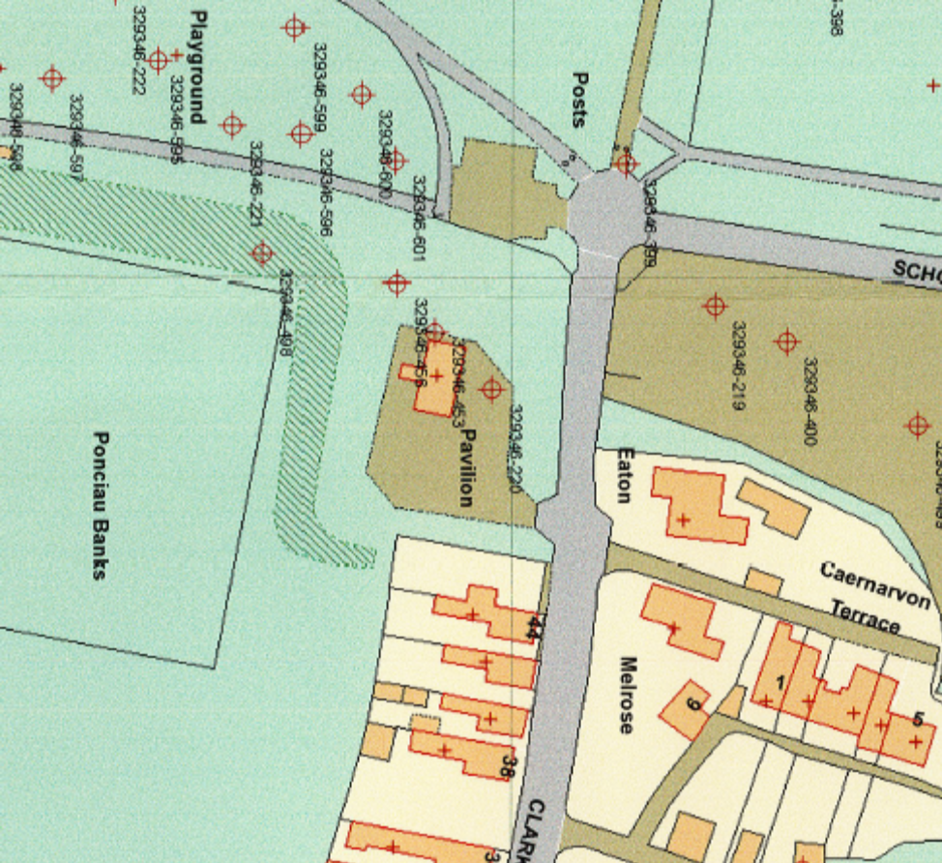
Figure 3 Location of shafts

- The site is underlain by the Main seam at a depth of 9m, with an easterly dip of 7.5°,
- The Brassey seam has been worked at a depth of 20m beneath the site,
- Shaft 220 was capped by Wrexham Rural District Council in 1974 to an unknown specification,
- Shaft 453 has been grouted and capped by the Borough Council to an unknown specification using a 4.27m x 2.44m cap.

Discussion and Conclusions
The two shafts on site appear to have been capped, with shaft 453 adjacent to the existing building also
grouted. Therefore, it must be assumed that their locations are accurately known.

Whilst it is technical possible to build over shafts, confidence would have to be available on the
level of treatment, which in this case is not known and would require extensive investigation.
However, the Coal Authority are not keen on building over shafts.

It would appear that shaft 453 may be within the influencing distance of the proposed building and will have to be considered during development. If the building location is fixed, it will be necessary to excavate and confirm its position and the capping details, to enable any foundations to be designed.

However, the most obvious cost-effective solution to the mining issues at the site is to move the building to the east of the site away from the shafts. The only expense would therefore be to drill and grout the underlying workings in the Main Coals seam, following which it would be necessary to construct the building on a raft foundation.

It should also be noted that un recorded shafts may be present beneath the eastern section of the site, and it would be prudent to investigate this possibility.

We trust this is satisfactory, should you have any queries please call Mike Scott on 01244 661361.

Yours sincerely


Mike Scott

Registered Office: Unit 1 Charter Court, Well House Barns, Chester Road, Bretton, Flintshire CH4 0DH
Company Registration: 5129487

APPENDIX A

Coal Consultants Report

