
Bob Dewey

PLANNING
GROUNDS OF APPEAL

PROPOSED ERECTION OF EXTENSIONS AND ALTERATIONS TO
6 ALBANY TERRACE WREXHAM
.

Proposal: The proposal is to construct extensions and internal alterations to an existing four bedroom HMO to provide a total of 6 bedrooms. The property is located at the rear of properties on Rhosddu Road, (B 5425) Wrexham. It is approx. 800 m from the town centre.

Planning Policy
The development plan is the Wrexham Unitary Development plan adopted 2005. Policy T8
requires developers to provide parking on site or nearby, in accordance with the current parking standards. However, regard will be paid to the public transport nearby, proximity to public car parking and to local services and facilities Also to road safety hazards and amenity considerations arising from on-site parking in the vicinity of the site.
The Council has also adopted local planning Guidance on parking (which sets out the car parking standards and other material considerations).

The standards are over by the Welsh Government’s policy on the matter. This clearly states (in the most recent version of Planning policy Wales no.9 that new developments should provide lower levels of parking than have generally been achieved in the past. Minimum parking standards are no longer appropriate.

Reasons for refusal:

The Council says:

“ The development makes insufficient provision for parking within the curtilage of the site. This has the potential to result in parking and access problems in the vicinity of the site. The development is therefore contrary to policies GDP1 (d) and T8 of the Wrexham UDP.”

SUPPORTING INFORMATION:

The proposal is to convert an HMO with four bedrooms to provide two addition bedrooms. The property is believed originally to have been a single dwelling with three bedrooms.

On that basis it would have required 3 parking spaces. The maximum parking standards for HMO are 1 space per 2 bedspaces. Thus the maximum requirement would be 3 parking spaces.

The Highway Authority’s comments recognise that the submitted drawing shows three spaces but argue that there is inadequate space for manoeuvring.
So the identified issue is not the lack of spaces but he alleged difficulty in manoeuvring.

The site has been re-measured and the parking area is 10.850 m by 10.850 m.

A car parking space based upon the Council’s guidance note should be 4.8 m with an aisle width of 6 m. Clearly whilst the submitted drawing implied an issue, there is no issue.

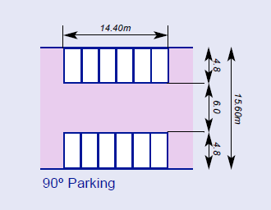

In any event, the back lanes in this area are not highways and many of the properties do not have parking – certainly not up to the “full” standard. If there is some on-lane manoeuvring, this is most unlikely to cause a problem to the highway.

Furthermore, the standards only require a maximum of three spaces. Despite the Highway Authority’s assertion, the standard would be met by two spaces. There is also a small public car park on the corner of Park Street (about 100 m away).

More to the point, the location of the property close to the town centre means that car ownership is likely to be low. The edge of the centre is less than 500 metres away. The bus station is only a short distance further. The college is some 400 m away. There are regular busses along Rhosddu Road (at least three per hour) connecting the site to the town centre and Llay. Wrexham Railway station is a little further but easily within walking distance.

The appellant has indicated (see attached copy letter)
None of the current residents own a motor vehicle, the property is mainly occupied by professional people who commute to and from without the need for their own vehicle. This has been the case over the last few years since the property has been occupied as a HMO.

So regardless of any of the above, it seems most unlikely that any issues of parking and access raised by the highway officer will occur.

CONCLUSION

This is a proposal to bring a property into a viable use and provide accommodation for people close to Wrexham Town centre.

No clear evidence has been put forward as to why the increased use would cause any parking or congestion issues which would be such as to harm the amenities of the area.

The inspector is requested to grant permission.

Robert A Dewey BA(hons) MBA MRTPI
Bobdeweyplanning
October 16th 2017. V1

Letter from appellant

6 Albany Terrace
Rhosddu
Wrexham
LL13 2NH

08th October 2017

Dear Carl,

I can confirm that the above property before being converted to a HMO was a 3 bedroom end terrace occupied by a family. None of the current residents own a motor vehicle, the property is mainly occupied by professional people who commute to and from without the need for their own vehicle. This has been the case over the last few years since the property has been occupied as a HMO.

Kind regards

Alan Taylor

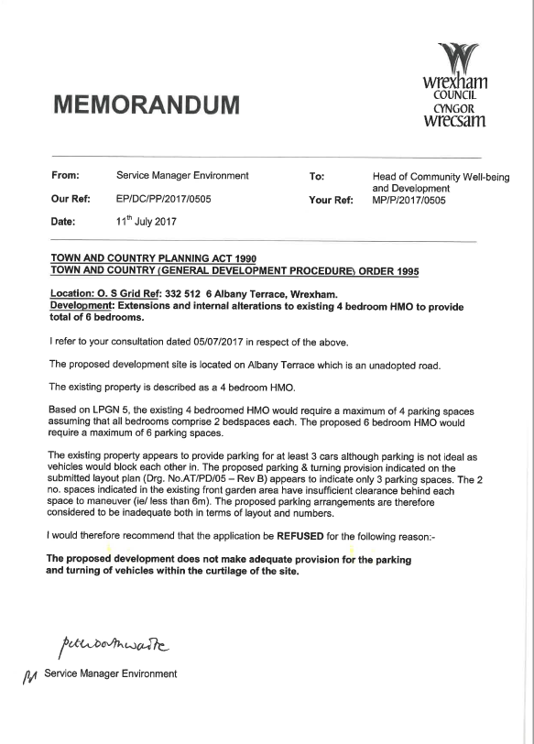
Wrexham Unitary Development Plan policies

Policy H4 The sub-division of existing dwellings will only be permitted where:-
a) sub-division is possible without major alterations, extensions, or additional new buildings which would significantly alter the character of the original dwelling; and
b) proposals accord with Policy GDP1;
and
c) adequate private open space is available.
d) the proposal would not result in the over-concentration of Houses in Multiple Occupation to the detriment of crime levels, the social fabric of the area, and the amenity of existing
residents.

Policy T8 Development granted planning permission will be required to provide vehicle parking spaces either on site or nearby ,in accordance with the Council’s current parking standards. Special regard will be paid to the following factors , as appropriate:-
a. the availability of public transport nearby
b. Proximity to public car parking
c. proximity to local services and facilities
d road safety hazards and amenity considerations arising from on-site parking in the vicinity of the site.
Where implementation difficulties arise in making parking provision nearby, the Council will require a developer to make financial contributions for measures to assist public transport, or walking and cycling as appropriate.

Policy GDP1 All new development should:-
a) Ensure that built development in its scale, design and layout, and in its use of materials and landscaping, accords with the character of the site and makes a positive contribution to the appearance of the nearby locality.
b) Take account of personal and community safety and security in the design and layout of development and public / private spaces.
c) Make the best use of design techniques, siting and orientation in order to conserve energy and water resources.
d) Ensure safe and convenient pedestrian and vehicular access to and from development sites, both on site and in the nearby locality.
e) Ensure that built development is located where it has convenient access to public transport facilities, and is well related to pedestrian and cycle routes wherever possible.
f) Ensure the safety and amenity of the public and safeguard the environment from the adverse effects of pollution of water, land or air, hazards from industry and quarrying, and associated noise,
odour or vibration arising from development.
….

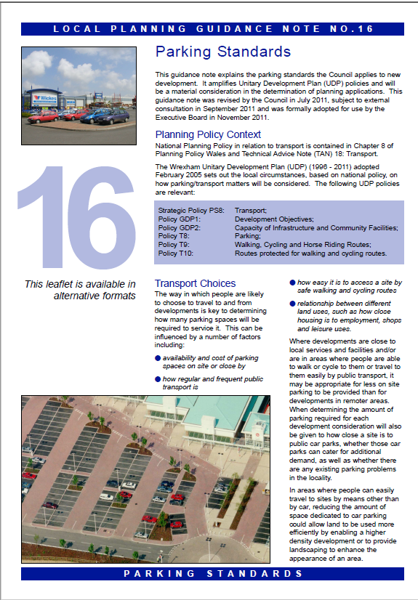
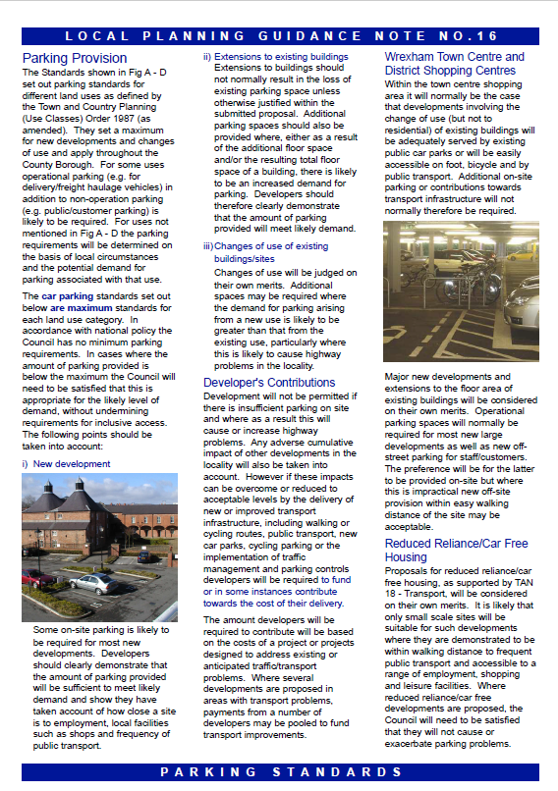

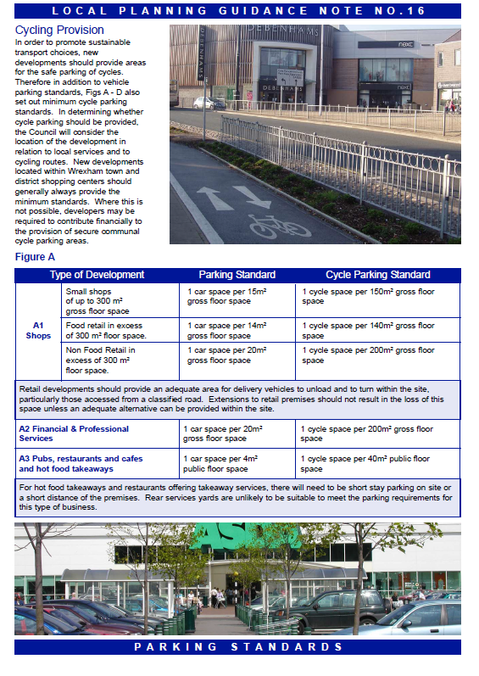
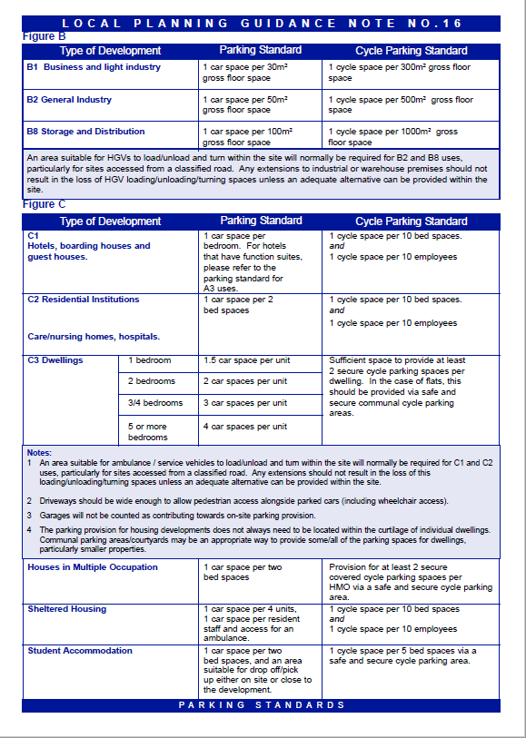
APPENDIX
RELEVANT EXTRACTS FROM POLICIES

Welsh Assembly web site
PLANNING POLICY WALES TECHNICAL ADVICE NOTE 18: TRANSPORT
4. Parking
4.1 The availability and price of car parking are key
elements in managing car use and a major influence on the
choice of means of transport. Car parking can take up large
amounts of space in developments, which decreases density
and therefore can represent an inefficient use of land. It can
also generate considerable additional trips if located in an
area without public transport. Poor design and layout of car
parking can also make it more difficult to provide effective,
walking, cycling and public transport links18.
Maximum parking standards
4.6 Maximum car parking standards should be used at
regional and local level as a form of demand management.
Turning minimum standards into maximum standards will
not necessarily be appropriate.
4.16 Local planning authorities should give greater weight
(than if considering non-residential uses) to the potential
adverse impacts likely to result from on-street parking
when the design and layout of the street is unlikely to
satisfactorily cope with additional residential parking
pressures. A site’s location and its relative accessibility should
inform guidance on maximum standards and the potential
lifestyle of occupants should be considered, both at the
forward planning and development control stages.
9.24 Maximum parking standards mean it is inappropriate
for commuted sums to be required in lieu of reduced levels
of parking at a site without establishing that harm would be
caused by lower provision of parking.
2.3 Integration of land use planning and development
of transport infrastructure has a key role to play in
addressing the environmental aspects of sustainable
development, in particular climate change and the outcomes
identified in the Assembly Government’s Environment
Strategy3. Integration can help the Assembly Government
achieve these environmental outcomes, together with
its wider sustainable development policy objectives by:
• promoting resource and travel efficient settlement
patterns;
• ensuring new development is located where there
is, or will be, good access by public transport, walking
and cycling thereby minimising the need for travel
and fostering social inclusion;
• managing parking provision;
2 ‘Draft Wales Transport
Strategy: Connecting
Wales’, Welsh Assembly
Government, 2006.
3 ‘Environment Strategy for
Wales’, Welsh Assembly
Government, 2006.
PLANNING POLICY WALES TECHNICAL ADVICE NOTE 18: TRANSPORT
• ensuring that new development and major alterations
to existing developments include appropriate provision
for pedestrians (including those with special access
and mobility requirements), cycling, public transport,
and traffic management and parking/servicing;
• encouraging the location of development near other
related uses to encourage multi-purpose trips;
• promoting cycling and walking;

Planning Policy Wales Edition 9 – November 2016 – Chapter 8 Transport

8.4.2 Car parking provision is a major influence on the choice of means of transport and the pattern of development. Local authorities should ensure that new developments provide lower levels of parking than have generally been achieved in the past. Minimum parking standards are no longer appropriate. Local authorities should develop an integrated strategy on parking to support the overall transport and locational policies of the development plan.

