The Planning Inspectorate
Crown Buildings
Cathays Park
Cardiff
CF103NQ Simon Draco
Springfield House,
02/06/17 Gamford Lane,
Rossett,
LL120EW
Dear Sir/Madam
SUBJECT: Town and Country Planning Act 1990 Section 78 Appeal at : Land at the Bungalow, Darland Lodge, off Darland Lane and Gamford Lane, Rossett, Wrexham

With reference to the above I would like to take this opportunity to make my representations in respect of the appeal that has been lodged by the Applicant (or their Agent –Land Planning Limited) and for them to be taken in consideration at the subsequent Hearing that will consider the development of 47 dwellings and infrastructure works on land known as the ‘Springfield’, immediately opposite my home.
The basis of my objection surrounds ‘material planning considerations’ as defined by Planning Aid (2015) that form the basis of the Local Authority’s Refusal to grant Planning Permission and the subsequent Grounds for Planning Appeal submitted by the Applicant (Land Planning Ltd, 2017).

Initial Observations
I have read in detail the grounds upon which the Planning Appeal is made and frankly the grounds are based upon the fact that the Applicant simply does not like the finding rather than evidence in support of material considerations!
As a professional investigator I found it unsurprising that the grounds of appeal submitted by the Applicant, in similar nature to the Design and Access Statement that was submitted with the initial planning proposal, is based upon hollow statements, anecdote, questionable findings, hyperbole and lacks conclusive information that can be considered as being or having ‘evidential value’ or ‘evidential weight’ to support their grounds of appeal. Such is the scant regard to facts, the reliance upon subjective opinion that is fundamentally motivated by profit, that there is absolutely no community derived benefit from the intended development, the refusal of the Local Authoirty is based upon due diligence expected of the public authority and the information presented is purely a perversion of the truth which, unfortunately, is not subject to criminal scrutiny or means of authenticating its voracity.

Key issues and grounds of Appeal
Ignoring the first two and a half pages of the Applicant’s Appeal (2017 p.1-3) which concerns the applicants unfounded complaints regarding the alleged unfairness of the planning process and their inability to meet planning deadlines, I shall focus upon the following points of determination identified by the Local Authority as grounds for refusal of the initial application, the grounds of appeal as identified by the Applicant and reinforce the basis of refusal, these are:

- The proposed development lies outside the settlement limits and within and areas designated as Green Barrier, and
- The removal of hedgerow along the boundary with Gamford Lane will have a detrimental impact on the visual amenity of the area and an adverse effect on the rural integrity of the lane

The first ground for refusal is factually correct and reinforced by reference to five of the policies that inform the Wrexham Unitary Development Plan (PS1 - Settlement lImits, PS2 - Development and the Environment, H5 -Housing in the Countryside, EC1- Green Barriers and GDP1 -Development Objectives) as the development is based upon Green Barrier land and more significantly, whilst the UDP is out of date (which may afford flexibility) the projections for residential development are currently in line with demand predicted by Wrexham Borough Council. This is a fact and is contrary to unsubstantiated statements from the applicant that “…it is likely that some residential development will be required upon land currently designated as Green Barrier, in order to address the current, significant shortfall in housing land supply” (Land Planning Ltd, 2017, p.2) which based upon recent communication to the Parish Council such demand is exaggerated and does not currently exist in Wrexham or Rossett.
The Applicant / Land Planning Ltd (2017, p.4) state that “there will be no significant adverse effects on the visual amenity on the residential and recreational receptors” with reference to their Landscape Visual Impact Assessment (LVIA). How remarkable that this is the conclusion from research commissioned by the Applicant?

Evidence to the contrary is drawn from the fact that the proposed site falls within an area designated as Green Barrier and special landscape, it is called the “Springfield” as this is where the new born lambs are raised and this area is synonymous with the cycle of nature with the local children in this respect. The proposed site is beautiful countryside hence I chose to live here with my family (as did many of my neighbours) due to the high degree of residential amenity that is afforded, this amenity is illustrated by reference to Photograph 1.

Photograph 1: The “Springfield” and beautiful Green Barrier countryside and agricultural land that proposed housing estate seeks to destroy.

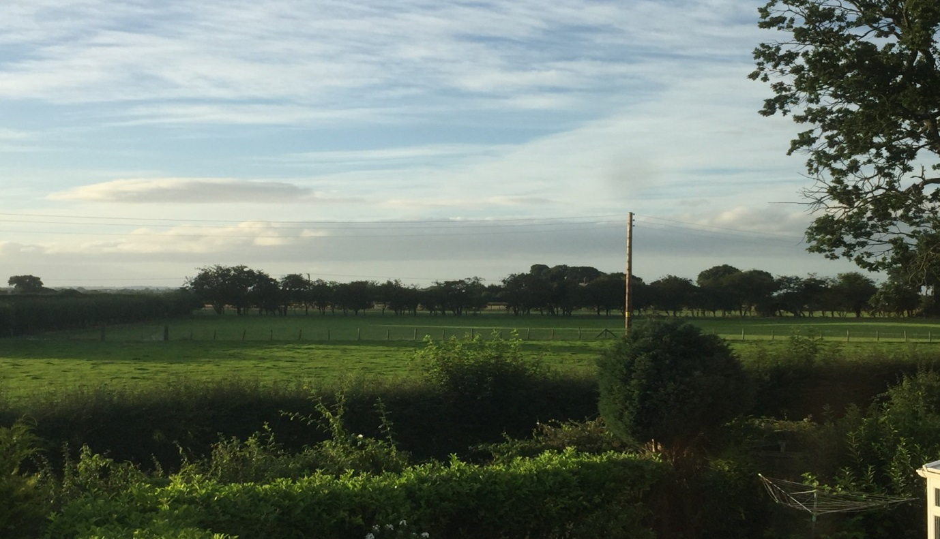
The proposed housing estate does absolutely nothing to integrate into the local area – fact – as determined by 57 objections and the planning refusal by Wrexham Borough Council (WBC).

The house designs proposed by the Applicant contrast significantly to virtually all the detached dwellings in the immediate area and some house designs, specifically, the cream “chocolate box” semi-detached houses illustrated in the Land Planning Information Leaflet (Photograph 2) would be more akin to a garish theme park or artificial “idyll” rather than reflecting the reality of the house styles in the immediate local area.

Photograph 2: Untypical and non-characteristic housing designs for intended development site.
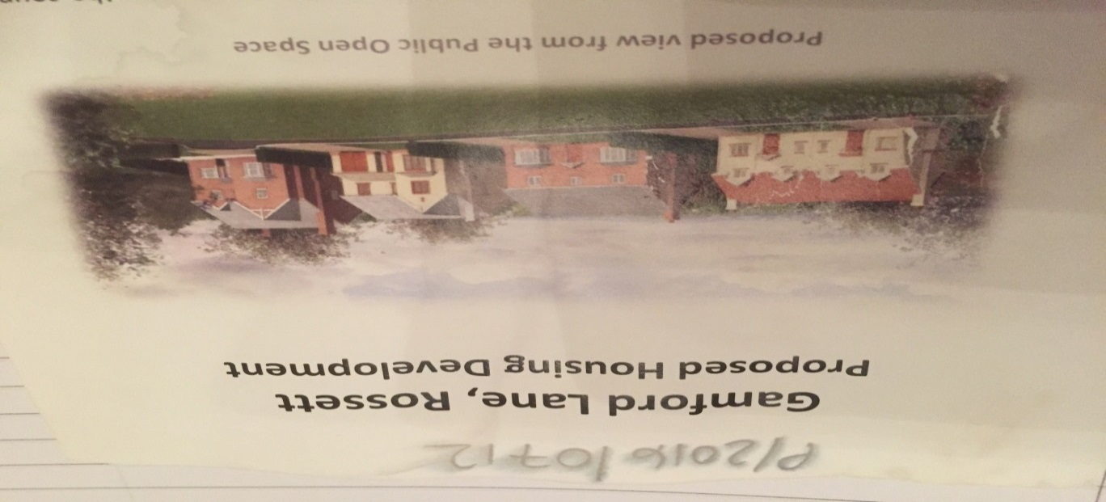
Moreover, the applicant’s initial Design and Access Statement that was considered in the initial determination states that the development will “integrate well into the structure of the village”, now the Applicant’s grounds for Appeal states that:

“…with careful landscaping and sympathetic scheme design, the rural character can be retained..” and “…it is therefore believed that the development of the application site will not unduly affect the character of the local landscape” (Land Planning Ltd, 2017, p.5)

In evidential terms, nothing has changed between the initial application and subsequent appeal – in fact, such statements could not be further than the truth, no new startling evidence has been adduced or presented that in any way contradicts the fact that the refused development is sited outside of the village in prime agricultural Green Barrier land and by definition this ‘barrier’ is to retain openness and restrict the merging of settlements akin to urban sprawl.

Nor has any evidence been provided that negates the permanent removal of 80m ancient hedges that define the character of this part of Rossett (see photograph 3) as identified within the Highways documentation or 130m initially to develop the site. This is supported by the fact that the character of the housing proposals and access points (where hedges will be removed permanently to allow access and regress from the site with necessary sweeps) will unduly affect the character of the local landscape and as mentioned on the applicants Design and Access Statement, this subsequent Planning Refusal is definitely not “in keeping with the local character” and does not create “a natural extension to the village in terms of scale, character, layout and landscaping”- fact.

Photograph 3: Typical Hawthorne hedgerows that characterise the location looking NW on Gamford Lane and the impact of their removal upon local amenity

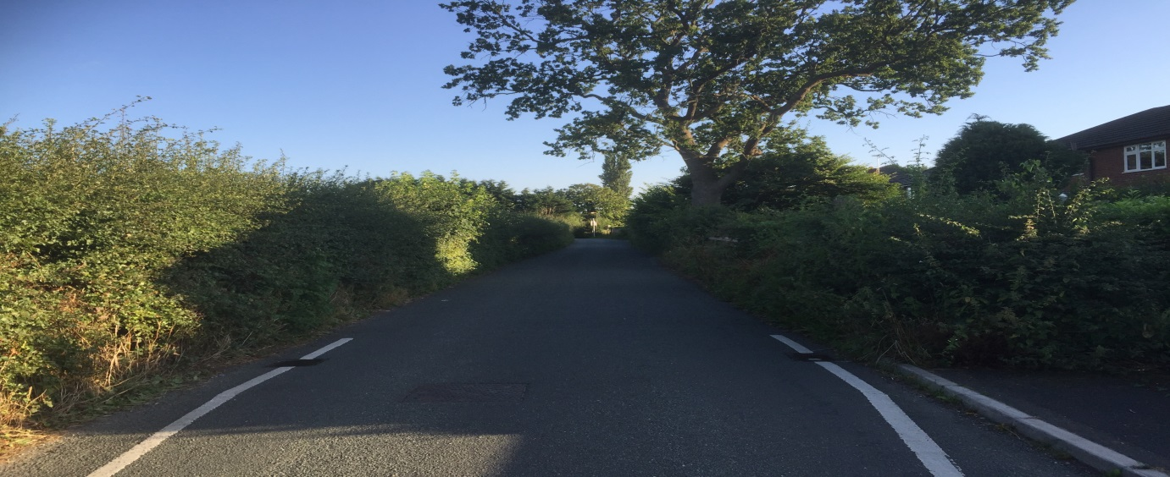
Permanent Removal of 80 m of 130m of Hedgerow

It is clear from the evidential photographs that if the Appeal were allowed “…the nature of the development would represent a significant urbanising change to the existing rural setting and would be detrimental to the landscape character” (WBC, 2017, P.1) as determined by the refusal. Furthermore, the Applicant / Land Planning Ltd (2017, p.9) identify that the “hedgerow could either be transplanted further back…or a new hedgerow could be planted to retain the hedgerow boundary”. The key words here are “could” as in this context and throughout their grounds for appeal a common theme present is that subsequent protestations represent an after-thought as such were absent in the initial application that was subject to a determination or refusal and serve as an illustration of the evidential impact that the development will have upon the local amenity as determined by WBC and the strength of feeling from local residents such as I.

When an inappropriate design for the local area and massive impact upon the ancient hedgerow (both initial and permanent) are combined, this weight of impact is so detrimental, need I say anymore in this respect?

The initial determination was made with due diligence, hence in the absence of any new evidence, the decision should stand against appeal and serves to reinforce the assertion that the applicant simply did not like the decision – a refusal.

- Disposal of surface water
There are two aspects to this issue that need very careful consideration to determine whether the need for profit as determined by the few outweighs the risk and harm to the many residents in the local community. On this basis, is this development the ethically right thing to do and from which there is a derived community benefit? In answering these fundamental questions the following underpin it:
- Disposal of surface water via the localised drainage network, and
- Current flooding on and surrounding the proposed development
The Design and Access Statement of the applicant refers to the fact that the site is “at little or no risk of flooding” and the small print references minimal “risk of coastal or tidal flooding”. What this omits completely is that the site is identified as being at risk of surface flooding as defined on the Flood Map for Surface Water (Natural Resource Wales, 2015). This is a fact.
Map 1 : Flood Map for Surface Water (NRW) 2015
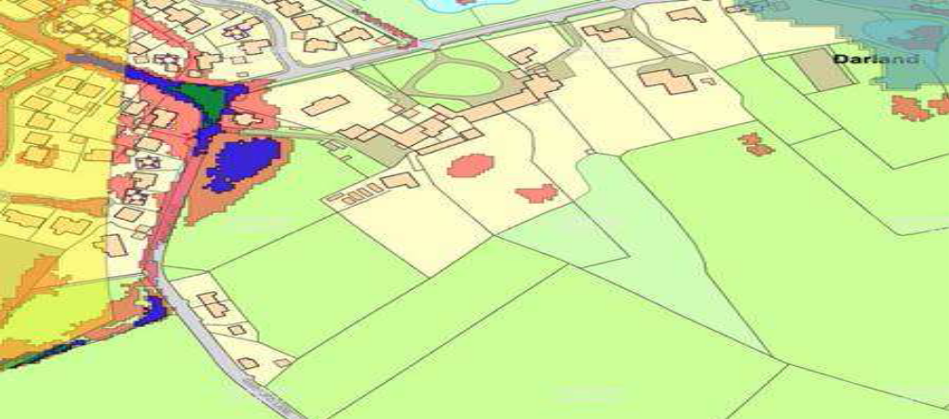
Proposed imposition site
From this map it is clearly apparent that the proposed site is subject to surface flooding as is the confluence of Darland Lane with Gamford Lane and the dirt track to the Bungalow adjacent to the site.
Moreover, as a resident who knows the surface flooding pattern and local hydrology in the vicinity very well (due to drainage disruption caused by the last developer in the area of Pippin Lane that is adjacent to proposed site and is informed by previous academic knowledge) evidence can be drawn from the fact that the ‘Spring field Site’ floods in the winter and acts as a ‘sump’ in which fouled surface water sits directly in the location of the proposed main access route to it.
Let me be absolutely clear - the proposed site floods naturally (in part due to the topology and the clay strata) and this ‘pooling’ as Map 1 illustrates clearly, is an inherent part of the local hydrological system; surface water in this location naturally forms a reservoir throughout the winter and is indicative of an inability for surface water to be absorbed due to saturation of sub-surface layers and hence flows into the road and over capacity drainage network.

I see this pooling every year on the proposed site and in fact, have rung the Emergency contact for Wrexham Borough Council for the gulley sucker to be deployed (at large public cost) to remove thousands of litres of water from this location to prevent flooding to my neighbour’s property, these calls are logged via the Command and Control system and are thus verifiable facts. The Applicants appeal makes no reference to such facts, I wonder why?
Such facts are contrary to the contention made by the Applicant / Land Planning Ltd (2017, p.8) who state that the truncation of the drainage network “is the cause of the surface water flooding which periodically occurs in the area during periods of extreme rainfall” or is due to “someone having fixed a tarpaulin over the drain (this is the truncation that is referred to)” – rather, the inherent propensity of the proposed site to flood plus the drainage network issue act together to cause such flooding, both are part of the causation as illustrated by Map 1. I am shocked at the naivety of the Applicant/ Land Planning Ltd (2017, p.8 )who suggest that a tarpaulin is the cause of significant localised flooding in winter months as opposed to appreciation of facts pertaining to the drainage pipe terminating under a residents garden (which floods) rather than extending into a drainage pond some 50+ meters away and lack of subsequent easement permissions through private land to empty the surface water into a nearby Pulford Brook which the Local Authority Engineers can verify and is known to me as a local resident!

Superficial statements by Land Planning Ltd such as this constitute the basis of their appeal and are clearly apparent throughout; Land Planning Ltd (2017, p.9) contend that by simply “reinstating the original drain system is proven to be viable and would resolve the current problem”, clearly this is a statement and lacks any evidence to support it when one considers the fact that the drainage network has not worked for 10 years since the development for residential housing in Pippin Lane was built and is unlikely to be resolved in the future due to lack of easement.

The propensity of the development site to flood per se is conveniently ignored by Land Planning Ltd and is particularly concerning when one considers that Natural Resource Wales (NRW) documentation from 10/08/16 rightly identify, there is no evidence included to suggest that surface waters generated by the large amount of new impermeable surfaces that the development brings could be acceptably and sustainably managed into the future, in fact, “the development is likely to increase the surface area of impermeable ground, thus decreasing percolation and increasing rapid run off” (NRW, 2016).

Bearing this conclusion in mind, again the Applicant/Land Planning Ltd was unable to submit a further Drainage Appraisal by Kane Design in time and unsurprisingly the reference to this work concerns terms based around the “potential”, or is “suggested that soakaways will work” and “with the drainage ditch /culvert in Darland Lane offering an alternative method of surface water disposal if required (subject to the existing drain being reinstated)” are all statements that lack evidential weight and as they rightly point out “a detailed drainage scheme ‘could’ have been made a condition of planning consent” but clearly there was no requirement to by WBC and why would they based upon such superficial consideration of the issue or convenient ignorance?

It is very significant that the Drainage Appraisal prepared by Kane Design (Kane, 2017, p.3) identifies that the “soakaway test suggested that soakaways will work within the site”. How reassuring to the residents of this part of Rossett! However what the appraisal also identifies, which is not mentioned in the Appeal, is that this was a single, visual test in a ditch that was 1.65m long in field that is 2.35 hectares in size and with reference to Map 1, is located in the higher area of the proposed development site that does not flood! Really?

Furthermore, Kane(2017) state that “all measurements are approximate” and that “assumptions” concerning the precipitation duration and impermeable area are an inherent part of the data. The subsequent calculation from which water storage volumes indicate soakaway diameters of 1200mm and apparent compliance with BS 365, frankly, have no degree of statistical confidence whatsoever and make them highly inaccurate and dubious. Indeed, Kane(2017, p.1 ) supports this contention by identifying that “test results do not remove the need for a site investigation and…there is no detailed analysis” which is absolutely correct in both respects and identify that WBC would want to be present if detailed site analysis was to be undertaken, which considering the superficial nature of the Applicant’s Appeal, I’m sure they would wish to be present.

Land Planning Ltd (2017, p.8) conclude in their Appeal that their application and weak consideration of flooding impact that I have articulated led to the application “being refused upon the grounds that no evidence had been provided to ensure a sustainable drainage scheme can be designed, to demonstrate that any potential flood risk can be acceptable managed” – from their lack of evidence, they are absolutely correct in this assertion!

The synergistic effect of this flooding on the proposed site when combined with the drainage network issue is to increase the surface flooding at the confluence of Gamford and Darland Lane rapidly, flooding my neighbour’s properties and causing a significant highway safety hazard. This is exactly the location where the access to the development proposal is afforded.
Photograph 4: Evidence of the surface flooding at the confluence of Gamford and Darland Lane.
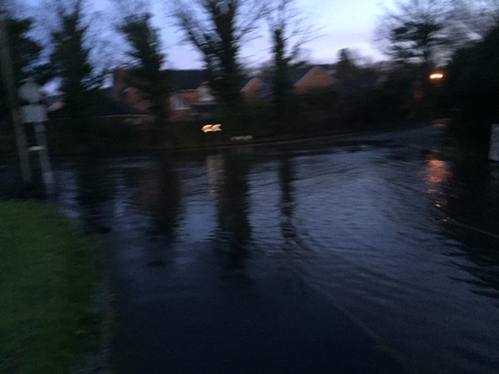
This surface water originates in part from the large agricultural fields on Gamford Lane to the NW of the site and uses the drainage ditch along Gamford Lane where it is stored in a linear reservoir until water volume exceeds capacity storage and it floods properties immediately adjacent to the site in Broadoaks . This foul water then over-spills into the proposed site using Gamford Lane as the conduit and into the dirt track that leads to the Bungalow at the North side of the site. The intention by the Applicant to use the over-capacity drainage ditch as “an alternative method of surface water disposal” (Land Planning Ltd, 2017, p.9) is inherently flawed and ill-considered as the photograph demonstrates.
By means of current context, following the development of Pippin Lane estate, nearly ten years later, the disruption to the natural hydrology is still so significant that flooding in the winter months occurs regularly as illustrated in Photograph 1 and the ability of the Council to rectify this is questionable as the expensive remedial works to reconnect the drainage system to an outflow have been hampered by landowners seeking to develop houses rather than grant easement permissions. On this basis, how can one trust the Appeal of the Applicant to fulfil promises post development that another was never held accountable for within fifty yards of the proposed site?

In fact, whilst he Applicant makes references to ‘other applications of interest’ (Land Planning Ltd, 2017, p.10) in the North Wales area; Gwersyllt, Summerhill and Ruabon – articulating these developments as being precedents for the approval of developments in Green Barrier land. What they conveniently neglect to mention are those examples of developments that have become infamous as planning disasters, namely Glasdir Housing Estate, Ruthin, Denbighshire.

The examples cited as grounds for appeal by the Applicant whilst appearing to be a ‘developers ideal’, they differ with the proposed development in that they did not involve residential development on a flood plain, agricultural land that floods and has the inability to dispose of surface water, which is exactly why this development in Gamford Lane, Rossett, is so similar with that of Ruthin.

Photograph 5: Devastation by flooding due to ill-conceived planning approvals on flood plains in Ruthin, N.Wales.

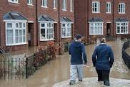

Photograph 6: Devastation by flooding due to ill-conceived planning approvals on flood plains in Ruthin, N.Wales.

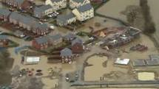

Such was the devastation from this inappropriate development on a flood plain in Ruthin, that the development was abandoned, and four years on, the site was not completed, many residents sought compensation from the developer (which was not forthcoming –no surprise) and typically, the planning authority, local authority and now defunct Welsh Development Agency sought to blame each other as all had referred to it as “a prime development site” (Daily Post, 2014).

I will go on record to state categorically that should the Planning Inspectorate allow this development and my property subsequently floods due to this imposition I will pursue legal redress vigorously against the Applicant and Planning Inspectorate as this situation is highly likely and avoidable with due diligence. The similarities with the Glasdir housing estate, whilst larger in scale, represent a modern “hell” for those residents who were ignored by developers and quasi-governmental organisations akin to the Planning Inspectorate.

Why is it that I am not surprised that the basis of the Appeal by the applicant is that the “assumptions” (Land Planning Ltd, 2017, p.7), not facts, that they naively made in their initial application concerning existing water discharge consent being applicable to the site, when scrutinised, were insufficient to reassure Welsh Water that simply disposing of surface water into the sewerage system really was not an effective solution. It lacked consideration and serves as a tacit acknowledgement of the profit motivation of the few against the stark community impact from such issues. This is further evidenced by their subsequent appeal being reliant upon work that has not been undertaken yet as “further detailed investigations are required” as to the use and effectiveness of soakaways to alleviate flooding on flood plains.

I see the pooling of surface water every year on and around the proposed site and in fact, have rung the Emergency contact for Wrexham Borough Council for the ‘gulley sucker’ to be deployed to remove thousands of litres of water from this location to prevent flooding to my neighbour’s property, these calls are logged via the Command and Control system, were a defined emergency and are thus verifiable facts.
Unsurprisingly, I am not reassured when the Design and Access Statement of the applicant identifies that “surface water run off drainage will be managed on site” as the NRW identify that there is no evidence that the site is suitable for infiltration and as a neighbour to the site, I can clearly testify that the field acts as temporary water storage or ‘sump’ and consequently this proposal is at odds with Section 8 TAN 15 (2004) whereby the development should not increase the flood risk elsewhere and this it clearly does. Such comments are clearly reflected by Welsh Water in their letter dated 05/08/16 and indeed the Welsh Government Planning Policy Wales provides that “development should not create additional run off compared to the undeveloped situation”.

Based upon the above, Unitary Development Plan 1996-2011 specifically identifies that:

“EC12 5.15 Development proposals within areas of flood risk are not only at risk of flooding, but may also exacerbate existing or create new flooding problems on other land or property through reductions in flood plain storage capacity or by impeding flood flows. Flood alleviation measures can only reduce the risk of flooding and can never eliminate the risk. For these reasons, development within land at an unacceptable risk of flooding will not be permitted.”

“EC13 Development which would result in an unacceptable adverse impact on the water environment due to additional surface water run-off will not be permitted”.

“Policy 5.18 Development on green field sites usually results in an increase in the amount of impermeable land. This can alter the natural water cycle as rates and volumes of surface water reaching a surface watercourse generally increase. Drains and sewers generally convey surface water from impermeable areas directly, or via a sewerage system, to a watercourse.”

It is my contention that this Appeal should be refused because of the evidential weight of the factors concerning surface water drainage and localised flooding which when combined are significant and all of these factors were considered during the initial determination.

When one considers the wholly inadequate drainage situation that currently exists immediately adjacent to the proposed site vicinity that was caused by previous housing development of which Wrexham Council is aware and still unable to rectify, then the true gravity of increased surface water flooding upon the safety of adjacent properties such as my own, must be considered as a material objection. Recent examples such as in Glasdir, Ruthin are testimony to the profit motivation of the few at the cost of the many.

- Impact upon protected species
The groundS of appeal by the Applicant simply identifies that because Natural Resource Wales concur with Lancaster (2016) in respect of statutorily protected species, specifically referring to badgers, then “the refusal should be discounted as erroneous” (Land Planning Ltd, 2017, p.9). This is clearly a convenient approach by the Applicant as it pays no credence to the fact that in WBC’s Refusal (2017, p.1)they identify that insufficient information had been submitted to assess what the impact the development will have upon statutorily protected species and does not mean that the impact upon other species such as bats can be ignored.

Contrary to the Ecological Phase 1 Survey, I can categorically state that there is a population of bats living in this vicinity (species unknown) as most evenings they feed upon insects around my house, local people walk in Gamford Lane to see the bats and this mammal uses the Hawthorne hedge opposite as a foraging flightpath.

Lancaster (2016) acknowledges the importance of hedges and trees for bats in the Ecological Phase 1 Survey in that “trees and hedgerows provide two other important resources for bats: as ‘linear land elements’ or navigation features by which bats commute safely and economically between roost and feeding sites” this serves to reinforce the importance of maintaining the hedge and trees on the proposed site and not destroying the environment.

Whilst Lancaster (2016) acts on behalf of the applicant and reports that “no bat signs where found during the survey” he also acknowledges that “survey constraints identify that bats may not be detectable” and that his survey has significant limitations and are reinforced by my testimony. The limitations are clearly day time research, on a sunny, hot day and bats are nocturnal – for one!

On this basis, the Planning Inspectorate should consider as the very minimum, a further comprehensive study to identify the bat species I refer to, identify their roost (due to the derelict buildings surrounding the development site) and foraging locations and afford the necessary protections provided under the Wildlife and Countryside Act 1981 and will thus inform the legal obligation to consider whether bats are likely to be affected by a proposed development (Bat Conservation Trust, 2017).

I have read in detail the Arboricultural Implications and Assessment, Ecology Report Phase 1, the Tree Report, Tree Survey and Tree Specimens Report.

The applicant’s Design and Access statement identifies that the proposed development will “be defined by existing hedgerows”, that “a small selection of trees and a small section of hedgerow is required to be removed” and the General Environmental Report states that “some of the trees will need to be removed for the development to proceed”.

This is an understatement on a grand scale and is misleading - a large proportion of the site will have the existing ancient Hawthorne hedgerows ripped up in order to facilitate access to the site via the main access point and two other access points along Gamford Lane towards the blind bend. From the plans submitted there is in excess of 130m of hedgerow in Gamford Lane alone to be removed, whilst this is a catastrophe in terms of Photograph 4 (as the hedges define and add character to the rural nature of Rossett in this area) it is, I believe, contrary to Wrexham Unitary Development Plan 1996-2011 Policy EC4, whereby:

“Development proposals should provide for the conservation and management of hedgerows, trees, orchards, woodland, wildlife and other natural landscape and water features, and include new planting in order to enhance the character of the landscape and townscape”

In addition, the Highways Assessment (11/08/16) identifies that due to the narrowness of Gamford Lane that a pedestrian pavement will be required along the full length of hedgerow and the carriageway will have to be widened from 4.2m to 5.5m along a large part of Gamford Lane where the current Hawthorne hedge is sited as the other side is a drainage ditch. To accommodate this requirement and junction splays, this amounts to significant destruction of the hedgerow, the habitat it creates and the flora and fauna it supports. Now add into this equation the removal of 12 trees (including 2 groups of trees) of the 20 trees surveyed, this equates to the destruction of 60% of all the trees in this locality irrespective of their condition, some are categorised as being of fair condition or representing distinct landscape features and pertain to species such as Horsechesnut (B2), Beech, fruit trees that are in “extreme decline”; Apple, Cherry and include outstanding specimens of Cherry Blossom opposite my house.

On this basis it is my contention that this proposal does none of the requirements of the Wrexham Unitary Development Plan 1996-2011, it is contrary to the Wrexham Tree and Woodland Strategy (2005) as it does not “contribute to a better quality environment” as in effect the environment and biodiversity is being irrevocably destroyed for profit and on this basis the Appeal should be unequivocally rejected.

- Resource implications in Rossett

Currently, the local Doctor’s Surgery, Dentist and local schools (St.Peters Primary and Darland Comprehensive) are full to capacity and on this basis the new proposal does not “integrate well into the structure of the village” and will only exacerbate the demand that currently outstrips supply.

Indeed, the Wrexham Unitary Development Plan 1996-2011, Policy GDP2 states that “where the capacity of infrastructure, including community facilities, is likely to be deficient as a consequence of new development, a planning agreement/obligation will be negotiated whereby the developer provides the additional capacity either on or off-site, and/or provides funding for the Council to provide the additional capacity itself. Requirements will be fairly and reasonably related in scale and kind to the proposed” and Policy GDP2 4.6 identifies that “changes in population resulting from new housing can exert pressure on the availability of school places. Locally, there is an increasing mismatch of education demand and supply”.

It is on this basis that the Appeal should be rejected.

- Summary

I believe the Appeal submitted by the applicant should be rejected based upon individual adverse impacts and consideration of all the collective weight and synergistic effects that when viewed together are massively undermining of the grounds for appeal and relate to significant issues for individuals such as I, that form the local community; flooding, risks of flood plain development, drainage network issues, destruction of the environment and reduction of local amenity and irreversible development of the Green Barrier that forms part of Rossett, to name a few.

Furthermore, it is apparent to me that the basis upon which the Appeal is made does not stand scrutiny, it relies upon unsubstantiated statements, blinkered arguments and the evidence that underpins them is superficial to say the least. Ultimately, the Applicant presents nothing of evidential weight or fact that would outweigh the initial determination and refusal of the Planning Authority and consistently wrestles with the fact that the Applicant (or agent Land Planning Ltd) does not like the Refusal or the fact that their initial planning application considerations were insufficient to meet the threshold test. This dissatisfaction does not naturally form the basis of Appeal, but one would think so having read the Applicants ill- conceived submission.

Please accept this letter and the ‘material planning considerations’ contained as a critical review of the Applicants Appeal from the perspective of a local resident who will be directly impacted upon unless it is rejected. It is these considerations that I would like you take account of in your decision making as to whether to approve or reject the Appeal in accordance with due diligence expected of a member of the Planning Inspectorate on behalf of the majority of people in Rossett.

I would also add that in respect of Land Planning’s comment that “development within Rossett is inevitable”(2016, p.4) – I believe this to be presumptuous, inaccurate and does not take account of the Appeal process whilst serving as evidence of profit motivation and illustrates their scant regard to the intelligence and lack of respect for the residents of Rossett.

I would be keen to attend the Appeal Hearing.

Yours sincerely,

Simon Draco BSc (Hons), MSc

-   :6 "" =
#%?%@53
937+"33$%
 +AB$%37%C
3'7$%
?%
+ @777$%$
>735,

