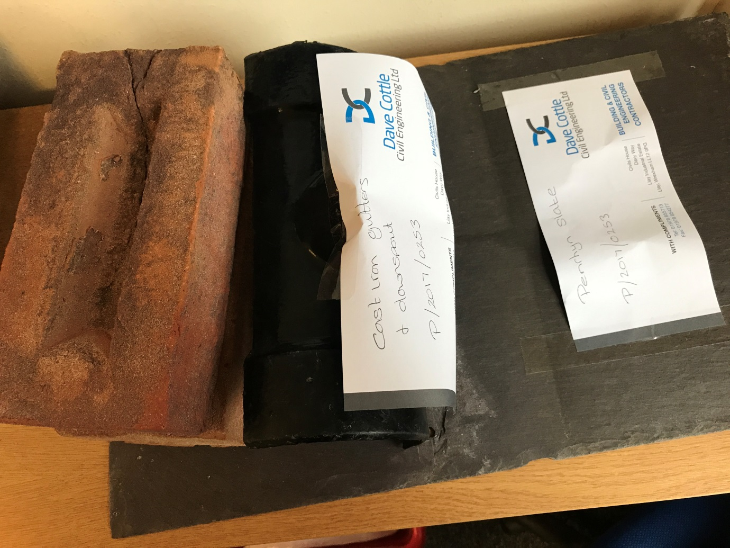
P/2017/0253 – Material samples

