PURE PLANTSCAPES
THE STUDIO, 17 SPRING ROAD, WREXHAM, LL112LU
Tel: 07931 383196 email: clare.2.dillon@gmail.com

PROPOSED PLANTING PLAN FOR JEFFREYS ROAD, WREXHAM
OVERVIEW
The new development on Jeffreys Road, Wrexham is a single block of residential dwellings. Externally, to the rear, there is a planned car park and green space. We propose to plant one specimen tree in this area – referred to on the plan as TREE A. The site adjoins Acton Park and the proposal here is to plant two native species of tree within the boundary of the park itself – referred to on the plan as TREE B and TREE C respectively. This proposal will outline the planting plan for each tree, including any considerations and assessment of the surrounding environment and a maintenance schedule.
CONSIDERATIONS
When planting in or near residential areas it is vital to choose the species of tree carefully. Consideration of proximity to surrounding buildings and to other features such as footpaths, water sources, roads or car parks is essential. In this case, the potential overhang of branches or debris from the trees and the possible effect this would have on cars using the car park has been taken into account. The particular species that have been recommended have been chosen for their overall suitability for a site of this type.
It is also extremely important to factor in the eventual height and spread of the trees at maturity. Other considerations to take into account when deciding on the suitability of a particular species include; whether the tree will bear fruit or produce a sap; its form, habit and density of canopy (particularly with regard to causing shadows); its interest to wildlife; as well as the usual aesthetic considerations.
The trees proposed will not only provide beautiful screening, protecting and improving the residential amenity but will also help to delineate the revised park boundary and provide a welcome habitat for a number of different wildlife species.
PLANTING SCHEDULES
TREE A – within the grounds of the development
Sorbus Hupehensis ‘Pink Pagoda’. Common name - Mountain Ash
This is a delightful ornamental tree recommended for its year-round interest. Beautiful spring blossom, followed by bright berries (attracting wildlife)and fabulous colour in autumn. In winter it loses its foliage to leave a pleasing form. This variety is compact and perfect for the suburban garden with a maximum Height of 6m and Spread of 3m. Time to maturity is 20 years.
- A planting hole of 600mm in depth and 600mm in width to be excavated and slow-release fertiliser added to the hole prior to planting.
- Once firmed in, the young tree will be staked to a height of approximately 1/3 of the leading stem height, using a length of 300mm x 300mm treated timber post and tied in using biodegradable hessian straps.
- The tree will then be well watered in and the surrounding bare soil top-dressed with a bark mulch to aid moisture retention
*Tree height at time of planting will be between 180-240cm
NB. It is recommended that Tree A is situated in the space that the temporary site office currently occupies. The reasons for this are as follows:
- Land which has heavy machinery rolling over it repeatedly will be extremely compacted and therefore poses certain problems – not just for the excavation of the planting hole but more crucially for the healthy development of the tree’s root system.
- In areas where concrete and cement have been mixed, the resulting residue is toxic to plant life. Areas that have been utilised in this way will require significant excavation and testing to ensure all contaminated soil is removed and fresh mid and topsoil added in order to plant safely.
The proposed site for Tree A has therefore been selected as this is an area that has been untouched by machinery during the build.
TREE B – within Acton Park
Betula pendula (alba). Common name - Silver Birch
A native favourite which can be found in other areas of Acton Park. This deciduous tree has a graceful and pendulous habit, with small, serrated leaves allowing for a light and airy canopy. The tree produces catkins in spring. Its silvery-white bark cracks with age, adding to its stark beauty, particularly in winter. Max height and spread are 7m x 4m. Time to maturity is 20 years.
The tree will be located as detailed on the plan L(9)01 Rev O 4m from the boundary.
*Tree height at time of planting will be between 300-600cm
- A planting hole of 600mm in depth and 600mm in width to be excavated and a slow-release fertiliser added prior to planting.
- Once firmed in, the young tree will be staked to a height of approximately 1/3 of the leading stem height, using a length of 300mm x300mm treated timber post and tied in using biodegradable hessian straps.
- Well watered in and the surrounding bare soil top-dressed with a bark mulch to aid moisture retention
TREE C – within Acton Park
Betula pendula (alba) – treatment as for Tree B
NB. Please be aware that the planting season for Betula pendula is late autumn/early winter. November would be the ideal time to plant as these young trees are delivered dormant and bare-rooted from the nursery at this time of year.
The tree will be located as detailed on the plan L(9)01 Rev P 4m from the boundary and 6m from tree B

MAINTENANCE SCHEDULE
The trees will require periodic observation and maintenance as and when required. annually is the recommendation here. Issues such as disease, deadwood, fungus (especially honey fungus) and vandalism may affect the trees and these problems can be tackled accordingly with regular monitoring. The stakes and ties will need checking and (if not already biodegraded) will require removing after around 3 or 4 years, subject to growth rates. In periods of drought, remedial watering will take place to ensure healthy growth. The die-back of leaves will also be monitored and assessed and action taken if and when required.

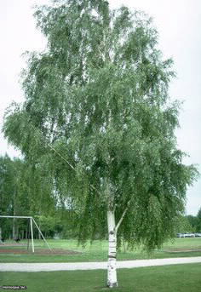 Betula pendula – Silver Birch

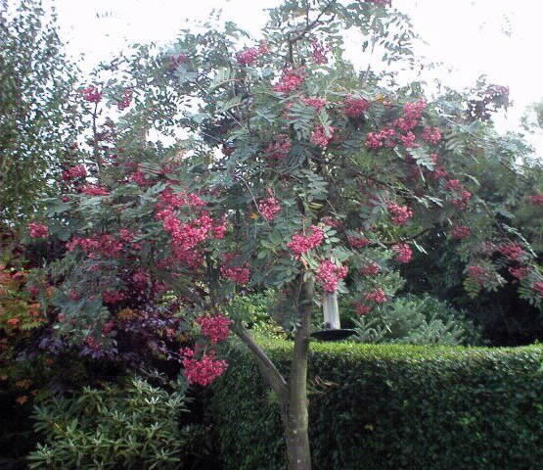 Sorbus Hupehensis – Mountain Ash

