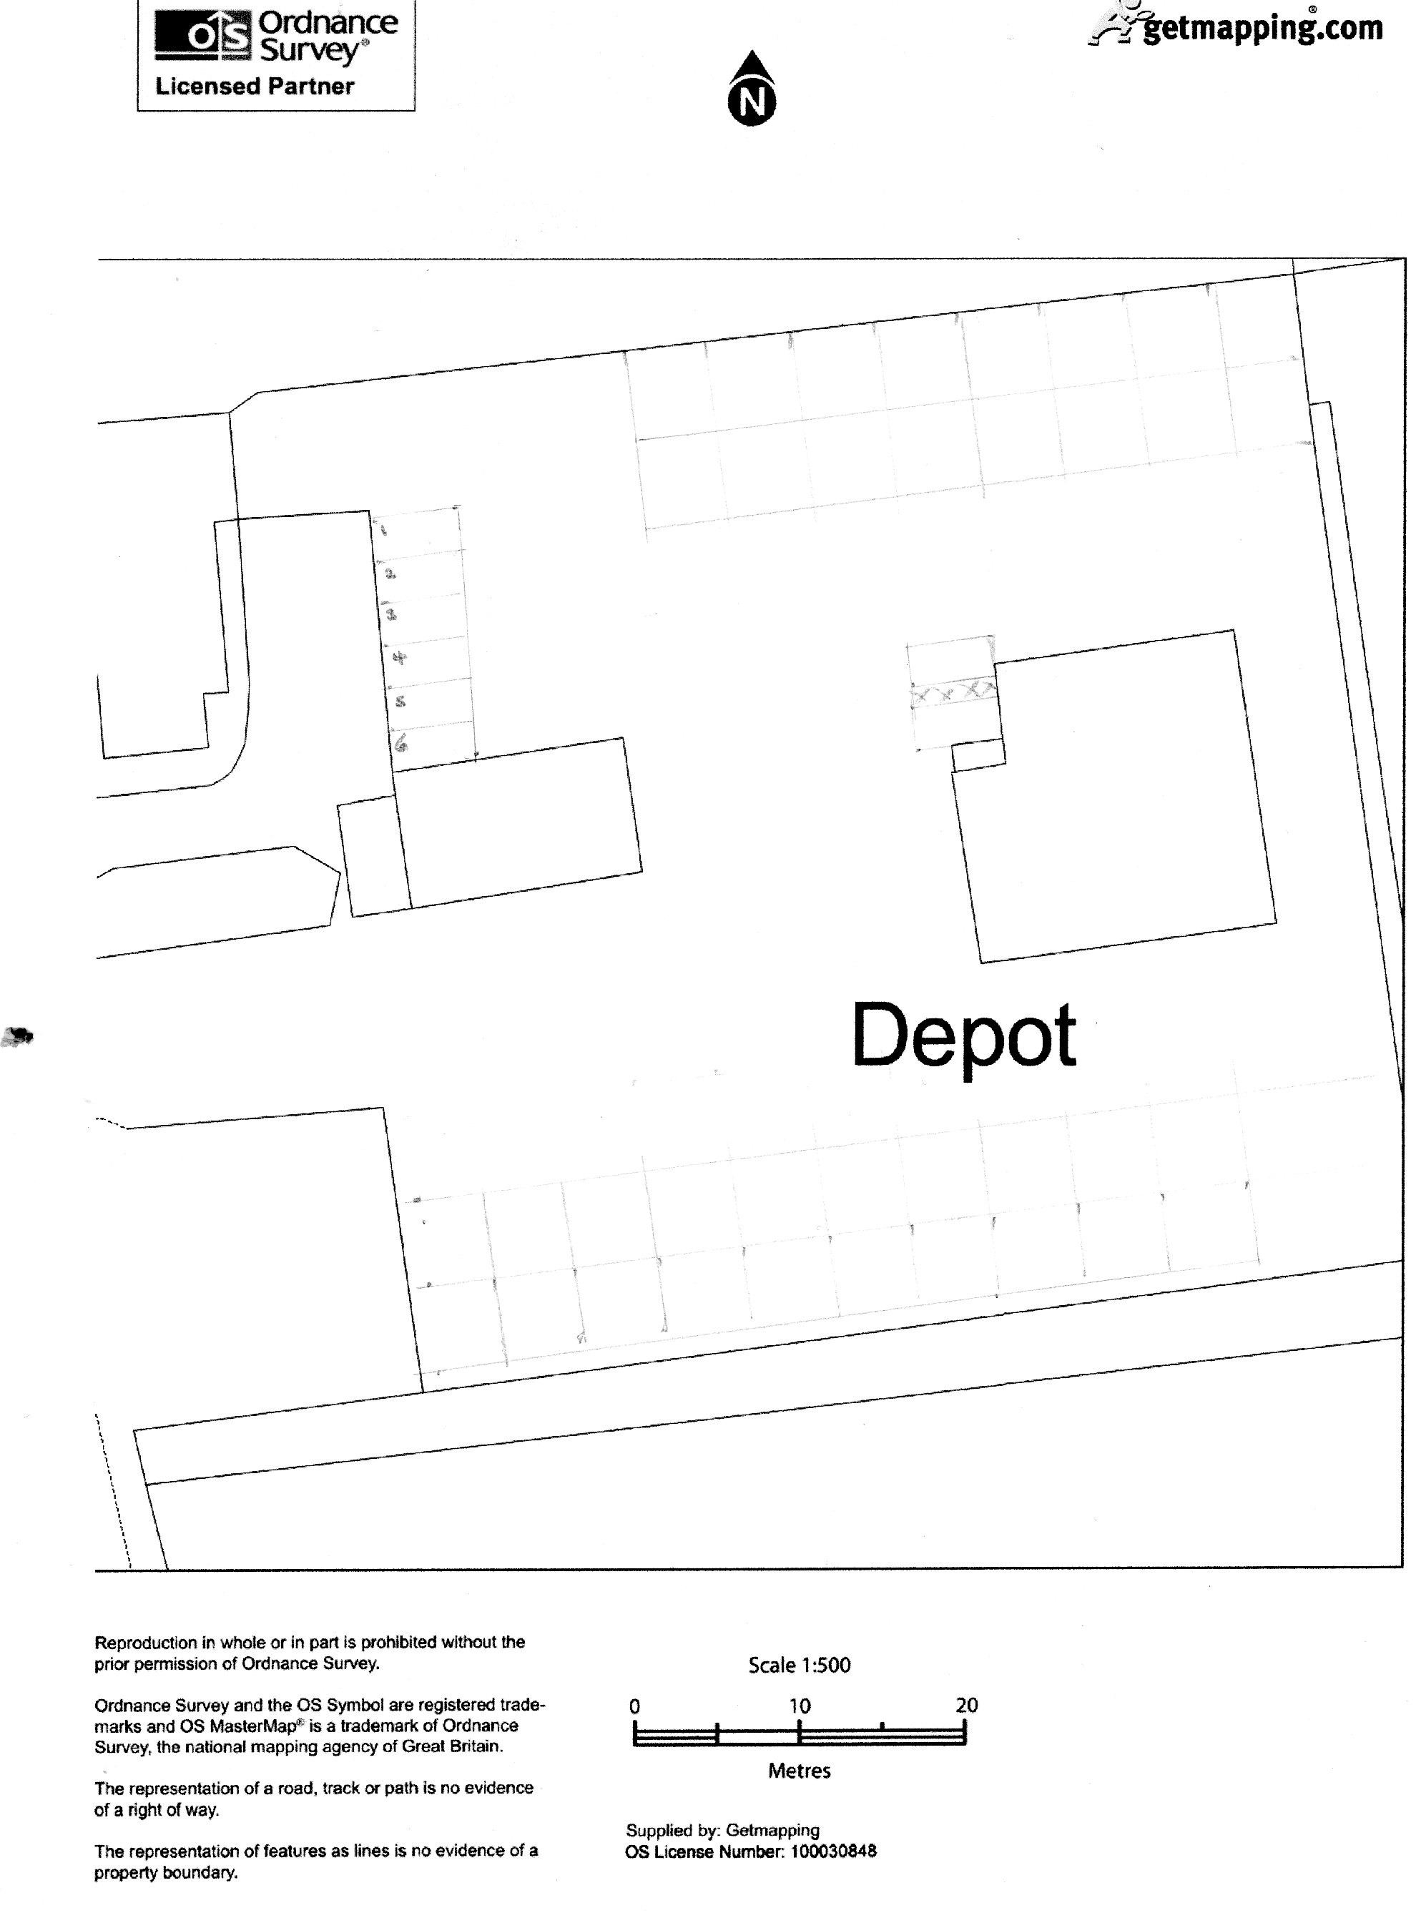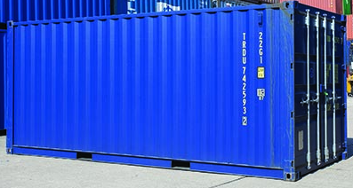
7 8
Staff parking
Equipment housing
6m x 2.44m x 2.59 high
Colour to be agreed
* Proposed office

10 metres long by
3.4 m wide by
3.4 m high
parking of tractors for sale
Building B
To be used for repair and servicing of tractors and agricultural machinery

Wash bay
Building A
Use for the display of vehicles for sale

Existing building demolished
Wash Equipment container (see below)
Cantilever canopy
Gable 1
C
A

Rev 12
Ex office.
re-used as parts store
Proposed *office unit
2 disabled parking spaces
Tractors awaiting repair

