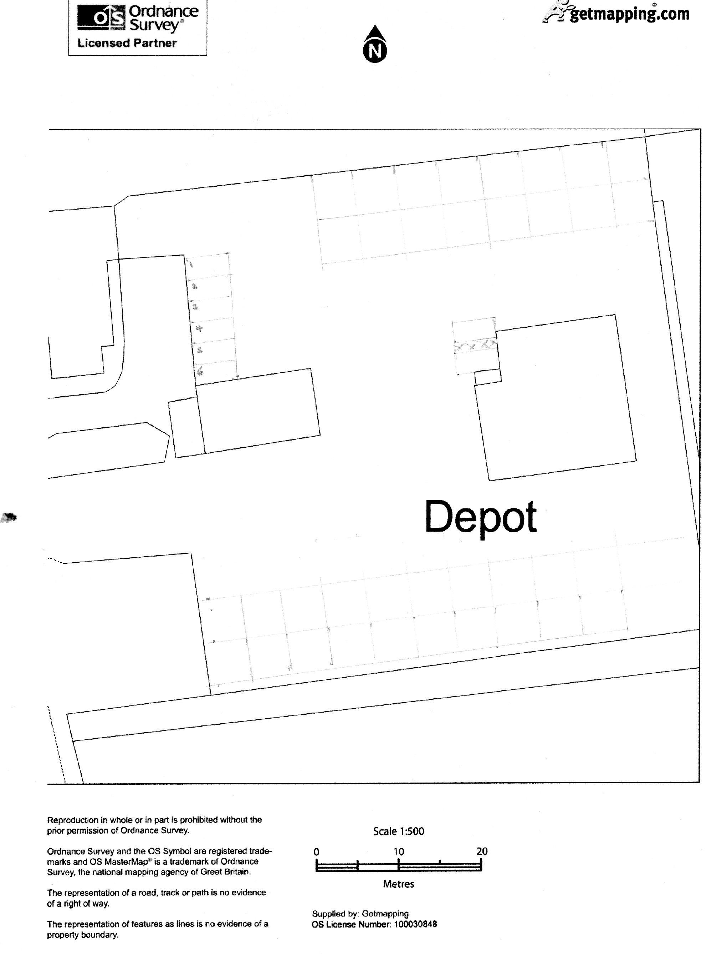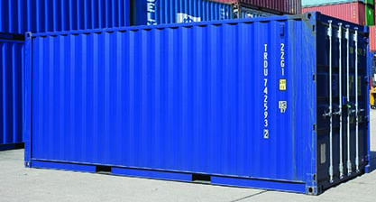
Equipment housing
6m x 2.44m x 2.59 high
Colour to be agreed
Wash Equipment container (see below)
Building B
Cantilever canopy
Gable 1
C
A
Wash bay

Rev 8
Ex office.
re-used as parts store
Proposed office unit
Building A
Tractor parking
2 disabled parking spaces
Staff parking
Tractors awaiting repair

