Landscape and Visual Summary

Erection of a Free Range Egg Production Unit including silos and associated works

On behalf of E & J Morris

July 2015

Roger Parry & Partners LLP
www.rogerparry.net
oswestry@rogerparry.net
Tel: 01691 655334



Landscape and Visual Summary

This section of the Design and Access Statement (DAS) presents the summary landscape and visual findings relating to the proposed free range egg production unit at CaeMor.

A full description of the proposed development is contained within Section 2 of the DAS but can be broadly summarised for landscape and visual purposes as one building 76 metres long and 19.8 metres wide and 3.35 metres to eaves and 7.15 metres at the ridge. Two silos would be associated with the buildings at the South Westerns end, each to a height of 6.03 metres.

The proposed building would be situated within approximately 195 metres of the existing CaeMor Farm complex and adjacent to the B4579 where a new access will be created to the proposed building. CaeMor currently consists of the farmhouse itself, with agricultural buildings set at various orientations within the landscape (as per the location plan).

The proposed poultry unit would be broadly orientated Northwest to Southeast and set within the open countryside at approximately 200 metres AOD, outside of the defined settlement limits of Llwynmawr.

The proposed agricultural building is situated within a Special Landscape Area. Within the Landmap evaluation (Visual and Sensory Layer) the proposed site is situated within the Berwyn Foothills Aspect Area which has an overall evaluation of ‘moderate’.

The proposed development would be of a similar size of several local agricultural buildings currently located in the area and would be located in proximity to these existing buildings at CaeMor. The appearance and materials/finishes of the proposed development would be typical of local agricultural buildings with the aim to fit with the local style and character of built form.

To the North and South of the site, the landform gently rises and gently slopes down to Llwynmawr, approximately 1.4 km away. The slope of the land is such that the existing CaeMor built form is generally screened by intervening land from the North (see Photo 1), with only intermittent and partial views of the existing built form in a Westerly view from unclassified roads. The nature of the landform around Llwynmawr itself, ,means that the low elevation of the village in relation to the existing farm complex and proposed development results in no visibility of the existing farm complex from the settlement. This would also be the case for the proposed development.

Views of the proposed development from the wider landscape would generally show partial built form, consistently seen in the context of existing buildings of similar size, style and colour, where the proposed agricultural building would be seen as a limited extension to the overall farmstead and would not be prominent or dominant within views.
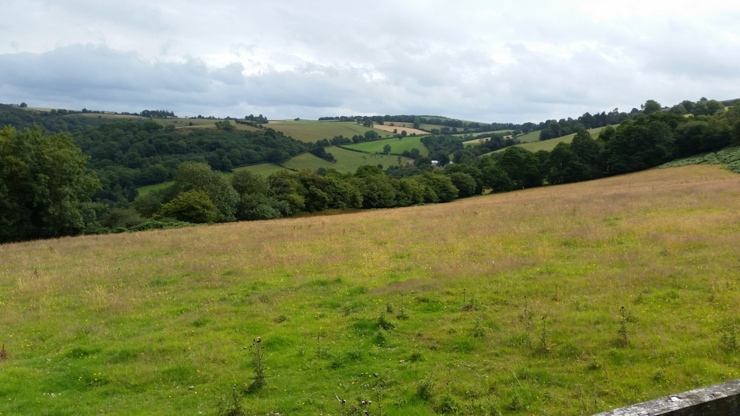

Photo 1: View of the site from the existing access into the field
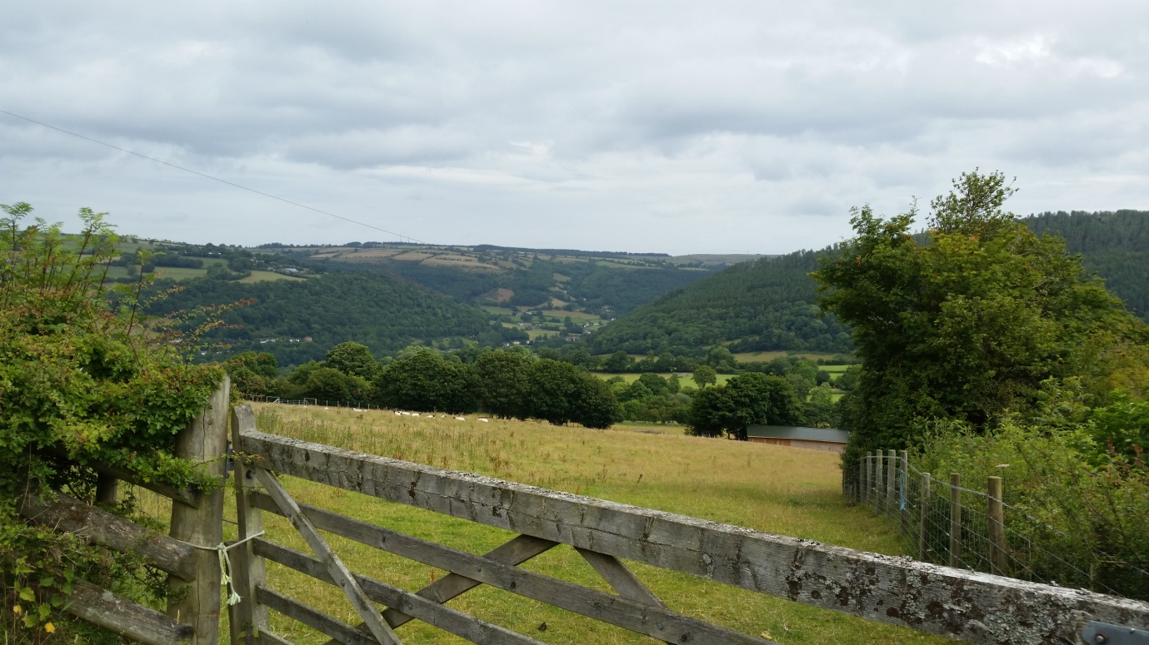
Photo 2: View towards Llwynmawr from B4579 at CaeMor

In Planning Policy terms, Planning Policy Wales (Edition 7 July 2014) in paragraph 7.3.3 states that “local planning authorities should adopt a positive approach to development associated with farm diversification in rural areas, irrespective of whether farms are served by public transport. While initial consideration should be given to adapting existing farm buildings, the provision of a sensitively designed new building on a working farm within existing farm complexes may be appropriate where a conversion opportunity does not exist.”

Location Options

A full farm holding appraisal was carried out in order to determine the most suitable position for the building. ( Refer to attached drawing )

Option A
- This area of land is approximately 10acres and will provide in sufficient ranging areas for the birds.
- The unclassified road leading down to the proposed position would be unsuitable for deliveries and collections.
- There is no natural screening on any elevations

Option B

- The unclassified road leading down to the proposed position would be insufficient for deliveries and collections
- The land and levels to this area are unsuitable to form a level base and access for the unit, a large infill of imported material would be required which would raise the building higher and would not have any natural screening.
- The building would be in very close proximity to the public footpath.
- A high voltage overhead cable runs above that field which would need to be moved.

Option C

- The access to the site can be created from the B Classified road and provide suitable visibility splays and create a new access road across the field to the unit.
- The land and levels to this area are steeper, this would require a large amount of excavation to achieve the building base and cause a large ammount of disturbance to the existing grasses and fauna
- Although deep excavations would provide natural screening to the rear and sides to the North Elevation will be unscreened.
- We discussed this position with the bio Diversity officer and it was felt to be better to move to Option D

Option D

- This is our preferred option
- The Unit position provided a clear access point from the B4579 with good visibility splays for access and egress
- The unit is centrally positioned within the holding to provide efficient range management.
- The position of the building allows natural screening by trees and hedgerows.
- There will be a reduced amount of excavation and disruption to existing levels and the building sits more naturally into the landscape and surroundings .

Conclusions

As identified within the Landmap classification, this is a landscape with a clustered settlement pattern, medium scale and diverse character. The area has muted colours and an organised pattern, frequent human access and a weak sense of place/local distinctiveness with an overall evaluation of moderate.

As such, the introduction of the proposed agricultural building within the context of the existing farmstead would not impact upon the local landscape character to a significant degree; the proposed building would be in keeping with the size and design of the existing surrounding buildings and would not significantly extend built form into the open landscape.

In visual terms, the proposed development would not be prominent or dominant in any views beyond Cae Mor. Given the size of the existing farmstead, the proposals would not significantly extend the built form of the farm within any views, with the result that the proposed building would be only a discernible addition in some views, as indicated by the photograph illustrations above.

In policy terms, the proposal complies with farm diversification measures set out with Planning Policy Wales.

