To: | Peter Jones
From: | Tony Johnson | Email: | tony.johnson@atkinsglobal.com
Phone: | 01925238330 | Date: | 09/06/2015
Ref: |  | cc: | Peter.Jones@wrexham.gov.uk
Subject: | Western Gateway FCA spine road update - Clarifications to Planning Conditions
Condition 2.
The image below shows pre (Blue) and post (Red) spine road development scenarios (0.1%AEP) flood extent. As can be seen there is a slight localised change in flood modelling extent associated with the spine road although the overall extent is greater under the pre spine road scenario as the road alignment does not flood under the 0.1%AEP. The flood level in this area is 95.407m AOD. This has been checked against the levels in and around this area. Figure 1 below shows that ground levels are generally higher on the northern side of the green line. The flood risk depicted in the model output below is a function of the model resolution. The flood cells are 5m grid squares. If part of that flood cell is below the flood level then the whole cell will be mapped as flooded whereas in reality the majority of the 5m grid square would be free from flooding. This seems to be the case in this instance where the model resolution has indicated that flooding north of the green boundary line yet further examination of the model flood level and ground levels suggest that this is not the case.

Figure 1 – 0.1%AEP pre and post spine road development

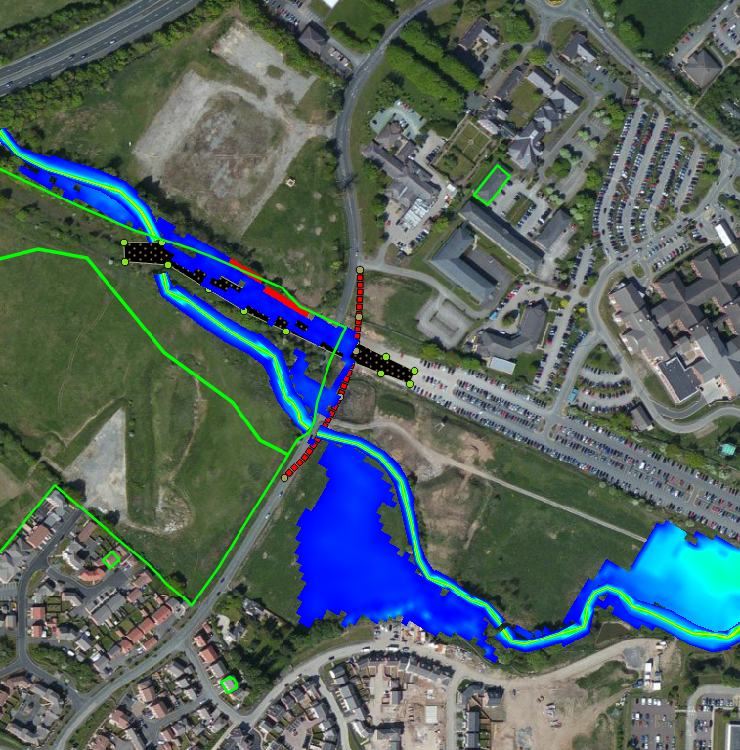
95.46m AOD
95.48m AOD

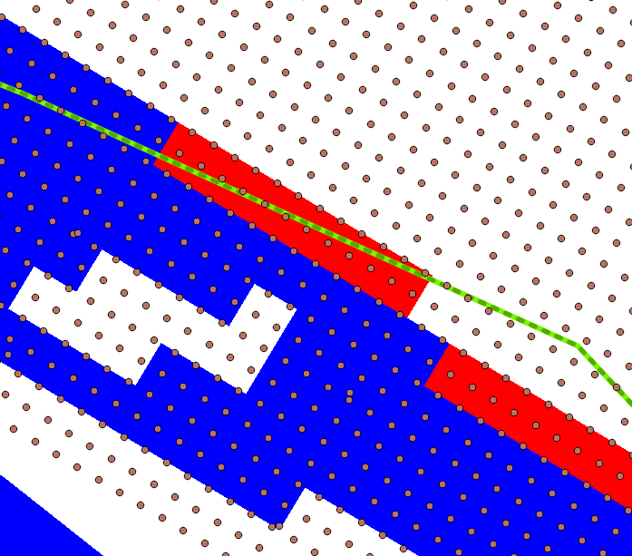
95.52m AOD

Condition 3, 4, and 5.
All proposed work (temp and permanent) will be undertaken above the soffit of the existing culvert. No works are proposed within the channel and flow capacity will be maintained at all times.

The representation of the new spine road alignment in the TuFlow model is an approximation of the more detailed plan provided as part of the detailed design process. The general principles (i.e. low spot) and elevations across the long section in both the TuFlow model and the latest detailed design drawings have been checked for consistency. Model and detail design drawing elevations are illustrated below. It can be confirmed that the latest design drawings and elevation across the road alignment are inline with those set out in the FCA and in the TuFlow model.

Figure 2 – Spine Rd alignment elevations.
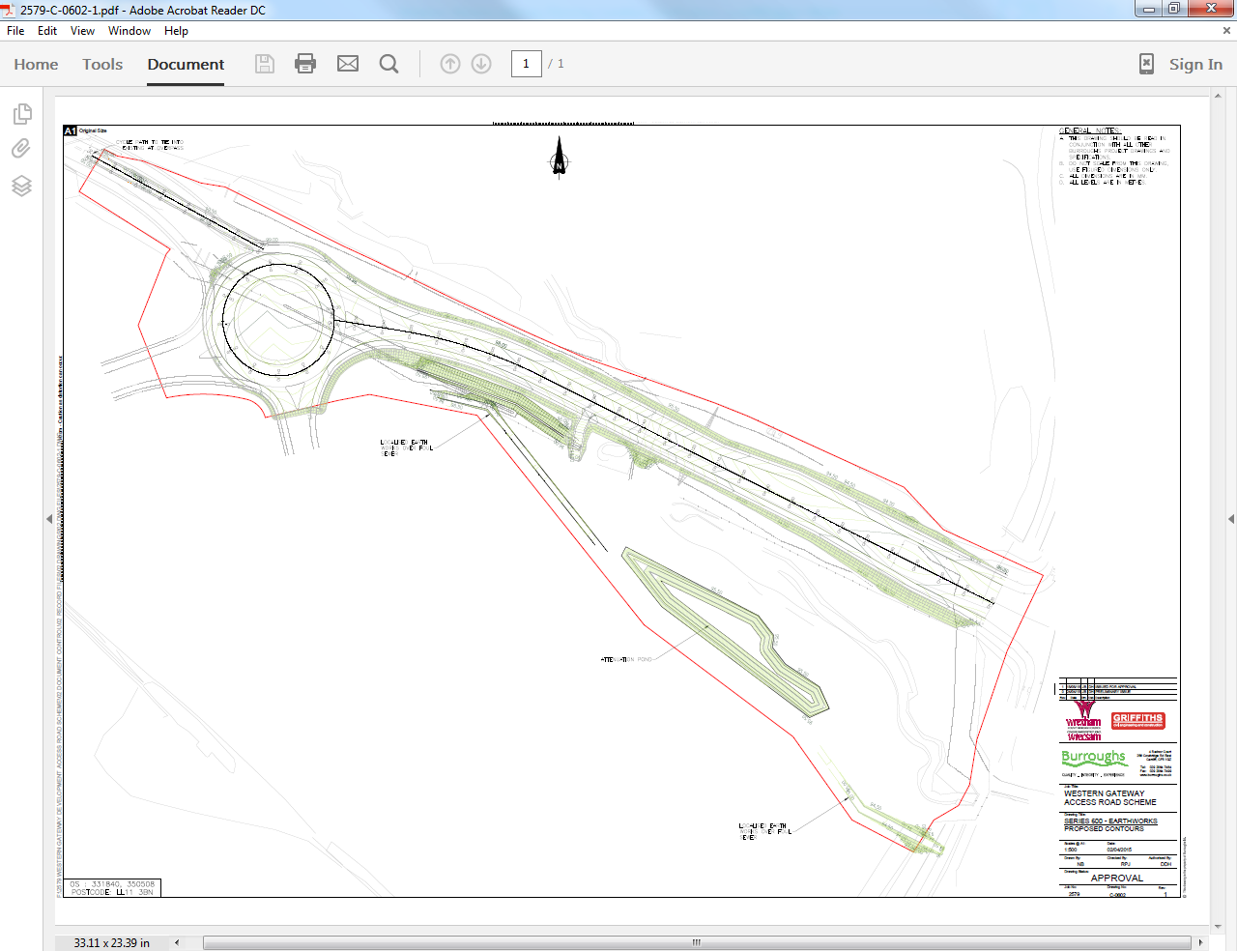
Approx Changage 130m
TuFlow Model = 96.6m AOD
Detailed Design Drawing = 96.6m AOD
Approx Changage 90m
TuFlow Model (Approx Level) = 95.8m AOD
Detailed Design Drawing = 95.8m AOD
Approx Changage 30m
TuFlow Model (Approx Level) = 96.2m AOD
Detailed Design Drawing = 96.2m AOD

Otter Pipes.

The otter pipe has not been modelled in the 2d model. The flood model is not sophisticated enough to model such structures in the 2d domain with any degree of accuracy. This is the case for most 2d flood models. Therefore, an alternative approach to flood calculation has been undertaken. At present, the 600mm otter pass has an invert elevation of 94.855m and is approx. 25m long. To check the flow through this circular concreate pipe and the potential impacts of pass forward flow on downstream levels, a simple Colebrook-White calculation has been undertaken. Based on these dimensions and an assumed gradient of 0.001 (design suggests a zero gradient), the flow capacity is 0.04m³/sec. The relationship between flow and stage in the Afon Gwenfro (pseudo rating based on the Q100 design event) suggest a change in water level of less than 0.01m. The change in water level and downstream flood risk associated with the otter pipe is considered to be negligible.

