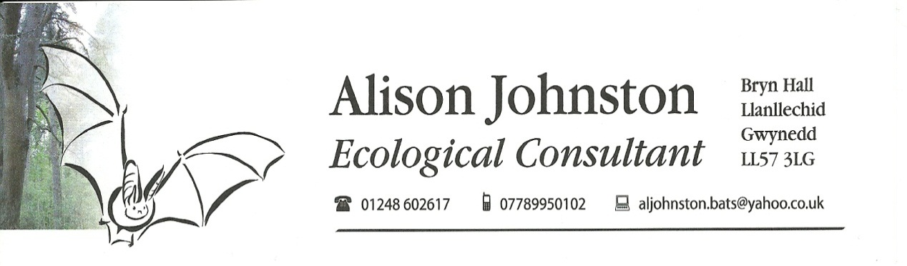

Protected Species Survey Report
Gredington Arms, Holt Road, Wrexham

Planning Application Number: P/2014/0651

Grid reference SJ 3676 5188

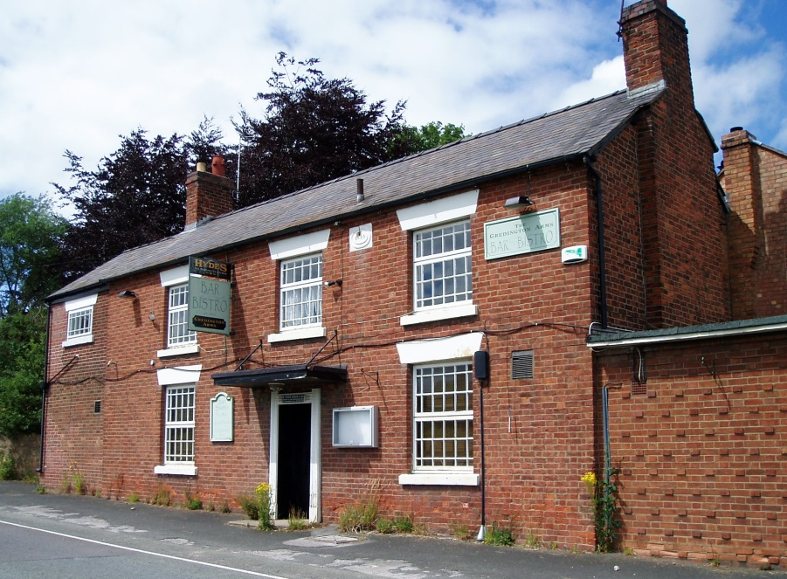

Undertaken by Alison Johnston Ecology

July 2015

- Introduction

  - I have been commissioned to undertake a bat survey and record other ecological issues at and around the buildings at the Gredington Arms, with reference to a planning application for conversion of the buildings into residential accommodation. The Gredington Arms site is located at grid reference SJ 3676 5188. The building and site survey were carried out on the 20th and 21st July 2015 and the dusk emergence surveys carried out on the 20th, 21st, 22nd and 23rd July 2015.

  - There are essentially two buildings on the site, the pub and the barn.

The pub is a two storey building of red brick construction with a pitched slate roof, there are numerous extensions attached to the pub with a combination of flat felt roofs and single pitch slate. There are gaps behind the wooden soffits, under slates and lead flashing. There is ivy and bramble growth of sections of the rear of the building. The roof voids in the building, which are felt lined, have a lot of cobwebs throughout.

The barn is a two storey building also of red brick construction with pitched slate roof. There is no roof void in the building, with the first floor being open to the beams. There are multiple gaps under the bottom layer of slates, many of which have slipped.

  - The site as a whole mainly consists of the buildings, car parking/hard standing and an area of over grown pub garden. To the north on the site boundary there is a strip of large trees and scrub including oak, damson plum, holly, hawthorn, sweet chestnut and elder. There is a section of red brick wall on the northern boundary of the car park, in which there is an entrance to a cellar/underground area built into the bank.

  - All bat species are protected under the Wildlife and Countryside Act 1981 as amended by the CRoW Act 2000 and Conservation (Natural Habitats, &c.) Regulations 1994 which states that it is illegal for anyone without a licence to intentionally or recklessly kill, injure, capture or handle a bat of any species in Britain; to disturb a bat when roosting; or to damage, destroy or obstruct access to any place that bats use for shelter, whether bats are present or not.

  - All wild birds are protected under the Wildlife and Countryside Act 1981 (as amended), making it illegal to:

- Kill, injure or take any wild bird (unless under licence)
- Take, damage or destroy a bird’s nest whilst it is in use or being built
- Disturb any wild bird listed on Schedule 1 of the Act while it is nest building or at a nest containing eggs or young, or disturb young of such a bird.

- Methods

  - Daylight inspection

Both the interior and exterior of the buildings were, where possible thoroughly inspected for bats or any indications of the presence of bats. Such as scratch marks, lack of cobwebs, droppings or oil staining from bat’s fur, audible squeaking and the presence of moth wings (indicates bat feeding perch). All crevices were inspected, so far as possible.

The presence of any other protected species or species of note was also recorded during the survey following the guidelines from the Chartered Institute of Ecology & Environmental Management (CIEEM).

2.2 Dusk emergence survey

From approximately half an hour before dusk the buildings were watched for bats or birds entering or exiting the building. Bat detectors were used to survey for emerging bats, which can convert the ultrasonic sounds emitted by bats into sounds audible to the human ear. These sounds can also be used as an aid to the identification of the different bat species. For this survey AnaBat and Batbox Duet bat detectors were used and any bats heard were recorded for analysis.

- Results

  - Daylight inspection and walkover survey – 20th May 2015

At approximately SJ 36784 51920 there is a brick wall with what appears to have a cellar/underground area built into the bank. No evidence of bats was found to be using the underground area during the survey, however it does have potential to be used by bats

There is a large amount of rabbit activity on the site, with many burrows. One borrow at approximate grid reference SJ 36823 51923 had been enlarged and a badger hair was found in the spoil from the hole. To the west of the hole there is an obvious mammal track into the scrub up the bank which has visible claw marks see photo numbers 7 and 8.

No bat droppings or signs of bat activity were found during the external building survey.

There is a bird nest behind the soffit on the east side of the chimney on the rear extension of the pub.

Daylight inspection of buildings – 21st May 2015

The roof voids of the pub buildings were checked for bats and evidence of use by bats, although none was found and e voids had a lot of cobwebs in them

It was not possible to access the first floor of the barn as it has been screwed shut to prevent people breaking in.

  - Dusk emergence survey north west side of pub building – 20th July 2015

On the day of the survey it was warm with occasional short showers. There was approximately 60% cloud cover.

Time | Temperature °c | Rain | Wind (Beaufort scale)
21:00 | 16.4 | 0 | 3
21:30 | 15.5 | 0 | 3
22:00 | 14.6 | 0 | 3
22:30 | 14.0 | 0 | 3

Results

No bats were observed exiting or entering the building during the dusk emergence survey.

Both soprano and common pipistrelle bats were observed flying past the rear of the building from a south westerly direction and feeding along the tree line. In addition a Noctule bat was heard but not seen at 22:23 hours.

An AnaBat detector was placed outside of the underground chamber during the survey, which recorded the following bats:

Time | Species
21:42 | Common pipistrelle
22:04 | Common pipistrelle
22:08 | Soprano pipistrelle
22:11 | Noctule
22:13 | Common pipistrelle x 3
22:16 | Soprano pipistrelle
22:16 | Noctule

Dusk emergence survey, rear of the buildings between the pub and barn – 21st July 2015

On the day of the survey was hot and dry. There was approximately 60% cloud cover.

Time | Temperature °c | Rain | Wind (Beaufort scale)
21:00 | 19.4 | 0 | 3
21:30 | 18.5 | 0 | 3
22:00 | 17.9 | Spitting with rain at 22:20 | 3
22:30 | 17.5 | 0 | 3

Results

No bats were observed exiting or entering the building during the dusk emergence survey.

Both common and soprano pipistrelle bats were observed feeding to the rear of the buildings. A Noctule bat passed over the pub from north to south west at 21:57 hours.

Dusk emergence survey south west corner of building – 22nd July 2015

On the day of the survey it was mostly dry and warm, with some showers around mid-day. There was approximately 80% cloud cover.

Time | Temperature °c | Rain | Wind (Beaufort scale)
21:00 | 13.5 | 0 | 2
21:30 | 13.0 | 0 | 2
22:00 | 13.0 | 0 | 2
22:30 | 13.4 | 0 | 2

Results

No bats were observed exiting or entering the building during the dusk emergence survey.

Both common and soprano pipistrelle bats were observed feeding and flying along the road and hedgerow. A Noctule bat has heard but not seen at 21:55 hours.

A barn owl was observed flying past the rear of the building at 22:05 hours.

Dusk emergence survey – 23rd July 2015

On the day of the survey it was warm and dry. There was approximately 95% cloud cover.

Time | Temperature °c | Rain | Wind (Beaufort scale)
21:00 | 16.8 | 0 | 3
21:30 | 16.6 | 0 | 3
22:00 | 16.2 | 0 | 2
22:30 | 15.6 | 0 | 2

Results

Common pipistrelle, soprano pipistrelle and Noctule bats were recorded during the survey.

- Proposed building works

  - I understand the buildings are due to be converted into residential accommodation. As part of this work the length of the barn will be reduced by moving the southern gable end of the barn approximately 1/2m north, to allow for better sighting along the road.

  - I understand that an additional planning permission has already been submitted regarding the building of houses on the land at Gredington Arms and that this application had its own ecological surveys carried out.

- Assessment

  - No bats were observed exiting the building during the dusk emergence surveys and no evidence of bat as found during the survey.

  - It was not possible to survey the first floor level of the barn at the time of the surveys as the doors had been screwed shut in such a way to prevent people breaking in. I have been informed that the underside of the slates have been sprayed with insulation making access into the barn from under the slates very difficult for bats.

  - The bat survey was carried out during the key bat activity.

  - A bird’s nest is located behind the soffit on the east side of the chimney on the rear extension of the pub.

  - The results of the COFNOD data search shows records of great crested newts, badgers, otters and grass snake within the 1000m search area along with a number of moths and butterfly species, see the attached COFNOD for more details.

  - In recent years the new Holt Road A534 has been built to the north of the site, as part of this scheme survey work would have been undertaken for all protected species. No record could be found online of this information and it wasn’t included in the data provided by COFNOD, but it is likely that the survey work covered the area of the Gredington Arms site.

- Conclusions and Recommendations

  - As no bats were observed exiting the buildings during the dusk emergence surveys and no evidence of bats was found, no development licence will be required at this time. However if works to the building are not started within two years it is recommended that an additional survey is undertaken in case bats have taken up resident since this survey.

  - As the COFNOD search shows both badger and great crested newts nearby the site, caution should be taken if any trenches or pits have to be dug. These should not be left open or uncovered overnight unless some means of escape is provided for both species, for example a wooden plank.

  - Care should be taken when storing materials onsite. Where possible they should be stored on pellets of the ground to prevent them becoming artificial refugia for newts or in the case of sand etc. which should not be left onsite for a long period of time in case badgers decide to dig into them.

  - Contractors working onsite must be made aware that there is always a possibility that bats may be present within the building while they are undertaking roofing repairs and conversion work. Work should stop immediately and the licenced bat worker (Alison Johnston 0789950102) or Natural Resources Wales (NRW) should be informed immediately if any bats are found or if the presence of bats is suspected. All bat species are protected under the Wildlife and Countryside Act 1981 as amended by the CRoW Act 2000 and Conservation (Natural Habitats, &c.) Regulations 1994.

Alison Johnston CIEEM
Ecological Consultant
29th July 2015

NRW Licence No. 55887:OTH:CSAB:2014

Unless you request otherwise, we intend to share all relevant biological survey data with the appropriate Local Records Centre.

This report may be copied, reformatted or re-bound. However the content of this report should not be deleted, reworded or otherwise altered without the agreement of the author.

Photograph 1. Gredington Arms – west end of pub

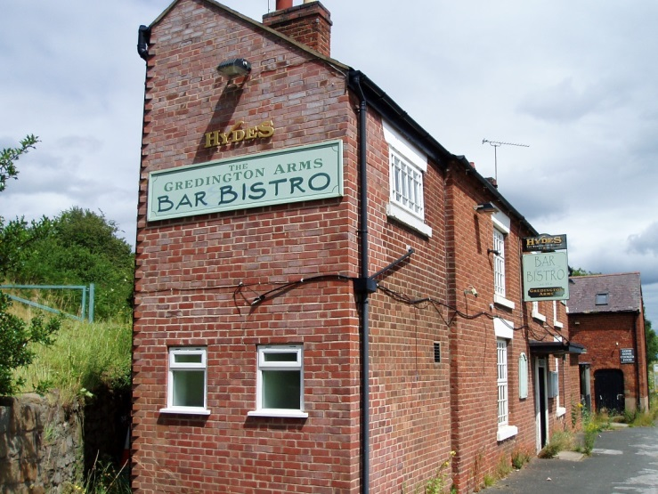

Photograph 2. Gredington Arms – rear of pub

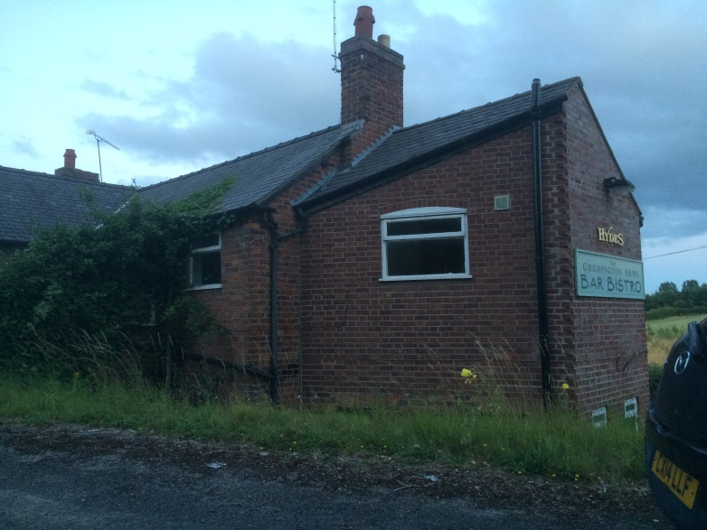

Photograph 3. Gredington Arms – porch over front door

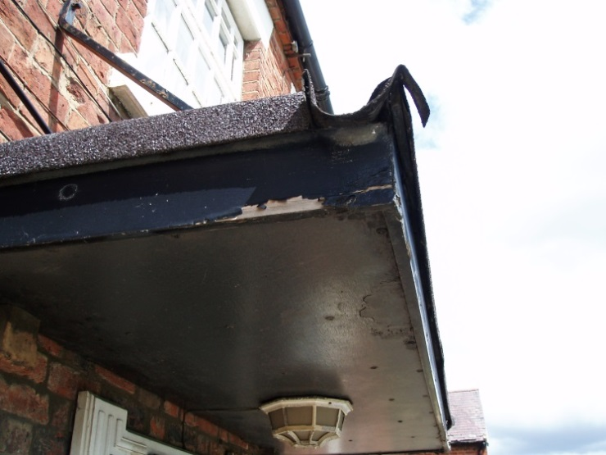
Gaps under the edge of felt roof

Photograph 4. Gredington Arms – extensions to pub

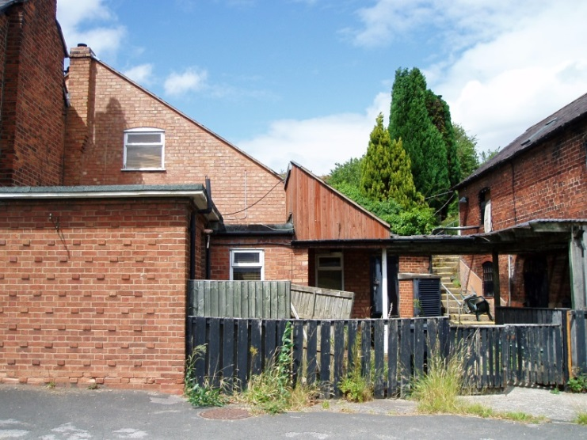

Photograph 5. Gredington Arms – pub roof void

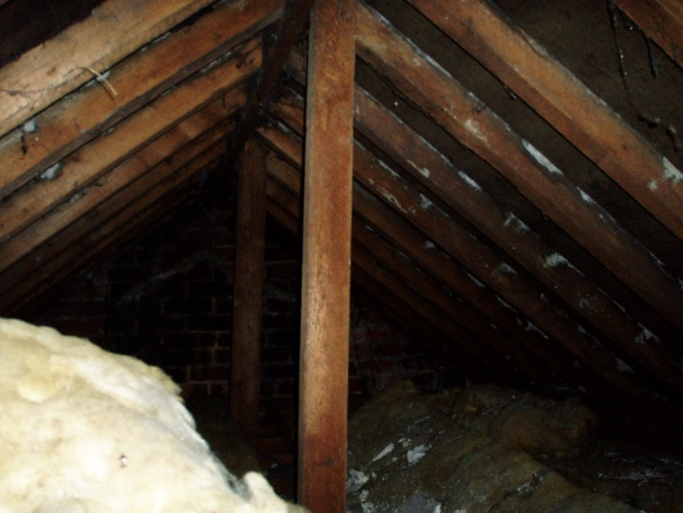

Photograph 6. Gredington Arms – south end of the barn

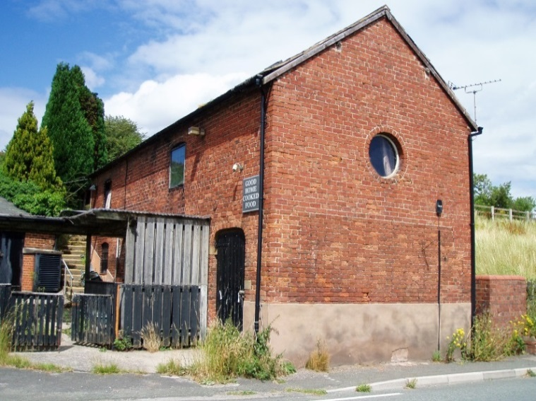

Photograph 7. Gredington Arms – Enlarged rabbit burrow with
Badger hair in spoil

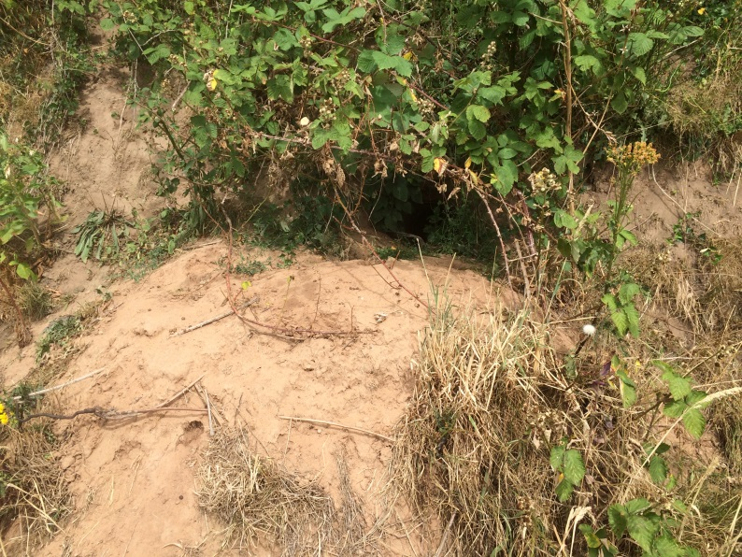

Photograph 8. Gredington Arms – Claw marks on mammal run above photograph 7

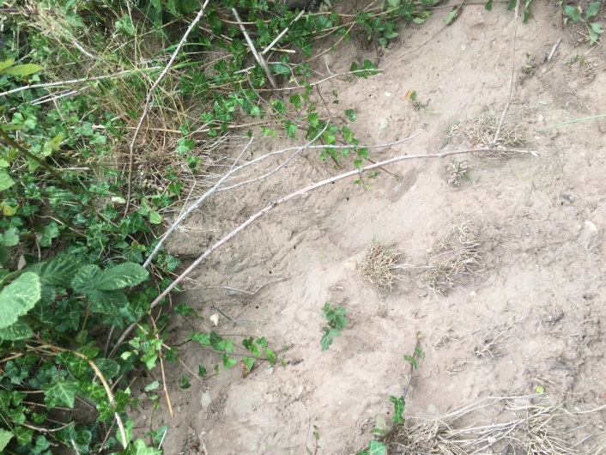
Claw marks

Figure 1. Site plan of Gredington Arms, Wrexham – not to scale N

Birds nest
Flat roofs
Car park area
Pub
Barn
Old Holt road

