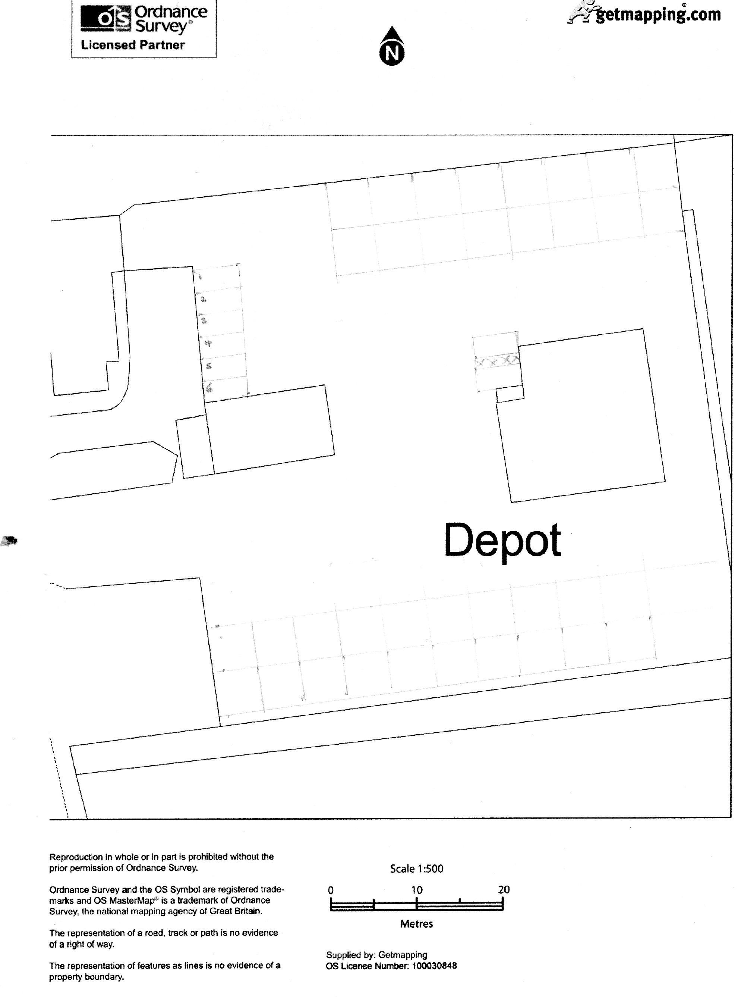
Staff parking
Tractors displayed for sale
2 disabled parking spaces
Tractors awaiting repair

