

North Wales Prison

Planning Conditions
Condition 14 and 15
Pedestrian / Cyclist Crossing and Bus Shelters

17th October 2014

Document Control

Version No. | Date of  first issue | Purpose of issue | Amendment summary
V01 | 17/10/2014 | Reserve Matter Discharge ~ Representation | First Issue

Condition 14

The reserved matters application shall include details of a new signalised pedestrian and cyclist crossing to be provided on Bridge Road. The development shall not be brought into use until a signalised pedestrian and cyclist crossing has been provided in accordance with the details as approved.

Condition 15

The reserved matters application shall include details of the siting and appearance of two new bus shelters that shall be provided on Bridge Road. The development shall not be brought into use until the two new bus shelters have been sited on Bridge Road in accordance with the details as approved.

Response :

Drawings included providing information to discharge the reserve matter condition 14 and 15:

Site Masterplan – NWP-AR-CAP-099-PA-01-1001 rev P07 demonstrating the proposed position of the two bus shelter and pedestrian crossing. Further detail to be provided prior to construction of these elements.

TPS design details to show crossing and bus stops.
Document Reference : NWP-CE-TPS-099-DR-XX-5003 rev P04

Bus shelters confirmed as Queensbury Shelters, Arun Specification as preferred by Wrexham CBC. See details on following sheet. Note exact specification to be agreed with Wrexham CBC prior to installation.

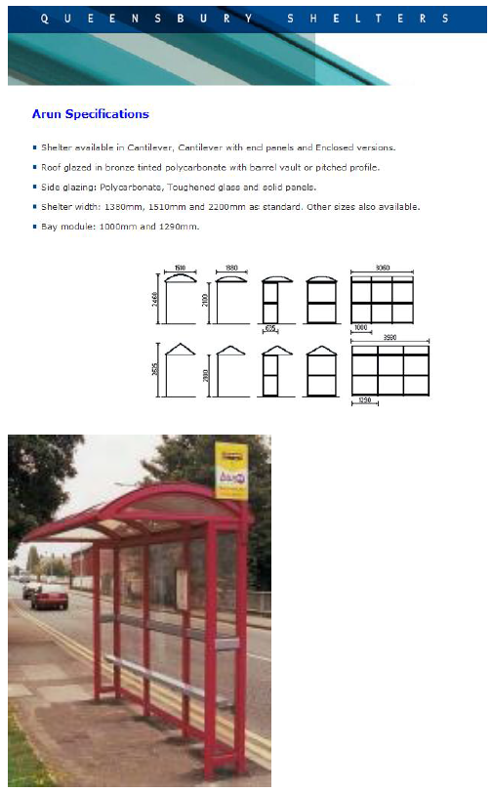

Documentation Provided :

2No paper copies of all documents, 2No Full size drawings and an electronic version.

