BRYMBO: RECLAMATION AND REDEVELOPMENT

PROPOSED HOUSING DEVELOPMENT (OUTLINE): P/2012/0817 and SUPERMARKET DEVELOPMENT (OUTLINE): P/2012/0818

LPG 32: Biodiversity and Development

Local Planning Guidance Note 32 amplifies the Council’s local development plan policies with regard to Nature Conservation, Protected Species and Biodiversity.
The two proposed developments on the former Brymbo Steelworks site both fall within areas which have undergone comprehensive reclamation and remediation as part of the permitted redevelopment process. In both cases this has meant total site clearance and excavation of all materials to a minimum depth of 5 metres, followed by replacement with clean material compacted to make the ground suitable for hard development. No soils have been placed over the compacted overburden material as this will form part of the redevelopment exercise at some time in the future.
As a result, the degree of vegetation growth on both sites is very limited and much of the surface is bare earth. The photographs below illustrate this point.
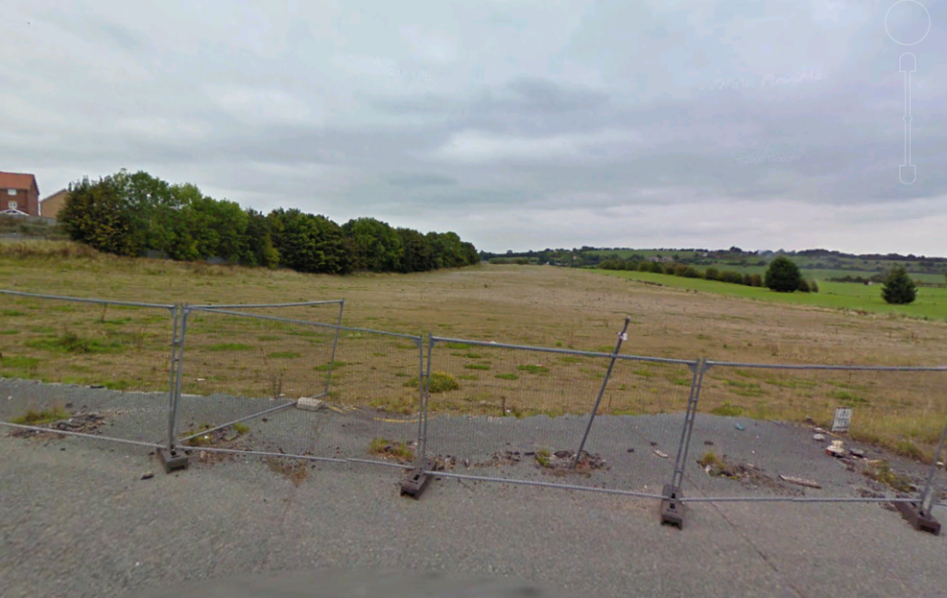
HOUSING SITE

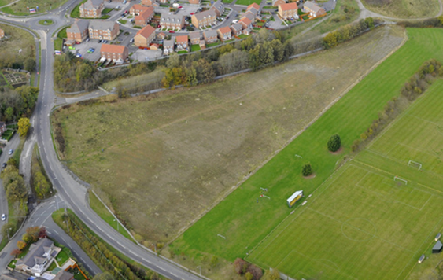
HOUSING SITE

With regard to the Housing Site the belt of trees to the south of the existing housing will be retained. The greener ‘more lush’ area adjacent to the Sports and Social Club falls outside the proposed development boundary and will be unaffected by the development.

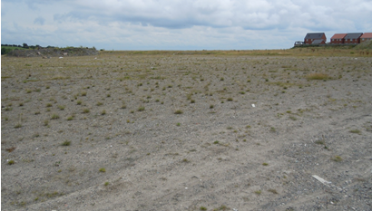
SUPERMARKET SITE

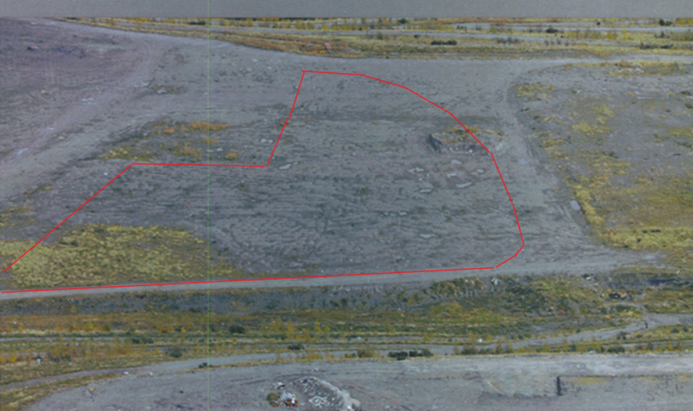
SUPERMARKET SITE

The Supermarket Site contains no tree/shrub growth at all and displays even less grass cover.
Dealing with those considerations (UDP Policies) identified in the LPG 32:
Policy PS2: Given the recent history and development of the site as indicated above it is considered that the proposed developments will have no material effect on the natural environment.
Policy PS11: The sites currently have very limited biodiversity value. It should be recognised that these developments form a part of a larger comprehensive redevelopment scheme which incorporates significant areas of open land including a specific area within the designated Heritage Area, set aside for its current and potential ecological/biodiversity value.
Policy EC4: The proposed developments will involve the loss of no trees, hedgerows or ancient woodlands. The retention of existing trees on the site boundary of the Housing area is one element of the submitted Design and Access Statement:
‘The existing site has been decontaminated and reclaimed from its former steelworks use. The site appears to have low ecological value. The outline proposal will provide new planting of native species to enhance the site and surrounding environment. The existing trees to the North boundary will be retained.’
Policy EC6: It is acknowledged that the Supermarket site fall within 500 metres of a known site of biodiversity interest – a colony of Great Crested Newts. The newts were relocated to their current location under the terms of a Licence under Regulation 44 of the Conservation (Natural Habitats etc) Regulations 1994 (14th May 2001 - Ref: GCN/056/NAW/IND). This related to the installation of permanent newt fencing around an area (within which four new ponds had been created) which was to act as a receptor site for translocated newts. A separate document dealing specifically with this issue and setting out the background, current and future position in this regard, has been prepared.
It is considered that the above should be sufficient to satisfy the requirements of LPG 32.

