THE SITE

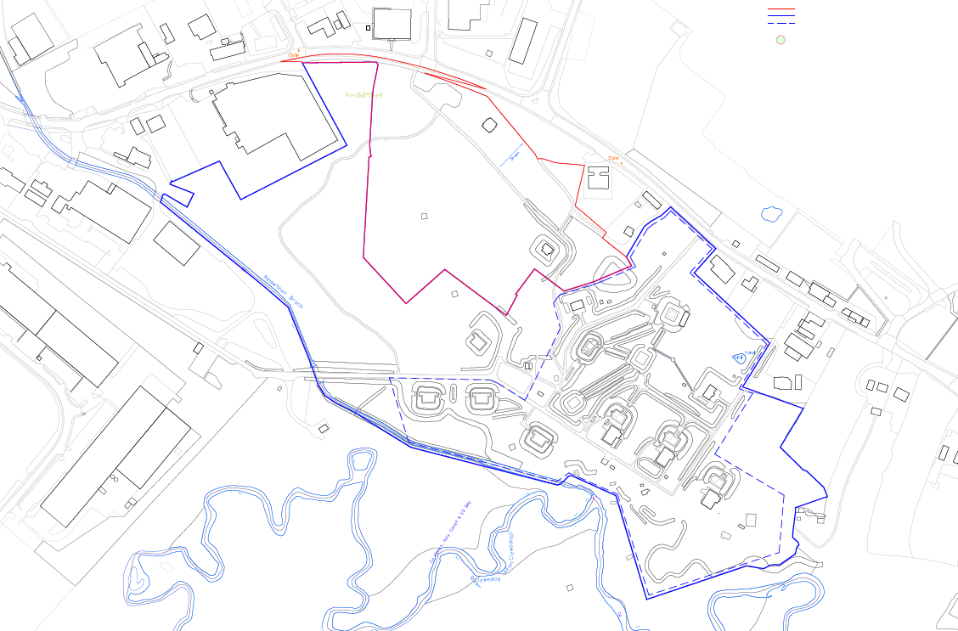

PROPOSAL

The proposal seeks outline planning permission with approval of access and layout for the proposed development of industrial units comprising B1 and B8 use classes.

HISTORY

P/2019/0877 Outline application with some matters reserved for proposed development of land for B1 light industrial and B2 / B8 industrial units including means of access and layout, illustrative strategic landscaping, with ecological, heritage and amenity mitigation zones. Refused 16/10/2020.
P/2000/0019 Industrial development. Approved 10/07/2000.

NATIONAL PLANNING POLICY

Planning Policy Wales 11 (PPW11)

Technical Advice Note (TAN) 23Economic Development

DEVELOPMENT PLAN

UDP Policies PS1, PS2, PS3, E4, EC4, EC6, EC9, EC11, GDP1, T8

Local Planning Guidance Notes 16, 17, 26, 29, 32.

CONSULTATIONS

Community Council: No objection.
Local Member: Notified 20.05.2021.
Highway Authority: Comments dated 11.08.2021. A right hand turn holding lane on Oak Road, as well as the widening of the bell mouth, is recommended on safety and capacity grounds.

Comments dated 12.10.2021. Following a meeting with the agent and Highway Consultant, as well as the additional information submitted on 14th September, this confirmed that the proposed access is acceptable in principle, given the reduction in the size of the development from that originally proposed under P/2019/0877. The HGV swept path analysis shows a slight encroachment onto the opposite carriageway, however this can be accommodated at the detailed design stage within land within the developers’ ownership.
NRW: Conditions relating to Great Crested Newts mitigation and contaminated land recommended. No concerns raised in regards to fluvial flood risk. Refers the LPA to NRW’s planning advice in regards to phosphates.
Ecology: Regardless of the reduction in scale to the previous application, reservations regarding this proposal remain. The proposal results in the loss of valuable Welsh Priority Habitat and designated Local Wildlife Site and the requirements for SUDs and site investigations further compound the loss. Both Grizzled and Dingy skipper were recorded from within the development boundary in 2021 and numbers on the site appear relatively stable despite its reputed loss of ecological value.
Investigation for the Local Development Plan deemed the site was unnecessary to facilitate projected growth and that economic development would be better located to the north of Wrexham Industrial Estate. The proposed extension to the Industrial Estate is on a far less ecologically rich site and is preferable for other highways and economic reasons. Preventing further loss of ecologically important sites on Wrexham Industrial Estate is key to ensuring a balanced approach to development, which has so far, been weighted heavily in favour of development and has resulted in permanent losses of sites which are impossible to recreate.
Trees: The scheme requires the unacceptable removal and loss of 2 no. category ‘B’ oak trees, subject to TPO and a further category ‘B’ oak tree. The trees on site are a significant material consideration and constraint to a development which fails to protect and integrate such features within the layout. The development conflicts with local and national planning policy.
Public Protection: No objection subject to conditions to limit rating level of noise generated by each unit and submission of dust management scheme. Informatives relating to construction noise, noise nuisance and burning of waste recommended.
Contaminated Land: No objection subject to conditions to secure submission of a phased site investigation scheme, remediation strategy and verification report.
CADW: No objection.

CPAT: No objection subject to a pre-commencement condition to secure a Level 4 Building Survey and implementation programme of archaeological work.
Coal Authority: No comments to make.
Conservation: No objection subject to conditions.
Welsh Water: No objection subject to a pre-commencement condition to secure submission of a foul water drainage scheme. The development is crossed by public sewer assets, no operational development shall take place within 3 metres either side of the centreline of the sewers.
HSE: The development site does not lie within the consultation distance of a major hazard site or major accident hazard pipeline.
Butterfly Conservation: Object. The site is located within a Local Wildlife Site which supports nationally important and declining species and habitats. The only way in which to ensure that the site continues as a functional ecological network for the Estate is to ensure it is protected and managed in its entirety.
Neighbours: 1 no. representation received objecting to the proposal. Concerns raised include increase in noise and light pollution, concerns regarding traffic and ecology.

SPECIAL CONSIDERATIONS
Policy: The application site is located within the Wrexham Industrial Estate Settlement Limit. The site is also a designated Local Wildlife Site.

Wrexham UDP Policy E4 allows employment development on unannotated land within settlement limits, subject to compliance with GDP1. Provided the proposal complies with Policy GDP1 and would not result in adverse impacts to material considerations associated with the scheme, the principle of development for the uses proposed within the settlement limit would be considered acceptable.

Ecology: NRW, in their role as Statutory Consultee, provide advice regarding protected species. In this respect, no objection is raised to the impact of the proposal on Great Crested Newts.

The Council’s Ecologist raises concerns with the proposal. The application would result loss Welsh Priority Habitat and part of a Local Wildlife Site. The requirement to provide a sustainable urban drainage system and site investigation works would further compound this loss.

The species of butterfly Grizzled and Dingy Skipper were recorded from within the development boundary in 2021 and numbers on the site appear relatively stable, despite the reputed loss of ecological value set out within the application submission.

Investigation for the Local Development Plan (LDP) deemed the site was unnecessary to facilitate the projected growth required for the Industrial Estate and that economic development would be better located to the north of the Estate.

The proposed extension to the Industrial Estate, put forward as part of the LDP, is on a far less ecologically rich site and was considered preferable for other material planning considerations. Preventing further loss of ecologically important sites on the Industrial Estate is considered to be crucial to ensuring a balanced approach to development overall.

UDP Policy EC6 states that development either within or close to sites of biodiversity interest will only be permitted where it can be clearly demonstrated that the need for the development outweighs the need to safeguard the intrinsic nature conservation value of the site. The policy text goes on to state that local nature reserves comprising habitats of local significance, can make a useful contribution both to nature conversation and to the opportunities for the public to see, learn about and enjoy wildlife.

The application needs to demonstrate that there is an overriding need for the proposed development, which would outweigh the loss of this designated Local Wildlife Site. This is considered further later in the report.

In addition to the ecological impacts that would arise on site as a result of the development, the impact upon the River Dee and Bala Lake Special Area of Conservation (SAC) must also be considered.

The application site proposes to dispose of foul water via the mains sewerage system which connects to the Five Fords wastewater treatment works (WWTW). This has provision to remove a percentage of phosphates from wastewater and consents to discharge treated water into adjacent watercourses (and therefore indirectly into the River Dee), subject to specific limits on the amount of phosphate within the treated water.

Whilst the WWTW is currently operating within its consented limits, the existing discharge consent is around 10 years old and pre-date recent case law, and as such need to be reviewed using new data and specially developed models. This work is being undertaken NRW and Welsh Water, but is not expected to be completed until the spring of 2022, at the earliest. Furthermore whilst the existing provisions in place at the WWTW removes a proportion of phosphate from waste water, a residual amount remains. Development which increases foul water flows to the WWTW will therefore also result in an increase in phosphate discharges into the SAC.

The proposed development will increase foul water flows to the WWTW by way of foul water generated by on-site facilities for staff and visitors. Accordingly it is not possible to conclude that the development is unlikely to adversely impact upon the SAC. Adversely impacting upon a statutorily protected site represents a further conflict with policy EC6 to the matters discussed above.

Trees: UDP Policy EC4 states that development proposals should provide for the conservation and management of hedgerows, trees, woodland, wildlife and other landscape features. Development which results in the loss or significant damage to valuable trees, important hedgerows or ancient woodland sites will not be permitted.
The policy goes on to state in the supporting text that developments may be resisted if they adversely affect the integrity or continuity of landscape features which are designated as of major importance for wild flora and fauna.

The scheme requires the removal and loss of 2 no. category ‘B’ oak trees subject to TPO WCBC 50/2000 and a further additional category ‘B’ oak tree. The 3 no. oak trees proposed for removal have sufficient amenity value with increased future amenity values to consider, should the site be developed sympathetically, and would integrate well amongst existing natural features. On this basis, the Tree Officer objects to the proposal given the trees on site are a significant material consideration and constraint to a development which fails to protect and integrate such features within the layout.

The trees, subject to TPO 50/2000 are considered to have a sufficient and increasing amenity value to justify such statutory protection, whilst providing an important component of on-site biodiversity and ecological resilience. The proposals also conflict with UDP Policy EC4, LPG 17 ‘Trees and Development’ and the Council’s Woodland Strategy.

Economic Benefits: Section 38(6) of the Planning and Compulsory Purchase Act 2004, states that planning applications must be determined in accordance with the development plan, unless material considerations indicate otherwise.

The site lies within settlement limit where there is a policy presumption in favour of employment development. Nevertheless the Council’s Tree and Ecology Officers raise concerns in regards to the environmental impact of the proposal. The proposals are also likely to result in harm to the River Dee and Bala Lake SAC. The development therefore conflicts with UDP Policies EC4 and EC6.

A judgement must therefore be made to establish whether the benefits in granting planning permission for this development would outweigh the ecological and arboricultural harm which has been identified. In this instance, the whether there are economic benefits that override the above considerations need to be considered.

Technical Advice Note 23 Economic Development

Technical Advice Note (TAN) 23 states in paragraph 2.1.5 that where a planning authority is considering a planning application that could cause harm to the environment, it will be necessary to assess whether there are any alternatives to the proposal, the number of jobs accommodated on the site and whether the development would make any special contribution to policy objectives.

As identified, development of this site would result in environmental harm, triggering the need to assess the above three tests as part of the decision making process.

The applicant has submitted an Employment Market Study (EMS) to justify why this site should be granted planning permission. The contents of this document is discussed further below.

Alternatives - if the land is not made available (application is refused), is it likely that the demand could be met on a site where development would cause less harm, and if so where?
The EMS has identified a list of sites and outlined why these are not suitable as alternative sites. Six criteria have been used in which to assess the suitability of the sites. No justification has been given as to why the six criteria used have been specifically chosen for this assessment. Furthermore, the six criteria are at odds with the grading criteria outlined in the Council’s Employment Land Review (ELR) 2015, which consist of ten individual measures. The ELR forms part of the evidence base in which the Local Planning Authority used to establish employment allocations as part of the LDP process, however it is also relevant evidence in the determination of individual planning applications.

Whilst the EMS states that the application site is the best out of ten sites identified located within the Industrial Estate and joint third overall in the borough, the Council’s own ELR concluded that the worst performing site in the analysis of available sites for employment is the Cefn Park site, subject of this application.

Notwithstanding that the applicant has chosen to use different and reduced criteria in which to assess their chosen sites in the Borough to those used by the Council it is considered that there is no reason for the applicant’s EMS to be given greater weight than the Council’s ELR in terms of the suitability of this site for employment.

The EMS includes a list of organisations (unnamed) which have shown interest in occupying the site and subsequent units, should this application be granted. However, no date has been given as to when these parties expressed interest. The site has been marketed since January 2018. Nineteen formal expressions of interest have been received since this date. The revised planning application was not submitted until May 2021 – over three years after the marketing period commenced. It is therefore unclear if the list of interested organisations is up to date or whether it has substantially during this time.

The matters discussed above suggests that this is a speculative proposal, indeed the fact the proposals have been made in outline lends further weight to this conclusion. Specific requirements of organisations seeking to locate to this site and the reasons why this site is essential to meeting the development aspirations of those businesses that have responded to the marketing exercise have not been demonstrated. Even by showing interest in the site and its potential for proposed units, this does not demonstrate actual commitment. It has also not been demonstrated why interested organisations could not find alternative, less constrained sites for their requirements elsewhere on the Wrexham Industrial Estate or indeed in the wider County Borough.

The EMS states at paragraph 8.5.3 that the site could be delivered within 1 – 3 years. However given the speculative nature of the proposals it is far from clear whether this would in fact be the case.

Jobs accommodated – how many direct jobs will be based at the site?

In terms of jobs accommodated, the application is made in outline and the applicant is not the developer. The application, by itself, does not demonstrate commitment in bringing the site forward for employment development.

Whilst the EMS suggests that the site could create around 201, given the speculative nature of the scheme it is far from clear that this number of jobs would in fact be generated.

Special Merit – would the development contribute towards any special policy objectives?

The site is a designated Local Wildlife Site and as previously stated the proposals are considered likely to have harmful ecological impacts. The foul drainage from the site is also likely to be harmful to the SAC.
This ecological importance of the site is recognised in the deposit Local Development Plan where the entire application site is proposed for removal from the Settlement Limit and designated as part of the Wrexham Industrial Estate Strategic Ecological Network and Local Designated Site of Nature Conservation.

Whilst only limited weight can be given to the deposit LDP at this stage, it should be noted that even so, the proposal does not make any contribution to special policy objectives within extant local or national planning policy.

Joint Employment Land Review (ELR) 2015

As required Planning Policy Wales (PPW), Wrexham Council’s Joint Employment Land Review (ELR) 2015 assesses the supply, need and demand for employment land and premises in Wrexham and provides evidence which has helped to inform the Council’s Local Development Plan.

The applicant’s Employment Market Study (EMS) states that there is an undersupply of employment land within the Wrexham Industrial Estate. This is not disputed and is acknowledged in the Council’s 2015 Employment Land Review.

The recommendations within the ELR essentially identifies a surplus of employment land within the County Borough, with the exception of the Wrexham Industrial Estate, where there is high demand and a constrained overall land supply. The report recommends that consideration should be given to identifying additional land within the WIE.

The application site was considered as part of the LDP process, scoring 28 out of 100 for its suitability and being excluded from the realistic supply of deliverable employment sites. The ecological constraints associated with this site is reinforced in the ELR which states at paragraph 11.32 that the application site forms part of a larger wildlife site with a range of ecological constraints, therefore rendering the site undevelopable for B1/B8 uses. This would indicate that the site is not viable or deliverable, therefore conflicting with the guidance set out in TAN 23.

The Employment Land Supply Summary within the ELR sets out all of the sites included within the supply analyses for B1 and B8 use classes. The application site was included in the analyses and taken into account as part of the identification of additional land required within the WIE. For the reasons set out above, the site was not considered suitable as part of the additional land required within the Wrexham Industrial Estate. This is reflected in the site area of Key Strategy Site 3 (KSS3) which is the land included within the extended Settlement Limit for the Industrial Estate. If the application site had been considered suitable for development, the proposed size of KSS3 may very well have been reduced given the supply could also have been accommodated elsewhere.

In relation to Employment Land Reviews, PPW paragraph 5.4.7 states that development management decisions should be based on up-to-date local and sub-regional evidence. On the basis of the above, the application site has not been identified as a suitable site for B1/B8 uses which is why it has not been proposed for inclusion within the WIE settlement limit for the forthcoming LDP.

Previously Developed Land

The EMS states that the site is brownfield land and that this should be taken into account as part of the planning balance. Whilst accepting that PPW11 supports the re-use of previously developed land, paragraph 3.55 confirms that not all such land is suitable for development. One of the reasons given for this is the presence of valuable habitats. Paragraph 2.3 of TAN 23 also states that ‘The TAN does not override any environmental legislative requirements that may apply to a particular site.’

In this context, it is considered that the proposal, by virtue of the loss of 2 no. TPO’s and 1 category B tree, the harm identified to the Local Wildlife Site and the likely harm to the SAC cumulatively mean that refusal of the application would be consistent with advice in paragraph 3.55 of PPW11. It is also worth noting that PPW11 specifically excludes from the definition of previously developed land areas where the remains of any structures or activity have blended into the landscape over time so they can be reasonably considered part of the natural surroundings. Whilst there is evidence of past use within the site it is nevertheless substantially covered in vegetation and arguably appears to be part of the landscape surrounding the Industrial Estate. It is therefore questionable as to whether the site can therefore be considered previously developed land.

Overall Planning Balance

Having regard to the above, it is not considered that the information submitted as part of the application meets the three tests set out in TAN 23.

Whilst the principle of employment development within the Wrexham Industrial Estate Settlement Limit is acceptable, the proposals are likely to result in considerable environmental harm which outweigh the potential economic benefits that the scheme may secure.

Layout and design: The layout of the development is broadly comparable to other similar developments within the wider industrial estate. Whilst scale and appearance are reserved matters it is reasonable to conclude that the proposed units would also be broadly reflective of existing industrial/warehouse units in the locality. By itself, there are no grounds to consider the proposed site layout to be inappropriate.

Heritage: CADW, CPAT and the Conservation Officer raise no objection subject to conditions.

Residential Amenity: The site does adjoin a residential properties (The Oaks). This property is situated to the rear of an existing industrial unit and close to a number of others. The site layout is considered unlikely to prove harmful to residential amenity, although the overall height of one of the proposed buildings would need to be considered further at reserved matters stage to ensure there was no adverse impacts upon amenity by way of loss of light or by being visually overbearing. In addition, conditions would be necessary in respect of noise levels, including the provision of suitable boundary treatment.

Highway Safety: Initial concerns were raised by the Highway Authority regarding the access junction and the requirement for a right turn holding lane on Oak Road on the basis of safety and capacity grounds. Additional information submitted has overcome these concerns.

Whilst the swept path analysis shows HGVs would slightly encroach onto the opposite side of the carriageway, this can be overcome through necessary design alterations within the applicants’ ownership and secured via planning conditions.

CONCLUSION

The proposal would result in harm to the Local Wildlife Site adversely impact upon the River Dee and Bala Lake SAC and result in unacceptable loss of trees therefore conflicting with policies GDP1, EC4 and EC6 of the Wrexham Unitary Development Plan. It is not considered that there is an overriding need for the development to sufficiently outweigh the concerns regarding these ecological and environmental impacts.

RECOMMENDATION: That permission be REFUSED

