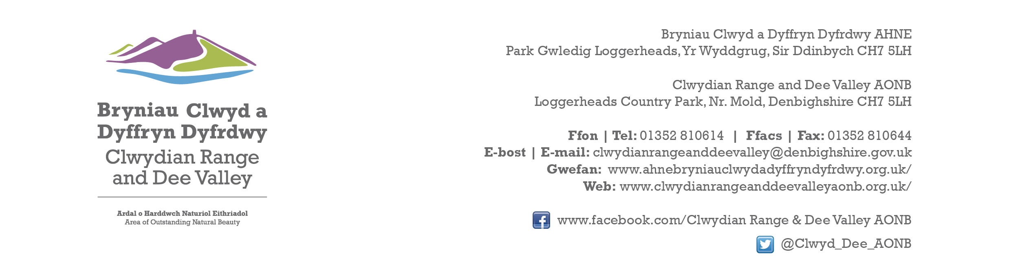

Ref P/2021/0701
Dyddiad | Date: 13th December 2023

Simon Greenland
Economy and Planning
Wrexham County Borough Council
Guildhall
Wrexham
LL11 1AY

Dear Simon,

PROPOSAL: Outline application for the erection of rural enterprise dwelling ( all matters reserved )

LOCATION: Garrig Llwyd, Blaenau Road, Froncysyllte, Wrexham

Thank you for re-consulting with the Joint Committee on this application. The following observations are submitted on behalf of the Joint Committee.

Subject to the proposal meeting the relevant functional and financial tests there are no objections in principle. The AONB can absorb a single dwelling in this location without any detrimental impact upon the character and appearance of the landscape. However, it would be preferable to re-site it closer to the farmstead and the proposed residential curtilage needs defining.

The site lies close to existing trees and established hedgerows so protective measures should be conditioned. You may also wish to consider the removal of permitted development rights given the sensitivity of the landscape. Whilst the application is in outline only, the Joint Committee would expect the scale and proportions of the proposed dwelling to be commensurate with that of the salary of a farm worker. On this note the Joint Committee respectfully request to be consulted on the reserved matters application should outline permission be granted.

I would be grateful if you could take account of the committee’s views when deciding this application.

Yours sincerely,

Dave Williams
AONB Planning Advisor
For the Clwydian Range and Dee Valley AONB Joint Committee

