Appendix C - Alternative sites

- Unit F1-F2, Bersham Enterprise Centre, Colliery Road, LL14 4EG, 2000sq ft, leasehold – Legat Owen

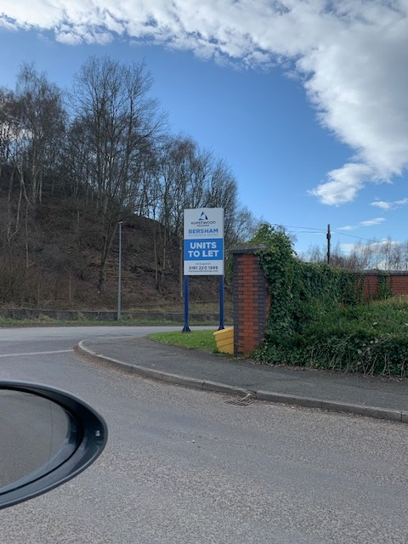

Site 1

- Unit 8A Pandy Business Park, LL11 2UD, 2000sq ft, leasehold – Wingetts

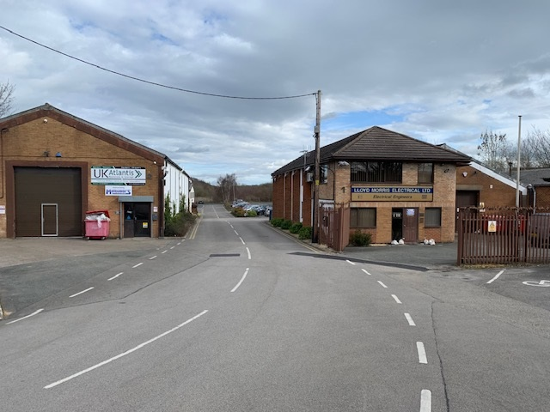

Site 2

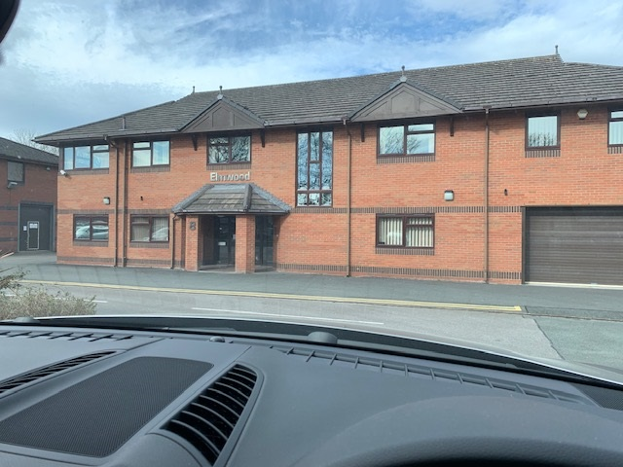

Site 2

- Unit 10 Rivulet Road, LL13 8DL, 2500sq ft, leasehold – Wingetts

- Unit 12A Rhosddu Industrial Estate, LL11 4YL, 3200sq ft, leasehold – Beresford Adams

- Site 4 Glywedog Road North, LL13 9XN. New industrial / warehouse units, with bespoke fit out available. 30,000 sq ft on 2.4 acres. (To let).

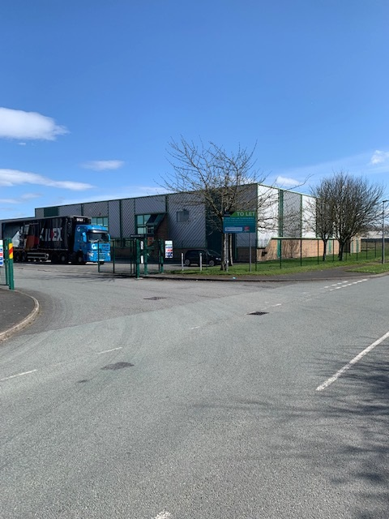

Site 4

- Office B, Llay Industrial Estate, LL12 0PG, 6200sq ft, leasehold – Legat Owen

- Unit 1A Gardden Industrial Estate, LL14 6RG, 6500sq ft, leasehold – Beresford Adams

- Point 36 Davy Way, Llay, LL12 0PG, 1,169 to 9,884 Sq Ft, leasehold – Hallams Property Consultants

- Unit 7 Caia Park, Wrexham, LL13 8UG, 15,494.4 Sq Ft, leasehold – WCBC Estates

- Unit 10 Vauxhall Industrial Estate, Ruabon, LL14 6HA, 8,172 Sq Ft, Freehold - Allsop

- Land at Gutter Hill, Rhos, LL14 1LT, Freehold £25,000, Pugh & Co

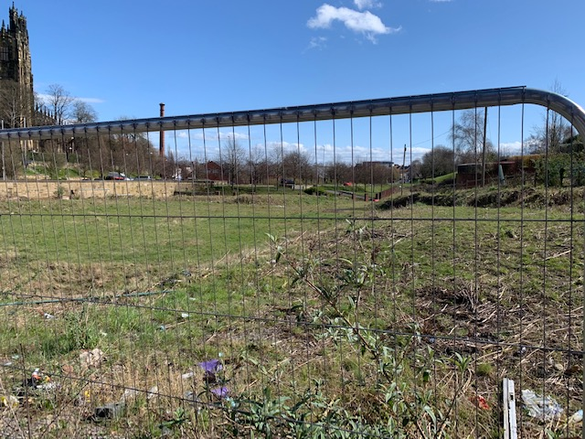

Site 11

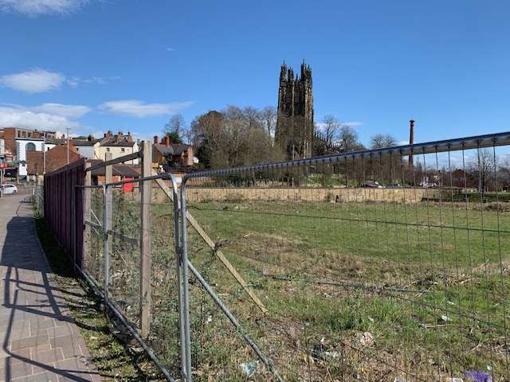

Site 11

- Land at St Giles Way, Wrexham, LL13 7DD, 1.03 Hectares (2.55 Acres), Freehold – Lambert Smith Hampton
- Land at Bryn Lane, Wrexham, LL13 9UT, 2.41 Acres (0.98 Hectares), Leasehold – Matthews Goodman

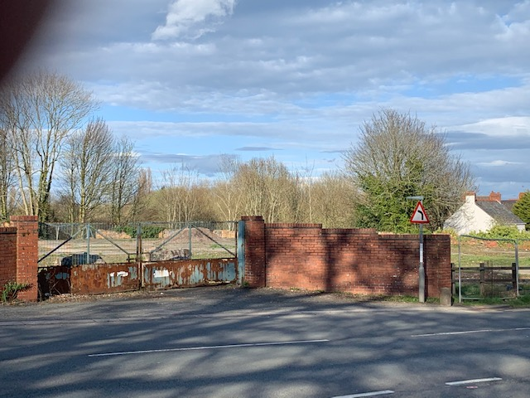

Site 13

- Norther Quarter, Plas Coch, Wrexham, LL11 2BZ, 7.38 Acres (2.99 Hectares, freehold £100,000 – Legat Owen

- Llay Industrial Estate, LL12 0PG, 8.05 Acres (3.26 Hectares, Freehold – Celt Rowlands

- Plot 36, Kingsmoor Park, Wrexham Industrial Estate, LL13 9JW, 47 Acres (19.02 Hectares), Freehold – Mathews Goodman

- Site 2 Clywedog Road North. New industrial / warehouse units, with bespoke fit out available. 30,000 sq ft on 2.4 acres. (To let). LL13 9XN – F1 Real Estate

Site 17
- Site 3 Clywedog Road North. New industrial / warehouse units, with bespoke fit out available. 50,000 sq ft on 2.7 acres. (To let). LL13 9XN – F1 Real Estate

Site 18

- Vauxhall Industrial Estate, Ruabon, Wrexham, LL14 6HA. Industrial unit. 4.24 hectares. (For sale) – Allsop

- First Floor, First Avenue, Wrexham Industrial Estate, Wrexham, LL13 9XR. Industrial unit. 54,000sq ft. (To let) – WCBC

- Units 45, 46, 51 & 52, Wrexham Industrial Estate, Wrexham, LL13 9QS. Building sizes from 1,500 to 45,718 Sq Ft (139.35 to 4,247.2 Sq M) (To let) – Lambert Smith Hampton

- Former Co-operative Store, Well Street, Rhosymedre, Wrexham, LL14 3YD. 8,252 Sq Ft (766.61 Sq M). (To let) – Emanuel Oliver

- The Site, Chirk Park, Chirk, Wales LL14 5AZ. Land, 1.12 Acres (0.45 hectares). (For sale) – Avison Young UK.

- Unit 11 Vauxhall Industrial Estate, Wrexham, Wrexham LL14. 6HA 1.02 Acres, 0.41 hectare. (For sale) - Allsop.

- Units A & B, Rhosddu Industrial Estate, Rhosrobin, Wrexham LL11 4YZ. Modern Trade Counter / Warehouse units situated within a self contained fenced site of 0.4 acres. Unit A - 7,914 sq ft, Unit B - 2,464 sq ft. (To let) – Legat Owen

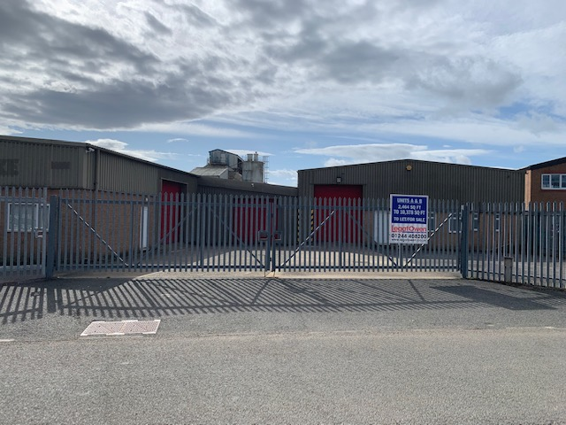

Site 25

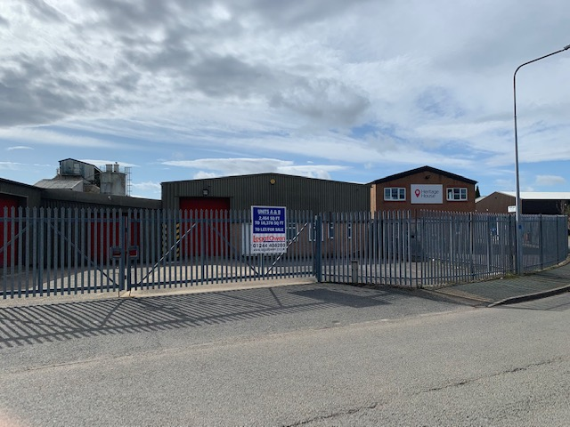

Site 25

- Wire 81, Ash Road North, WIE, LL13 9JT, 81580sq ft, Freehold, Leasehold - B8 Real Estate

- Rackery Lane, Llay Industrial Estate, LL12 0PB, various sizes, sale or let – Prospect Estates

