Water Management Surface Plan

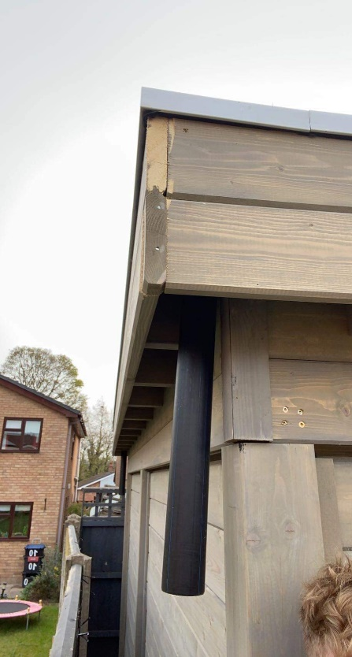

Flat pent roof covered with a high quality EPDM rubber roof covering.
Down flow pipe fitted to drain off excess water.
Appropriate guttering to be installed to flow into a water butt with the water to be recycled and used for watering the garden through the year.

Any rain water over and above that cannot be reused in the water butt will be released into the garden which is well draining.

